**NAME : SSONAM RASTOGI**

**PROJECT : ONLINE TEST WEBSITE**

**WEBSITE NAME : QuizApp**

**TOOLS: VISUAL STUDIO, BOOTSTRAP V5.2 & GIT HUB,ANGULAR,NODE**

**LANGUAGES : HTML 5, CSS 3 & TYPESCRIPT**

**GIT HUB LINK: https://github.com/sonamr8/QuizApp.git**

**Introduction**

A blogging website is used for listing blog posts.

It has multiple categories and posts written by many users which is posted only after reviewing.

It also contains Newsletter, so that user can get latest news as per the categories choosen by them.

The website is responsive ie compatible with pc, tab and mobile devices.

**Purpose**

The website is interactive and user friendly, where user can read and review the blogs posted by experts and other users, as per their choice of categories

The website also allows user to create their own blog content without any hasle, which will be posted after reviewing by experts.

The website allows the user to get the latest news as per the categories they choose.

**Features**

It has a Brand Logo,which was customized as per the requirement of the customer.

It contains a Home page, Create a Blog Page and a Terms and Conditions page.

Navbar and Footer are common in all pages.

*Navbar* contains Brand Logo, Home, Create Your Blog, Signup, Login and a Search Button.

*Footer* has a Terms and Conditions anchor tag.

*Home page :* Home page contains a navbar, carousel(which welcomes the user), cards(which contains blog as per the categories), accordion(which contains the newsletter as per the different categories)

*Create a Blog page : This page contains a form in which user can add their details, choose their category and write the blogging content .*

Terms and Condition page *:* This page contains Terms andConditions of the website.

**Tools and Languages Used**

*Tools* : Visual Studio, bootstrap v5.2 and Github

*Languages*: HTML5, CSS3, JavaScript

**Contraints**

The biggest constraints was the time given to deliver the website. Client ask for specific colors and fonts,thus the creative team feels that this limits their creativity but on the contrary it helps to define project scope and help to deliver the project on time.

**Steps Involved**

**STEP 1**

After gathering the requirement of the project, I have the backlog. Then divided the User Story into Sprints

**1st sprint - navbar , brand logo and Signup/Login modals**

**2nd sprint-Developing Home page ie carousel, blog area, newsletter area, quick links**

**3rd sprint- Designing and developing Create a Blog page ie form**

**4th sprint- Designing and developing Footer for each page and Terms and Condition page**

**STEP 2**

Added a folder in my computer ,then opened Git Bash in that folder ,then typed following codes:

* $ git config –global—user.name”Sonamr”
* $ git config –global—user.email “[sonamrastogi8@gmail.com](mailto:sonamrastogi8@gmail.com)”
* $ git log
* $git init

This will add local repository in the folder.

Then created a blogging.html file and started coding there. After that added the file in index ,then saced in the .git folder by following code:

* $ git add blogging.html
* $ git commit –u”first commit”

This will save the file in the local repository.

* $ git status

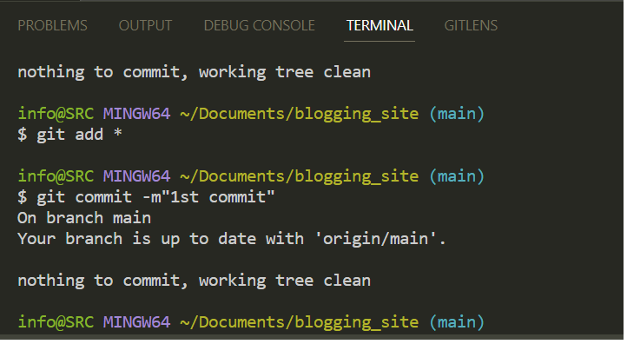

By this you will know that your file is saved in local repository.

This step is used again and again to add a file in index and then in local repository

**STEP 3**

A remote repository must be created and then added to the git bash

* $ git add README.md
* $ git commit -m "first commit"
* $ git branch -M main
* $ git remote add origin <https://github.com/sonamr8/blogging.git>

To push the code to remote repository, we use following code:

* $ git push -u origin main

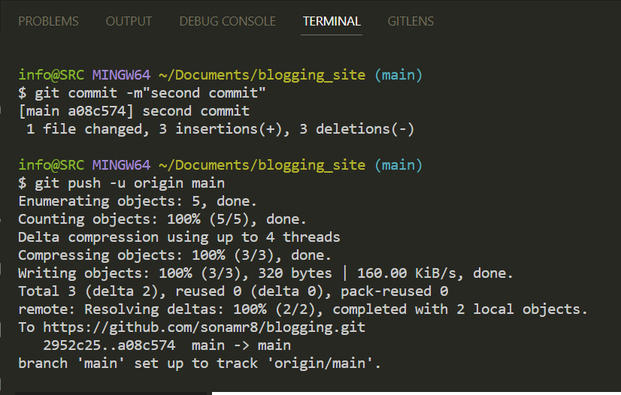

**STEP 4**

Before the final push, I have removed the node_module as I have added a node file by using node init code in the Terminal of VS code, as it was an unwanted file.

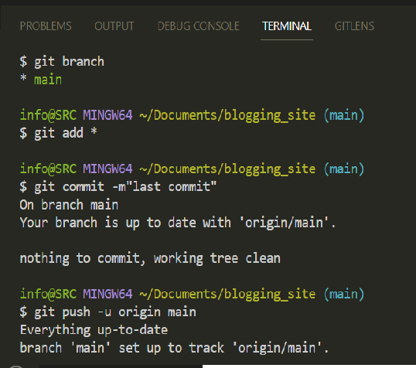

And then checking the status.

