SEC 508 STANDARD | PASS/FAIL
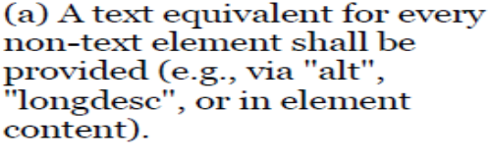 | PASS
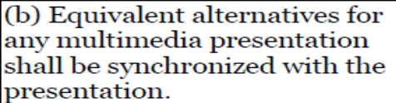 | N/A
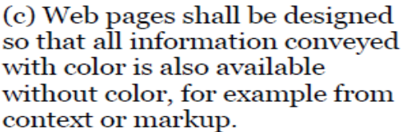 | PASS
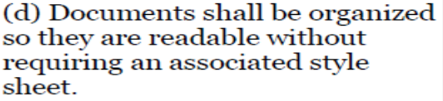 | PASS
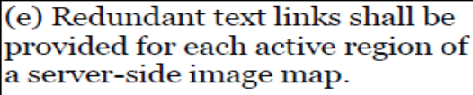
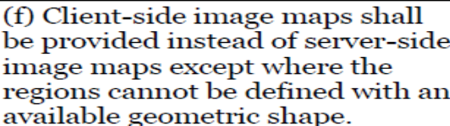 | PASS
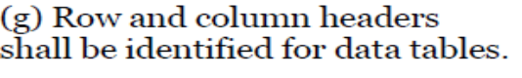 | PASS
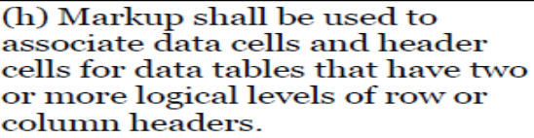 | PASS
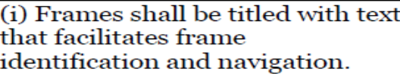 | N/A
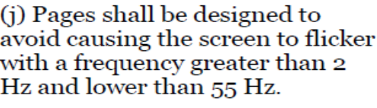 | N/A
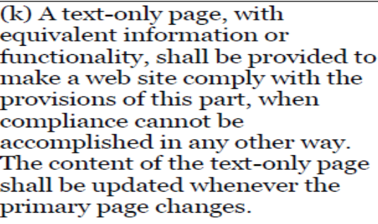 | N/A
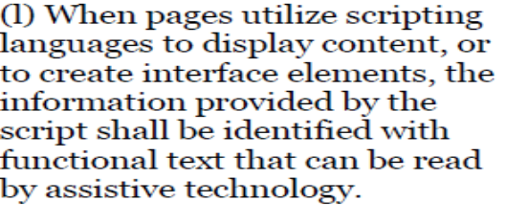 | FAIL
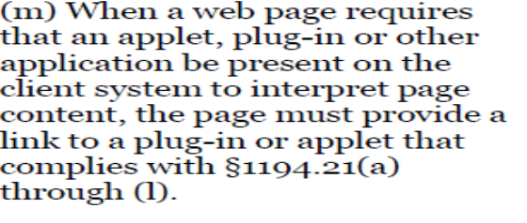 | N/A
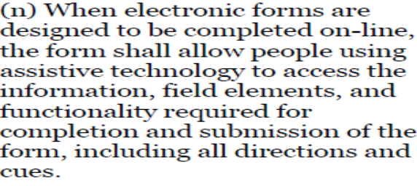 | PASS
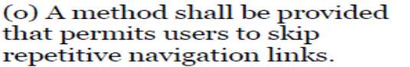 | FAIL
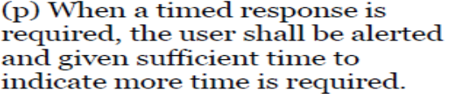 | N/A

