**Cpts 322: Software Engineering Principles I  
Dr. Haipeng Cai**

**Project Milestone 2**

Coding Girls and a Manager

|  |  |
| --- | --- |
| 11514680 | Madison Jane Holcomb |
| 11611751 | Kadupitige Ashi Chamarasinghe |
| 11625004 | Sydney Erin Gormley |
| 11628495 | Navroop Kaur |
| 11689463 | Sonam Yangtso |
| 11701083 | Jongyun Kim |

February 23, 2020

1. **Stakeholders**
   * Developers: As service provider of the project, developers need to implement the application depend on client demands.
   * Business Owner: A client of the project who orders development services. Owner wants to manage the gym by tracking the number of users, and revenue analysis.
   * Trainers and customers: the end-users who mainly utilizes scheduling services through the application.
2. 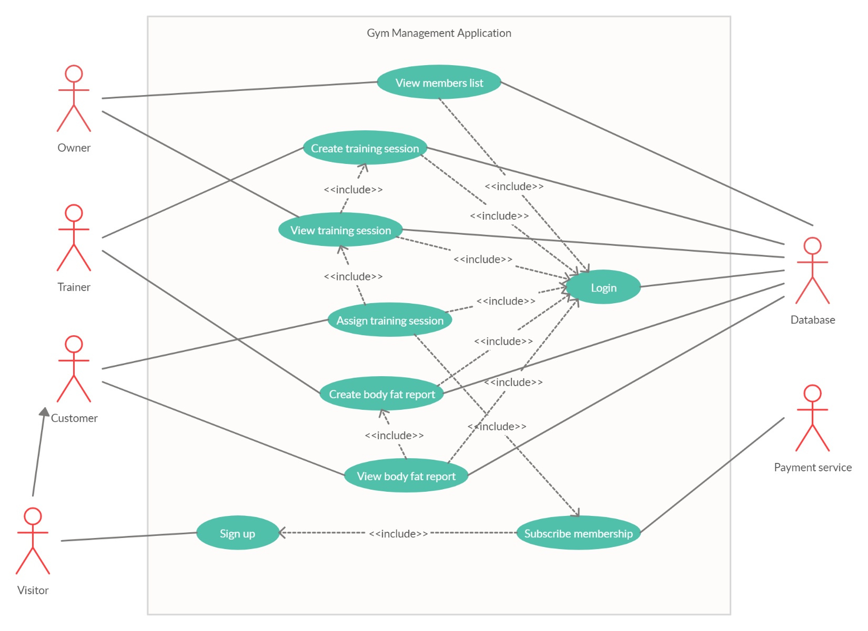**Use Case Diagram (powered by Creately)**

|  |  |
| --- | --- |
| **Name** | View Members List |
| **Actor** | * Owner * Database |
| **Goal** | * View all gym users * Check the user’s membership status. |
| **Preconditions** | * Owner must be authorized at login |
| **Scenarios** | * Go to the gym website and login * Select view all membership gym users * Notice user who has expired membership |
| **Exceptions** | * Not authorized as Owner |

|  |  |
| --- | --- |
| **Name** | View training session |
| **Actor** | * Owner * Database |
| **Goal** | * View all training sessions which have been activated |
| **Preconditions** | * Owner must be authorized at login * At least one training session created by trainers |
| **Scenarios** | * Go to the gym website and login * Select Trainers * Select view training sessions * A list of all (open and closed) sessions for each trainer will appear * Calculate trainer incentive based on activated training sessions |
| **Exceptions** | * Not authorized as Owner |

|  |  |
| --- | --- |
| **Name** | Create training session |
| **Actor** | * Trainer * Database |
| **Goal** | * Create training sessions depending on his/her working schedule |
| **Preconditions** | * Trainer must be authorized at login |
| **Scenarios** | * Go to the gym website and login * Select create training session page * Open empty training session |
| **Exceptions** | * Not authorized as trainer |

|  |  |
| --- | --- |
| **Name** | Create body fat report |
| **Actor** | * Trainer * Database |
| **Goal** | * Create customer’s body fat report |
| **Preconditions** | * Trainer must be authorized at login * Customer uses the body fat analyzer at the gym |
| **Scenarios** | * Go to the gym website and login * Select customer * Select create body report * Fill information in the web form |
| **Exceptions** | * Not authorized as trainer |

|  |  |
| --- | --- |
| **Name** | Assign Training session |
| **Actor** | * Customer * Database |
| **Goal** | * Customer registers for the training session among available trainers |
| **Preconditions** | * Customer must be authorized at login * Customer must have membership * Customer needs to view training sessions |
| **Scenarios** | * Go to the gym website and login * Find an available trainer and his/her open training sessions * Select the trainer and register for the training session on desired date and time * Attend the training session |
| **Exceptions** | * Not authorized as customer * Not eligible unless he/she has a membership |

|  |  |
| --- | --- |
| **Name** | View body fat report |
| **Actor** | * Customer * Database |
| **Goal** | * View customer's body report |
| **Preconditions** | * Customer must be authorized at login * Trainer create body fat report |
| **Scenarios** | * Go to the gym website and login * Select body fat report page * Review body fat report |
| **Exceptions** | * Not authorized as customer * Body fat report is not created by trainer yet |

|  |  |
| --- | --- |
| **Name** | Sign up |
| **Actor** | * Visitor |
| **Goal** | * Want to access the gym or get a membership |
| **Preconditions** | * Have own Email address and phone number |
| **Scenarios** | * Go to the gym website * Sign up the website with filling up the form |
| **Exceptions** | * none |

|  |  |
| --- | --- |
| **Name** | Subscribe membership |
| **Actor** | * Payment service |
| **Goal** | * Charge the membership fee from customer |
| **Preconditions** | * Have own PayPal account or valid credit card |
| **Scenarios** | * Redirect to payment page * Select membership term * Fill in the card information |
| **Exceptions** | * Customer doesn’t accept the agreement |

|  |  |
| --- | --- |
| **Name** | Login |
| **Actor** | * Database |
| **Goal** | * Give proper credential to each user |
| **Preconditions** | * User data exists in database |
| **Scenarios** | * Login page launch up * Match the ID and Password * Redirect to dashboard |
| **Exceptions** | * User data does not exist in database |