**Cpts 322: Software Engineering Principles I  
Dr. Haipeng Cai**

**Project Milestone 5**

Coding Girls and a Manager

|  |  |
| --- | --- |
| 11514680 | Madison Jane Holcomb |
| 11611751 | Kadupitige Ashi Chamarasinghe |
| 11625004 | Sydney Erin Gormley |
| 11628495 | Navroop Kaur |
| 11689463 | Sonam Yangtso |
| 11701083 | Jongyun Kim |

April 27, 2020

*powered by draw.io

1. 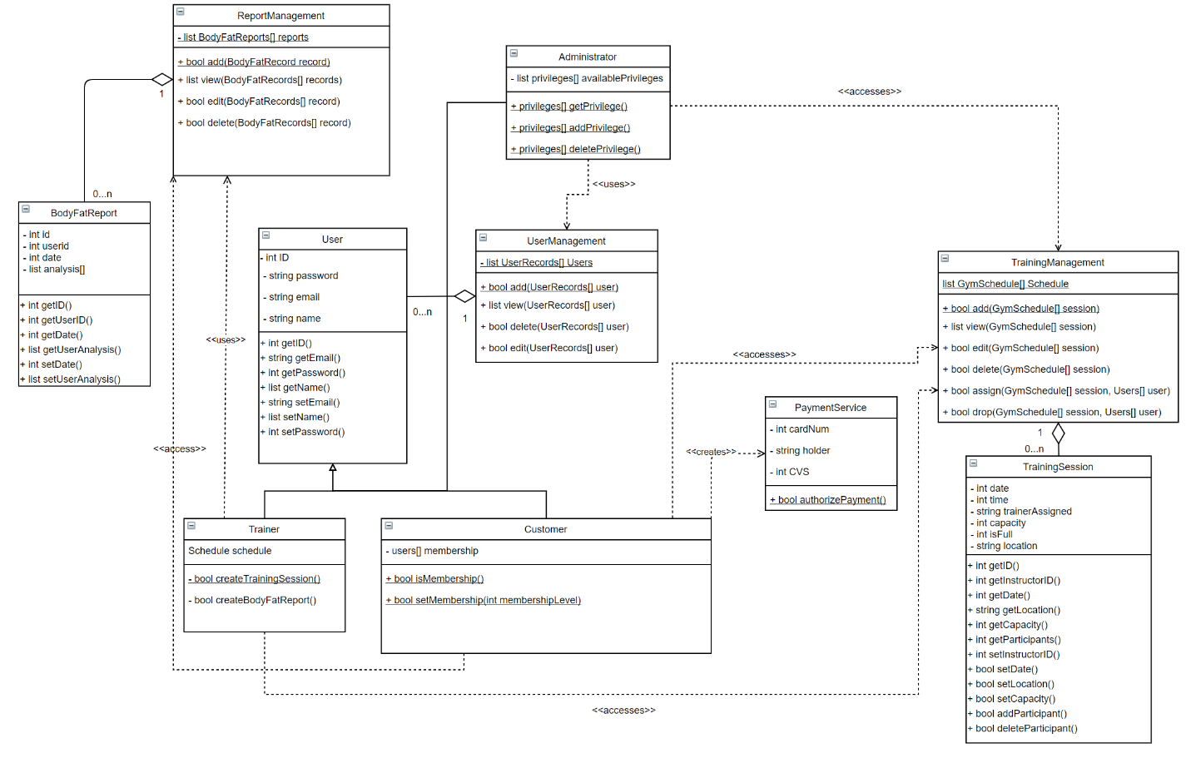**Elaborated Design Classes**
2. **Elaborated Component Diagram\***

**2.1. Input Controller**

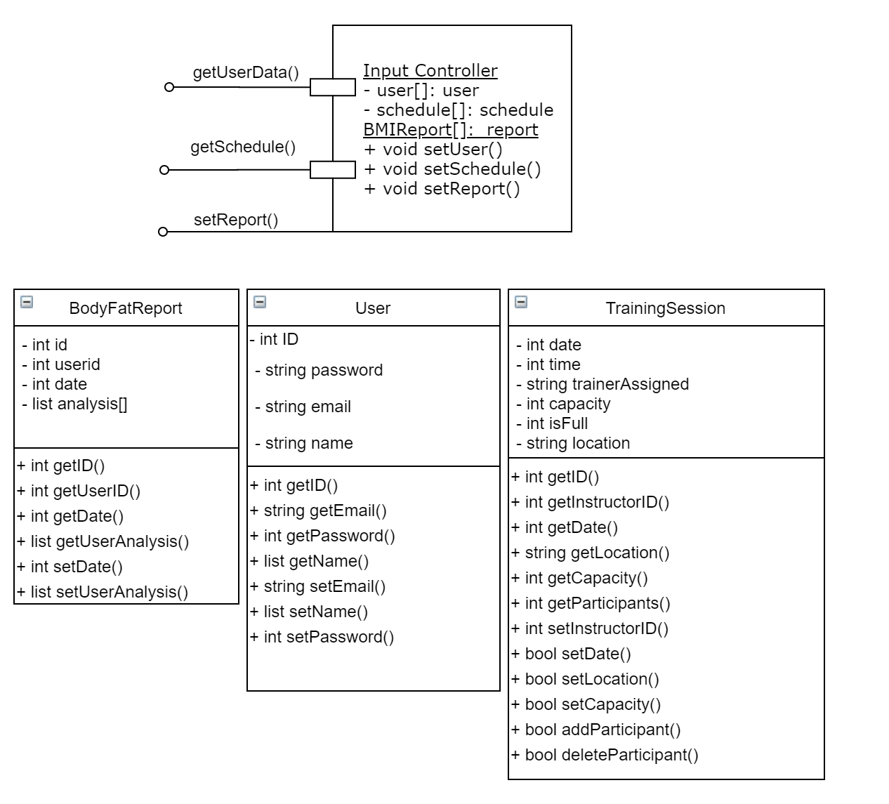

**2.2. Manager Controller**

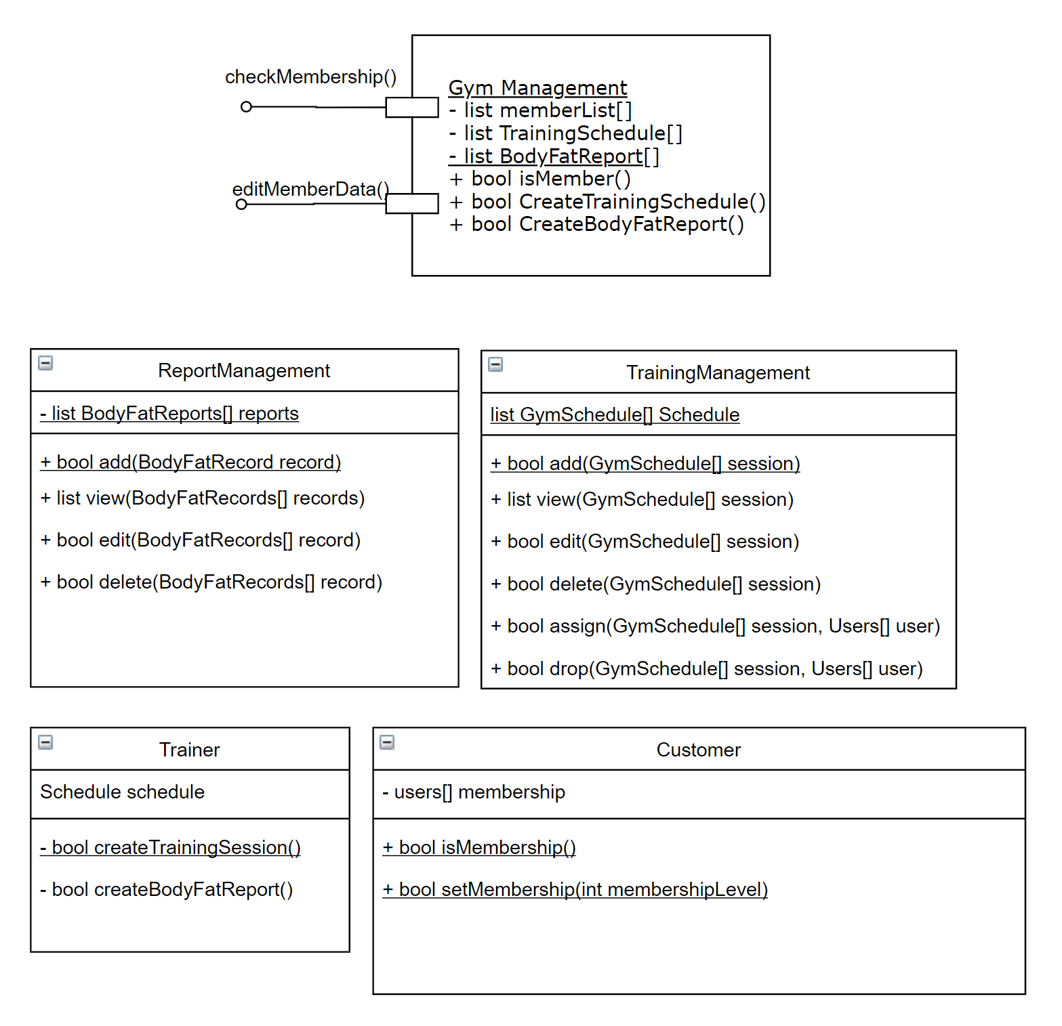

**2.3. Output Controller**

