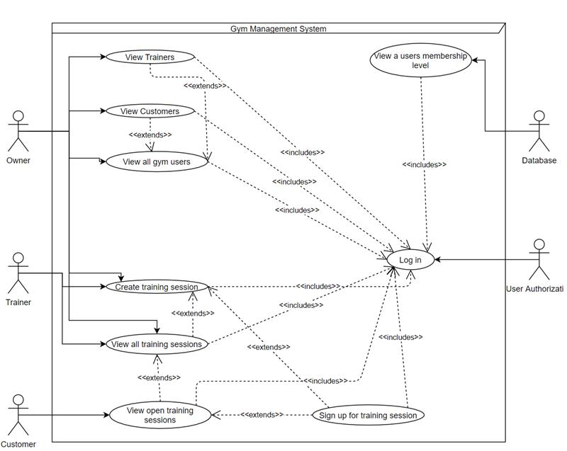

|  |  |  |  |  |  |  |  |  |  |  |  |  |  |  |  |  |  |  |  |  |  |  |  |  |  |  |  |  |  |  |  |  |  |  |  |  |  |  |  |  |  |  |  |  |  |  |  |  |  |  |  |  |  |  |  |  |  |  |  |  |
| --- | --- | --- | --- | --- | --- | --- | --- | --- | --- | --- | --- | --- | --- | --- | --- | --- | --- | --- | --- | --- | --- | --- | --- | --- | --- | --- | --- | --- | --- | --- | --- | --- | --- | --- | --- | --- | --- | --- | --- | --- | --- | --- | --- | --- | --- | --- | --- | --- | --- | --- | --- | --- | --- | --- | --- | --- | --- | --- | --- | --- |
| **Holcomb, Madison Jane**    13 minutes ago   |  |  | | --- | --- | | Actors: | Owner | | Goal: | View all gym users | | Preconditions: | Owner must be authorized at login | | Scenarios: | * Go to owner home page * Select view all gym users | | Exceptions: | There are no gym users |      |  |  | | --- | --- | | Actors: | Owner | | Goal: | View list of Trainers | | Preconditions: | Owner must be authorized at login | | Scenarios: | * View all gym users * Select Trainers * A list of current trainers shows up | | Exceptions: | There are no trainers signed up at the gym |      |  |  | | --- | --- | | Actors: | Owner | | Goal: | View list of Customers | | Preconditions: | Owner must be authorized at login | | Scenarios: | * View all gym users * Select Customers * A list of current customers shows up | | Exceptions: | There are no customers signed up for the gym |      |  |  | | --- | --- | | Actors: | Owner | | Goal: | View membership level | | Preconditions: | Owner must be authorized at login | | Scenarios: | * View all gym users * Select view gym user’s membership level * A list of all gym users and membership levels will appear | | Exceptions: | There are no members of the gym |      |  |  | | --- | --- | | Actors: | Owner | | Goal: | Create training session | | Preconditions: | Owner must be authorized at login, the trainer isn’t currently taken at that time slot | | Scenarios: | * View all gym users * Select Trainers * Select view all training sessions * Select add training session * Select a trainer who needs a session added * Add session details (Trainer, open spots, time range, etc) * Submit training session | | Exceptions: | There are no trainers at the gym |        |  |  | | --- | --- | | Actors: | Owner | | Goal: | View all training sessions | | Preconditions: | Owner must be authorized at login | | Scenarios: | * View all gym users * Select Trainers * Select view all training sessions * A list of all (open and closed) sessions for each trainer will appear | | Exceptions: | There are no training sessions scheduled. | |