TITLE: TO ANALYSE THE SEMICONDUCTOR DIODE

OBJECTIVE:

1. To find the current and voltage of the diode.
2. To know the current and voltage relation or characteristics from the found data’s.

EQUPMENT USED:

1. Bread board
2. Jumper
3. A diode
4. A resister

THEORY:

The element whose conductivity lies in between that of the conductor and insulator is known as semiconductor material. A semiconductor diode is made with the combination of the two doped semiconductor. In the PN junction diode when we supply voltage in a increasing manner than the current will also increase but the increase is very-very small but a case arises when after a certain voltage the increase in current is very large. This point of voltage is known as breakdown voltage. Generally it is 0.7 V.

We can see the VI characteristics in graph as follows:-

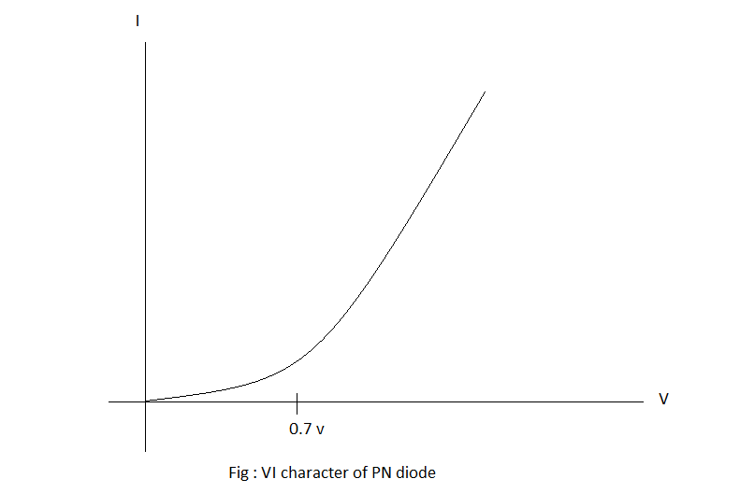

OBSERVATION:

We made a simple circuit with a diode in bread board find the current value giving different voltage value. The data’s we obtained are listed below.

|  |  |  |
| --- | --- | --- |
| Vs(Supplied voltage) | Vd(Voltage at diode) | Id(Current at diode) |
| 5 | 0.69 | 2.38 |
| 12 | 0.68 | 8.75 |
| 30 | 0.74 | 24.8 |

CONCLUSION:

In this way we proved the VI characters practically in the lab.