ACKNOWLEDGEMENT

The project would not have been completed without the support and guidance of some mentionable names. A lots of ideas and tricks have been given by them to make the project a successful one. And the hard work and determination added the color on it.
We would like to thank our project guide Mr. Isaac Shrestha who has guided us throughout the making of this project. We would also like to thank all my friends and Deepak sir who has helped us at any time when we needed them and we will be expecting their help in future days too.

Group Member’s

Sonahang Rai – (310496)
Kamal Sunar – (313871)
Saurav Shrestha – (310494)

INDEX

CONTENTS

- Acknowledgement………………………………………………………1
- Introduction to bus reservation system…………………………………..3
- Objective……………………………………………………………....3-4
2.1 Limitations
2.2 Aim & Goal to be achieved
- Scope…………………………………………………………………….4
3.1 Background
- Analysis...………………………………………………………………5
4.1 Requirement Analysis
4.2 Operational Feasibility
- Software & Hardware Requirement……………………………………..5
5.1 Software Requirement
5.2 Hardware Requirement
- Flow Chart………………………………………………………………..6
- Program structure with screenshots…………………………………..7-10
- Limitation of the Project………………………………………………..10
- Conclusion………………………………………………………………11
- Bibliography…………………………………………………………….12

- INTRODUCTION TO BUS RESERVATION SYSTEM

The project named “bus reservation” system is the software developed to contribute the bus reservation system in our country. The focus of the project is to computerize bus reserving process to manage data, so that all transactions becomes fast and errorless. It replaces all the paper-work. It keeps records of all passengers also giving to ensure 100% successful implementation of the computerized Bus reservation system. This program “Bus Reservation System” provides bus transportation system, a facility to reserved seats, cancellation of seats and different types of enquiry which need an instant and quick reservation. It is built to manage and computerize the traditional database, ticket booking and tracking bus and travel made easy. It maintains all data’s of users, bus details, reservation details, booking details, customer details.

- OBJECTIVE

The main objective of the proposed system” Bus Reservation System” is to eliminate the manual reservation system. Making the reservation system, fast, user friendly and avoiding the unnecessary delay in reservation. This system helps to develop and can handle lots of records and reports efficiently. Searching information about reservation data etc will be only on one click. Response time is very less comparative to manual system.
The objective and scope of our project Bus Reservation System is to details of various user .It will simplify the task and reduce the paper work. The system is very user friendly and it is anticipated that functions of the system will be easily accessed by administrators.

2.1 THE MAIN LIMITATIONS OF THE PREVIOUS SYSTEM OF BUS RESERVATION SYSTEM

- The early bus reservation system were not as effective as the paper works were done to store the data of the passengers.
- There was the problem of data loss.
- The distribution of the data’s were very long time consuming process.

2.2 AIM AND GOALS TO BE ACHIEVED

- Provide Accuracy
- Reduce Redundancy of data
- Conserve data safely
- Reduce time in transactions.
- To provide computer based system to overcome shortfalls in current manual system.
- Add or delete the customer list.
- Update the reserver’s information easily.
- Cancellation of the reserved bus seats.

- SCOPE OF THE PROJECT

The scope of this project is wide in the coming recent years because these days the number of traveling and tourist people are extending in a large rate. The file based reservation process may not be helpful during this time. The more the data’s of the passengers are to be stored the more the hard process it will be in the file based reservation process. The data’s may get the problem of duplication or may sometimes get’s mixed up with the odd one’s. So in this way we can find that this system of computerized bus reservation system has a great scope in the upcoming future.

3.1 BACKGROUND

These days “Bus Reservation” is done by the manually which takes a lot of time for one reservation because the officer should check the unreserved seats manually. To know about the details of past reserved seats takes a lot of time. But after implementing this system all this work will be done only on one click. Today the “Time is money” no one has time to waste in queue to reserve the ticket for bus or the hotel booking mainly at the time of children school holidays.
Registers, pens, store rooms for entry stationary will not be needed.

- ANALYSIS

4.1 REQURIMENT ANALYSIS

A requirement is a feature of that must be included in the system. Before the actual design and implemented is of prime importance.
The main emphasis should be on the output of the system the output expected from the system the people involved in the working of the system the volume of data inputs and the amount of information (outputs that will be involved).
With respect to the system itself, the following facts should be taken into consideration. The major processes involved the main points of application the processing rule for the collected data the exceptions that may be present the checks that should be in places in order to avoid wrong entries

4.2 OPERATIONAL FEASEABILITY

Operationally the project is feasible. It consists of simple graphical user interface. Only the TurboC, DevC etc framework are needed for opening the system. Working of the project will be very simple. A non-professional person can also handle this system.

- SOFTWARE AND HARDWARE REQUIREMENTS
Tools platform and hardware the application is meant to work on windows based platform. The various software and hardware configuration for the application are as following.

5.1 SOFTWARE RECOMMENDATION:

OPERATING SYSTEM:
MICROSOFT WINDOWS XP, VISTA , 7,8,10 OR LINUX

COMPILER:
Turbo c or Dev c

5.2 HARDWARE RECOMENDATION:

RAM:
DDR2 512MB(minimum)

HARD DISK:
10GB(minimum)

PROCESSOR:
0.5 GHZ (minimum)

- Flow Diagram
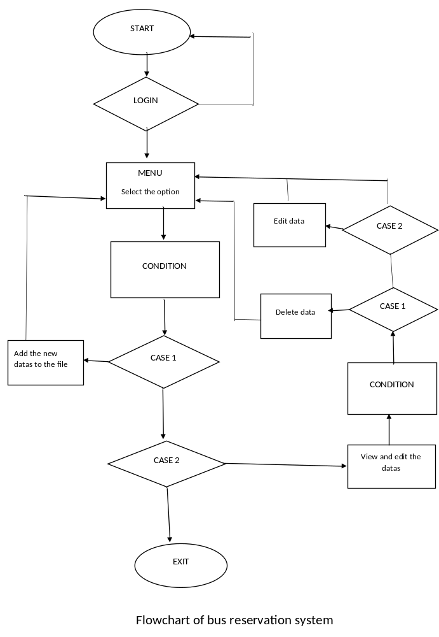

- PROGRAM STRUCTURE
This program consists of the three main parts.
- Login
- Main menu
- View and enter new data’s
- See the total data’s and edit or delete them

- Exit

Login
Here the password is required to access the system. Without the password the system do not get started.
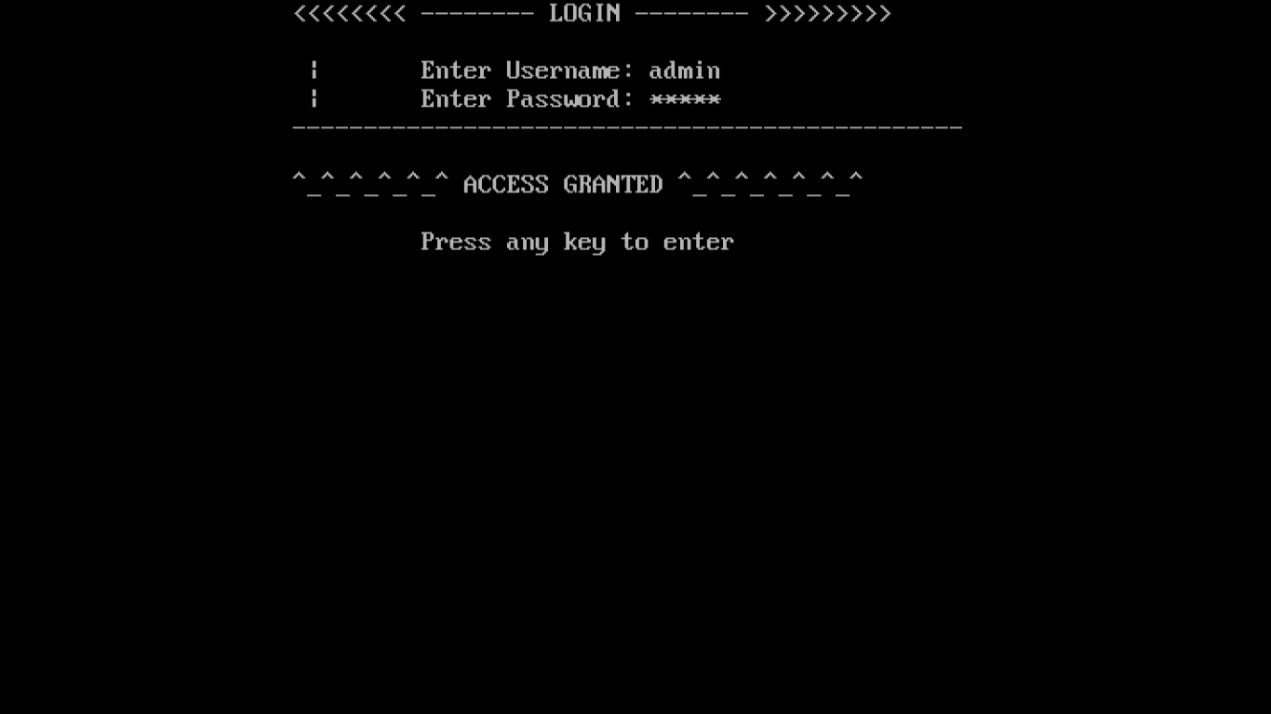
Fig: The login

Main menu
Here the available seat’s can be figured out and after that the required seat’s can be reserved. Here the data’s of the costumer’s are entered.
Here we can also see the overall passenger list’s. If some modification is needed to the data than it can be performed here. The deletion of the data’s can also be performed here. The ticket view can be seen here.
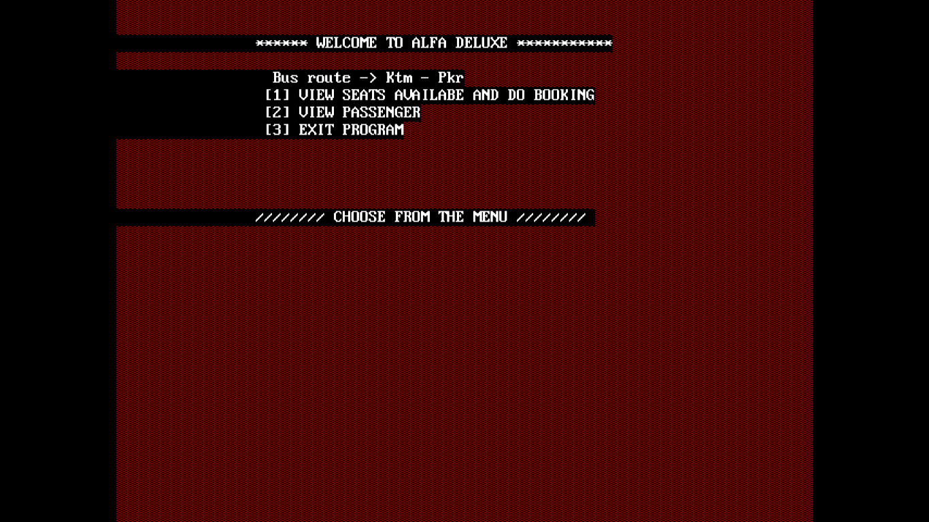
Fig: The main menu

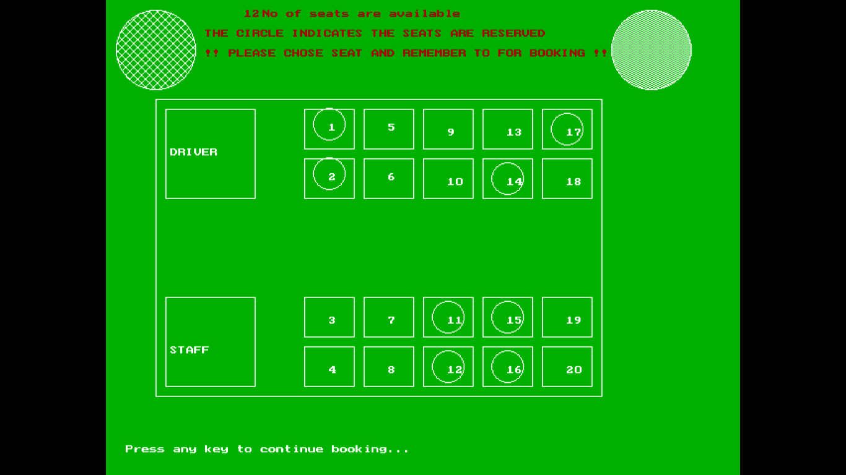
Fig: The seats view


Fig: Data entry

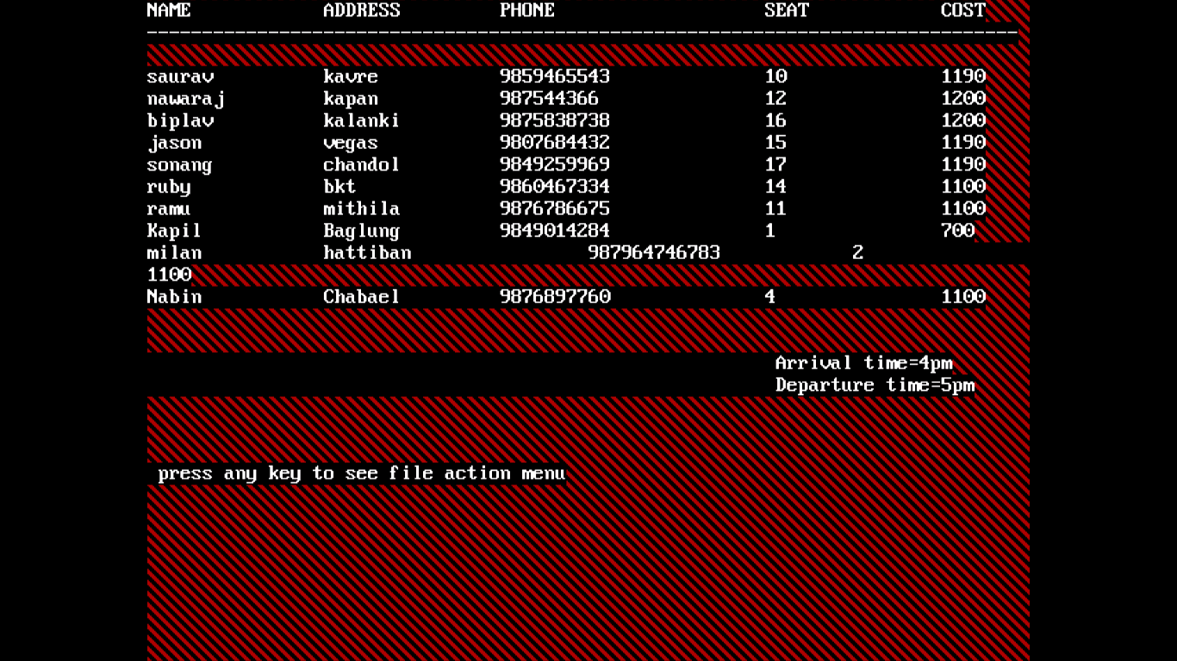
Fig: Data view

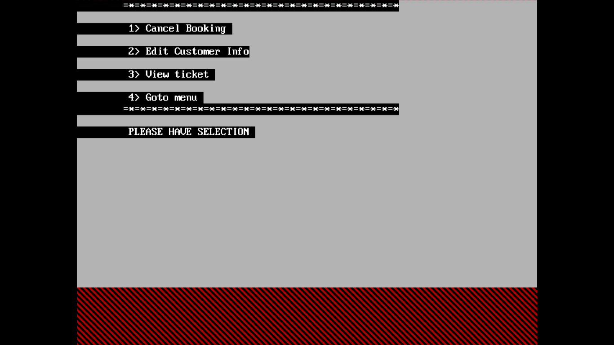
Fig: Data modification menu

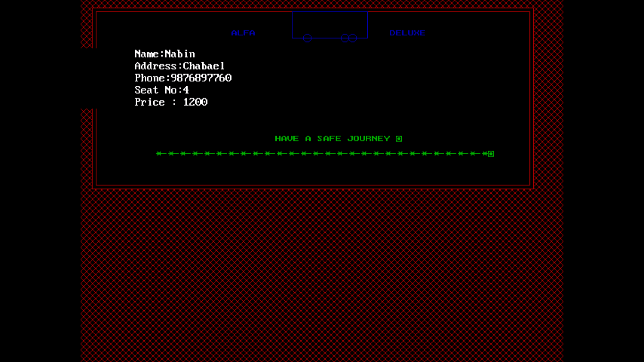
Fig: Ticket view

Exit
Lastly the program is ended.

(8) LIMITATION OF THE PROJECT
1. It is not on-line project.
2. It shows all the entries, it doesn’t show the one day entries separately.

- CONCLUSION:
Finally we finished this project with a lots of effort and this made a great experience in the c language. We can say that the project has been a success but sill there are some demerits in this program. So this is a simple computerized of bus reservation system having offline features.

(10) BIBLIOGRAPHY

- Balagurusamy .E., Programming In ANSI C, the Tata McGraw-Hill Companies, 8th Edition, 2008.
- Kanetkar Yashavant, Let Us C, BPB Publication, 9th Edition, 2009.
- Gottfried, Baryon S, Schaum’s outlines Programming With C, the Tata McGraw-Hill, 2007.
- www.programmingsimplified.com/c/graphics.h

