BIGDATA

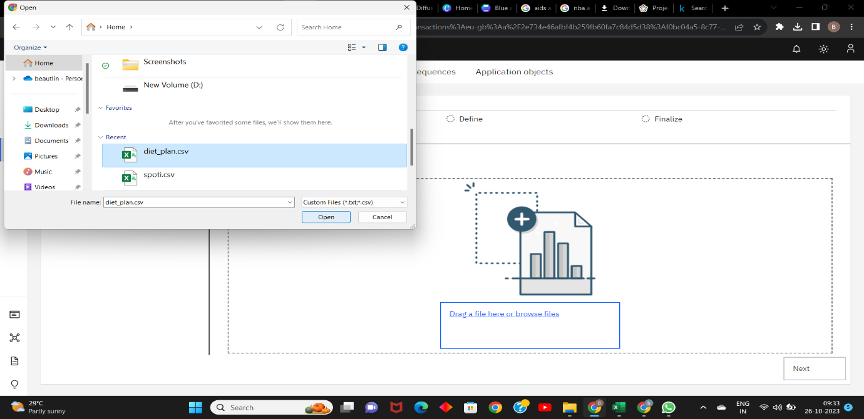

I have inserted the dataset of diet_plan.csv that contains details of certain amount of peoples diet plans

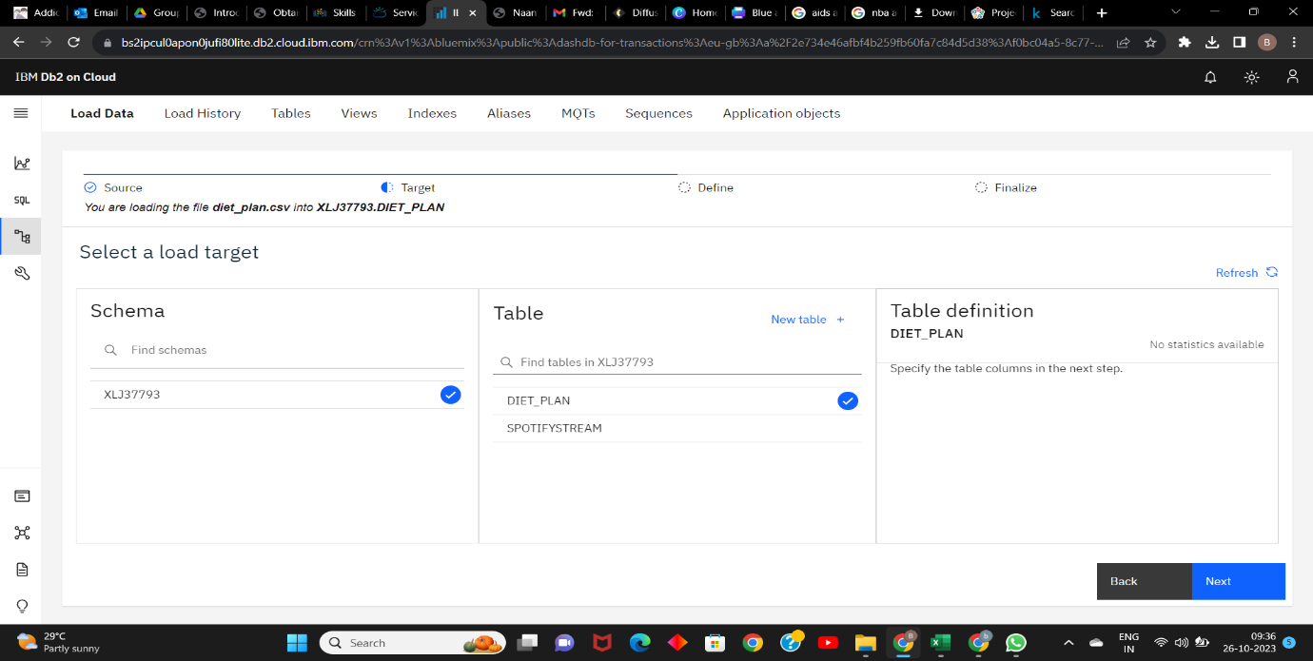

After uploading the dataset I have selected the table and to continue with the process click on to the next

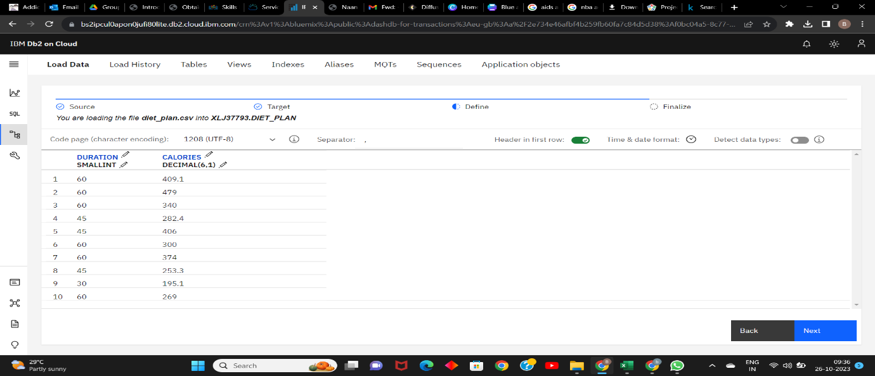

After the table has been successfully uploaded. The table is been displayed to continue click on to next.

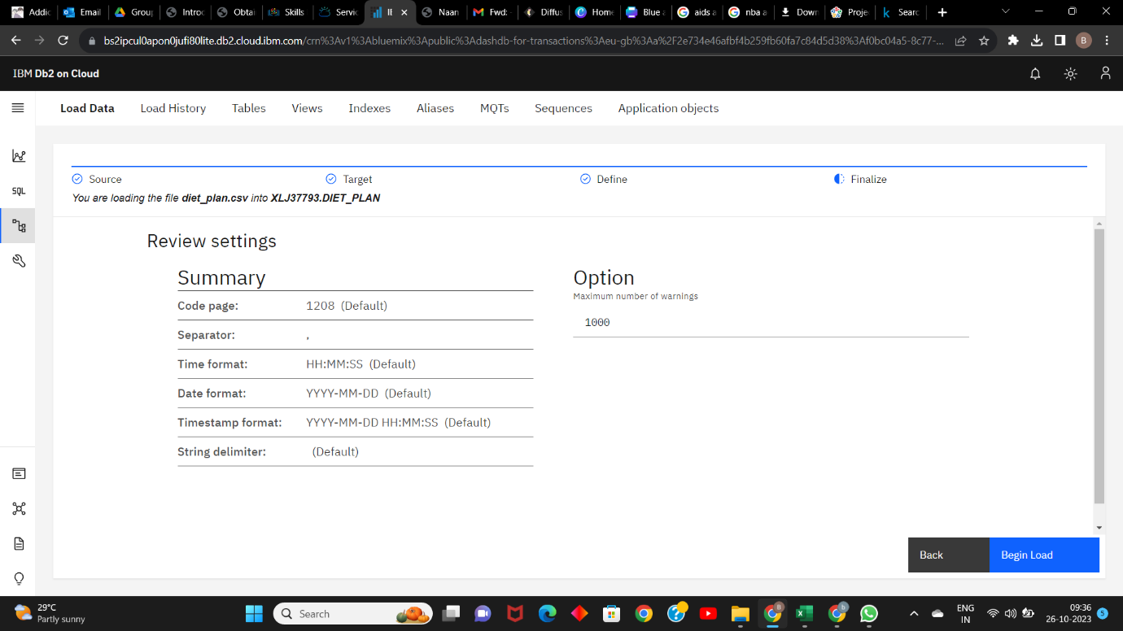

After that the summary is been displayed then click on to the begin load then redirected to next steps

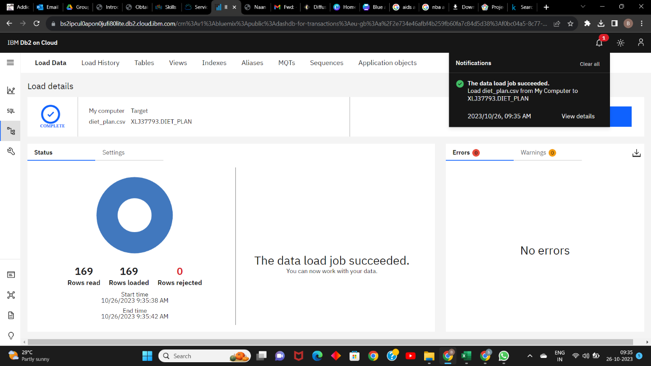

The data has been loaded

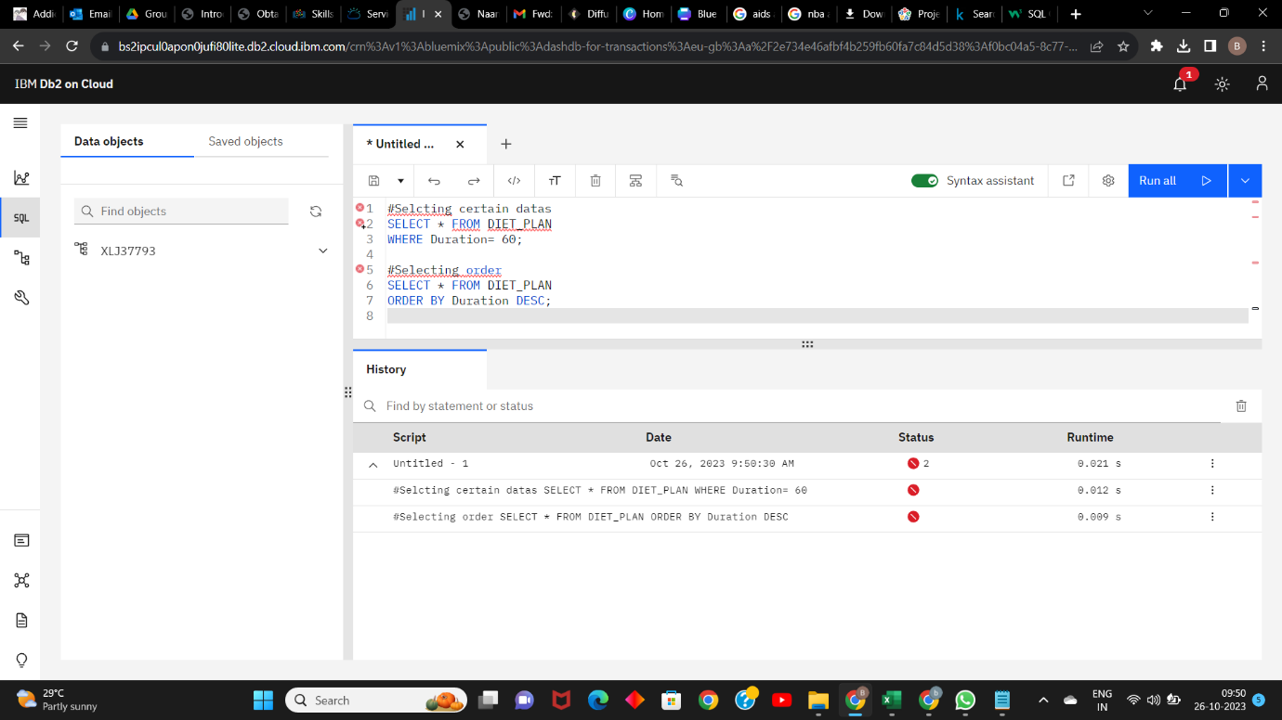

The sql commands has been executed in the dataset and the result has been displayed