Project Name
VoxLog

Mini Project Report

Submitted by

Sonat Joseph
Reg. No.: AJC23MCA-I059

In Partial fulfillment for the Award of the Degree of
INTEGRATED MASTER OF COMPUTER APPLICATIONS

(INMCA)



AMAL JYOTHI COLLEGE OF ENGINEERING AUTONOMOUS
KANJIRAPPALLY

[Approved by AICTE, Accredited by NAAC with A+.
Koovappally, Kanjirappally, Kottayam, Kerala – 686518]

2025-2026

DEPARTMENT OF COMPUTER APPLICATIONS

AMAL JYOTHI COLLEGE OF ENGINEERING AUTONOMOUS
KANJIRAPPALLY



CERTIFICATE

This is to certify that the Project report, “VoxLog” is the bona fide work of SONAT JOSEPH (Regno: AJC23MCA-I059) carried out in partial fulfillment of the requirements for the award of the Degree of Integrated Master of Computer Applications at Amal Jyothi College of Engineering Autonomous, Kanjirappally. The project was undertaken during the period from December 01, 2025 to March 27, 2026.

Guide Name Coordinator Name
Internal Guide Coordinator

Dr. Bijimol T K
Head of the Department

DECLARATION

I hereby declare that the project report “VoxLog” is a bona fide work done at Amal Jyothi College of Engineering Autonomous, Kanjirappally, towards the partial fulfilment of the requirements for the award of the Integrated Master of Computer Applications (INMCA) during the period from December 01, 2025 to March 27, 2026.

Date: SONAT JOSEPH
KANJIRAPPALLY Reg: AJC23MCA-I059

ACKNOWLEDGEMENT

First and foremost, I thank God almighty for his eternal love and protection throughout the project. I take this opportunity to express my gratitude to all who helped me in completing this project successfully. It has been said that gratitude is the memory of the heart. I wish to express my sincere gratitude to our Director (Administration) Rev. Fr. Dr. Roy Abraham Pazhayaparampil and Principal Dr. Lillykutty Jacob for providing good faculty for guidance.

I owe a great depth of gratitude towards our Head of the Department Dr. Bijimol T K for helping us. I extend my whole hearted thanks to the project coordinator Coordinator Name for her valuable suggestions and for overwhelming concern and guidance from the beginning to the end of the project. I would also express sincere gratitude to my guide Guide Name for his inspiration and helping hand.

I thank our beloved teachers for their cooperation and suggestions that helped me throughout the project. I express my thanks to all my friends and classmates for their interest, dedication, and encouragement shown towards the project. I convey my hearty thanks to my family for the moral support, suggestions, and encouragement to make this venture a success.

SONAT JOSEPH

ABSTRACT

Attendance management remains an essential administrative task in educational institutions, yet traditional processes such as manual roll-calling, paper registers, and biometric systems are time-consuming, prone to errors, and lack real-time automation. VoxLog presents a modern, AI-assisted, voice-driven attendance platform developed using React for the frontend, Bootstrap for responsive UI design, and Python Flask for backend processing and server-side logic.
VoxLog adopts a simplified and highly reliable two-step method for attendance capture. First, the teacher uploads a classroom image, and the system uses a computer vision–based head-counting model to estimate the total number of individuals present. This count serves as a verification reference. Next, students announce their roll numbers verbally, and the system converts the speech into text. Roll numbers spoken as “12” directly mark presence, while missing entries are handled using structured input such as “11 absent, 12”, ensuring clarity and preventing confusion. This eliminates the need for complex voice identity matching while maintaining a streamlined and accurate workflow.
To ensure consistency, VoxLog integrates an intelligent Smart Roll Sequence Validation module. This feature automatically checks whether the spoken roll numbers follow the expected sequence, instantly identifying skipped, duplicated, or out-of-order entries. The system also cross-verifies the voice-marked attendance count with the head-count estimation, ensuring that classroom strength and attendance entries align.
Beyond capturing attendance, VoxLog offers a wide range of performance eenhancing functionalities, making it a comprehensive and user-friendly system. By combining AI-powered automation with a modern web architecture, VoxLog ensures fast, transparent, and efficient attendance workflows suitable for real educational environments.
CONTENT

SL. NO |  | TOPIC | PAGE NO
1 |  | INTRODUCTION
1.1 |  | PROJECT OVERVIEW
1.2 |  | PROJECT SPECIFICATION
2 |  | SYSTEM STUDY
2.1 |  | INTRODUCTION
2.2 |  | EXISTING SYSTEM
2.3 |  | DRAWBACKS OF EXISTING SYSTEM
2.4 |  | PROPOSED SYSTEM
2.5 |  | ADVANTAGES OF PROPOSED SYSTEM
3 |  | REQUIREMENT ANALYSIS
3.1 |  | FEASIBILITY STUDY
3.1.1 |  | ECONOMICAL FEASIBILITY
3.1.2 |  | TECHNICAL FEASIBILITY
3.1.3 |  | BEHAVIORAL FEASIBILITY
3.1.4 |  | FEASIBILITY STUDY QUESTIONNAIRE
3.1.5 |  | GEOTAGGED PHOTOGRAPH
3.2 |  | SYSTEM SPECIFICATION
3.2.1 |  | HARDWARE SPECIFICATION
3.2.2 |  | SOFTWARE SPECIFICATION
3.3 |  | SOFTWARE DESCRIPTION
3.3.1 |  | PHP
3.3.2 |  | MYSQL
4 |  | SYSTEM DESIGN
4.1 |  | INTRODUCTION
4.2 |  | UML DIAGRAM
4.2.1 |  | USE CASE DIAGRAM
4.2.2 |  | SEQUENCE DIAGRAM
4.2.3 |  | STATE CHART DIAGRAM
4.2.4 |  | ACTIVITY DIAGRAM
4.2.5 |  | CLASS DIAGRAM
4.2.6 |  | OBJECT DIAGRAM
4.2.7 |  | COMPONENT DIAGRAM
4.2.8 |  | DEPLOYMENT DIAGRAM
4.2.9 |  | COLLABORATION DIAGRAM
4.3 |  | USER INTERFACE DESIGN USING FIGMA
4.4 |  | DATABASE DESIGN
5 |  | SYSTEM TESTING
5.1 |  | INTRODUCTION
5.2 |  | TEST PLAN
5.2.1 | UNIT TESTING
5.2.2 | INTEGRATION TESTING
5.2.3 | VALIDATION TESTING
5.2.4 | USER ACCEPTANCE TESTING
5.2.5 | AUTOMATION TESTING
5.2.6 | SELENIUM TESTING
6 | IMPLEMENTATION
6.1 | INTRODUCTION
6.2 | IMPLEMENTATION PROCEDURE
6.2.1 | USER TRAINING
6.2.2 | TRAINING ON APPLICATION SOFTWARE
6.2.3 | SYSTEM MAINTENANCE
7 | CONCLUSION & FUTURE SCOPE
7.1 | CONCLUSION
7.2 | FUTURE SCOPE
8 | BIBLIOGRAPHY
9 | APPENDIX
9.1 | SAMPLE CODE
9.2 | SCREEN SHOTS
9.3 | GEO-TAGGED PHOTOS PANEL REVIEW 1 & 2
9.4 | GIT LOG

List of Abbreviations

CHAPTER 1

INTRODUCTION

PROJECT OVERVIEW
VoxLog is a comprehensive, cloud-native Academic Management System (AMS) designed to streamline the administrative and educational workflows of modern institutions. The platform caters to three primary user groups: Administrators, Faculty Members, and Students, providing a centralized hub for managing the entire academic lifecycle.
The project focuses on digitalizing traditionally manual processes such as attendance tracking, timetable generation, and leave management. By leveraging real-time data synchronization through Firebase, VoxLog ensures that academic stakeholders have access to accurate, up-to-the-minute information regarding class schedules, student progress, and institutional events.
Core Objectives:
- Centralized Administration: Manage departments, degree programs, and subject-level courses through a unified interface.
- Dynamic Scheduling: Automated and manual timetable management for various departments and semesters.
- Accurate Attendance: Real-time recording of student attendance by faculty with automated history tracking.
- HR & Operations: Integrated faculty leave applications, substitution management, and faculty attendance auditing.
- Institutional Connectivity: A shared Master Calendar system to keep the entire school aligned on academic events and holidays.

PROJECT SPECIFICATION

CHAPTER 2

SYSTEM STUDY

INTRODUCTION

EXISTING SYSTEM

2.2.1 NATURAL SYSTEM STUDIED

2.2.2 DESIGNED SYSTEM STUDIED

DRAWBACKS OF EXISTING SYSTEM

PROPOSED SYSTEM

ADVANTAGES OF PROPOSED SYSTEM

CHAPTER 3

REQUIREMENT ANALYSIS

FEASIBILITY STUDY

Economical Feasibility

Technical Feasibility

Behavioral Feasibility

    - Feasibility Study Questionnaire

3.1.5 Geotagged Photograph

SYSTEM SPECIFICATION

Hardware Specification

Processor -
RAM -
Hard disk -

Software Specification

Front End -
Back End -
Database -
Client on PC - Windows 7 and above.

Technologies used - JS, HTML5, AJAX, J Query, PHP, CSS, List APIs, List Technologies

SOFTWARE DESCRIPTION

Eg.PHP

Eg. MySQL

CHAPTER 4

SYSTEM DESIGN

  - INTRODUCTION

UML DIAGRAM

USE CASE DIAGRAM
Explanation, Diagram

SEQUENCE DIAGRAM
Explanation, Diagram

4.2.2 State Chart Diagram
Explanation, Diagram

Activity Diagram
Explanation, Diagram

Class Diagram
Explanation, Diagram

Object Diagram
Explanation, Diagram

Component Diagram
Explanation, Diagram

4.2.8 Deployment Diagram
Explanation, Diagram

4.2.9 Collaboration Diagram
Explanation, Diagram

4.3 USER INTERFACE DESIGN USING FIGMA

Form Name: abcc

Screenshot

Form Name: abcc

Screenshot

All Forms

4.4 DATABASE DESIGN

4.4.1 Relational Database Management System (RDBMS)

Explanation

4.4.2 Normalization
Explanation with example

4.4.3 Sanitization

4.4.4 Indexing

4.5 TABLE DESIGN
1.Tbl_users_login
Eg.Primary key: loginid
Eg.Foreign key: loginid references table Tbl_users_login

No: | Field name | Datatype (Size) | Key Constraints | Description of the field

##All tables

CHAPTER 5

SYSTEM TESTING

  - INTRODUCTION
Explanation

TEST PLAN
Explanation

Unit Testing
explanation

Integration Testing
Explanation

Validation Testing or System Testing
Explanation

Output Testing or User Acceptance Testing
explanation.

    - Automation Testing
explanation.

    - Selenium Testing
explanation.

Example:
Test Case 1

Code

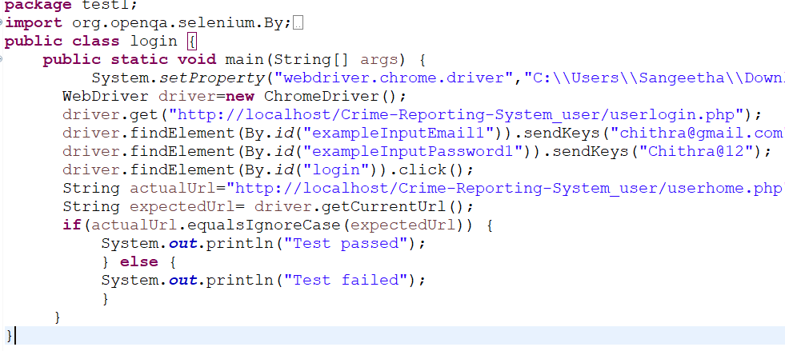

Eg.Screenshot

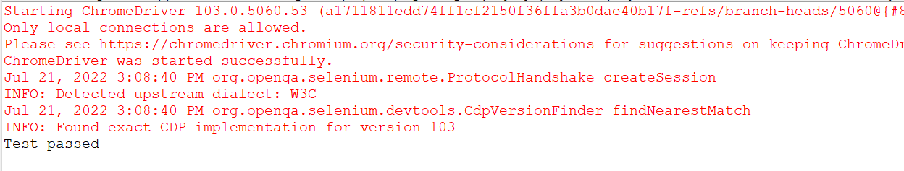

Eg.Test Report

Test Case 1
Project Name:
Login Test Case
Test Case ID: Test_1 |  |  | Test Designed By:
Test Priority(Low/Medium/High): |  |  | Test Designed Date:
Module Name: |  |  | Test Executed By :
Test Title : |  |  | Test Execution Date:
Description:
Pre-Condition :User has valid username and password
Step | Test Step | Test Data | Expected Result | Actual Result | Status(Pass/  Fai l)
1
2
3
4
5
6
7
Post-Condition:

Test Case 2:

Code
Screenshot
Test report

Minimum 4 test cases (1 login 3 functionalities)

CHAPTER 6

IMPLEMENTATION

INTRODUCTION
Explanation

IMPLEMENTATION PROCEDURES

Explanation

User Training
Explanation

Training on the Application Software
Explanation

System Maintenance
Explanation

    - Hosting
Explanation

Eg.000Webhost
Explanation

Procedure for hosting a website on 000Webhost:
Step 1: explanation
Step 2: explanation
Step 3: explanation
.
.
Hosted Website:
Hosted Link: https://abc.000webhostapp.com
Hosted Link QR Code
Screenshot

CHAPTER 7

CONCLUSION AND FUTURE SCOPE

CONCLUSION

.

  - FUTURE SCOPE

.

CHAPTER 8

BIBLIOGRAPHY

REFERENCES:

    - ..#Books

    - ..

    - ..

    - ..
    - ...

WEBSITES:

    - ..

    - ..

    - ..

    - ..

CHAPTER 9

APPENDIX

Sample Code
Main functionalities

Screen Shots

Geo-Tagged Photos Panel Review 1 & 2

Git Log

