First publish
- Go to https://visualstudiogallery.msdn.microsoft.com/ and click Upload button and sign in if necessary.
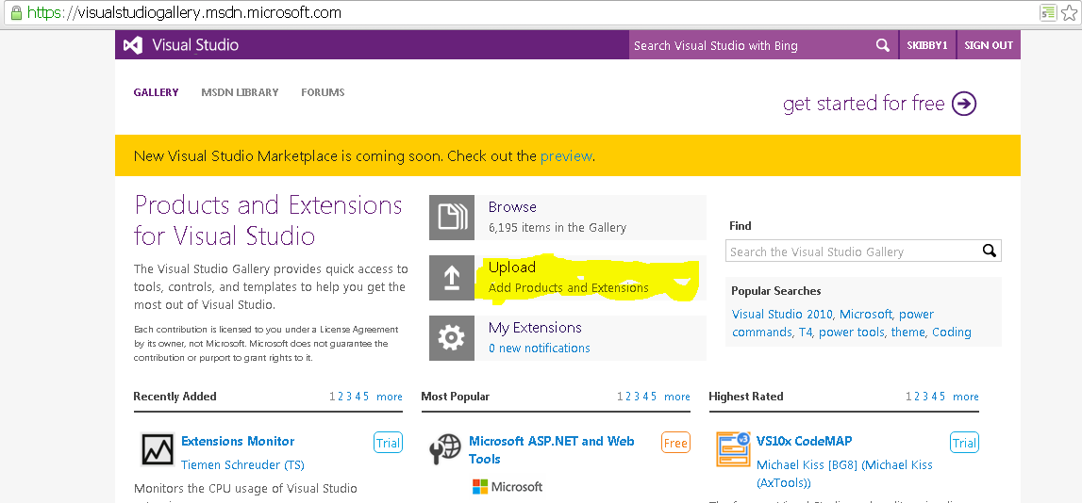
- Choose “Tool” extension type and click Next
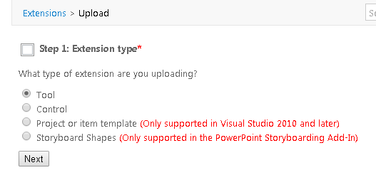
- Choose “I would like to upload my tool”, use “Choose File” button to select *.VSIX file from local disk and click Next to upload the package:
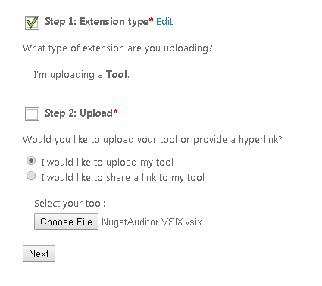
- Fill in any missing data, carefully read Contribution agreement ☺ and click Create contribution:
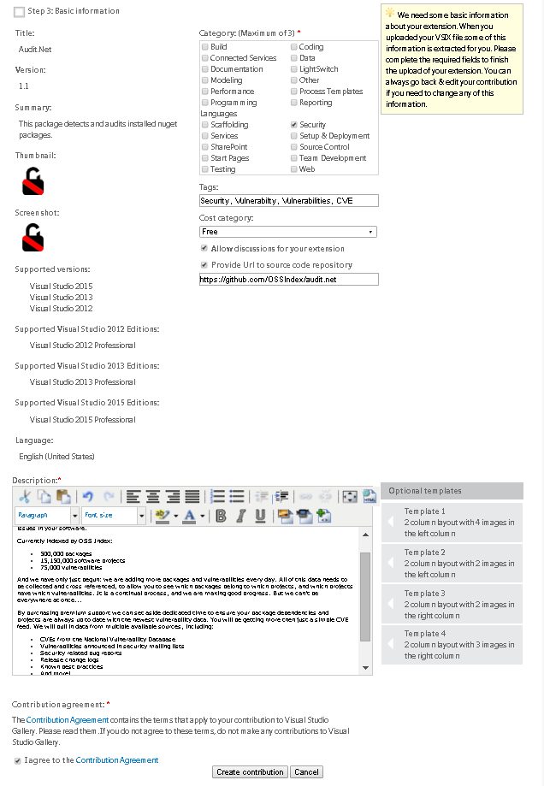
- … and publish your extension:
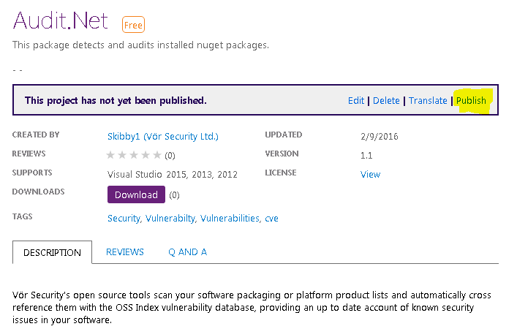

Publishing updated version

- Open solution in Visual Studio and raise assembly version in file “AssemblyVersion.cs”:
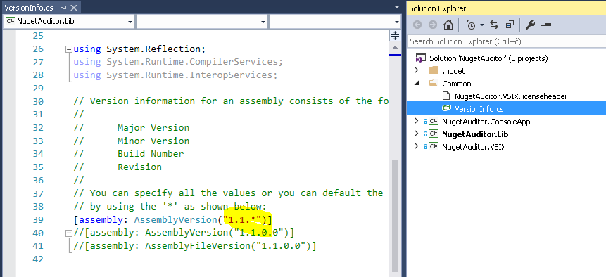
Next release: “1.2.*”

- Locate “source.extension.vsixmanifest” file in project NugetAuditor.VSIX, double click it to open VSIX manifest editor and modify Version attribute accordingly:
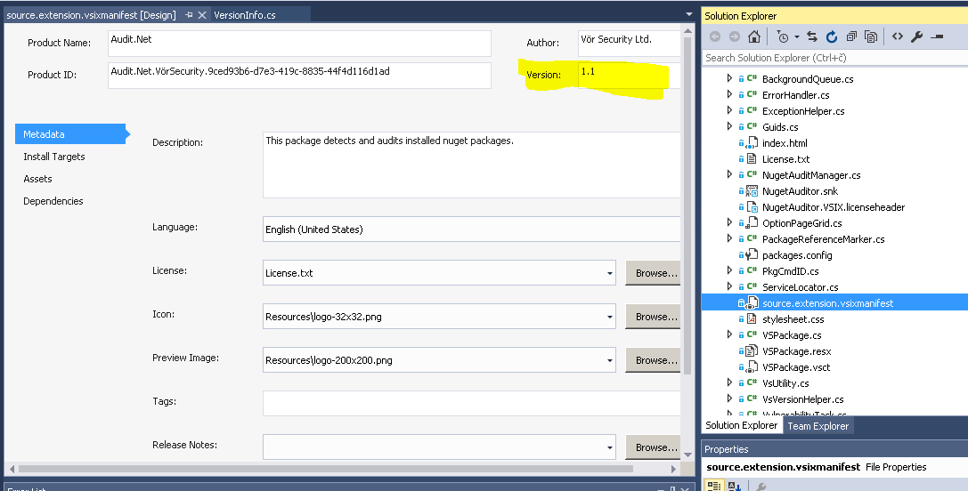Next release: “1.2”
- Rebuild solution so new VSIX file is created in output folder (bin/debug/ or bin/release/).
- Go to https://visualstudiogallery.msdn.microsoft.com/ and open your profile page by clicking your username in top right corner:
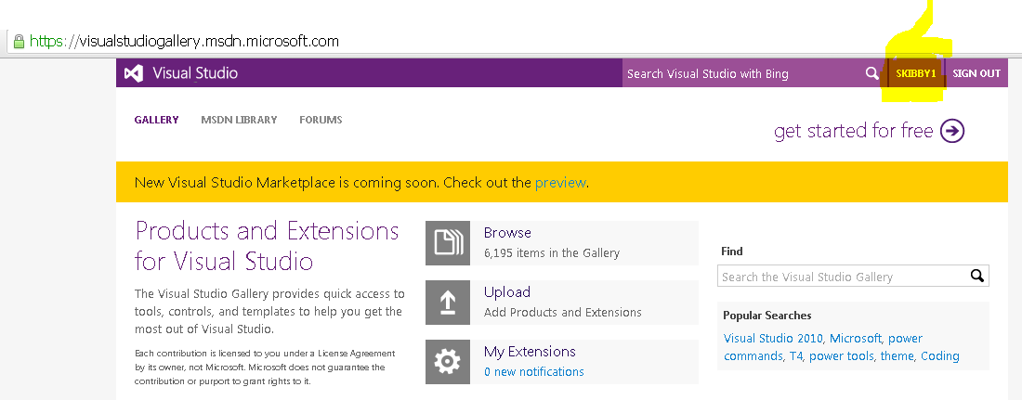

- Open extensions tab and click on Audit.Net extension:
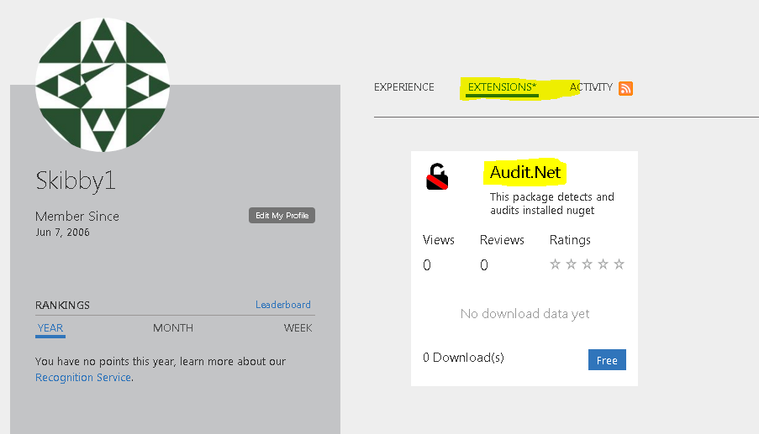
- Choose “Edit”:
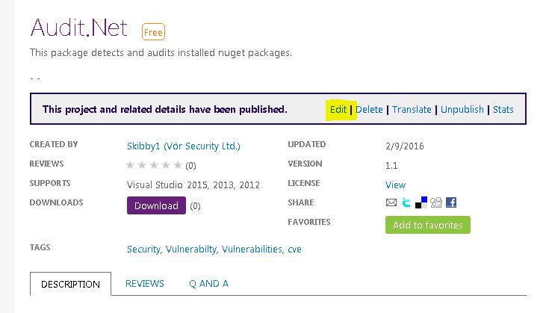

- Click on “Change” link in Upload section, upload new VSIX file you find in bin/debug or bin/release , modify any attributes if needed and click “Save”:
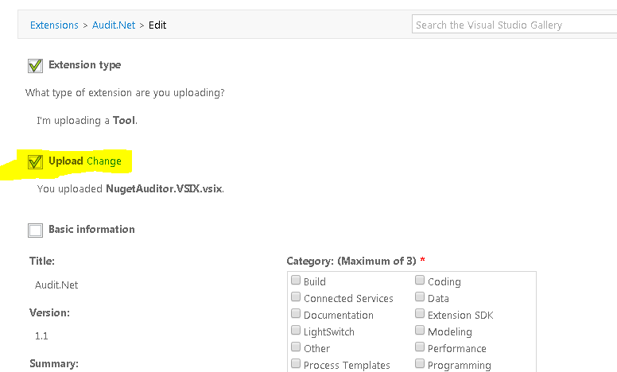

- That should do it. Users should now see new available update in Extensions and Updates tool inside Visual Studio.

