RESUME
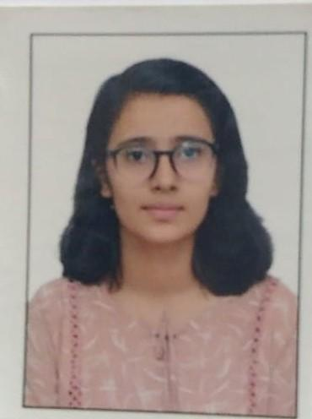
Name : Kirti Ramnath Sonawane
DOB : 10/05/2008
Branch : Electrical Engineering
Email : sonawanekirti89@gmail.com
Linkedin : https://www.linkedin.com/in/kirti-sonawane
QULIFICATIONS :
Sr.no | Exams | Percentage
1. | SSC | 90.00%
2. | HSC | 61.17%
3. | MHT-CET | 88.86%
4. | JEE Mains | 64.35%

HOBBIES :
Reading Books, Explore new things, Playing Chess, Drawing, Watching Movies
SKILLS :
Teamwork And Collaboration,
Communication skill,
Problem Solving’
Time Management

Technical Skills:
᪑Basic Electrical Engineering Concepts
᪑C Programming
᪑Computer Fundamentals
᪑MS Word, MS PowerPoint
᪑Circuit Analysis Basics
᪑Basics of Solar Energy Systems
᪑Electrical Safety & Measuremen

Soft Skills:
᪑ Communication Skills
᪑Leadership Ability
᪑Teamwork & Collaboration
᪑Time Management
᪑Creativity & Innovation
᪑Problem-Solving Skills
᪑Adaptability & Flexibility

Career Objective
To develop strong technical knowledge and practical skills in Electrical Engineering, contribute effectively to academic and industrial projects, and grow as a confident, innovative, and responsible engineer.

