# Report: Battleship online project

Group Members:

* Lê Thanh Sơn
* Trần Phi Hùng
* Đào Cao Duy

1. ***Application protocol***

* Architecture: Client / Server
* Message type: string
* Example:

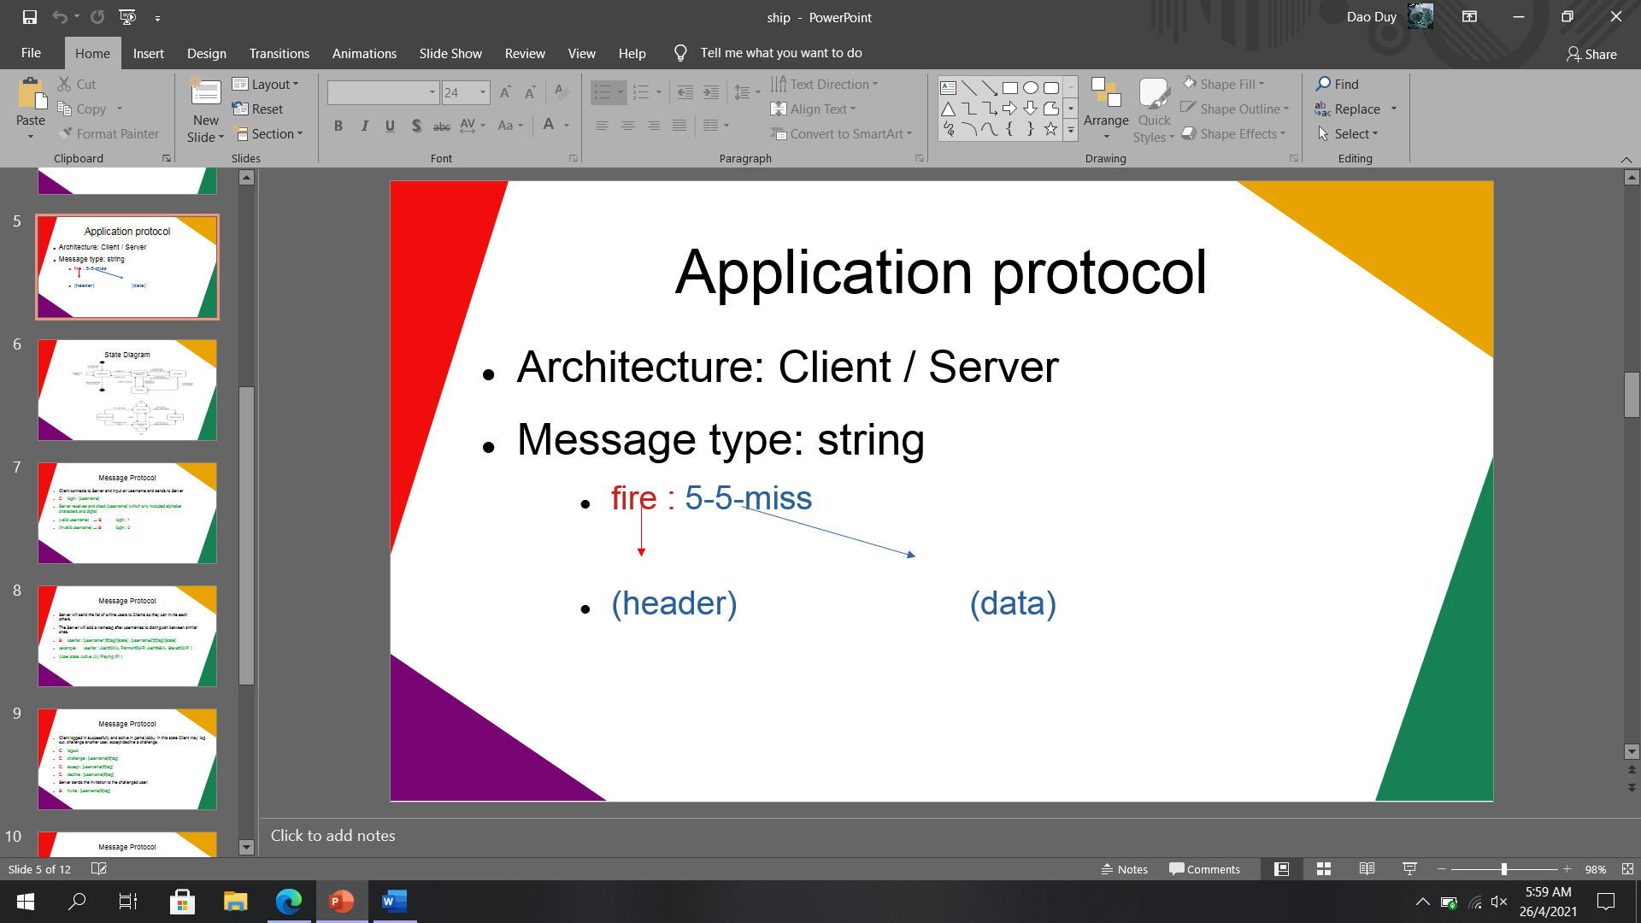

1. ***State Diagram***

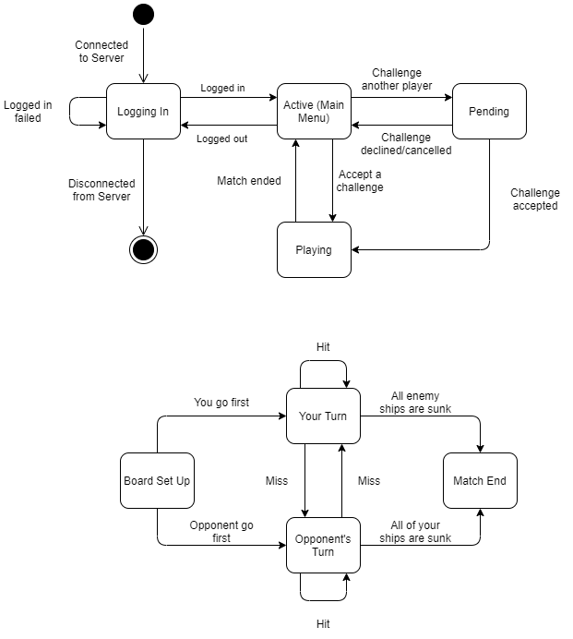

1. ***Message Protocol***

* Client connects to Server and input an username and sends to Server

**C: login : [username]**

* Server receives and check **[username]** (which only included alphabet characters and digits)

(valid username) → **S: login : 1**

(invalid username) → **S: login : 0**

* Server will send the list of online users to Clients so they can invite each others.
* The Server will add a nametag after usernames to distinguish between similar ones.

**S: userlist : [username1]#[tag]/[state] , [username2]#[tag]/[state] .**

* example: **userlist : Josh#20/A, Paimon#33/P, Josh#69/A, Steve#20/P.**

(User state: Active (**A**), Playing (**P**) )

* Client logged in successfully and active in game lobby. In this state Client may: log out, challenge another user, accept/decline a challenge.

**C: logout**

**C: challenge : [username]#[tag]**

**C: accept : [username]#[tag]**

**C: decline : [username]#[tag]**

* Server sends the invitation to the challenged user:

**S: invite : [username]#[tag]**

* When a challenge is accepted, Server sends a message to both clients to start a match:

**S: matchstart**

* 2 players set up ship formation and send to server, server then decide who go first and start the game:

**2 Clients → Server: setup : V-4-3-10 , H-3-5-2 , … , H-1-8-8 .**

**Ship info ( [Horizontal/Vertical]–[Ship length]–[Coordinate X]–[Coordinate Y] )**

**S: gamestart : 1** ( **1**: go first, **2**: go second )

* In-game: Players in their turn send coordinate information to shoot each other’s board to Server, Server process and send result to both players.

**Client 1: fire : 4-4** ( fire : [Coordinate X]-[Coordinate Y] )

**Server → Client 1: miss**

**Server → Client 2: fire : 4-4-miss**

- When all the ships of a player sunk, Server sends result message to 2 players. Then both players return to lobby.s

**Server → Client 1: matchend : win**

**Server → Client 2: matchend : lose**