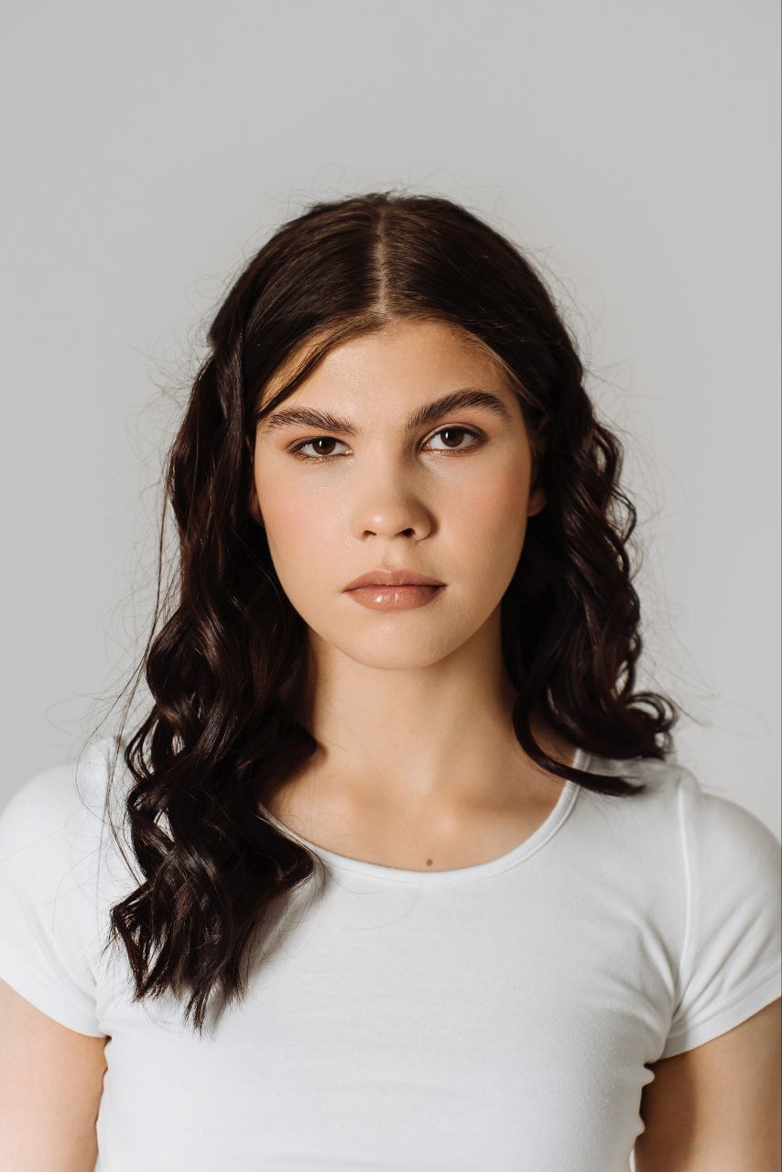
Nikonorova Sofya
Junior frontend-developer
18 years old, Russia, Novosibirsk
Phone: + 7(913) 000-23-88
WA: + 7(913) 000-23-88
Tg: teamafia (@sonchouzzzzzz)
Ig: son.chouz, tea.mafiaa

Personal information
Citizenship: Russian Federation
Education: secondary general
Educational institution: at the moment I am receiving a special secondary education in NATK. Named by B.S. Galуschak, in the specialty «Information Systems and Programming»
Hard skills
- HTML5, CSS3
- Tailwind CSS framework
- graphic editor Figma
- Python
- JS elements
Soft skills
- responsibility
- communicative
- fast learning

My projects
- development of telegram-bot on anime «Bungou stray dogs»
(https://github.com/sonchouz/bsdbot)
- development of a model mobile application for the dance house «Pandora»
(https://www.figma.com/design/BlEoTyK58LbNXTXobd8kbx/pandora?node-id=0-1&node-type=canvas&t=eMnNRezFA5Gs6viM-0)
- development of a website for the sports team «Khaperskiy team»
(https://github.com/sonchouz/khaperskiy_team)

