Which Scenario Am I In?
Kiosk Deployment Router (One Page)
Last updated: 2025-12-23

- 1) Lifecycle stage
- Event is live now -> Scenario F (Live Event Support)
- Event finished / returning / warranty -> Scenario G (Post-Event / After-Sales)
- Preparing for deployment -> continue
- 2) Unit condition
- Brand new from supplier/factory -> Scenario A (Brand New)
- From storage and boots normally -> Scenario B (From Storage)
- Does not boot / unstable -> Scenario C (Failed Unit)
- 3) Content mode
- Stable internet -> Scenario D (Online URL)
- Internet unreliable -> Scenario E (Offline Localhost)

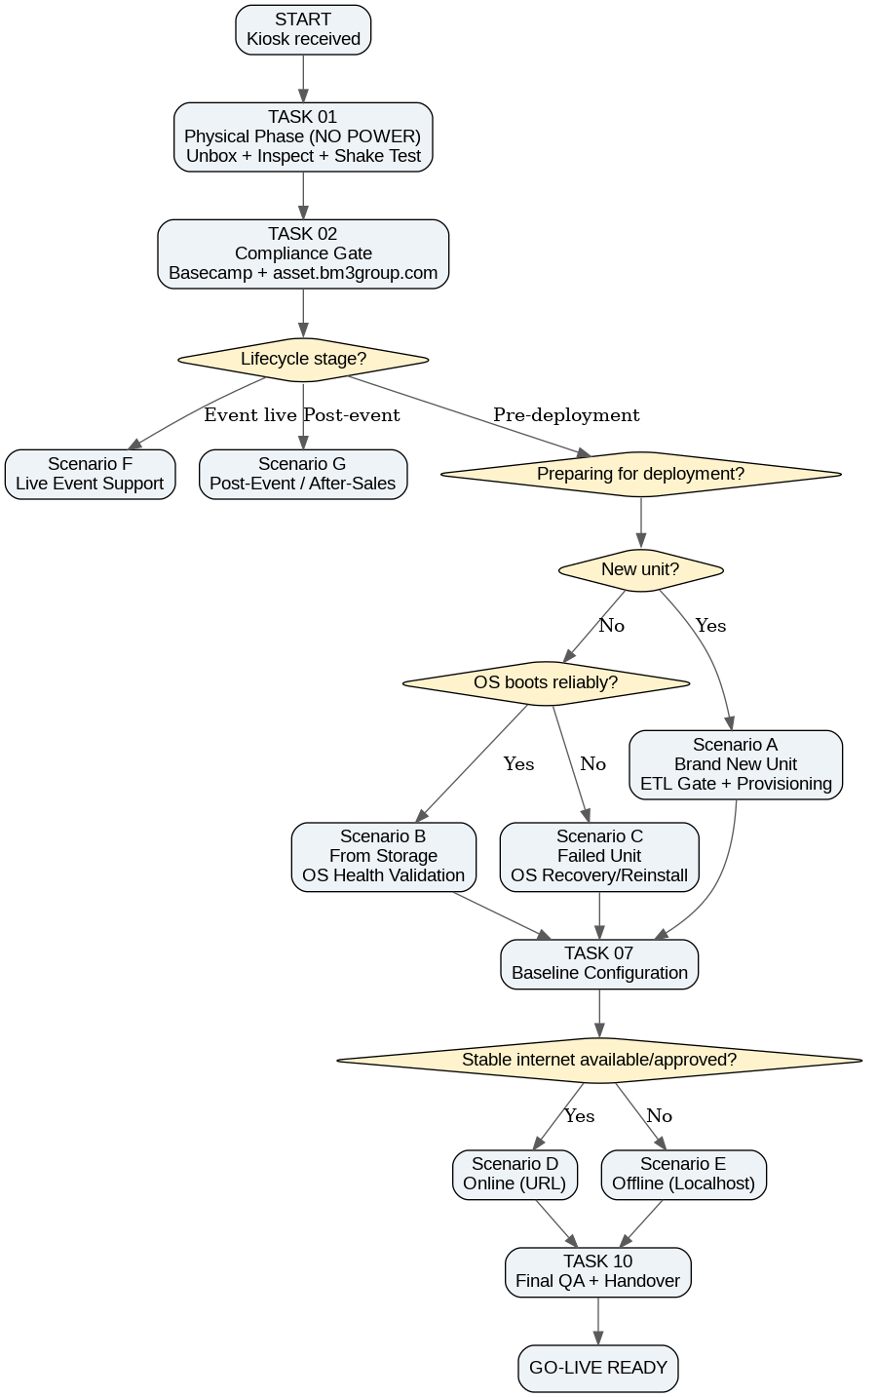

Most common combinations (write this in your notes):
Hardware state / Content | Online | Offline
New | A + D | A + E
From storage | B + D | B + E
Failed (after rebuild) | C + D | C + E

