5.3

The program can save to a text file the data of shape:

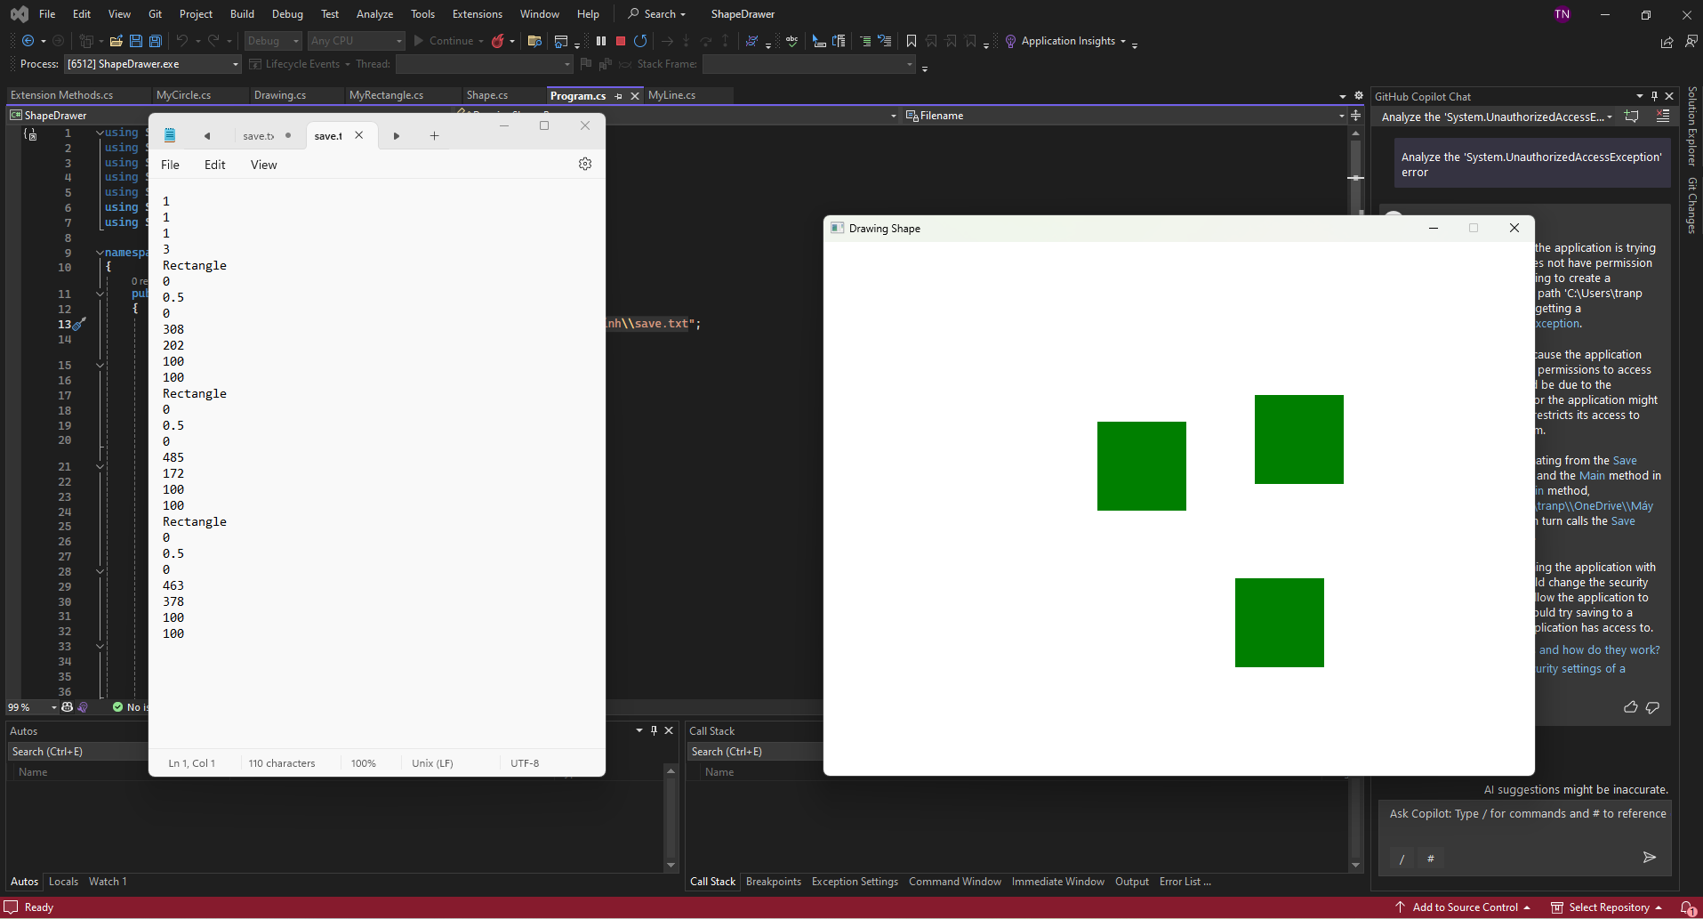

And after that, it can lolad from blank space to a program contains shape in the txt file

