3.3 Shape Drawer

When first running, the program look like :

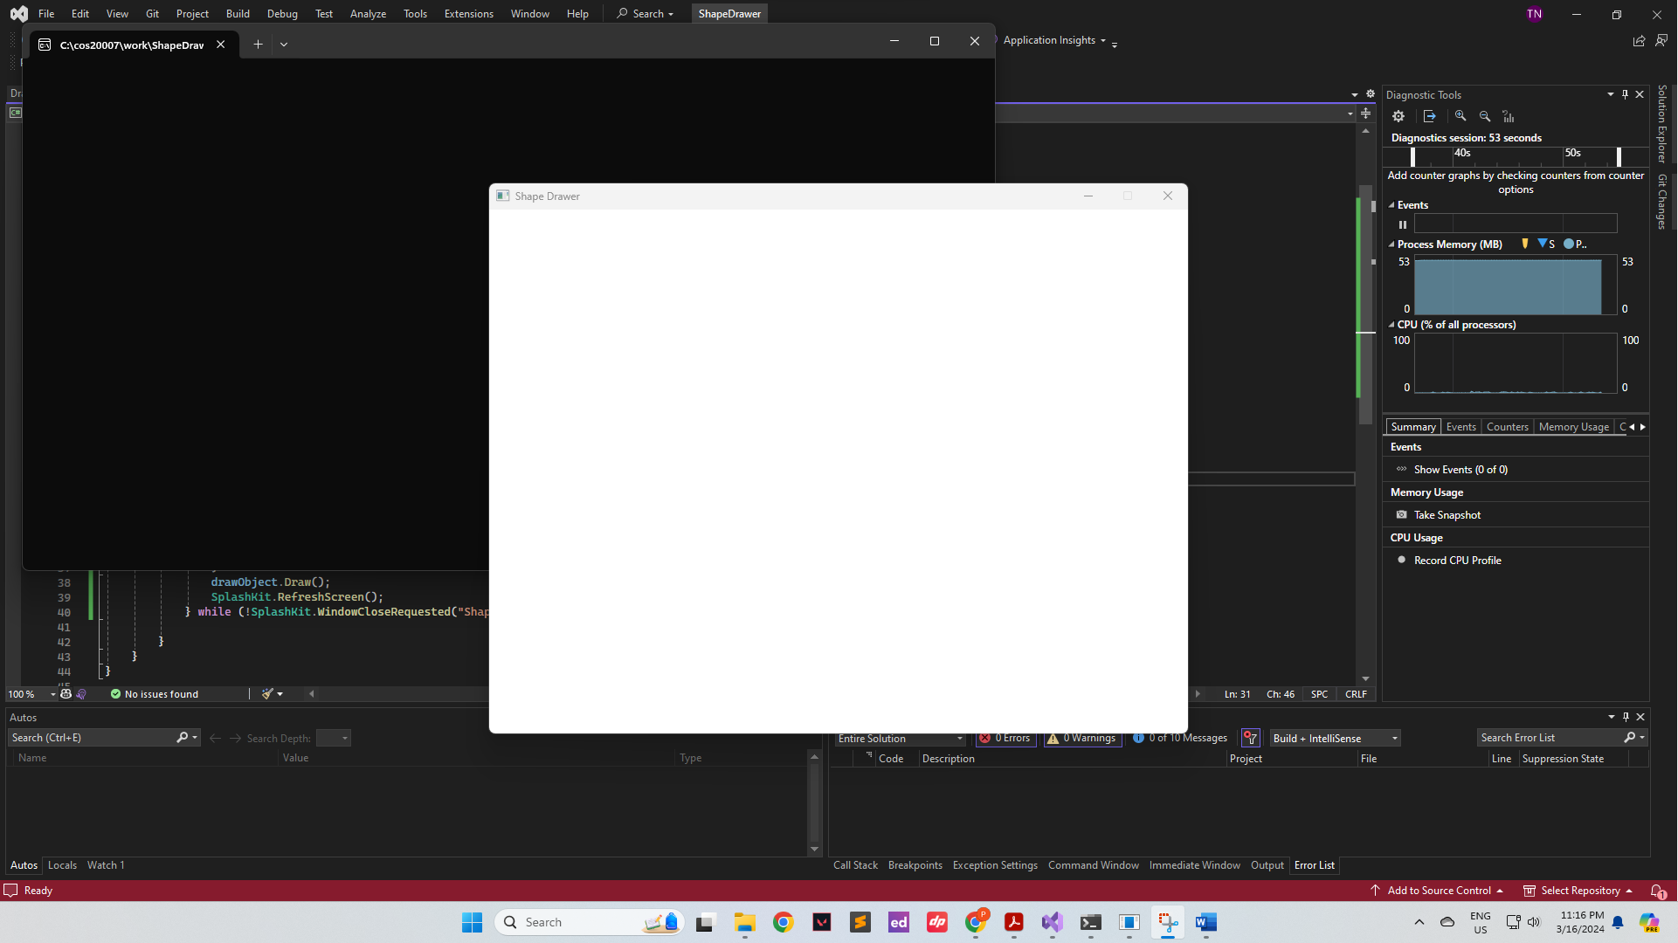

When click on a random spot on the window:

When clicking on space button:

When right click on the square:

Press delete on the selected square:

