Rack — Design & Business Requirements
Oct 24, 2026 · @The Genius

Overview
Rack is an agentic fashion marketplace. Shoppers describe, upload or photograph an outfit, and RackGPT finds matching pieces from local fashion stores. They can then try the pieces on virtually and check out in one flow. Vendors get a storefront inside the same app.
- Tagline (from Figma): "The future of fashion stores" / "The agentic fashion store that does all the manual browsing for you"
- Problem: fashion shopping in Lagos is split across Instagram DMs, WhatsApp catalogues and physical stores. Finding "that outfit I saw" means scrolling, asking for prices and guessing your size.
- Vision: you show Rack what you want and it does the browsing, matching, fitting and buying.
- RackGPT in one line: an AI stylist that turns a photo or description into ranked, shoppable matches with % match, price, sizes and availability.
This spec is based on the Ready for Dev page in the Rack Figma file: 7 RackGPT screens and 17 commerce screens. The Ideation and Landing Page pages fill in the website and the positioning.

Business requirements
Rack makes money when a match turns into a purchase. Revenue comes from commission on GMV, plus sponsored placement, which the Figma already designs into the home feed (the "Sponsored" hero card).
Target market: launch in Lagos with independent fashion brands and boutiques (e.g. Fashion Nova and Micah in the mocks), and 18–35 shoppers who discover fashion on Instagram and TikTok.
Value proposition
- Shoppers: get from "I saw this look" to "it's at my door" without DMing five vendors.
- Vendors: a storefront, AI-driven discovery traffic and checkout without building their own site.
Revenue model
Stream | How it works | In Figma?
Transaction commission | % of each order's GMV, taken at checkout | Implied
Sponsored placement | Brands pay for the home hero and "Sponsored Brands" slots | Yes
Vendor subscription (later) | Paid tier for analytics, more listings, priority matching | No
Delivery margin (later) | Markup on door-step delivery vs store pick-up | Partly
Goals and KPIs for the first 90 days after launch
Goal | KPI | Target
Prove RackGPT works | Uploads that return ≥1 match at ≥80% | Open question: set after the first test set
Prove intent | Match → add-to-cart rate | Open question
Prove supply | Live vendors with ≥10 listings | Open question
Build-in-public reach | Followers across TikTok, X and Instagram | Set in the content calendar
Competitive landscape: Instagram and WhatsApp vendors (where Rack's supply already sells), general marketplaces like Jumia, and global visual-search tools like Google Lens and Pinterest Lens. Rack's edge is visual search that only returns local, in-stock, purchasable items, with fit and checkout in the same flow.

Users and personas
Onboarding asks one question, "What brings you here?", and splits into two profiles: I am buying (customer) or I am selling (vendor).
Persona | Who | Job to be done | Key screens
The Screenshot Shopper | 22–30, saves outfits from IG/TikTok, buys from Lagos vendors | "Find me this look, in my size, near me, at a fair price" | RackGPT, match results, AR try-on
The Browser | Shops by brand, follows local labels | "Show me what my favourite stores just dropped" | Home, stores near you, brand store
The Boutique Vendor | Runs a label from IG + WhatsApp | "Get my pieces discovered and paid for without chasing DMs" | Vendor profile, store, orders (not yet designed)
Jobs-to-be-done the product must serve
- Turn visual inspiration into a shoppable list.
- Reduce fit uncertainty before paying.
- Pay and track delivery with confidence.
- For vendors: list once, get matched often, fulfil easily.

Product scope and functional requirements
The product has three areas: RackGPT (the agentic core), the shopper marketplace and the vendor side. The Figma covers the first two end to end. The vendor side exists only as an onboarding choice.
RackGPT
ID | Requirement | Figma reference
G1 | Input by text description, image upload or camera capture, plus an optional message | RackGPT empty state and input with attachment chip
G2 | Show analysis as visible steps: analyze image → detect items → match products → find best deals, with a % progress | "Analyzing your image" screen
G3 | Return ranked matches, each with store, item name, price, sizes and a % match score | "AI matched 2 similar items"
G4 | Add or remove items from the results without leaving the chat, with a running total and checkout CTA | Results with Added/Remove and Total Amount bar
G5 | "Edit Request" refines the search without starting over | Edit Request link
G6 | Only match in-stock items from Rack vendors; show nearest-location stock first | Implied by "From stores near you"
G7 | "Ask Rackgpt" floating entry point on Home and store pages | Floating button
Shopper marketplace
ID | Requirement | Figma reference
M1 | Sign up with Google or email, then pick buyer or vendor | Onboarding and login
M2 | Home: search, filter, sponsored hero with brand/type/sizes/location, Stores near you, Explore grid | Home
M3 | Brand store: header, search, category tabs, 2-column product grid | Fashion Nova store (3 states)
M4 | Product detail: image gallery, size and colour pickers, quantity, Similar Products, Add to cart | Drew's Shirt PDP
M5 | AR try-on: guidance (stand in front of a mirror), capture image or upload from media, colour/size swap, save photo, add to cart | AR Try On sheet and camera screens
M6 | Cart: line items, quantity, remove, subtotal, shipping and tax calculated at checkout | Your Cart
M7 | Checkout: store pick-up or door-step delivery, address book, card or bank transfer | Checkout (2 states) and Enter Address
M8 | Review order, then confirmation with order #, estimated delivery and Track Order | Review Order and Confirmation
M9 | Order tracking timeline: Confirmed → Processing → Shipped → Delivered, with timestamps | Track Order
Vendor side (to design)
ID | Requirement
V1 | Vendor onboarding: store name, logo, location, payout account
V2 | Listing creation: photos, category, sizes, colours, price and stock, with AI auto-tagging so RackGPT can match the item
V3 | Order inbox with status updates that drive the shopper's tracking timeline
V4 | Basic analytics: views, matches, add-to-carts, sales
Non-functional requirements
- RackGPT returns its first results in under 10 seconds, with the step-by-step progress covering the wait.
- Images are processed for matching and not stored beyond the session unless the user saves them.
- Payments go through a Nigerian processor (e.g. Paystack or Flutterwave) that supports card and bank transfer.

Design requirements
Rack's design is quiet and editorial: monochrome UI so the product photography carries the colour, and black primary buttons. It's mobile-first at iPhone 14/15 Pro size (393 × 852).
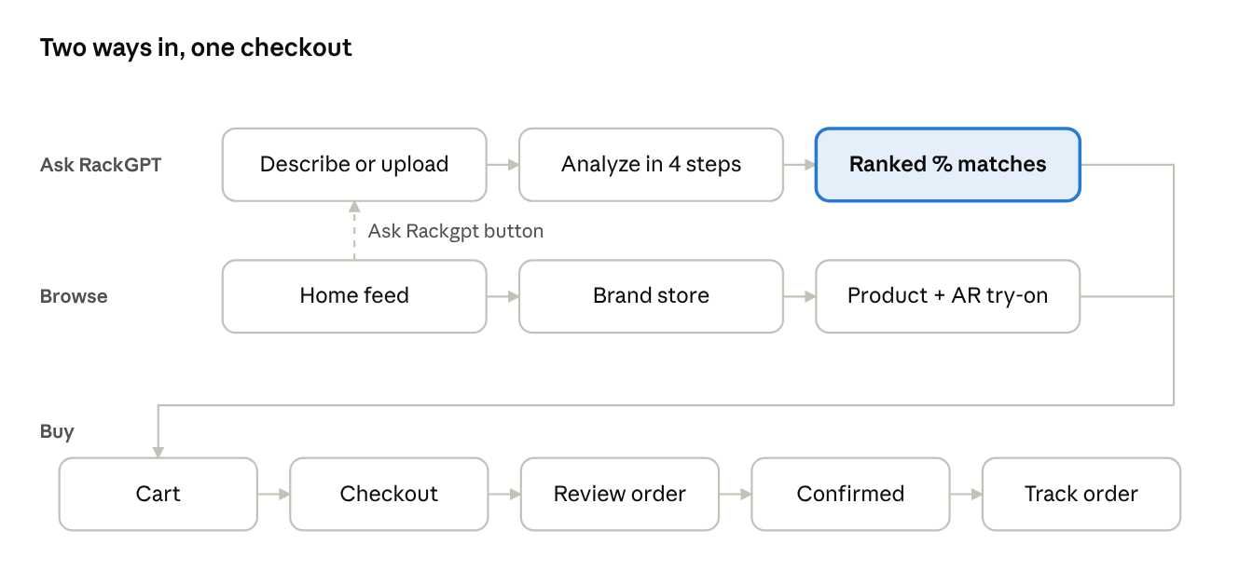
core shopper journey · 2 entry paths, 1 checkout
Both discovery paths end in the same cart. RackGPT is the hero, and "Ask Rackgpt" floats over every browse screen so you're never more than one tap from it.
Design language (from the Style Guide and screens)
- Colour: white surfaces, light-grey cards, near-black text and CTAs. The only accents are status colours (red Remove, green progress) and product imagery. The onboarding screens are dark, over store photography.
- Type: one sans family on a Tailwind-style scale (text-xs to text-9xl, thin to black). The wordmark "R ck" uses an open "A".
- Shape: rounded image cards, pill size chips (S/M/L/XL), full-width primary buttons with a trailing arrow, bottom sheets for secondary flows (AR Try On).
- Shadows: sm, sm-strong, md and lg tokens from the Style Guide.
- Imagery: real Nigerian fashion (agbada, buba, gowns, Ankara) shot editorially. This is a differentiator, so keep it.
Component inventory to build
Search bar with filter and cart; Sponsored hero card; product card (store, name, price); size chip and colour swatch; quantity stepper; match card (% badge, Add/Added state); AI progress stepper; chat input with attachment chip; bottom sheet; radio list (delivery/payment); order timeline; sticky total bar; floating Ask Rackgpt button.
Motion
- The RackGPT analysis steps animate in sequence with the % bar so the wait feels like work being done.
- Match cards stagger in. Add flips to Added with a total-bar count-up.
- The landing site is scroll-driven ("The Fitted Reality" hero video concept, Pinterest-style reference).
Accessibility: 4.5:1 contrast on grey-on-grey captions (several Figma captions are too light today); 44pt tap targets on size chips; alt text from AI tags on every product image; a non-camera path through AR try-on (upload).
Design gaps to close before or during the build
- ☐ Vendor screens (V1–V4)
- ☐ Empty, error and no-match states for RackGPT
- ☐ Profile, saved items and order history
- ☐ Desktop web layout for the marketplace (the Landing Page has marketing only)
- ☐ The Landing Page still holds leftover Habitline copy ("Start tracking for free"). Swap it for Rack copy.

3-week MVP and build plan
The MVP is RackGPT plus one complete buy flow in a single city, with vendors onboarded by hand. Everything else waits until the core loop (upload → match → buy) works on real inventory.
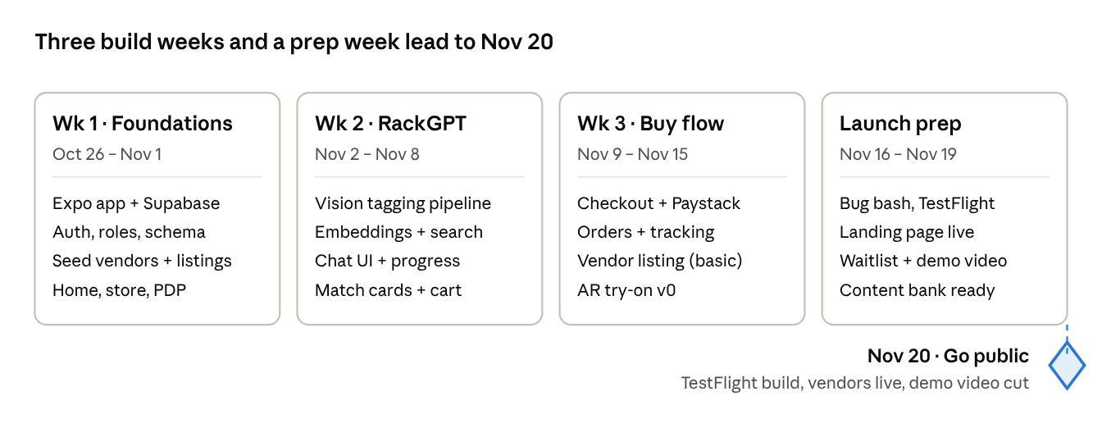
build roadmap · Oct 26 – Nov 20
Each week ends with something demoable, which is also that week's content.
MVP in / out
In the MVP | After launch
G1–G7 RackGPT (text + image; camera via the system picker) | Live camera capture inside RackGPT
M1–M4, M6–M9 | Full AR try-on with body tracking
M5 AR try-on as v0: 2D overlay or a virtual try-on API on an uploaded photo | Vendor analytics (V4), subscriptions
V2 vendor listing in a simple web form or admin; V3 order status | Self-serve vendor onboarding (V1)
Paystack: card + bank transfer | Sponsored placements self-serve
Suggested stack for Claude Code
- App: Expo (React Native + TypeScript) to match the mobile-first Figma, with Expo Router and NativeWind so the Tailwind-style type scale maps directly.
- Backend: Supabase for Postgres, auth (Google + email), storage for product images, and pgvector for similarity search.
- RackGPT: a vision model tags each listing (category, colour, pattern, fabric, style) and each user upload the same way. Matching combines image embeddings with tag filters (size, location, in stock), then ranks by similarity, which becomes the % match.
- Payments: Paystack.
- Landing site: the existing Figma Landing Page, rebuilt as the motion-heavy site you planned.
Risks
- Match quality on thin inventory. With few listings, "88% match" can feel wrong. Seed at least 3 vendors and about 60 well-photographed items before demoing.
- AR scope creep. True AR try-on alone could eat the 3 weeks. Ship a v0 and show the real version as a roadmap teaser.
- Building and posting at once. Batch-record during the build so posting from Nov 20 never depends on that day's progress.
Open questions
- ☐ Prices in ₦ or $? The Figma shows $, but launch is Lagos.
- ☐ Commission rate and who pays delivery.
- ☐ Which vendors are the launch partners (are Fashion Nova and Micah real)?
- ☐ App store launch on Nov 20, or TestFlight/waitlist with a public demo?
- ☐ Does the Rack/Closedeck name question need settling before going public?

