**Question:**

What is your name?

What is your email?

How often do you use smartphone per day?

* Less than 3 hours
* 3-5 hours
* More than 5 hours
* Other

Do you use phone before bedtime?

* Yes
* No

what time do you sleep ?

* 10-12 p.m
* 0-1 a.m
* 1-2 a.m
* After 2 a.m
* Other

If you don't use your phone and try to sleep before this time, how would you feel?

* Struggled, difficult to sleep
* Annoying and wanting to use the phone
* I can sleep if I want to
* Other

How do you feel when you wake up?

* lack of sleep, want to sleep more
* tired
* Good

How long has this habit been around for?

* 1-2 months
* 3-4 months
* more than 4 months
* Other

Are you irritable in everyday activities?

* Yes
* No

How do you feel without your phone?

* Worry
* Normal
* Unpleasant, needy
* Other

Do you regularly check your phone for notification?

* Yes
* No

How often do you check your phone for notification?

* 1 - 2 minutes / time
* 3-5 minutes / time
* 6-7 minutes / time
* more than 7 minutes / time
* Other

Sometimes you feel your phone vibrate like notification or incoming call, but when you check again nothing?

* Always
* Sometimes
* Rarely

Why do you feel worried when your phone battery runs out?

* Can't play the game
* Cannot connect with others
* I do not know
* Other

Do you feel comfortable using your phone to communicate, connect with others or meet in person?

* By phone
* Meet in person
* Other

When a stranger comes to ask a story, do you often look at smartphone even though there is not notification or phone call?

* Yes
* No
* Other

Does using your phone make you spend less time with family (less talking,sharing)?

* Yes
* No
* Other

During your family time, what purpose do you use your phone?

* Texting
* Social media news
* Playing gaming
* Other

If your phone is out of power, what will you do?

* Charge the phone and use it.
* Watch TV
* Talking with others

When going out with friends (cafe, ..), do you use your cell phone when the atmosphere is quiet?

* Yes
* No

When in that atmosphere, how do you feel without a phone?

* Stress
* Confused
* Normal
* Uncomfortable
* Other

Do you often initiate stories for that silent atmosphere?

* Yes
* No

Will the phone distract you while studying by yourself?

* Yes
* No

Have you ever been studying and received a text message, you reply to that message and unconsciously use your phone and forget to study?

* Always
* Sometimes
* Rarely
* Other

In the course of class, how did the phone distract you from studying?

* Incoming messages and notices.
* Surf the web because it's more fun than learning
* Both reasons above
* I am not distracted by phone in studying
* Other

Do you often ask the teacher when you have a question?

* Wait for the teacher to come up and ask
* Ask directly
* Go home and study the problem

Other

Are the study results as you expected?

* Yes
* No

It's not too bad and not too good but it's acceptable

Do you feel pressured to study?

* Yes
* No
* A little bit

**Data collected:**

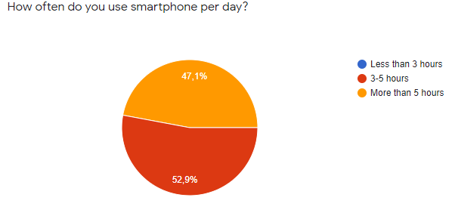

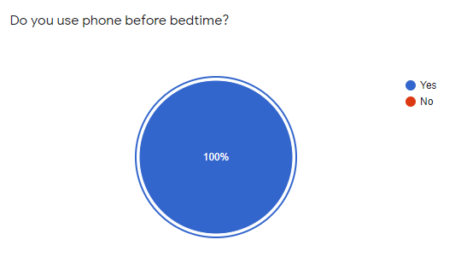

Based on the above chart, we can see that the majority of students and students use their phones for 3-5 hours a day (about 52.9% equivalent to 9 people / 18 interviewers). This is a good level of use for students. About 47.1% (equivalent to 7 people / 18 interviewers), students and students use telephones with high frequency for more than 5 hours per day. 100% of students surveyed have a habit of using a phone before going to bed.

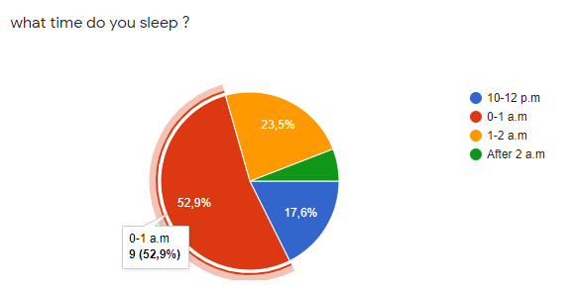

Most students have the habit of going to bed very late after 12 o'clock. Very few students have the habit of sleeping early (17.6%). Most students usually use the phone and go to bed between 0-1 hour. The number of students going to bed from 1 to 2 hours late (23.5%) was more than that of students going to bed early (17.6%). A few have a habit of sleeping very late after 2 hours (6%).

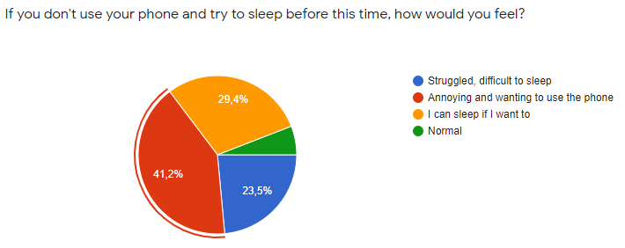

When asked about pre-bed use, many students say they can't sleep without using their phone before bed. 23.5% of students find it difficult to sleep without using their cell phones before going to bed. 41.2% feel uncomfortable and want to use the phone. 29.4% feel fine and can sleep if they want to. A few feel normal. The numbers show that using the phone before bed is indispensable for most students.

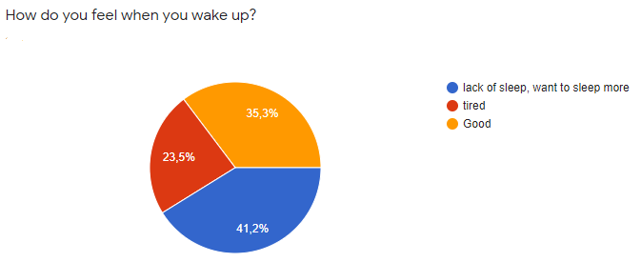

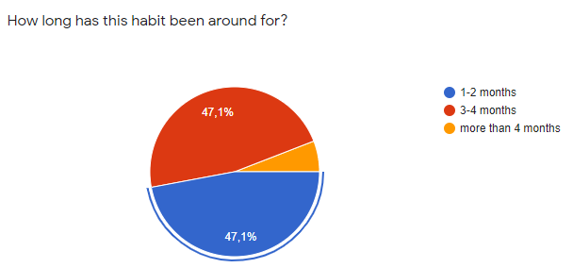

Approximately more than 58.8% of students show signs of fatigue and sleep when waking up. And the rest feel fine. Approximately 47.1% of students have maintained this habit for 1-2 months and 3-4 months. A small number of students maintain this habit for more than 4 months (5.8%).

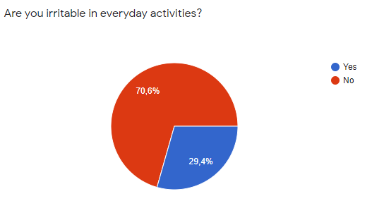

When asked about students' reactions to daily activities, about 29.4% said that they feel frustrated and bitter about normal activities of the day.

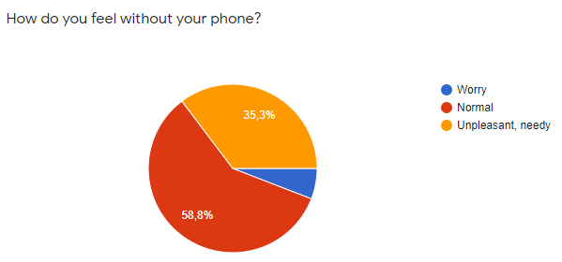

58.8% of students feel fine without their cell phones. 35.3% feel unsettled, want to use the phone and a few feel worried when they don't have their phone nearby (5.9%).

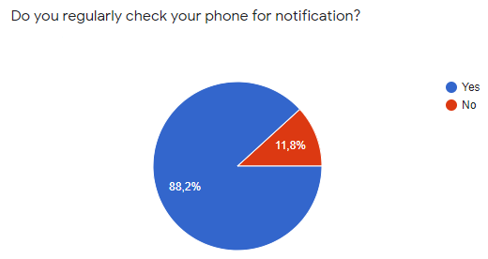

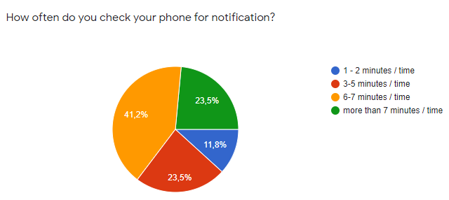

While using the phone, 88.2% always check the phone to see notifications. The frequency of students checking notifications is quite dense. Yes 11.8% tested 1-2 minutes / time, 23.5% tested 3-5 minutes / time, 41.2% tested 6-7 minutes / time.

23.5 test from more than 7 minutes / time.

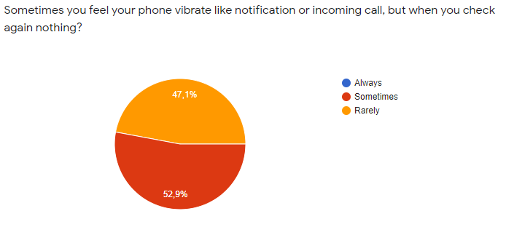

Up to 52.9% of students feel the phenomenon of notification comes that when checked without notice. In addition to the frequency of checking notifications from the young people above, we can see. This shows that students always have a mentality of being afraid of missing something on their phone. This has made students feel more informed (But in fact, they don't).

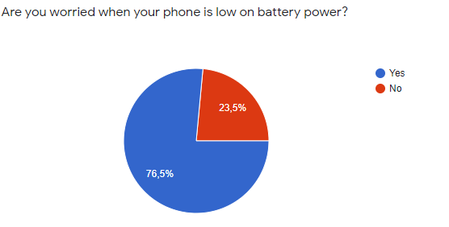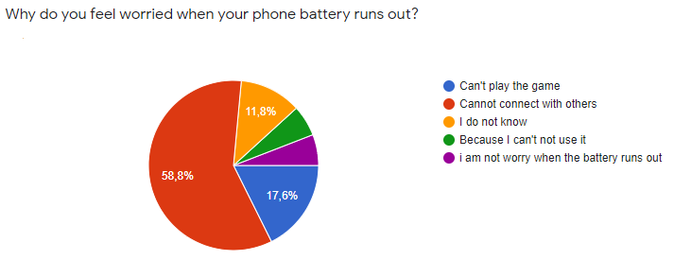

Up to 76.5% of students feel worried when their phones run out of battery. About 58.8% of that anxiety comes from not being able to connect with others. 17.6% feel worried because they cannot use their phones to play games. 11.8% felt unreasonable worries when their phones ran out of battery. 5.9% are worried about not being able to use the phone. The remaining 5.9% feel that the phone is out of battery is no problem.

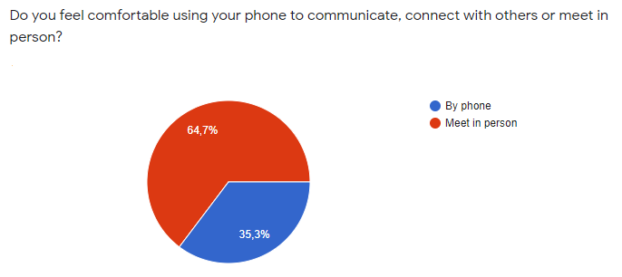

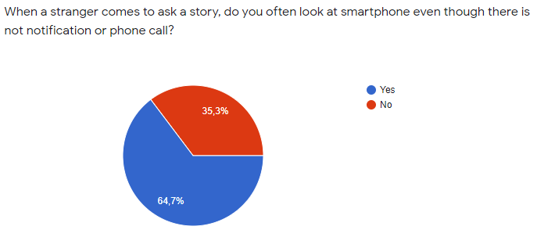

Students are more likely to connect with people over the phone (64.7%) because they feel that connecting over the phone is more comfortable than in person. When a stranger talks, about 64.7% of students look at their phones unconsciously. This shows that they see their phone as an elusive, shy way in a conversation.

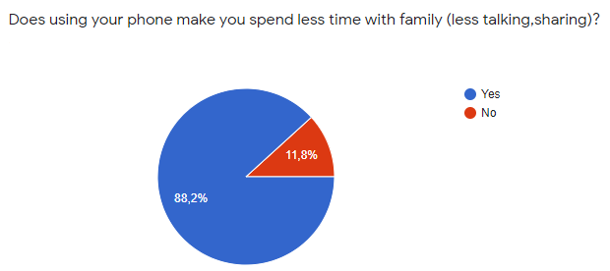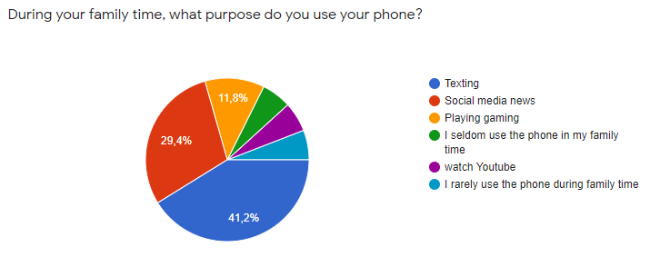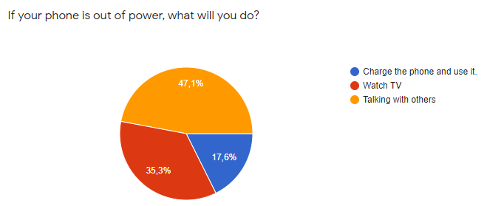

Most students consider using a phone to make family time less (88.2%). During family activities, the majority of students use their cell phone for purposes such as : Texting (41.2%), Social media news (29.4%), Playing game (11.8%), watch Youtub (5.9%). A small number of students (11.8%) use phones less during the family time. When their phones ran out of battery during family hours, 35.3% of students stopped using their phones but watched TV, 17.6% went to charge and continued to use and 47.1% stopped using their phones and talked to relatives around. The above parameters show that phone use indirectly hinders and worsens family relationships by preventing communication between family members.

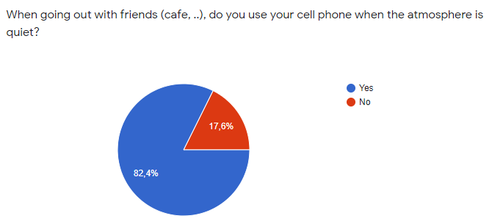 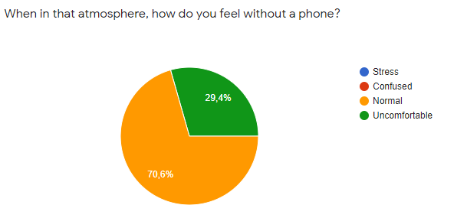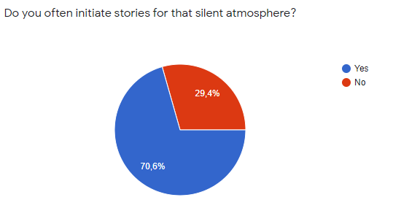

When students go out with their friends, they also use their phones to avoid silent atmosphere (82.4%). comfortable in that quiet atmosphere. Also up to 29.4% of students find it difficult to open the story in that atmosphere.

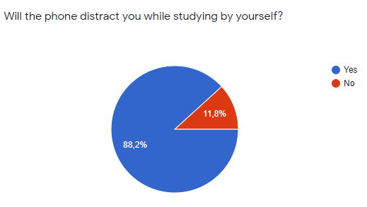

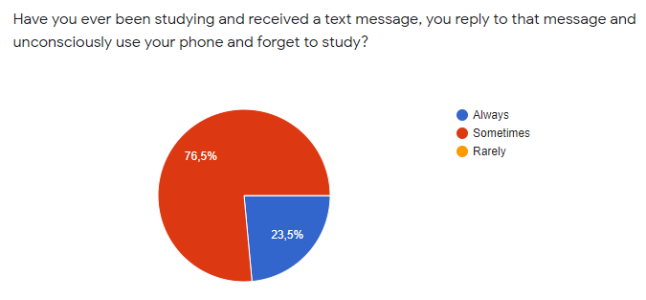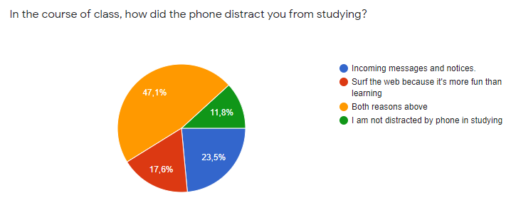

Up to 88.2% of students feel that being by phone affects their learning.

More specifically, when asked about notification messages from phones, up to 76.5% of students use phones during self-study hours when text messages or notifications arrive. This disrupts the self-study process of students, thereby affecting learning results. During class time, 23.5% of students were bothered by text messages and notifications, 17.6% felt attracted to the internet, 47.1% said they were attracted to the 2 above and 11.8%. assume I'm not bothered by the phone. Through the above numbers, it can be seen that phone use has a large impact on student learning. The attractiveness of the phone affects the process of concentrating and continuing the lesson of students.

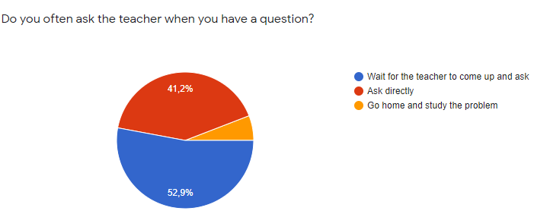

When having a question, up to 52.9% of the students waiting for her to come to him ask. This shows that students are currently afraid of being noticed. Approximately 5.9% of students dare not ask questions and learn about problems at home.

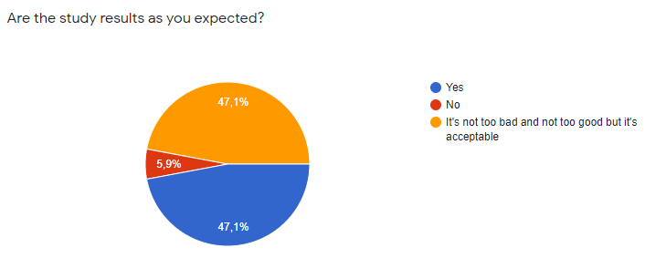

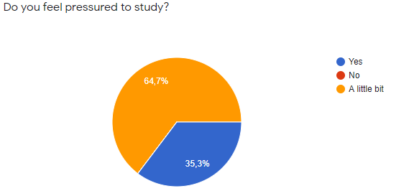

Student performance shows that the majority of students are not getting the results they want. Approximately 5.9% did not achieve the desired results and 47.1% did not perform as well as they expected. Unexpected results of learning cause the learning pressure of students. About 64.7% feel a little pressure to study. 35.3% feel awake about the pressure to study.

Conclude:

Based on the above expressions, one can conclude that phone use can be addictive and makes students afraid to socialize.

Use has a strong effect on student performance, indirectly causing academic stress. The fact that students may have communication problems, which can lead to relationships. deterioration (friends, family). This directly affects student development.