First, we'll import the required libraries: CSV, Datetime and Regex (re):

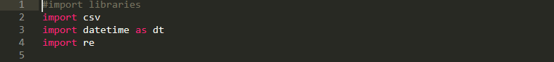

Open the original CSV file, we read it as key-value (dict reader):



Create a new CSV file (result):



Create column (keys) for the new CSV file:

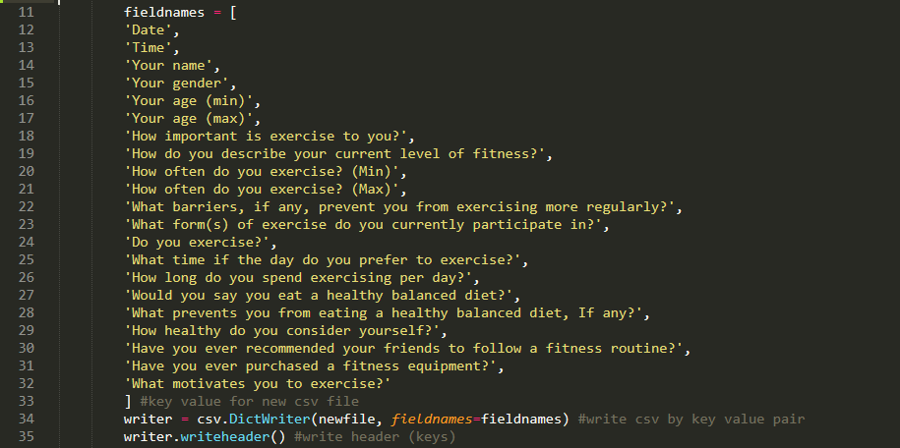

Then, read each row of the original CSV file and get the required values.

As for time format, we just separate the date and time:

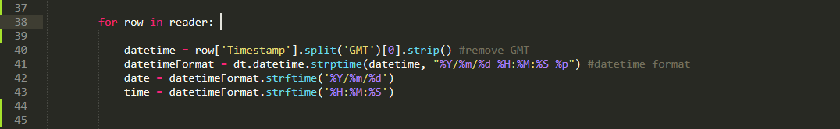

For age, we will split into two columns of lowest and highest age (min and max). We use Regex to get the age values, for example “19 to 25”, the min value is 19, the max is 25. Or if the row has only min value (example: 40 and above) then the max value will be 100.

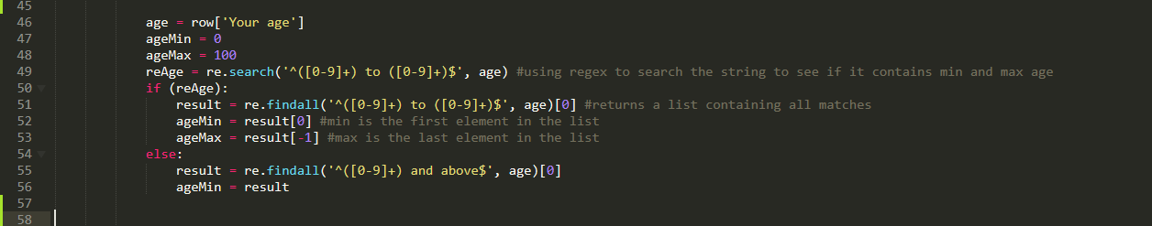

For the number of workouts per week, we also split into two columns min and max. Both the min and max columns will be 0 if the value in the row is "Nerver", and 7 if "Everyday". If there are exercise counts, continue to use Regex to get the min and max values.



As for the time to exercise each time, it would initially be zero if he never went to exercise. Use Regex to check (search), if row has exercise time, switch to minutes format.

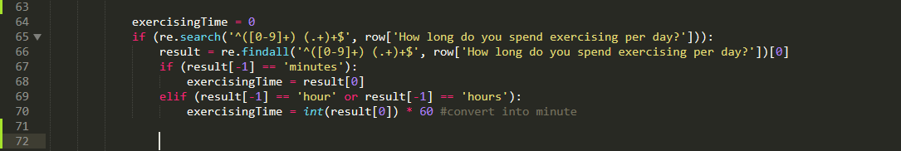

Finally, write the rows into the new CSV file as key-value:

