|  |  |  |
| --- | --- | --- |
| **ID** | **Type** | **Reason why I decide it belong to functional or non functional requirement** |
| 1 | High level Functional | Customers need their own account to place, purchase and pay |
| 2 | Functional | If you have to log in to view products, companies will not be able to recommend their products |
| 3 | Non-Functional | Since such design will make the website more professional, the user can also easily visualize the product. |
| 4 | High level Functional | Custom-made orders require different requests from customers, so the function of sending messages and pictures will help avoid errors in the request and collect requests faster. |
| 5 | Functional |  |
| 6 | Non-Functional | Because this is about website performance for a better user experience |
| 7 | Functional | It is a function that helps increase the accuracy of time, but without it, the website can still function well and complete all the necessary requirements. |
| 8 | Functional |  |
| 9 | Functional | This functionality is essential for the director to be able to make the right decisions for the company |
| 10 | Non-Functional |  |
| 16,19 | non |  |
| 12 | Functional | Việc thay đổi thông tin của khách hàng theo chi tiết cập nhật mới nhất |
| 13 | Functional | This is a function, because the glassblower has the right to keep their profession a secret, not to share how they work for outsiders. |
| 14 | Functional |  |
| 15 |  |  |
| 16 | Non |  |
| 17 |  |  |

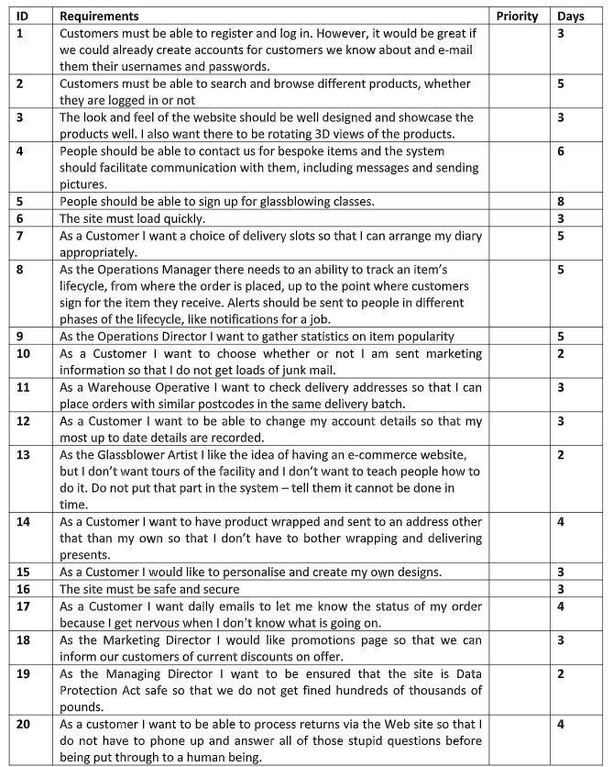

|  |  |  |
| --- | --- | --- |
| **ID** | **Reason why the requirement is essential for website ( justify based on case study)** | **Notes** |
| 1 |  |  |
| 5 |  | Combine requirement 1 and 2 -- |
| 2 |  |  |
|  |  |  |
| … |  |  |
| 10 |  |  |