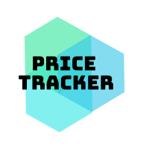

**Idea**

Price tracker is a software solution used to track your online shopping lists. It allows to track items from any online shop. Features include grouping and having a favorite list of your items. As well as periodical price refreshing and notifications to the users whenever the price drops or reaches a desired amount.

**Stages**

This project is going to be composed of four stages:

1. Android and iOS app - something similar to [this](https://www.youtube.com/watch?v=tmVmjghHzKg) (most importantly, getting items via ‘share’ functionality of the browser) and improved by remembering websites without the need to specify the price.
2. Personal accounts where watched items can be shared across devices, as well as for the premium features.
3. Google chrome extension to easily add items to the watched list from your web browser.
4. Web app with the same functionality as the mobile app. (paid feature?)
5. Single page website to promote this product.

**Market**

Android google play store has 200k+ combined downloads of similar apps, yet most of them have a very poor rating. Similar situation is with iOS app store. This solution would be an improvement of all of these apps and these users would most likely be happy to switch. Keep in mind, this is only the potential of user base who would consider switching from current applications.

**Business model**

Ads ([Google mobads](https://admob.google.com/home/resources/how-much-revenue-can-you-earn-from-admob/)) with a monthly subscription plan or a one time purchase, which allows to turn the ads off and use the web app on a desktop computer. Ads would be thrown in at the either the bottom of the screen, or at the top.

**Examples of use cases**

**Mobile phone**

1. User browses the internet and finds a jacket that he really likes, yet the price is too steep. The user would be happy to pay 30£ instead of the current 55£ that it costs.
2. User adds the item to the Price Tracker app in the following way (or by entering URL in the app):

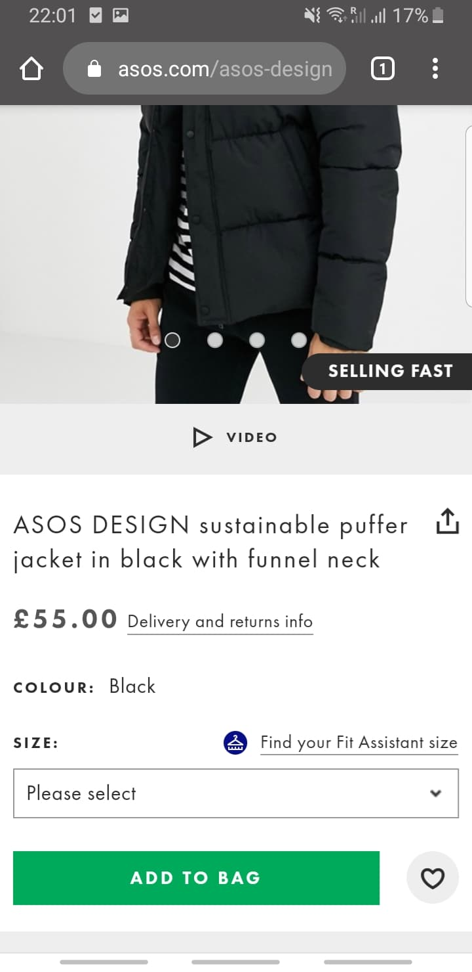 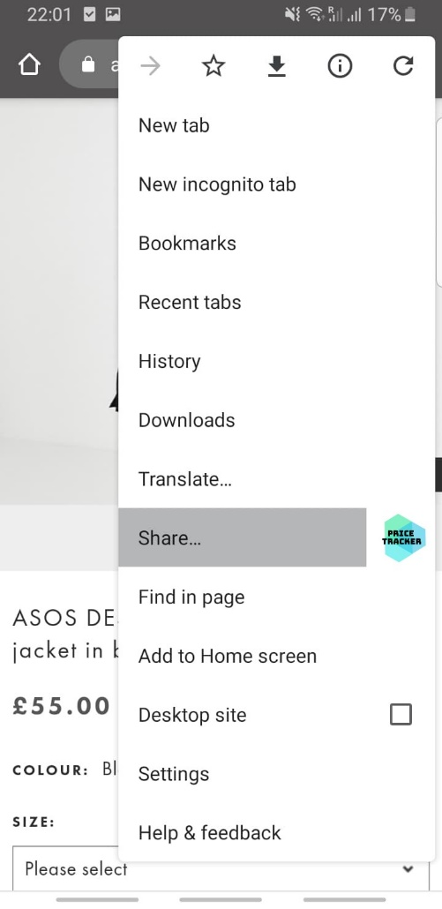

1. The item goes to the app where the user can choose the price he wants to be notified about.

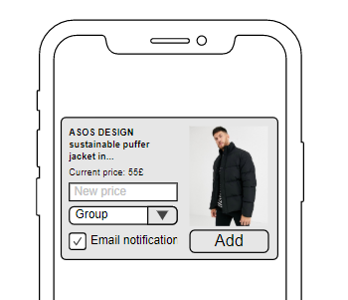

1. After the item is saved, the user can see all of his items and modify them accordingly. The prices are then checked periodically and if an item has the desired price attribute and it hits it, the user is notified by a notification and optionally the email as well.

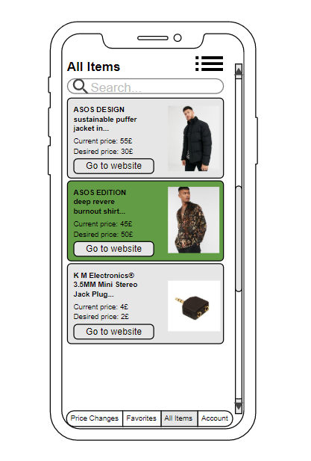

**Desktop browser**

1. User is logged into the Price Tracker application and has the google chrome extension downloaded. Then he finds an item he might want to buy and adds it to his list. Furthermore, the person wants to be notified if the price would drop below 30£.
2. The user selects the desired price and presses ‘Add’.

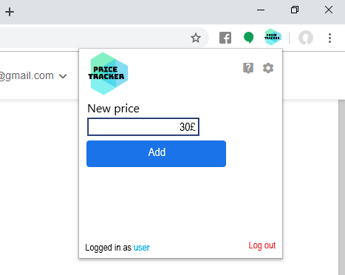

1. Item is added to the account and the full list can be seen on the mobile app or web app.

**Web app prototype**

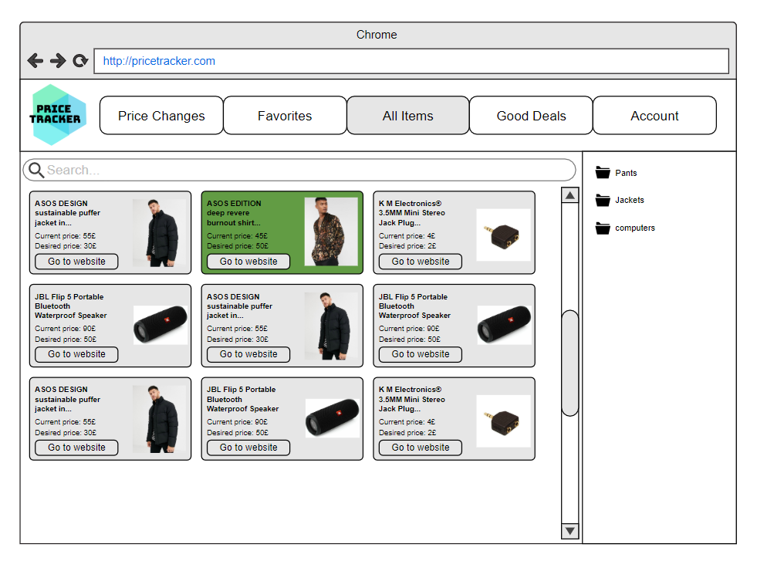

**Mobile App**

Mobile app has four different tabs – price changes, favorites, all items and account information. As well as some additional screens. Each one is discussed further below:

**Log in screen**

This is the first screen the user will see. User must own an account in order to store items. There is also a register option for new users.

**Adding an item (known website)**

Item can be added by sharing the link through the browser or simple by pasting a link in the app. If the website is already learnt, then the price, logo and name is automatically scraped.

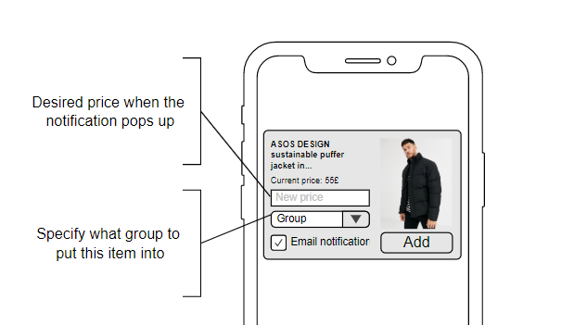

**Adding an item (unknown website)**

If the website is unknown and used for the first time, user input might be needed. In this case, the user would be asked to identify the price, logo and the title of item manually.

**Price Changes**

This tab is used to display the items that have dropped in price since you last added them.

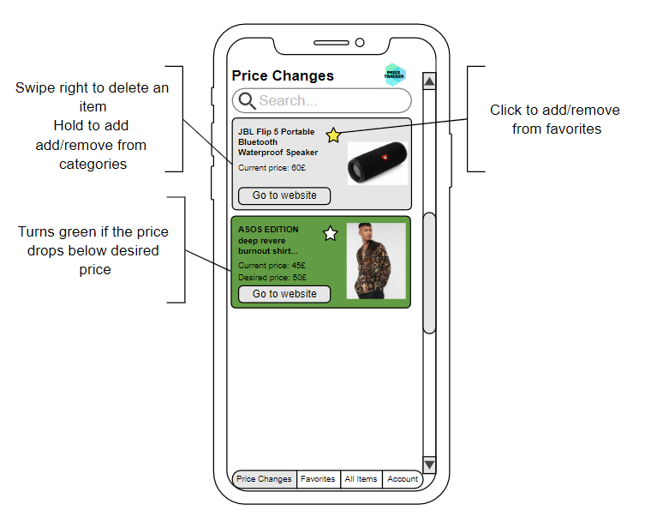

**Favorites**

In this tab, favorite items are shown.

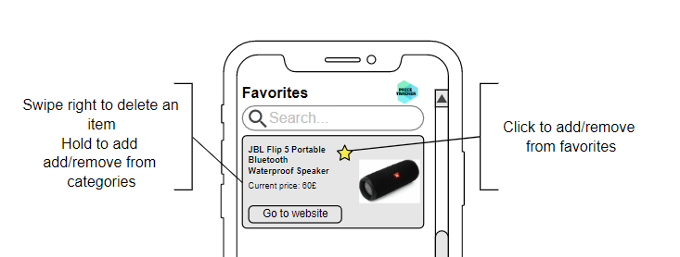

**All Items**

This tab holds all the items and they can be filtered by the group that the item is in and also the search key words.

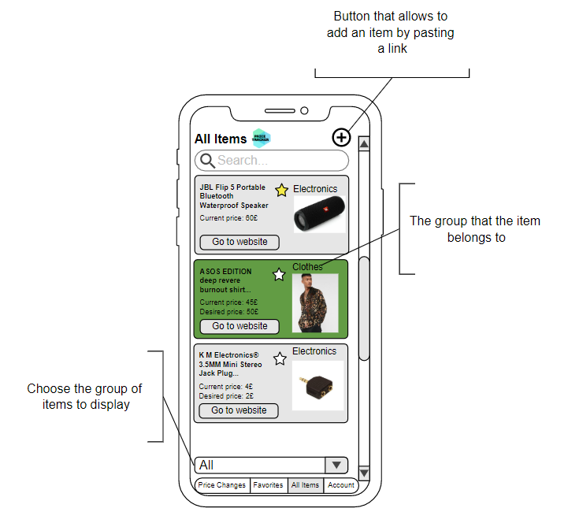

**Account**

This tab is responsible for handling of the user account.

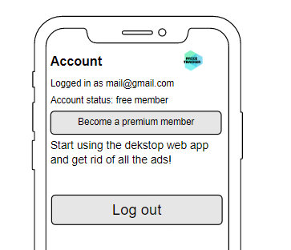

**Full workflow**

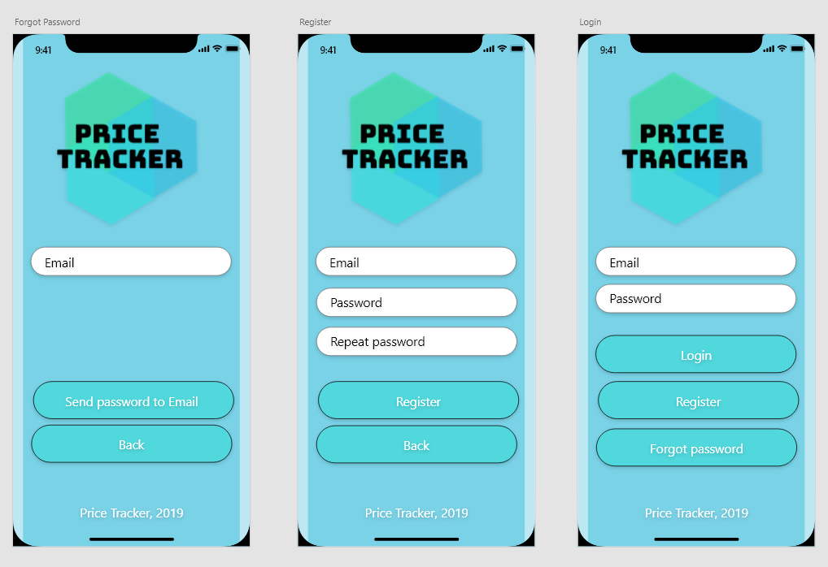

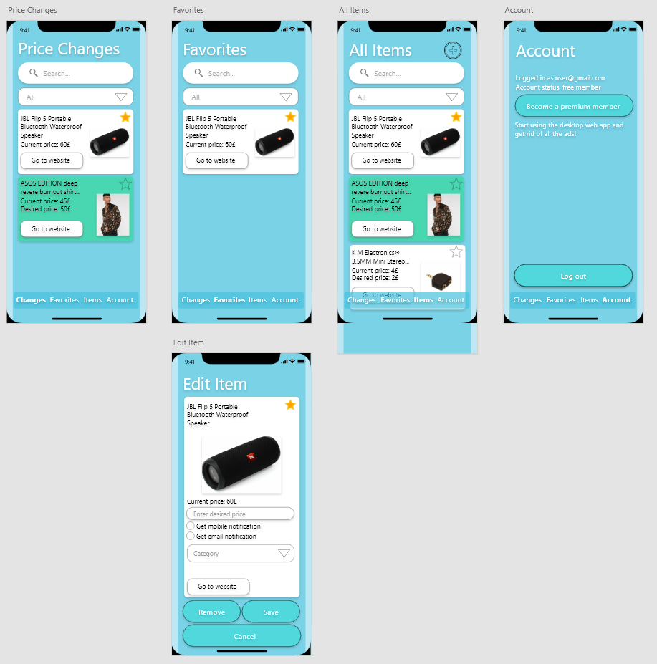

*Full working workflow in project directory (mobile app prototype.xd) or* [*here*](https://xd.adobe.com/view/b432b803-6aa2-4d30-4e87-c34f05714e41-c203/?fullscreen)*.*

**Google chrome extension**

* TBA

**Web app**

* TBA

**Website**

* TBA

**Technical**

Primary colors:

* #31c6eb  #31e89f  #31e8e8*

Mockups:

<https://app.moqups.com/>

Adobe XD

Ideas:

Google Firebase for backend.