APB Verification
Using UVM RAL
Design, RAL Modeling, Integration, Debugging and Verification Results

SystemVerilog | UVM | RAL | APB | Questa

Prepared by | Sondos Ahmed
Project type | Individual RTL Verification / UVM RAL Portfolio Project
Simulator | Questa Sim-64 2021.1
Final status | PASS - 0 UVM errors, 0 UVM fatals

Portfolio note
The base APB UVM environment was provided as starter code. This report clearly separates the supplied environment from the RAL model, integration, register sequences, coverage, reporting, and stabilization changes added during the project.

1. Executive Summary
A concise view of the project scope, contribution and final outcome.
This project extends a provided UVM verification environment for a small APB peripheral with a complete UVM Register Abstraction Layer (RAL). The design exposes five memory-mapped registers: a 4-bit control register at address 0x00 and four 32-bit general-purpose data registers at 0x04, 0x08, 0x0C and 0x10.
The RAL implementation models register fields and reset values, creates the register block and APB address map, translates register operations through an adapter, keeps the model mirror synchronized through an explicit predictor, and drives five modular register sequences that demonstrate both frontdoor and backdoor access. Per-register functional coverage and UVM reporting were also added.
The integration phase also exposed timing and observability issues in the starter environment. The APB read path and monitor sampling were corrected so PRDATA is captured after the DUT nonblocking assignment update, the scoreboard was made transaction-based and CNTRL-aware, and the missing 0x08 address constraint was restored. The DUT RTL itself was not behaviorally modified.
5  Mapped registers | 5  Modular RAL sequences | 2  Access paths: frontdoor + backdoor
1  Explicit predictor | 0  Final UVM errors | 0  Final UVM fatals

Final result
The final Questa run completed all five register sequences at 900 ns with UVM_INFO = 59, UVM_WARNING = 0, UVM_ERROR = 0 and UVM_FATAL = 0.

Project objectives achieved
Objective | Status | Evidence
RAL register fields and registers | PASS | CNTRL field-level model plus reusable 32-bit data-register class.
Register block and address map | PASS | CNTRL=0x00, REG1=0x04, REG2=0x08, REG3=0x0C, REG4=0x10.
Adapter and predictor | PASS | APB adapter + explicit uvm_reg_predictor connected to the existing monitor.
Five modular register sequences | PASS | One sequence per register, started sequentially from the test.
Frontdoor and backdoor access | PASS | update/read/write through APB plus peek/read through HDL backdoor.
RAL reporting | PASS | DESIGN, DESIRED and MIRRORED values printed during each operation.
Coverage collection | PASS | Per-register covergroups plus simulator coverage saved to UCDB.

2. DUT and Register Map
The hardware register bank being modeled by the RAL layer.
The DUT is an APB-based peripheral with five software-visible registers. APB transfers complete when PSEL and PENABLE are asserted; PWRITE selects write versus read. Writes update the selected register, while reads place the selected register value onto PRDATA through an internal rdata_tmp register.
Address | Register | Width | Access | Reset
0x00 | CNTRL | 32-bit word; only [3:0] implemented | RW lower 4 bits; reserved [31:4] read 0 | 0x00000000
0x04 | REG1 | 32 bits | RW | 0x00000000
0x08 | REG2 | 32 bits | RW | 0x00000000
0x0C | REG3 | 32 bits | RW | 0x00000000
0x10 | REG4 | 32 bits | RW | 0x00000000

CNTRL field breakdown
Bits | Field | Access | Reset / behavior
[3] | CTRL3 | RW | 0
[2] | CTRL2 | RW | 0
[1] | CTRL1 | RW | 0
[0] | CTRL0 | RW | 0
[31:4] | RESERVED | RO | 0 / always reads zero

Important modeling detail
Although CNTRL is accessed as a 32-bit APB word, only the low four bits are implemented in RTL. The RAL model therefore represents CTRL0..CTRL3 as separate RW fields and the upper 28 bits as an RO reserved field.

DUT RTL was kept unchanged
The APB.sv design file was intentionally left behaviorally unchanged. Verification work was performed in the UVM/RAL layer and in the supporting testbench timing/observation logic. This keeps the project aligned with the core verification principle that the checker should adapt to the design interface rather than changing the DUT to make a test pass.

3. Baseline Environment vs. RAL Contribution
A file-level trace of what was already provided and what was added or modified.
The starter project already contained the APB DUT, interface, transaction item, sequencer, driver, monitor, agent, scoreboard, environment, test, top module, waveform script and run script. The required RAL infrastructure was not present.
File | Baseline | Final state | Role / change
APB.sv | Provided | Unchanged | APB DUT with CNTRL and REG1..REG4.
APB_If.sv | Provided | Unchanged | APB signal interface.
my_sequence_item.sv | Provided | Modified | Added missing 0x08 to the legal address constraint.
my_sequencer.sv | Provided | Unchanged | Existing APB sequencer reused by the RAL frontdoor path.
my_driver.sv | Provided | Modified | Corrected APB setup/access timing and PRDATA sampling.
my_monitor.sv | Provided | Modified | Publishes only completed transfers; delays PRDATA sample after NBA update.
my_agent.sv | Provided | Unchanged | Existing driver/sequencer/monitor composition reused.
my_scoreboard.sv | Provided | Modified | Initialized expected values, masked CNTRL, and reports mismatches as UVM errors.
apb_ral_model.sv | Not present | Added | Register fields, register classes, block, map and covergroups.
apb_reg_adapter.sv | Not present | Added | uvm_reg_bus_op <-> APB transaction conversion.
ral_sequences.sv | Not present | Added | Five modular sequences with frontdoor/backdoor APIs and reporting.
my_env.sv | Provided | Extended | Builds RAL, adapter and predictor; connects frontdoor and prediction paths.
my_test.sv | Provided | Extended | Prints RAL model and starts all five sequences in order.
files.txt | Provided | Modified | Adds the new RAL source files in compile order.
run.do | Provided | Extended | Saves transcript to ral_simulation.log and coverage to apb_ral.ucdb.
wave.do | Provided | Unchanged | Existing waveform view already included APB and internal register signals.

Portfolio takeaway
This is not a “UVM from scratch” project. The engineering value is in building a correct RAL layer, integrating it into an existing environment, and debugging the boundary between abstract register operations and real APB timing.

4. Final Verification Architecture
How RAL frontdoor, backdoor, scoreboard checking and explicit prediction work together.
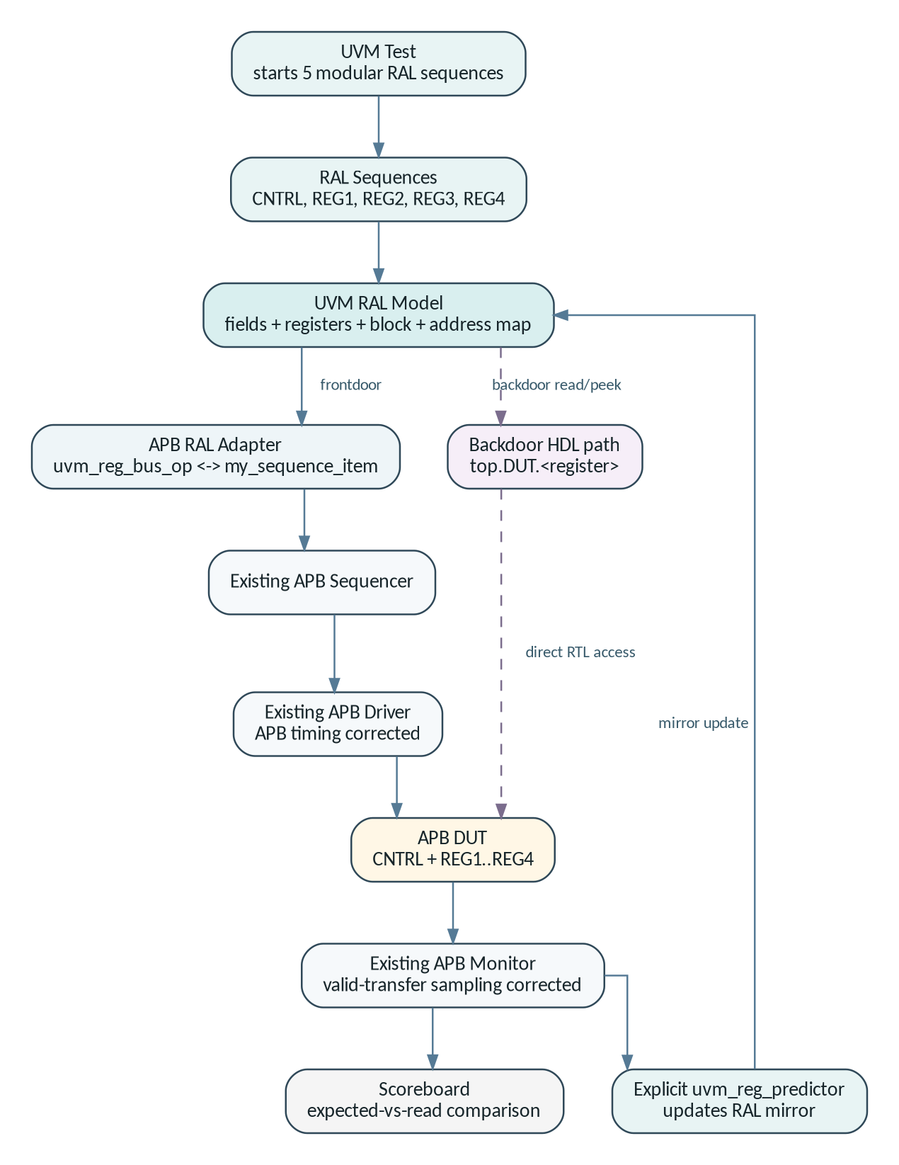
Figure 1 - Final UVM/RAL architecture and data flow.
The frontdoor path translates high-level register operations into normal APB bus traffic. The backdoor path bypasses APB and reads the RTL register directly through an HDL path. Independently, the monitor feeds both the scoreboard and the explicit predictor. This allows the RAL mirror to be synchronized from observed bus traffic rather than assuming the requested operation always succeeded.

Frontdoor path
A call such as model.reg2.write(...) is resolved through the register map, converted by the adapter into my_sequence_item, sent through the existing APB sequencer and driver, and finally executed by the DUT. Frontdoor activity is therefore visible in the APB waveform.

Backdoor path
The model root is set to top.DUT and each register is configured with its RTL variable name. UVM backdoor read/peek APIs can therefore inspect the physical design register without generating APB bus activity. In this project, backdoor access is especially useful to verify the value written by a frontdoor operation.

Explicit prediction
The monitor publishes valid completed APB transactions to uvm_reg_predictor. The predictor uses the same adapter and register map to identify the addressed register and update the RAL mirrored value. Because prediction is explicit, default_map.set_auto_predict(0) is used to avoid double prediction.
Figure 2 - Relationship between Desired, Mirrored and Design values in the RAL flow.
Desired is what the model wants the register to contain; Mirrored is what the model believes the hardware currently contains; Design is the actual RTL value. After set() only the desired value changes. After a successful write/update and observed prediction, the three values should converge for the tested RW register.

5. RAL Model Implementation
Key SystemVerilog snippets from the implemented register model.

5.1 CNTRL fields
CNTRL is modeled as a 32-bit uvm_reg with four one-bit RW control fields and a 28-bit RO reserved field. The field offset and access policy mirror the specification.
Code 1 - CNTRL field configuration in apb_ral_model.sv
CTRL0.configure(this, 1, 0, "RW", 0, 1'h0, 1, 1, 0);
CTRL1.configure(this, 1, 1, "RW", 0, 1'h0, 1, 1, 0);
CTRL2.configure(this, 1, 2, "RW", 0, 1'h0, 1, 1, 0);
CTRL3.configure(this, 1, 3, "RW", 0, 1'h0, 1, 1, 0);
RESERVED.configure(this, 28, 4, "RO", 0, 28'h0, 1, 0, 0);

5.2 Reusable data-register class
REG1 through REG4 have the same 32-bit RW structure, so one data_reg class is instantiated four times. This reduces duplicated code while preserving separate register instances and coverage state.
Code 2 - Shared 32-bit RW register model
class data_reg extends uvm_reg;
rand uvm_reg_field DATA;
virtual function void build();
DATA = uvm_reg_field::type_id::create("DATA");
DATA.configure(this, 32, 0, "RW", 0,
32'h0000_0000, 1, 1, 0);
endfunction
endclass

5.3 Register map
The APB data bus is 32 bits, so the map uses a 4-byte bus width. The register offsets exactly match the DUT address decode.
Code 3 - APB register address map
default_map = create_map("default_map", 32'h0, 4,
UVM_LITTLE_ENDIAN, 1);
default_map.add_reg(cntrl, 32'h00, "RW");
default_map.add_reg(reg1, 32'h04, "RW");
default_map.add_reg(reg2, 32'h08, "RW");
default_map.add_reg(reg3, 32'h0C, "RW");
default_map.add_reg(reg4, 32'h10, "RW");

5.4 Functional coverage
Each register instance owns a small covergroup. CNTRL tracks all 16 possible 4-bit values. Data registers classify sampled values into zero, low, high and all-ones ranges. The current directed sequence demonstrates collection; it is not intended to close every defined bin.
Code 4 - Data-register coverpoint
covergroup reg_cg;
option.per_instance = 1;
cp_data : coverpoint cov_value {
bins zero = {32'h0000_0000};
bins low = {[32'h0000_0001:32'h0000_FFFF]};
bins high = {[32'h0001_0000:32'hFFFF_FFFE]};
bins all_ones = {32'hFFFF_FFFF};
}
endgroup

6. Adapter and Predictor Integration
The bridge between generic UVM register operations and the existing APB transaction layer.

6.1 APB RAL adapter
uvm_reg works with generic uvm_reg_bus_op operations, while the existing driver consumes my_sequence_item. The adapter converts between these two representations. reg2bus() is used for outgoing frontdoor traffic; bus2reg() is used by the predictor to interpret observed APB transfers.
Code 5 - Adapter conversion functions
virtual function uvm_sequence_item reg2bus(const ref uvm_reg_bus_op rw);
my_sequence_item tr = my_sequence_item::type_id::create("tr");
tr.paddr = rw.addr;
tr.pwrite = (rw.kind == UVM_WRITE);
tr.pwdata = rw.data;
return tr;
endfunction
virtual function void bus2reg(uvm_sequence_item bus_item,
ref uvm_reg_bus_op rw);
my_sequence_item tr;
if (!$cast(tr, bus_item))
`uvm_fatal("APB_ADAPTER", "bus_item is not a my_sequence_item")
rw.kind = tr.pwrite ? UVM_WRITE : UVM_READ;
rw.addr = tr.paddr;
rw.data = tr.pwrite ? tr.pwdata : tr.prdata;
rw.status = UVM_IS_OK;
endfunction

6.2 Environment integration
Code 6 - RAL construction, frontdoor binding and explicit prediction
regmodel = apb_reg_block::type_id::create("regmodel");
regmodel.configure(null, "");
regmodel.build();
regmodel.set_hdl_path_root("top.DUT");
regmodel.lock_model();
regmodel.reset();
adapter = apb_reg_adapter::type_id::create("adapter");
predictor = uvm_reg_predictor#(my_sequence_item)::type_id::create(
"predictor", this);
regmodel.default_map.set_sequencer(agent.seqr, adapter);
predictor.map = regmodel.default_map;
predictor.adapter = adapter;
agent.mon.mon_ap.connect(predictor.bus_in);
regmodel.default_map.set_auto_predict(0);

Why explicit prediction?
It updates the RAL mirror from what the monitor actually observed on the APB bus. This is more informative than simply assuming the requested register operation completed exactly as intended.

7. Register Sequences and RAL APIs
Five modular sequences exercise the registers one after another.
Sequence | Register | First value | Second value
ctrl_reg_seq | CNTRL | 0x00000005 | 0x0000000A
reg1_reg_seq | REG1 | 0x11110001 | 0xA5A50001
reg2_reg_seq | REG2 | 0x22220002 | 0x5A5A0002
reg3_reg_seq | REG3 | 0x33330003 | 0xDEADBEEF
reg4_reg_seq | REG4 | 0x44440004 | 0x12345678

Common sequence flow
A shared exercise_reg() task keeps the five sequence classes modular while avoiding duplicated register-access code. Each sequence still has its own class, stimulus values and coverage sampling, as required by the project structure.
Code 7 - Frontdoor/backdoor APIs used by every register sequence
rg.set(first_value); // model only
rg.update(status, UVM_FRONTDOOR, model.default_map, this);
rg.peek(status, bd_value, "", this); // direct HDL check
rg.read(status, fd_value, UVM_FRONTDOOR,
model.default_map, this); // APB read
rg.write(status, second_value, UVM_FRONTDOOR,
model.default_map, this); // APB write
rg.read(status, bd_value, UVM_BACKDOOR, null, this);

DESIRED vs MIRRORED vs DESIGN reporting
The sequence deliberately prints RAL state after important operations. For example, set(5) changes DESIRED to 5 while MIRRORED remains 0. After update() performs a frontdoor write and the predictor observes it, the design value, desired value and mirrored value converge to 5. This makes the abstract RAL state visible and easy to debug.
RAL concept in one sentence
DESIRED = what the model wants; MIRRORED = what the model believes is in hardware; DESIGN = what is physically stored in the RTL register.

8. Debugging and Stabilization
The integration exposed real timing issues at the APB/UVM boundary, which were diagnosed and corrected.

8.1 Missing REG2 address in the sequence item
The original paddr constraint allowed 0x00, 0x04, 0x0C and 0x10 but omitted 0x08. Since REG2 is mapped at 0x08, the constraint was corrected to include all five legal register addresses.
Code 8 - Corrected legal APB register addresses
constraint paddr_c {
paddr inside {'h0, 'h4, 'h8, 'hC, 'h10};
}

8.2 Stale PRDATA race
The DUT updates rdata_tmp using a nonblocking assignment on the APB access edge. In the initial integration, the driver/monitor could sample PRDATA before that NBA update became visible. This produced an intermediate run with five scoreboard mismatches even though the written register values were correct.
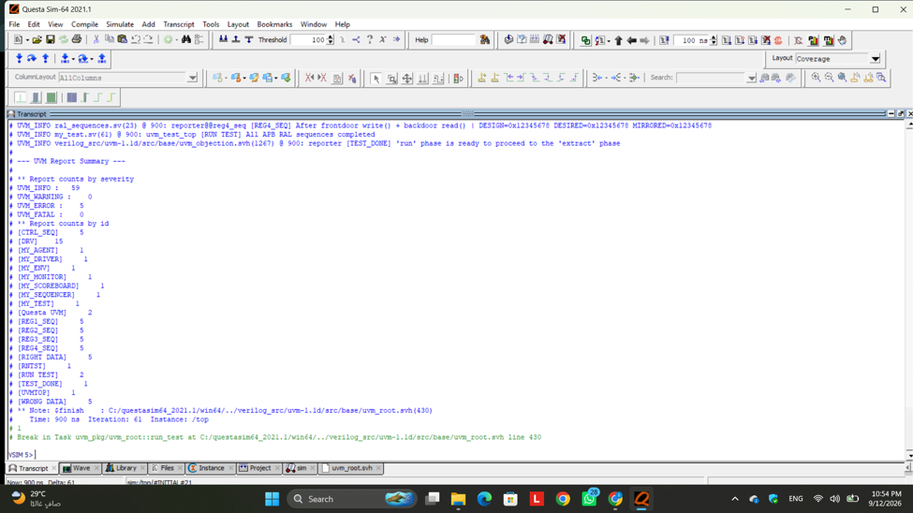
Figure 3 - Intermediate debug run: five UVM errors exposed the stale-read sampling problem.
The fix preserves the transfer-valid decision at the active clock edge and delays only the PRDATA sample by #1. The monitor also publishes a transaction only when PSEL && PENABLE && PRESETN are true. This prevents idle cycles or pre-access cycles from being interpreted as completed register operations.
Code 9 - Correct completed-transfer sampling in the monitor
@(posedge APB_vif.pclk);
if (APB_vif.psel && APB_vif.penable && APB_vif.presetn) begin
seq_item.paddr = APB_vif.paddr;
seq_item.pwrite = APB_vif.pwrite;
seq_item.pwdata = APB_vif.pwdata;
#1; // allow DUT NBA update to settle
seq_item.prdata = APB_vif.prdata;
mon_ap.write(seq_item);
end

8.3 Scoreboard robustness
The scoreboard was changed to use the transaction sampled by the monitor instead of re-reading live interface values later. Reset/default expected values were initialized for all five addresses, CNTRL writes are masked to the implemented low four bits, and mismatches use `uvm_error rather than being printed as informational messages.
Code 10 - CNTRL-aware scoreboard and real UVM error reporting
if (seq_item.pwrite) begin
if (seq_item.paddr == 32'h00)
Assoc_Array[seq_item.paddr] = {28'h0, seq_item.pwdata[3:0]};
else
Assoc_Array[seq_item.paddr] = seq_item.pwdata;
end
else if (seq_item.prdata !== Assoc_Array[seq_item.paddr]) begin
`uvm_error("WRONG DATA", $sformatf(...))
end

9. Simulation Results
Evidence from the final verified Questa run.

9.1 Waveform: all five register addresses and final data values
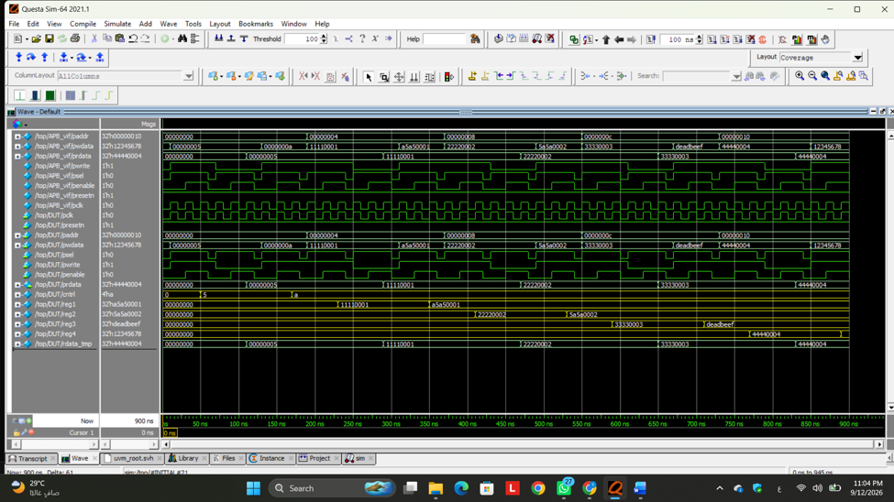
Figure 4 - Final APB waveform. The address sequence 0x00, 0x04, 0x08, 0x0C and 0x10 is visible together with PSEL, PENABLE, PWRITE, PWDATA, PRDATA and the internal DUT registers.
Register | Observed final value | Interpretation
CNTRL | 0x0000000A | Final second pattern; only [3:0] implemented.
REG1 | 0xA5A50001 | Final second pattern from reg1_reg_seq.
REG2 | 0x5A5A0002 | Final second pattern from reg2_reg_seq.
REG3 | 0xDEADBEEF | Final second pattern from reg3_reg_seq.
REG4 | 0x12345678 | Final second pattern from reg4_reg_seq.

9.2 RAL model printout and state reporting
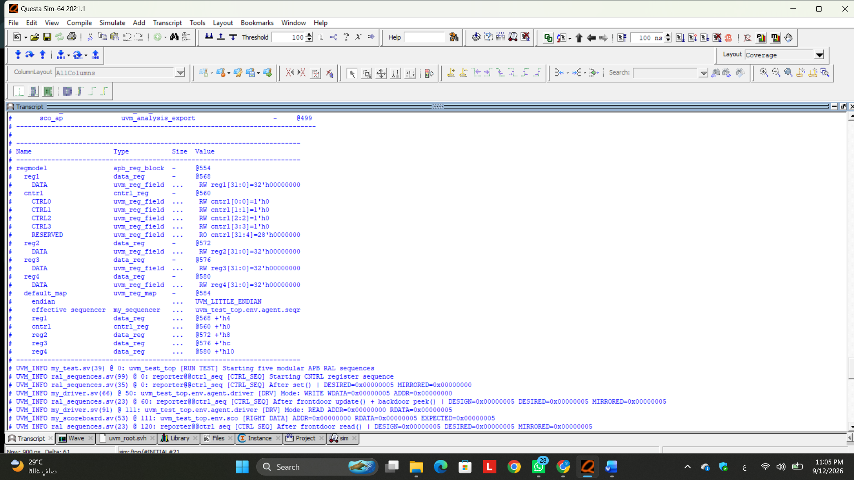
Figure 5 - RAL hierarchy, mapped offsets and sequence reporting. The log shows DESIRED, MIRRORED, DESIGN and RIGHT DATA messages.
The log confirms the model contains CNTRL, REG1, REG2, REG3 and REG4 with offsets 0x00, 0x04, 0x08, 0x0C and 0x10. For CNTRL, the sequence first reports DESIRED=0x00000005 and MIRRORED=0x00000000 after set(), then reports DESIGN=DESIRED=MIRRORED=0x00000005 after the frontdoor update and backdoor check.

9.3 Final UVM report summary
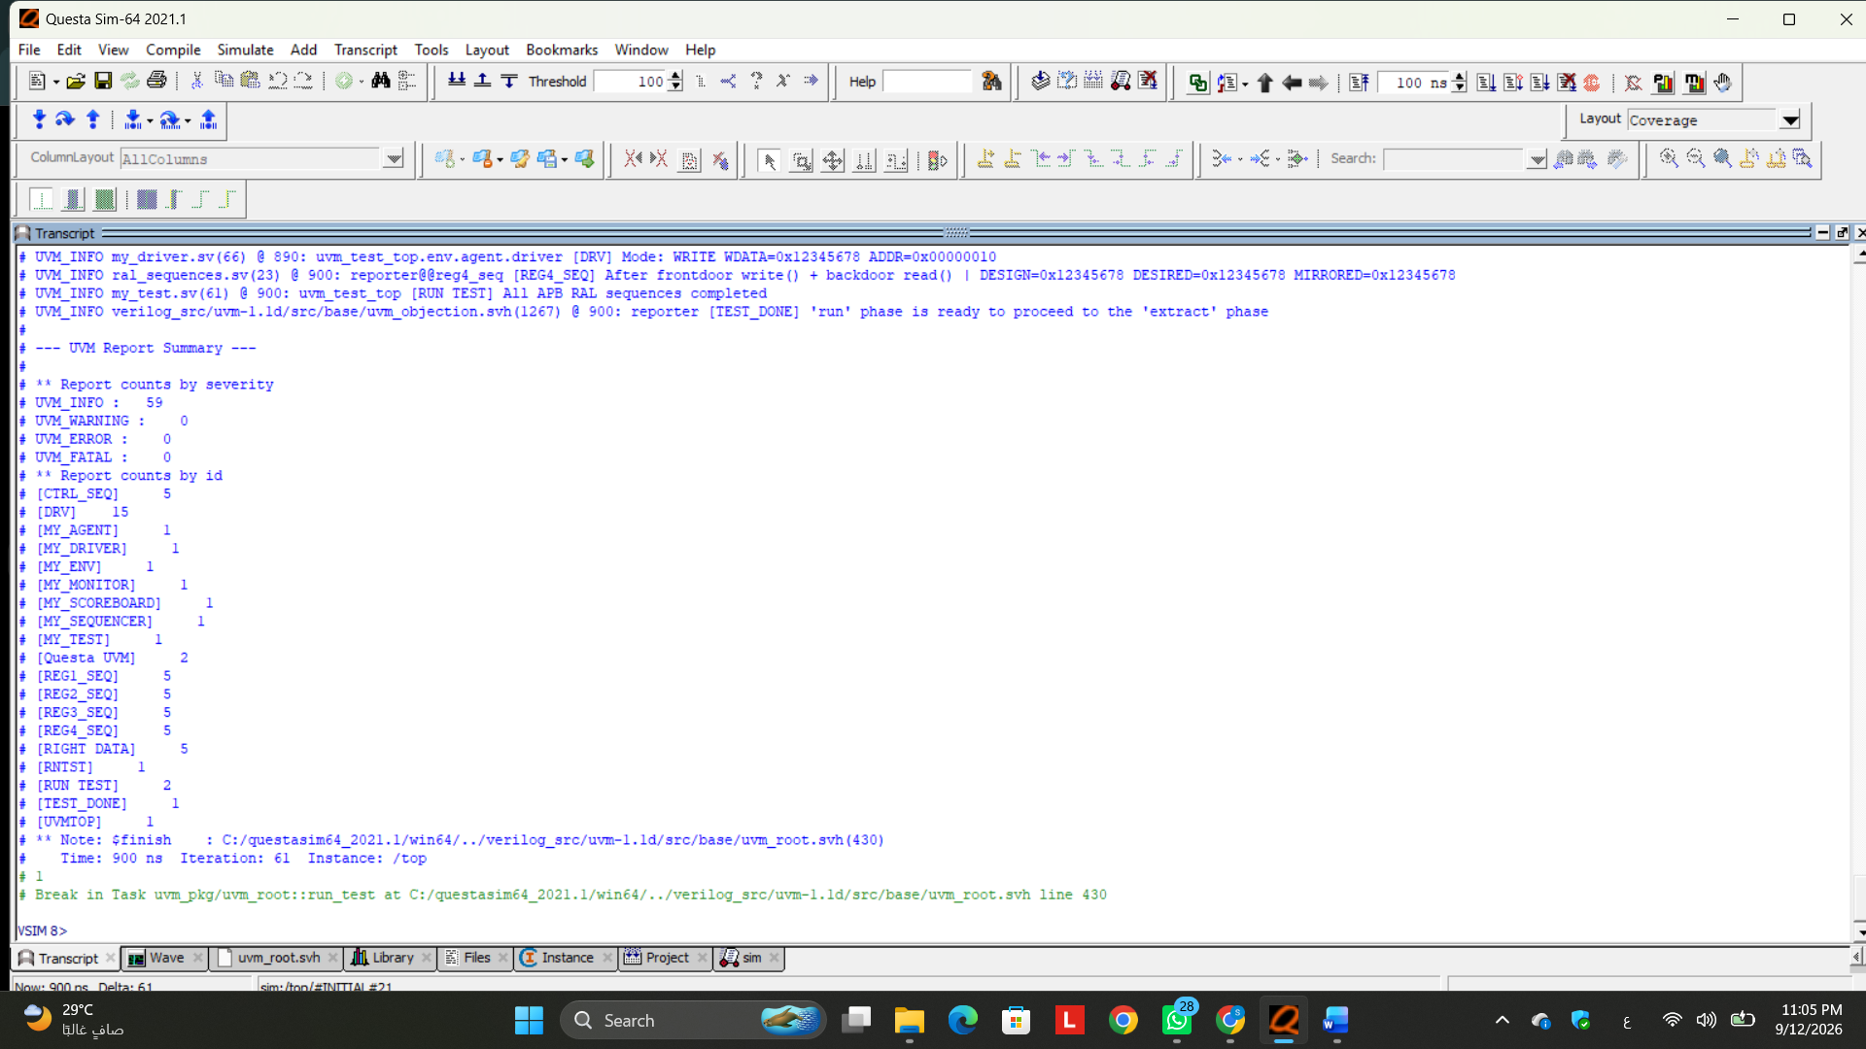
Figure 6 - Final UVM report summary from Questa Sim-64 2021.1.
Metric | Final result
Simulation time | 900 ns
UVM_INFO | 59
UVM_WARNING | 0
UVM_ERROR | 0
UVM_FATAL | 0
Sequence completion | All APB RAL sequences completed

PASS condition
The final test completed without warnings, errors or fatal messages. The earlier five readback errors were eliminated by correcting APB observation timing rather than changing the DUT.

9.4 Coverage evidence
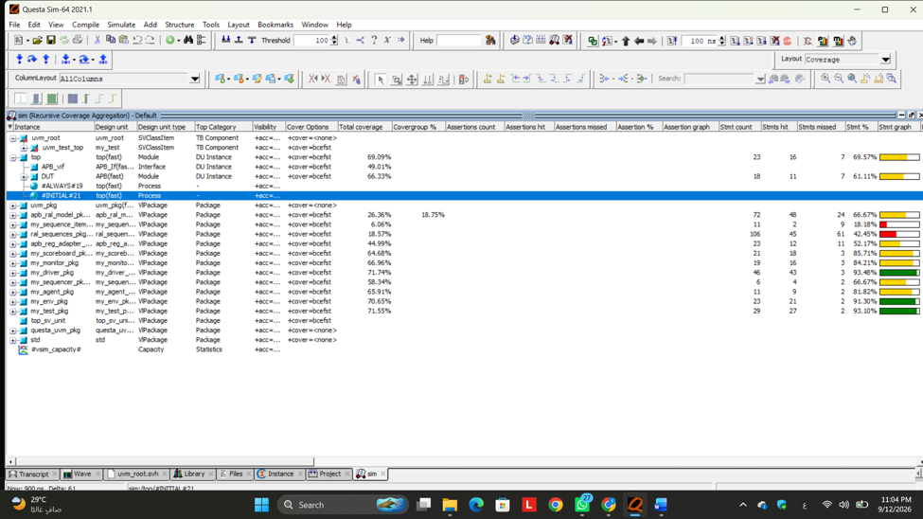
Figure 7 - Questa coverage window after the final run.
Coverage collection is enabled in the compile/simulation flow and the run script saves the database as apb_ral.ucdb. The screenshot above is the simulator coverage view and includes code/statement coverage for multiple design and testbench units in addition to the RAL covergroups. The current directed RAL sequences demonstrate coverage sampling but do not claim complete closure of every functional coverage bin.

10. Reproducing the Run
Minimal steps for a clean GitHub repository and Questa simulation.

Compile and run
Questa Transcript commands
cd <APB_RAL_Project_folder>
do run.do

The provided run.do creates the work library, compiles the ordered source list, starts the top-level simulation with coverage enabled, loads the waveform configuration, runs until completion, writes the transcript log, and saves coverage data.
Code 11 - Final run.do
transcript file ral_simulation.log
vlib work
vlog -f files.txt +cover
vsim -voptargs=+acc work.top -cover
run 0
do wave.do
run -all
coverage save apb_ral.ucdb

Repository structure
Suggested GitHub tree
APB_RAL_Project/
|-- APB.sv
|-- APB_If.sv
|-- my_sequence_item.sv
|-- my_sequencer.sv
|-- my_driver.sv
|-- my_monitor.sv
|-- my_agent.sv
|-- my_scoreboard.sv
|-- apb_ral_model.sv # added RAL model + coverage
|-- apb_reg_adapter.sv # added APB adapter
|-- ral_sequences.sv # added 5 register sequences
|-- my_env.sv # RAL integration + predictor
|-- my_test.sv # starts all sequences
|-- top.sv
|-- files.txt
|-- wave.do
`-- run.do

Generated simulation artifacts
Artifact | Purpose
ral_simulation.log | Complete transcript with RAL reporting and UVM summary.
apb_ral.ucdb | Questa coverage database generated by the run script.
Wave window | APB signals and DUT register values loaded by wave.do.

11. Engineering Takeaways and Next Steps
What this project demonstrates beyond simply making the test pass.

What the project demonstrates
- How a RAL model separates register intent from bus protocol details.
- How the adapter allows reusable register sequences to drive an existing APB agent.
- How an explicit predictor keeps the mirrored value synchronized with observed bus traffic.
- How frontdoor and backdoor accesses complement each other when verifying register behavior.
- Why monitor sampling time matters when the DUT updates read data with nonblocking assignments.
- Why verification checkers should operate on stable sampled transactions instead of live interface values.
- How coverage, reporting, waveforms and a zero-error UVM summary combine into defensible verification evidence.

Potential extensions
- Add a dedicated reset sequence and verify register reset values through both mirror and DUT readback.
- Add negative testing for CNTRL reserved bits by writing upper bits and confirming they always read as zero.
- Drive zero and 0xFFFFFFFF into the data registers to close the currently defined edge-value coverage bins.
- Add constrained-random register sequences and cross coverage between address, operation type and data classes.
- Create a reusable APB RAL base environment that can accept generated register models for larger peripherals.
Key portfolio message
The most important result is not only “0 errors.” The project shows the complete reasoning chain from register specification -> RAL model -> APB translation -> observed bus traffic -> prediction -> scoreboard comparison -> waveform/log evidence.

12. Portfolio Summary
A concise project description suitable for a GitHub README or LinkedIn project post.
Built and integrated a complete UVM Register Abstraction Layer for a five-register APB peripheral using SystemVerilog/UVM. The implementation includes field-level register modeling, a register block and address map, an APB RAL adapter, an explicit predictor, modular frontdoor/backdoor register sequences, RAL state reporting and per-register functional coverage. I also debugged APB read/monitor timing and strengthened the scoreboard, resulting in a clean Questa run with 0 UVM warnings, 0 errors and 0 fatals.

Skills / keywords
SystemVerilog | UVM | UVM RAL | APB | Register Modeling
Frontdoor / Backdoor | Adapter | Predictor | Functional Coverage | Questa

Suggested repository description
GitHub short description
SystemVerilog/UVM project implementing and integrating a UVM RAL model for a five-register APB peripheral, including adapter, explicit predictor, frontdoor/backdoor sequences, functional coverage, scoreboard checks and Questa simulation evidence.

Acknowledgment of starter code
For transparency, the APB DUT and basic UVM environment were supplied as starter files. The main project work documented here is the RAL model and its integration, the five register sequences, coverage/reporting, and the APB/UVM timing fixes required for a stable zero-error verification run.

13. Project References
Source material used to define the required register behavior and project scope.
Reference | Use in this report
Project specification | Advanced Peripheral Bus (APB) - Verification Using UVM RAL. Defines the five-register map, field access, required RAL components, modular sequences, coverage and reporting.
Starter source tree | Provided APB DUT and base UVM environment (driver, monitor, sequencer, agent, scoreboard, environment, test, run.do and wave.do).
Final source tree | Completed v2 project containing apb_ral_model.sv, apb_reg_adapter.sv, ral_sequences.sv and the integration/timing fixes described in this report.
Simulation evidence | Questa Sim-64 2021.1 screenshots captured from the final run and included in this report.

End of report

