AXI4 CLASS-BASED VERIFICATION PROJECT
Final Verification Report
Directed Testing • Constrained-Random Verification • Scoreboarding • Assertions • Functional & Code Coverage
Team Members
Person 1: Sondos Ahmed 480
Person 2: Mai Mokhles 491

AXI4 Memory DUT Verification

1. Introduction
This project verifies an AXI4-based memory design using a class-based SystemVerilog verification environment. The environment was built to generate both deterministic and randomized AXI transactions, drive them to the DUT, observe the actual interface behavior, predict the expected behavior independently, compare actual versus expected results, check protocol properties using assertions, and measure functional and structural coverage.
A major goal of the work was not simply to obtain a high coverage percentage, but to use coverage and self-checking components to identify real design problems. This is important in verification because 100% functional coverage means that the planned scenarios were exercised; it does not automatically mean that the DUT is correct. In our results, the scoreboard still exposed read-data mismatches, which led to identification of defects in the supplied memory RTL.

2. Project Objectives
- Verify basic AXI write and read operations and burst transfers.
- Exercise invalid-address and 4 KB boundary-crossing behavior and check the expected SLVERR response.
- Use directed tests for scenarios that must occur deterministically, then constrained-random tests for broader exploration.
- Build an independent reference model and scoreboard so DUT bugs are reported rather than hidden.
- Use SystemVerilog assertions to check AXI stability and protocol-related behavior.
- Measure functional coverage, code coverage, FSM coverage, toggle coverage, and assertion coverage.
- Analyze every uncovered item and determine whether it is a meaningful verification gap, an unreachable/ignored combination, or a DUT-related limitation.

3. Team Work Division
Role | Member | Main Work
Person 1 | Sondos | Generator/driver side, directed sequences, constrained-random stimulus, targeted coverage-closure stimulus.
Person 2 | Mai | Monitor, reference model, scoreboard, functional coverage collection/checking and result analysis.
The environment was then integrated and debugged together. Both members participated in simulation review, coverage closure, analysis of failing transactions, interpretation of the coverage reports, and final report preparation.

4. Verification Environment and Methodology
The verification flow follows the standard self-checking structure: Generator/Sequences → Driver → DUT → Monitor → Reference Model/Scoreboard, with a parallel coverage collector and assertion module. Mailboxes are used to transfer transaction objects between class-based components, keeping stimulus generation, driving, checking, and coverage responsibilities separated.

4.1 Directed Tests Before Random Testing
Directed testing was deliberately executed before constrained-random traffic. The reason is that critical scenarios such as a known write/read pair, a specific burst, an invalid address, and a 4 KB boundary crossing should not depend on probability. After these guaranteed tests, targeted coverage-closure sequences fill rare bins, and only then are randomized transactions used to broaden the explored input space.
coverage_seq = new(gen2drv);
//======================================================
// Directed Functional Tests
//======================================================
$display("[%0t] AXI_GENERATOR: directed tests started",
$time);
// Basic write followed by read
single_wr.start(
16'h0020,
32'hA5A5_1234
);
single_rd.start(
16'h0020
);
// Four-beat burst write/read
burst_wr.start(
16'h0100,
4
);
burst_rd.start(
16'h0100,
4
);
// Invalid address tests
invalid_seq.start_write();
invalid_seq.start_read();
// 4 KB boundary-crossing tests
boundary_seq.start_write();
boundary_seq.start_read();
//======================================================
// Targeted Coverage Closure
//======================================================
coverage_seq.start();
//======================================================
// Constrained Random Tests
//======================================================
$display(
"[%0t] AXI_GENERATOR: %0d constrained-random transactions started",
$time,
random_transactions
);
repeat (random_transactions)
send_random_transaction();
//======================================================
// End-of-Test Sentinel
//======================================================
This ordering made debugging easier because deterministic failures could be reproduced, while the later random phase still provided variation. It also explains why directed testing was important for coverage closure: randomization can produce many legal transfers without ever generating the exact LEN × SIZE or boundary/response combination needed by a remaining cross bin.

4.2 Targeted Coverage-Closure Sequences
class axi_coverage_closure_sequence extends axi_base_sequence;
function new(mailbox #(axi_transaction) gen2drv);
super.new(gen2drv);
endfunction
// ---------------------------------------------------------
// Half-word transfer WRITE
// Covers SIZE = 1
// ---------------------------------------------------------
task halfword_write();
axi_transaction tr = new();
tr.op = axi_transaction::WRITE;
tr.addr = 16'h0200;
tr.len = 0;
tr.size = 1;
tr.data = new[1];
tr.data[0] = 32'h0000_55AA;
send(tr);
endtask
// ---------------------------------------------------------
// Half-word transfer READ
// Covers SIZE = 1 for READ
// ---------------------------------------------------------
task halfword_read();
axi_transaction tr = new();
tr.op = axi_transaction::READ;
tr.addr = 16'h0200;
tr.len = 0;
tr.size = 1;
tr.data = new[1];
tr.data[0] = '0;
send(tr);
endtask
// ---------------------------------------------------------
// Large burst WRITE
// len = 16 means 17 beats
// Hits burst_large bin [16:255]
// ---------------------------------------------------------
task large_burst_write();
axi_transaction tr = new();
tr.op = axi_transaction::WRITE;
tr.addr = 16'h0400;
tr.len = 16;
tr.size = 2;
tr.data = new[17];
foreach (tr.data[i])
tr.data[i] = 32'hAB00_0000 + i;
send(tr);
endtask
The coverage-closure sequence intentionally creates half-word, byte, mid-length, and large-burst cases. These tests were added because the coverage model divides burst length and transfer size into explicit bins. A random distribution is useful for exploration, but it cannot guarantee that every cross combination will be hit in a limited simulation. Targeted transactions therefore close the remaining measurable functional holes efficiently.

4.3 Self-Checking Scoreboard
ref_model.predict_write(tr, exp_response);
if (tr.response !== exp_response) begin
$error("[SCB][WRITE] addr=%0h BRESP mismatch: expected=%0b got=%0b",
tr.addr, exp_response, tr.response);
ok = 1'b0;
end
end else begin
bit [31:0] exp_rdata[];
bit [1:0] exp_response;
bit [15:0] exp_addrs[];
ref_model.predict_read(tr, exp_rdata, exp_response);
ref_model.expected_addr_sequence(tr, exp_addrs);
if (tr.read_data.size() != tr.len + 1) begin
$error("[SCB][READ] addr=%0h burst length mismatch: got %0d beats, expected %0d",
tr.addr, tr.read_data.size(), tr.len + 1);
ok = 1'b0;
end else begin
if (!tr.saw_last) begin
$error("[SCB][READ] addr=%0h RLAST not asserted on final beat (beat %0d)",
tr.addr, tr.read_data.size() - 1);
ok = 1'b0;
end
for (int i = 0; i < tr.read_data.size(); i++) begin
if (tr.read_data[i] !== exp_rdata[i]) begin
$error("[SCB][READ] addr=%0h(base) beat=%0d expected_addr=%0h DATA mismatch: expected=%0h got=%0h",
tr.addr, i, exp_addrs[i], exp_rdata[i], tr.read_data[i]);
ok = 1'b0;
end
end
end
if (tr.response !== exp_response) begin
$error("[SCB][READ] addr=%0h RRESP mismatch: expected=%0b got=%0b",
tr.addr, exp_response, tr.response);
ok = 1'b0;
end
end
if (ok) pass_count++;
else fail_count++;
The scoreboard compares the monitored DUT response against an independent reference model. For reads, every returned beat is checked against the expected data and expected address sequence; response codes and LAST behavior are also checked. Therefore, a scoreboard FAIL is meaningful: it indicates a difference between specified/expected behavior and actual DUT behavior, not merely that a transaction was generated.

4.4 Functional Coverage Model
covergroup cg;
option.per_instance = 1;
cp_op: coverpoint is_write_flag {
bins wr = {1};
bins rd = {0};
}
cp_addr_valid: coverpoint addr_valid_flag {
bins valid = {1};
bins invalid = {0};
}
cp_boundary: coverpoint boundary_cross_flag {
bins no_cross = {0};
bins crossed = {1};
}
cp_len: coverpoint len_flag {
bins single = {0};
bins burst_small = {[1:3]};
bins burst_mid = {[4:15]};
bins burst_large = {[16:255]};
}
cp_size: coverpoint size_flag {
bins byte_xfer = {0};
bins half_xfer = {1};
bins word_xfer = {2};
// Unsupported transfer sizes for this 32-bit datapath
illegal_bins unsupported_size = {[3:7]};
}
cp_resp: coverpoint resp_flag {
bins okay = {2'b00};
bins slverr = {2'b10};
}
cx_op_resp: cross cp_op, cp_resp;
cx_op_len: cross cp_op, cp_len;
cx_len_size: cross cp_len, cp_size;
// The reference model makes valid/invalid <-> OKAY/SLVERR a strict
// 1:1 mapping (see axi_reference_model::is_valid()/predict_write()/
// predict_read()), so valid+SLVERR and invalid+OKAY can never occur.
// These are excluded as unreachable, not hidden by lowering the goal.
cx_valid_resp: cross cp_addr_valid, cp_resp {
ignore_bins valid_slverr =
binsof(cp_addr_valid.valid) && binsof(cp_resp.slverr);
ignore_bins invalid_okay =
binsof(cp_addr_valid.invalid) && binsof(cp_resp.okay);
}
// A boundary-crossing transaction is always flagged invalid by
// is_valid_addr(), so "crossed" can only ever pair with SLVERR.
// crossed+OKAY is unreachable and is excluded.
cx_boundary_resp: cross cp_boundary, cp_resp {
ignore_bins crossed_okay =
binsof(cp_boundary.crossed) && binsof(cp_resp.okay);
}
endgroup
The functional model covers operation type, address validity, boundary crossing, burst length, transfer size, and response, then crosses the important dimensions. Unsupported transfer sizes are declared illegal, while combinations that contradict the intended response model (for example valid+SLVERR or crossed-boundary+OKAY) are ignored. This is important because coverage should measure meaningful, reachable verification intent rather than reward impossible combinations.

4.5 Assertions
@(posedge ACLK) disable iff (!ARESETn)
(valid && !ready) |=> valid;
endproperty
assert_awvalid_stable: assert property (p_valid_stable(AWVALID, AWREADY))
else $error("[ASSERT] AWVALID deasserted before AWREADY");
assert_wvalid_stable: assert property (p_valid_stable(WVALID, WREADY))
else $error("[ASSERT] WVALID deasserted before WREADY");
assert_arvalid_stable: assert property (p_valid_stable(ARVALID, ARREADY))
else $error("[ASSERT] ARVALID deasserted before ARREADY");
assert_bvalid_stable: assert property (p_valid_stable(BVALID, BREADY))
else $error("[ASSERT] BVALID deasserted before BREADY");
assert_rvalid_stable: assert property (p_valid_stable(RVALID, RREADY))
The assertions check VALID stability and related channel behavior. Stability properties become non-vacuous mainly when VALID remains asserted while READY is low. Consequently, assertion coverage depends strongly on whether the stimulus creates back-pressure/stall situations.

5. Simulation Evidence and Screenshot Analysis
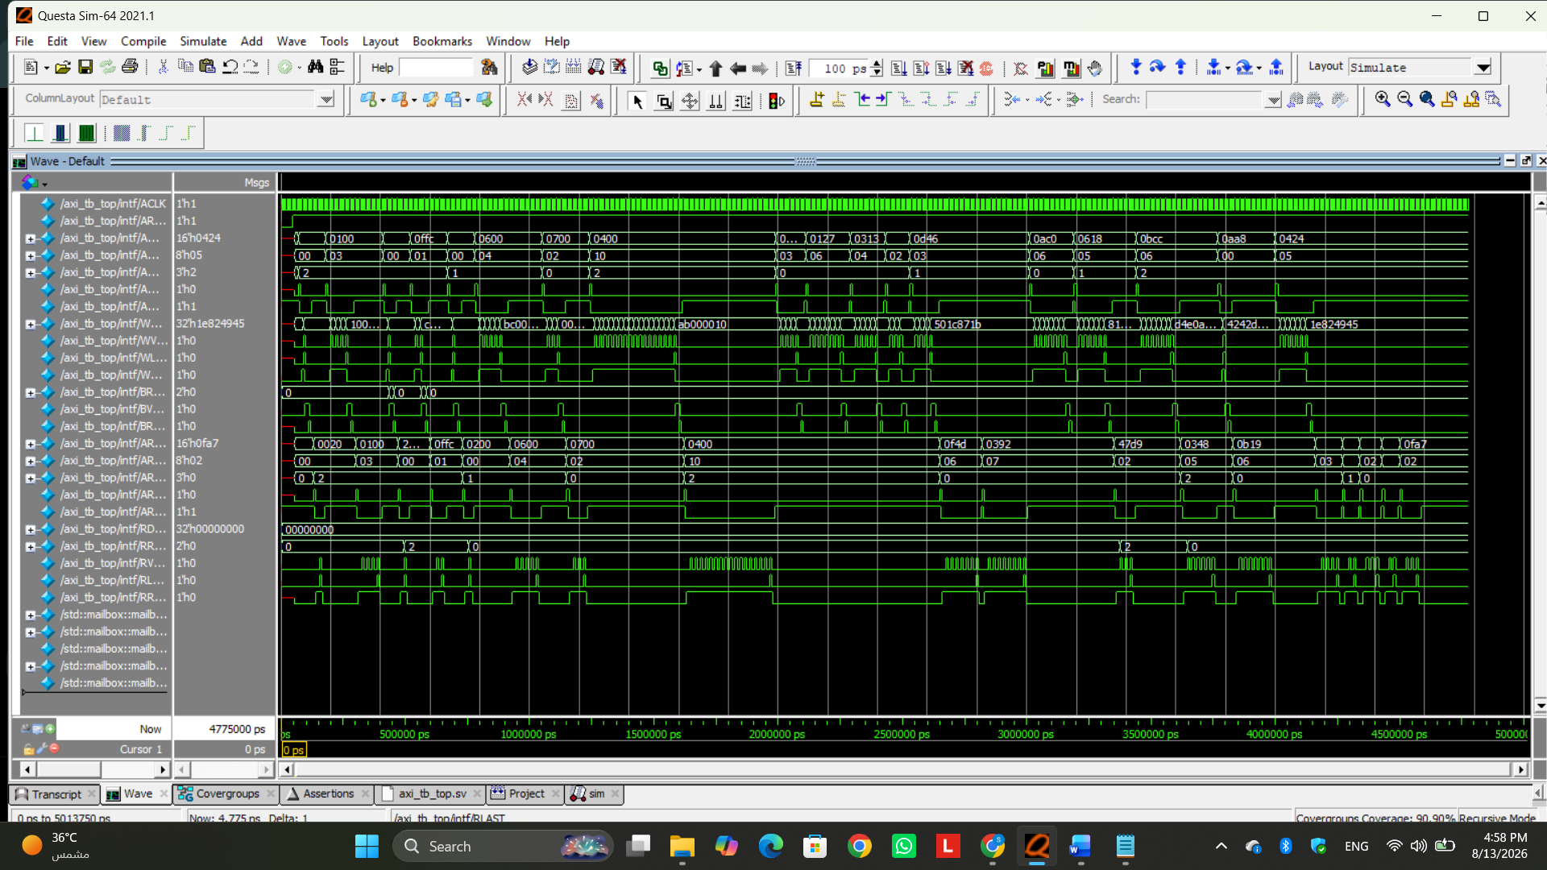
Figure 1.
The waveform provides cycle-level evidence that write and read channels are active across the simulation. Address, data, VALID/READY, response, and LAST activity can be inspected together. This is useful for correlating transaction-level scoreboard messages with the actual AXI handshakes and confirming that the testbench is driving real protocol traffic rather than only manipulating transaction objects.
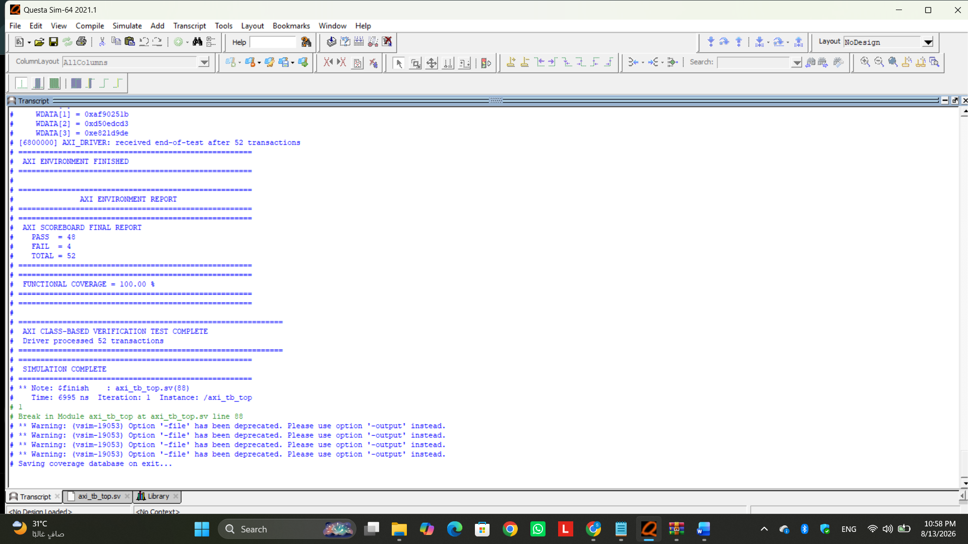
Figure 2.

The transcript demonstrates that the environment is self-reporting each transaction and its checking result. PASS messages confirm cases where DUT behavior matches the reference model; error messages identify mismatches. The transcript is therefore evidence that the environment is active, self-checking, and able to expose incorrect behavior.
This view provides more detail around the failing read behavior. The important point is that the failures are data-comparison failures rather than generator failures. The testbench intentionally keeps the expected model independent from the DUT, so incorrect RTL behavior appears as a mismatch instead of being silently accepted.
The scoreboard summary is used as a correctness metric alongside coverage. Coverage answers 'did we exercise the planned scenarios?', while the scoreboard answers 'did the DUT produce the expected result?'. This distinction is why high coverage and some failing transactions can legitimately coexist.

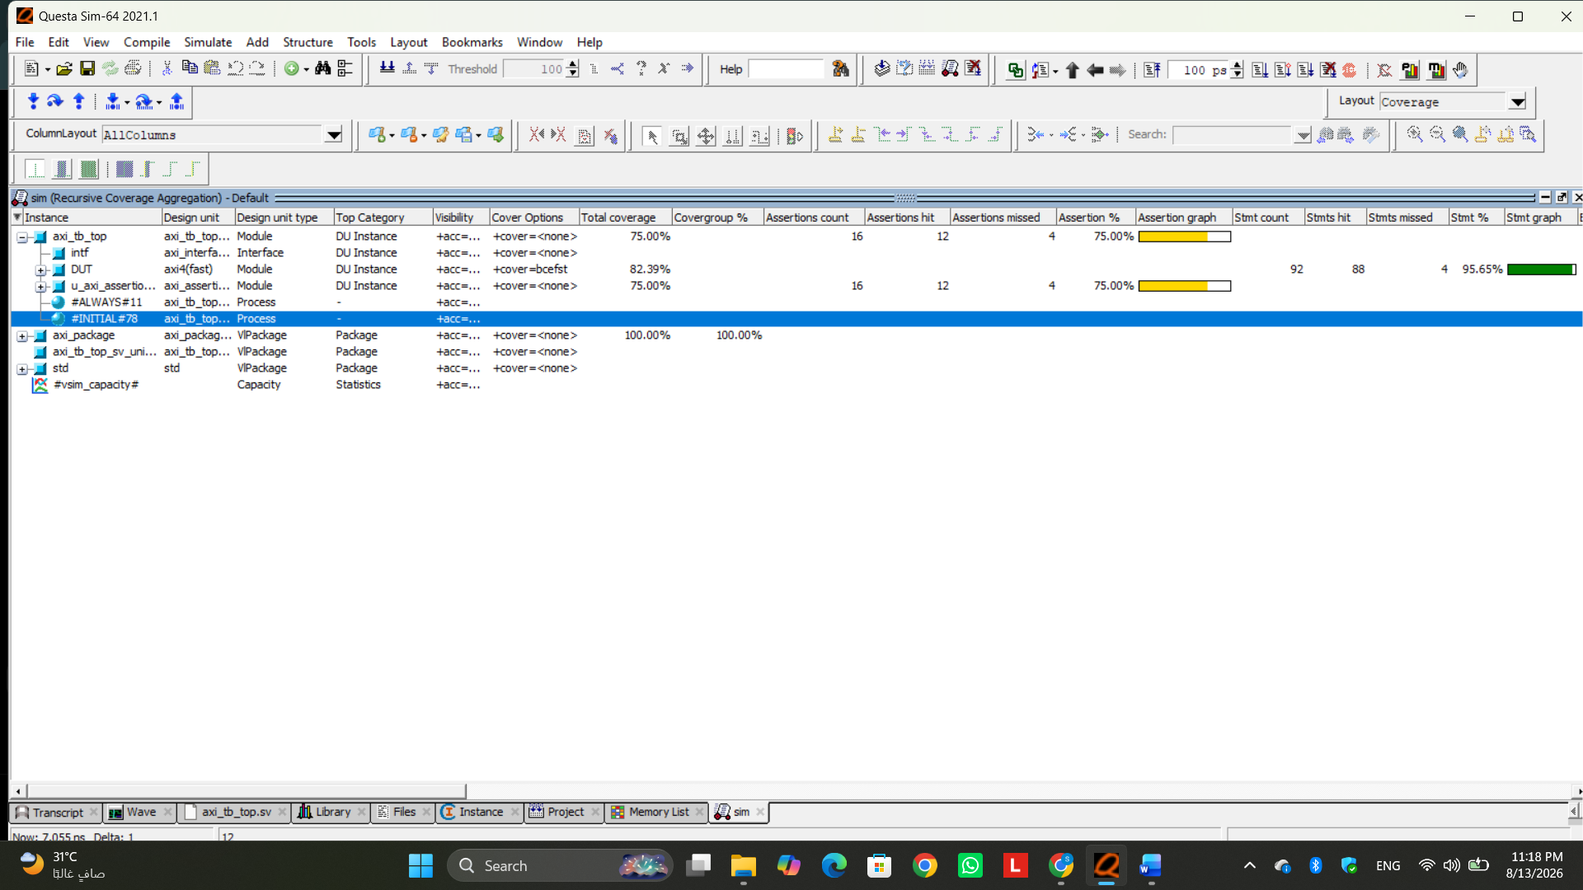
Figure 3
The assertion window shows which protocol properties were exercised and whether they passed, failed, or remained vacuous. The final assertion report records 16 assertions, 12 covered and 4 not covered (75% assertion coverage), with four stability properties recording one failure each in the final run.

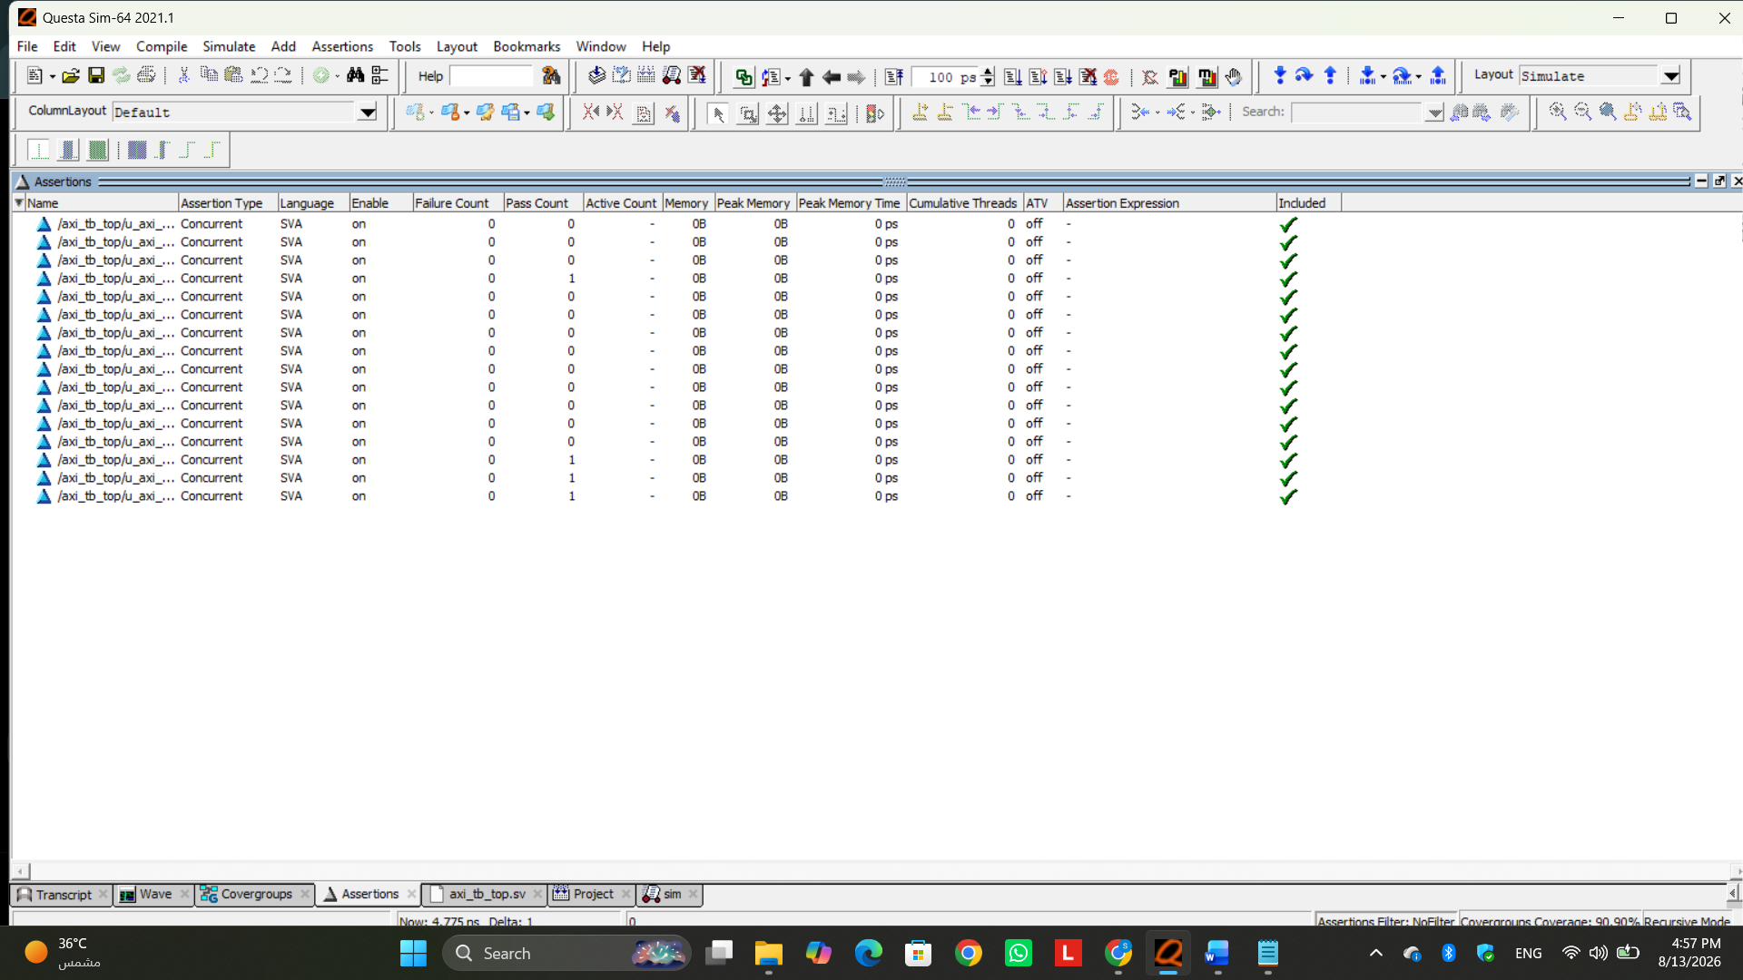
Figure 4
This screenshot is useful for distinguishing a real assertion failure from a vacuous evaluation. A vacuous result means the antecedent condition was not activated; it is not the same as a property violation. More READY/VALID back-pressure testing would increase activation of the stability assertions.
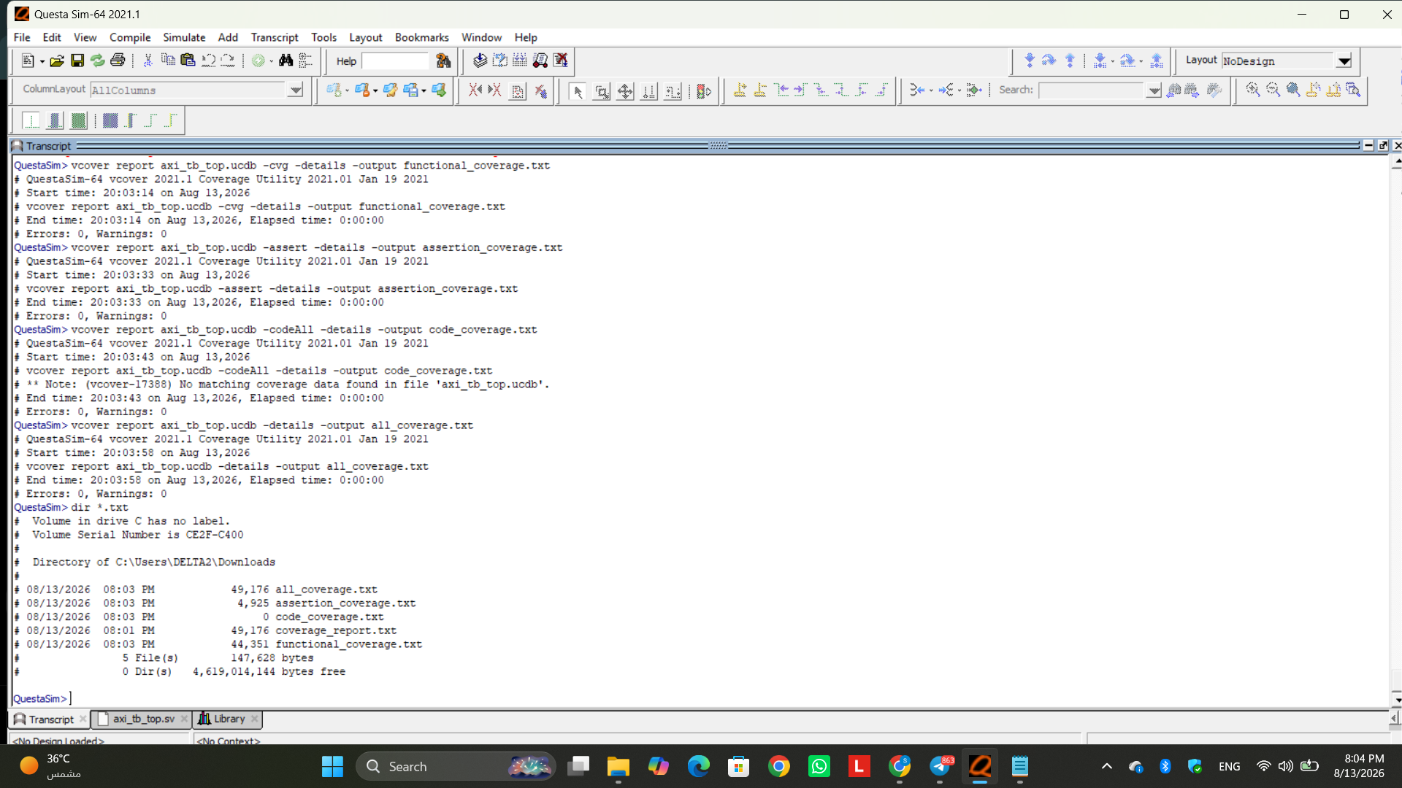
Figure 5
The final text reports provide the authoritative numeric coverage evidence. Functional coverage is 100% with 44/44 covergroup bins hit. Code and assertion coverage remain below 100% for specific, explainable reasons discussed in the next sections.

6. Functional Coverage Analysis
The final functional coverage report reaches 100.00%: all 44 defined covergroup bins are covered. Operation coverage includes both writes and reads; valid and invalid addresses are hit; both crossed and non-crossed 4 KB boundary cases are hit; all four length classes are hit; byte, half-word, and word transfers are hit; and both OKAY and SLVERR responses are observed. The operation/response, operation/length, length/size, valid/response, and boundary/response crosses are also fully covered.
Covergroup Bins: 44 total, 44 covered, 0 missing = 100.00%
cp_op = 100% | cp_addr_valid = 100% | cp_boundary = 100%
cp_len = 100% | cp_size = 100% | cp_resp = 100%
cx_op_resp = 100% | cx_op_len = 100% | cx_len_size = 100%
cx_valid_resp = 100% | cx_boundary_resp = 100%
Why were some bins shown as ZERO? The report contains illegal/ignore bins such as unsupported_size, invalid_okay, valid_slverr, and crossed_okay. ZERO here is expected and correct: these bins are excluded because they represent unsupported or specification-inconsistent combinations. They should not be forced just to increase coverage. The meaningful reachable bins are all covered.

7. Code Coverage Analysis
Metric (AXI4 DUT) | Final Result | Why Not 100%? | Assessment
Statement | 97.64% (83/85) | Two statements in exceptional/default paths were not executed. | Excellent
Branch | 94.28% (33/35) | Two branches, mainly exceptional/default FSM paths, were not taken. | Excellent
Condition | 73.91% (17/23) | Some non-masking READY/VALID Boolean combinations were not created because the driver usually completes handshakes quickly. | Acceptable with rationale
Expression | 100.00% (5/5) | All monitored expressions were exercised. | Complete
FSM States | 100.00% (7/7) | Every read/write state was reached. | Complete
FSM Transitions | 70.00% (7/10) | W_ADDR→W_IDLE, W_DATA→W_IDLE, and R_ADDR→R_IDLE recovery transitions were not activated. | Acceptable for current scope
Toggle | 55.75% (397/712) | High address/length bits, unsupported size bits, constant response/data paths, and bug-affected read signals do not toggle in normal meaningful tests. | Expected / analyzed
The lower condition coverage is mainly caused by handshake terms such as AWVALID&&AWREADY, WVALID&&WREADY, BREADY&&BVALID, and ARVALID&&ARREADY not being independently exercised in all non-masking combinations. To raise this metric, the driver would need deliberate back-pressure and prolonged READY/VALID deassertion. That is a useful future enhancement, but the current result is acceptable because the normal functional paths, error responses, expressions, and all FSM states were exercised.
The 70% FSM transition coverage is also explainable. The uncovered transitions are recovery/abort-style paths back to IDLE, not the normal write/read transfer sequence. Reaching them would require reset-during-transaction or specifically forced abnormal control scenarios.
Toggle coverage is intentionally not treated as the sole completion criterion. Forcing every high-order address bit, every unsupported size encoding, or every unused internal bit to toggle could increase the number without adding meaningful verification value. Functional coverage and correctness checks therefore provide the primary interpretation.

7.1 Memory Submodule Coverage
The memory submodule is significantly lower: 40.00% branch coverage, 71.42% statement coverage, and 41.36% toggle coverage. This is consistent with the observed memory defects. In particular, mem_rdata remains inactive in many cycles and the faulty reset/read behavior prevents the submodule from exercising the intended read path normally. The low memory coverage is therefore documented as a DUT-related observation rather than hidden by modifying the reference model.
Memory instance:
Branches = 40.00%
Statements = 71.42%
Toggles = 41.36%
mem_rdata[31:0] toggle = 0.00% in the reported run

8. Assertion Coverage Analysis
The final combined coverage report records 16 assertions, with 12 covered and 4 not covered, giving 75.00% assertion coverage. Four stability assertions — AWVALID, WVALID, ARVALID, and WLAST stability — each record one failure in the final run. The other assertions include successful checks for BVALID/RVALID behavior, address/length/size/data stability, LAST validity relationships, and reset clearing of valid outputs.
Assertions: 16 total | 12 covered | 4 not covered | 75.00%
assert_awvalid_stable : Failure Count = 1
assert_wvalid_stable : Failure Count = 1
assert_arvalid_stable : Failure Count = 1
assert_wlast_stable : Failure Count = 1
The large number of vacuous evaluations in stability properties is expected because the antecedent typically requires VALID to remain high while READY is low. The current driver normally performs handshakes promptly, so many cycles do not activate those antecedents. Additional back-pressure tests would improve assertion activation. The four recorded failures should be kept in the report because assertions are intended to expose protocol issues; deleting or weakening them merely to obtain 100% would reduce verification quality.

9. DUT Bug Investigation
The scoreboard read-data mismatches led directly to inspection of the supplied memory RTL. Two root causes were identified. These are DUT defects, not scoreboard defects, because the scoreboard/reference model implement the expected memory behavior independently.
// Memory write
always @(posedge clk) begin
if (rst_n)
mem_rdata <= 0;
else if (mem_en) begin
if (mem_we)
memory[mem_addr] <= mem_wdata;
else
mem_rdata <= memory[mem_addr+1] ;
end
end

9.1 Bug 1 — Active-Low Reset Polarity
The signal is named rst_n, so reset is active when rst_n = 0. However, the memory code clears mem_rdata when rst_n = 1. This means the read-data register is continuously cleared during normal operation instead of during reset. The intended form would use if (!rst_n). This explains why a previously written value can later be read back as zero.

9.2 Bug 2 — Off-by-One Memory Read Address
The memory read uses memory[mem_addr+1] instead of memory[mem_addr]. This shifts every read to the next memory location and causes a mismatch with the expected address sequence. The correct read for the intended memory model is mem_rdata <= memory[mem_addr].
These bugs are intentionally documented rather than compensated for in the verification environment. A verification testbench should expose incorrect RTL behavior; changing the reference model to imitate the bug would make failing DUT behavior appear correct.

10. Final Results Summary
Result | Final Value | Interpretation
Functional coverage | 100.00% (44/44 bins) | All meaningful planned functional bins/crosses covered.
Statement coverage | 97.64% | Very high; only two exceptional/default statements unexecuted.
Branch coverage | 94.28% | Very high; two branches not taken.
Condition coverage | 73.91% | Missing some handshake stall/non-masking combinations.
Expression coverage | 100.00% | Complete.
FSM state / transition | 100.00% / 70.00% | All states reached; three recovery transitions not exercised.
Toggle coverage | 55.75% | Expected lower due constrained/constant/unused/bug-affected bits.
Assertion coverage | 75.00% (12/16) | Four stability properties not covered; four stability failures recorded.
DUT bug status | 2 root causes identified | Wrong active-low reset handling and off-by-one read address.
 |  | The scoreboard processed 52 transactions in the final run. 48 transactions matched the independent reference model, while 4 read transactions failed due to the identified DUT memory defects. These failures are valid verification findings rather than testbench failures, demonstrating that the self-checking environment successfully detected incorrect DUT behavior.
  Scoreboard Results
  48 PASS / 4 FAIL / 52 TOTAL

11. Conclusion
The AXI4 verification environment achieved the project objectives by combining directed tests, targeted coverage-closure tests, constrained-random stimulus, transaction monitoring, an independent reference model, a self-checking scoreboard, assertions, and multiple coverage metrics. Directed testing was particularly important because it guaranteed critical error and boundary scenarios and closed rare cross bins that random traffic alone did not reliably hit.
The final scoreboard processed 52 transactions, of which 48 passed and 4 failed. The four failing transactions were read-data mismatches traced to the identified defects in the supplied memory RTL, specifically the incorrect active-low reset handling and the off-by-one memory read address. Therefore, these failures do not indicate a failure of the verification environment; instead, they demonstrate that the independent reference model and scoreboard successfully detected real DUT defects.
Final functional coverage reached 100% with all 44 meaningful bins covered. Code coverage was strong for the main DUT (97.64% statements and 94.28% branches), while the lower condition, transition, and toggle percentages were traced to specific handshake-stall, recovery, constant-bit, unsupported, or bug-affected cases. Assertion coverage reached 75%, and the remaining activation/failure behavior was explicitly analyzed rather than hidden.
Most importantly, the project found real DUT defects. The memory RTL incorrectly treats active-low rst_n as active-high when clearing mem_rdata and reads from memory[mem_addr+1] instead of memory[mem_addr]. These defects explain the read-data mismatches observed by the scoreboard. Therefore, the verification environment did what a good verification environment should do: it exercised the design broadly, measured what was and was not tested, and exposed incorrect DUT behavior instead of modifying the expected model to make the design pass.
Transfer-Size Testing:
The implemented memory is a 32-bit word-addressable memory, therefore word-sized transfers (AWSIZE/ARSIZE = 2) represent the normal supported operating case. Byte and half-word transfer sizes were also generated intentionally as corner/negative verification scenarios to exercise the DUT response and improve functional coverage. These cases were included to verify behavior outside the primary word-transfer use case, not to redefine the intended memory interface

KB Boundary Verification Concern:
During verification, a potential off-by-one issue was identified in the DUT's 4-KB boundary-check calculation. According to the AXI4 protocol, AWLEN/ARLEN represents the number of transfers minus one; therefore, the total transfer size should be calculated as:
(LEN + 1) × (1 << SIZE)
The verification environment uses this interpretation in the reference model and includes dedicated boundary-crossing test cases to validate the DUT behavior. A burst that crosses a 4-KB boundary is considered invalid as a whole transaction. The expected behavior is for the DUT to reject the complete burst and return SLVERR, rather than executing the portion that remains within the boundary and then stopping. If a valid portion of the transfer is required, the master must split the operation into separate bursts. This case is therefore treated as an RTL correctness check, with the verification environment responsible for detecting and reporting any discrepancy between the DUT and the AXI-compliant reference behavior.
Then some edits have been done:
axi_interface.sv
Interface and Modport Enhancement:
The AXI interface was updated by adding MASTER, SLAVE, and MONITOR modports. The MASTER modport defines the signals driven and observed by the verification driver, while the SLAVE modport represents the DUT-side signal directions. The MONITOR modport provides read-only access to all AXI signals. This improves signal-direction control, prevents unintended driving by passive components, and satisfies the project requirement for interface-based connectivity using modports.

axi_driver.sv
Driver Protocol Correction and Legal Backpressure:
The driver was updated to use the MASTER modport of the AXI interface. Artificial AW/W/AR stalls that were previously inserted after completed handshakes were removed because they could create protocol-invalid behavior and cause unnecessary assertion failures. The driver now keeps AWVALID, WVALID, and ARVALID asserted only until the corresponding READY handshake occurs. Legal backpressure is generated using BREADY and RREADY, which are master-controlled signals. This allows response-channel stability to be tested without violating AXI protocol behavior. The driver continues to obtain transactions from the generator through the gen2drv mailbox and reports the number of successfully processed transactions. An end-of-test event is generated after the sentinel transaction is received.

axi_monitor.sv
Monitor Robustness Improvement:
The monitor was updated to use the read-only MONITOR modport. Transactions are reconstructed only from successful AXI handshakes (VALID && READY). Instead of waiting indefinitely for WLAST or RLAST, the monitor now calculates the expected number of beats using LEN + 1 and captures exactly that number of handshakes. It also checks whether WLAST/RLAST occurs on the correct final beat and reports early or missing LAST conditions. This prevents simulation hangs and allows malformed bursts to reach the scoreboard for proper error reporting.

Environment Integration and End-of-Test Synchronization:
The environment was updated to create separate MASTER and MONITOR virtual-interface views from the same AXI interface instance. The driver receives the master view while the monitor receives the read-only monitor view. Generator, driver, monitor, scoreboard, and coverage components continue to execute concurrently.
axi_test.sv
Test-Level Integration:
The test class retains the existing architecture and creates the verification environment using the AXI virtual interface. It configures the constrained-random transaction count, runs the complete environment, and then prints the final scoreboard and functional coverage reports. No redesign of the test architecture was required.
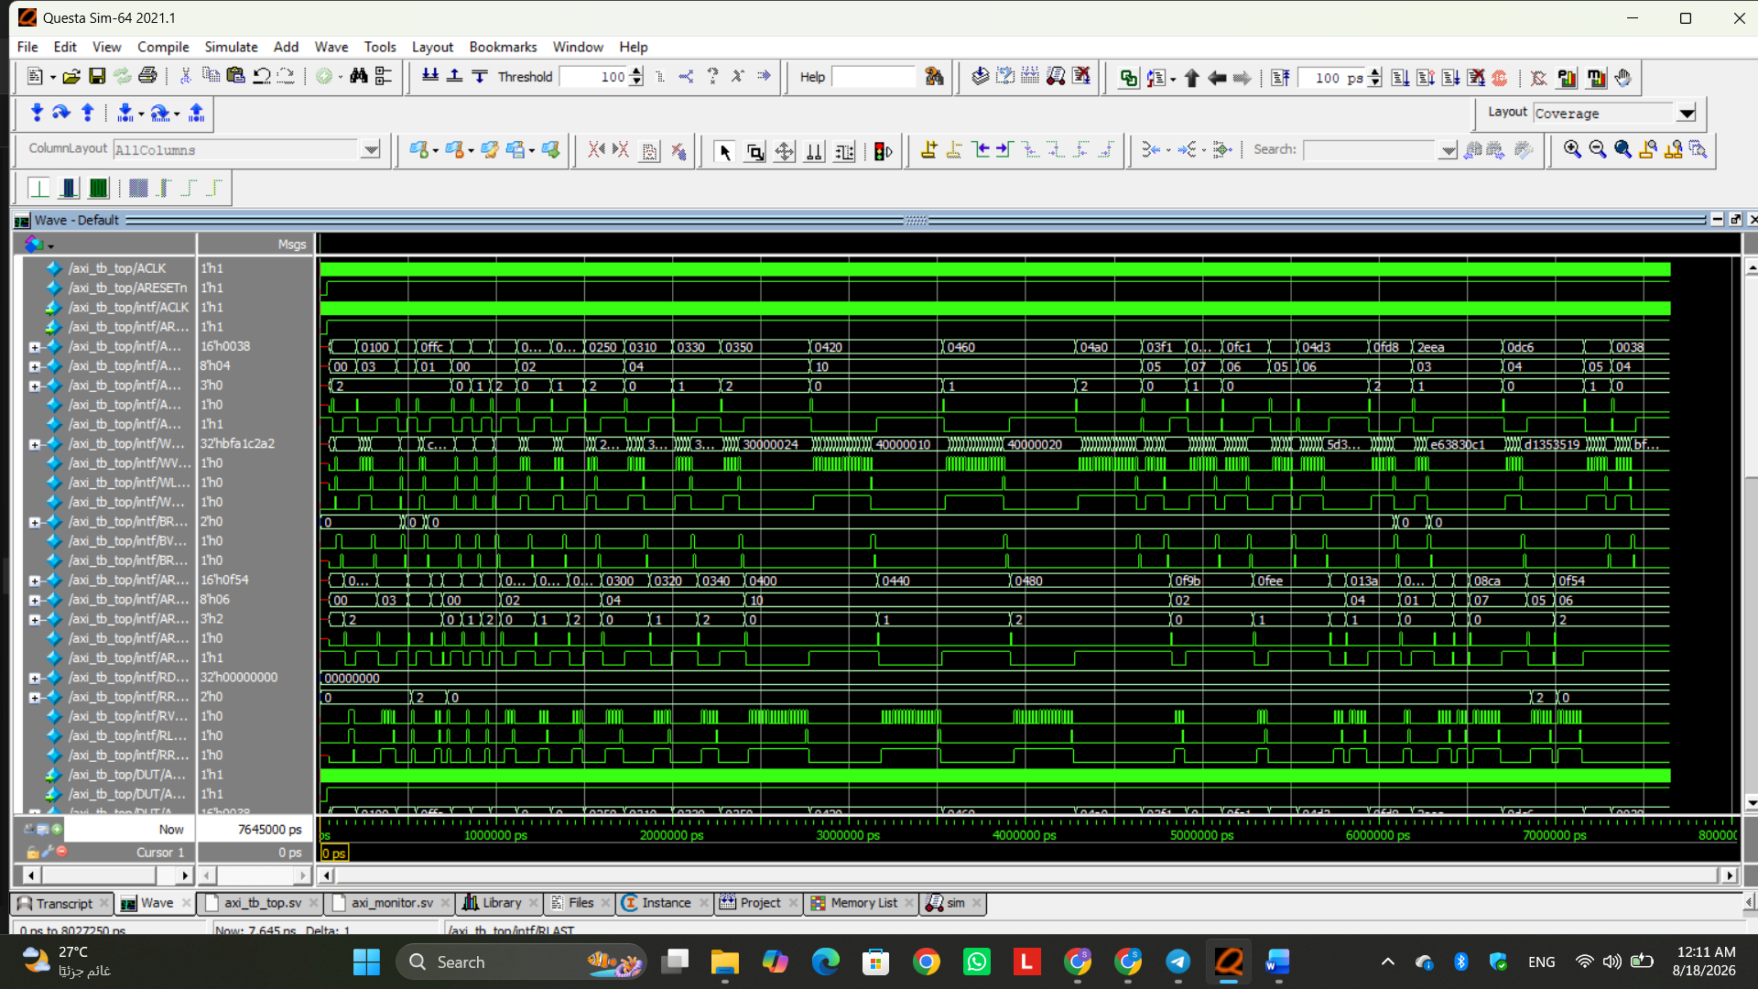
Figure 6

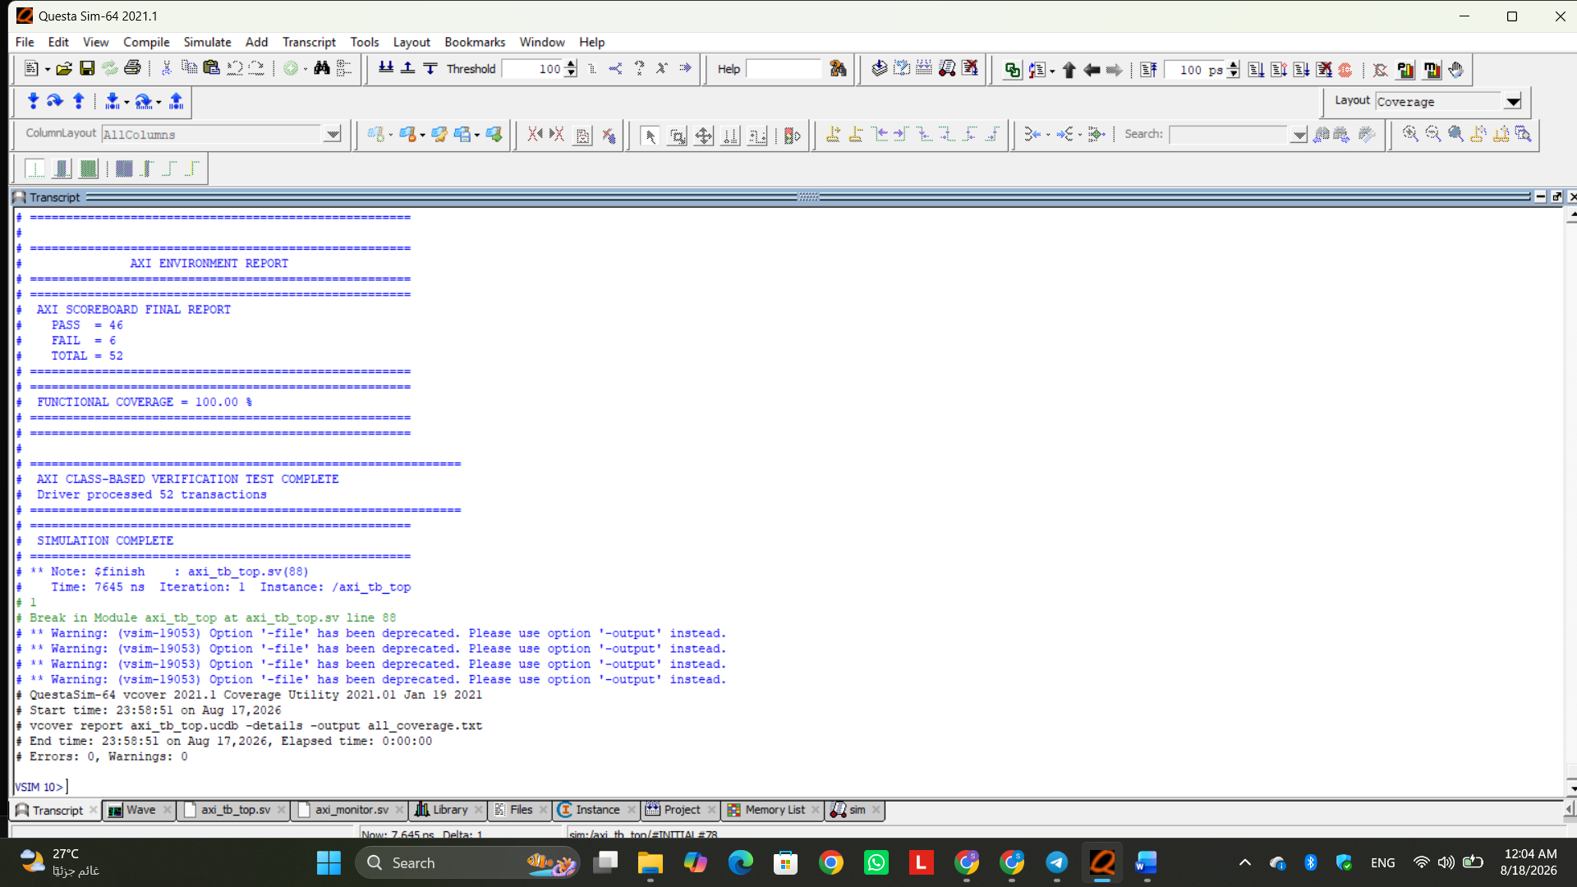
Figure 7

Final Regression Result:
The final integrated verification environment completed successfully without compilation errors or end-of-test synchronization hangs. A total of 52 transactions were processed. The scoreboard reported 46 PASS and 6 FAIL, while the functional coverage reached 100.00%. The remaining failures are preserved as verification findings because the scoreboard and reference model are intentionally independent from known DUT behavior. Therefore, the verification environment successfully completed its stimulus, checking, monitoring, and functional coverage objectives while continuing to expose DUT discrepancies.

1. Functional Coverage Analysis — 100%
Functional Coverage Analysis:
The verification environment achieved 100% functional coverage, with all 44 defined functional coverage bins successfully exercised. This result is considered excellent and fully acceptable, since all functional scenarios represented in the coverage model were reached during simulation.
The achieved coverage includes both READ and WRITE operations, valid and invalid address scenarios, bursts that remain within the 4-KB boundary and bursts that cross it, different burst-length categories, all supported transfer sizes, and the expected AXI response types. The defined cross-coverage combinations were also exercised, demonstrating that these features were not tested only individually but also in meaningful combinations.
The unsupported size illegal bin was not hit. This is the expected and desirable result, because the generator is constrained to generate only the transfer sizes supported by the project. An illegal bin represents behavior that should not occur during legal stimulus; therefore, zero hits on this bin should not be interpreted as missing functional coverage.
The coverage report also indicates an occurrence of the ignored valid_slverr combination. Since this bin represents a valid-address transaction receiving a SLVERR response, its occurrence is important even though it is excluded from the functional coverage percentage. This observation is consistent with the DUT discrepancies detected independently by the scoreboard and should therefore be documented as DUT behavior rather than hidden by the coverage model.
Conclusion: Functional coverage is fully acceptable. The 100% result demonstrates complete closure of the functional coverage model defined for the verification environment.

2.Main DUT Statement Coverage — 97.64%
Statement Coverage Analysis:
The main AXI DUT achieved 97.64% statement coverage, with 83 out of 85 statements executed. This is considered an excellent and acceptable result.
Only two statements were not executed during the regression. According to the coverage report, the uncovered statements are associated with paths in the DUT state-machine logic that were not entered during the executed transactions. The normal functional paths required for AXI read and write operation were extensively exercised.
Achieving 100% statement coverage by artificially forcing abnormal or unreachable internal states would not necessarily provide additional meaningful verification. Coverage closure should focus on requirements and realistic DUT behavior rather than forcing execution solely to increase a numerical coverage value.
Conclusion: The 97.64% statement coverage is acceptable and very strong, with the remaining uncovered statements corresponding to unexercised internal paths rather than a major functional verification gap.

3. Main DUT Branch Coverage — 94.28%
Branch Coverage Analysis:
The main DUT achieved 94.28% branch coverage, with 33 out of 35 branch bins covered. This result is considered very good and acceptable.
The uncovered branches are associated with paths that were not selected during the executed regression, particularly internal state-machine/default or recovery-related behavior rather than the normal transaction flow.
The high percentage confirms that nearly all meaningful decision outcomes within the main AXI controller were exercised. The remaining branches should not be forced merely to obtain 100% coverage unless the project specification explicitly requires those scenarios to occur.
Conclusion: The 94.28% branch coverage is acceptable, because the primary functional decision paths were exercised and the small remaining gap is associated with unentered internal paths.

4. Condition Coverage — 78.26%
Condition Coverage Analysis:
Condition coverage reached 78.26%. This result is lower than statement and branch coverage but can be considered acceptable with justification, although it also identifies opportunities for additional targeted testing.
The uncovered condition combinations mainly correspond to specific VALID/READY timing combinations. For example, some conditions require AWVALID to remain asserted while AWREADY is LOW, WVALID while WREADY is LOW, or ARVALID while ARREADY is LOW. These situations represent deliberate channel stalls or backpressure conditions.
The current regression primarily exercised normal successful handshakes, so several alternative Boolean combinations inside these conditions did not naturally occur. Another uncovered combination involves the relationship between WLAST and the internal write-burst counter, where the particular combination required by the coverage tool was not generated by the legal burst termination behavior used in the test.
Therefore, the uncovered condition bins do not automatically indicate incorrect DUT operation. They indicate that not every possible Boolean sub-condition combination was observed.
Conclusion: The 78.26% condition coverage is acceptable for the current functional regression, but it is not complete coverage. Additional directed backpressure and timing tests would be required if full condition-coverage closure were a project requirement.

5. Expression Coverage — 100%
Expression Coverage Analysis:
Expression coverage reached 100%, meaning that all expression coverage bins identified by QuestaSim were exercised during the regression.
This is an excellent and fully acceptable result because it demonstrates that the relevant logical expressions within the DUT were evaluated across the required outcomes during testing.
The result is particularly useful when considered together with the dedicated valid/invalid-address and 4-KB-boundary scenarios in the functional verification environment.
Conclusion: Expression coverage is fully closed and requires no additional action

6. FSM State Coverage — 100%
FSM State Coverage Analysis:
FSM state coverage reached 100%, demonstrating that every recognized state in the DUT's write and read state machines was entered during simulation.
The write-channel FSM exercised its normal transaction states, including the address, data, response, and idle stages, while the read-channel FSM exercised its address, data, and idle stages.
This result confirms that the verification stimulus successfully exercised the complete normal state space of the AXI controller.
Conclusion: FSM state coverage is excellent and fully acceptable, with no uncovered states remaining.

7. FSM Transition Coverage — 70%
FSM Transition Coverage Analysis:
FSM transition coverage reached 70%. Although this percentage is lower than the state coverage, the result is acceptable with justification because all normal functional transaction transitions were exercised.
The uncovered transitions correspond primarily to transitions from intermediate transaction states directly back to the IDLE state. Such transitions are typically associated with reset or recovery behavior occurring while a transaction is already in progress rather than with the normal successful transaction sequence.
During normal operation, the write state machine follows its complete address → data → response → idle sequence, while the read state machine follows its address → data → idle sequence. These normal functional transitions were exercised.
To exercise the remaining transitions, reset or another applicable recovery condition would need to be introduced intentionally while the DUT is in specific intermediate states. Such testing may improve structural coverage, but it should only be considered mandatory if mid-transaction reset/recovery is explicitly required by the verification specification.
Conclusion: The 70% FSM transition coverage is acceptable with justification, because the uncovered transitions are associated with special recovery/reset paths rather than missing normal AXI transaction flows.

8. Toggle Coverage — 55.19%
Toggle Coverage Analysis:
The main DUT achieved 55.19% toggle coverage. Numerically, this value is considerably lower than the statement and branch coverage and therefore should not be described as excellent coverage by itself. However, the uncovered toggles can be partially justified by the constrained nature of the AXI stimulus and the width of several buses.
Toggle coverage requires individual bits to transition in both directions, 0→1 and 1→0. Several address, burst-length, transfer-size, data, and internal memory-related bits did not perform both transitions during the selected regression.
This is expected for some signals. For example, the verification environment uses only the transfer sizes supported by the project. Consequently, higher bits of AWSIZE and ARSIZE may never become 1. Similarly, high-order address or burst-length bits may not toggle when the generated transactions intentionally remain within the project's useful or supported ranges.
Wide data buses also make 100% toggle coverage considerably harder to achieve because every individual bit must transition in both directions.
Conclusion: The 55.19% toggle result is relatively low as a raw structural coverage number and should be reported transparently. However, a significant portion of the gap can be explained by constrained legal stimulus, unused/high-order field values, and wide data buses. Functional coverage should therefore be considered alongside toggle coverage when evaluating verification completeness.

9. Internal Memory Statement Coverage — 71.42%
Memory Statement Coverage Analysis:
The internal memory module achieved 71.42% statement coverage. This value is lower than the main AXI controller coverage and should therefore be considered acceptable only with proper justification, rather than being presented as complete coverage.
The coverage report shows that some memory statements were never executed. This indicates that the specific control conditions required to reach those memory operations were not activated during the regression.
The verification effort was primarily focused on the AXI system behavior observed through the external protocol interface. Therefore, not every internal memory implementation path was necessarily exercised.
In addition, the scoreboard and independent reference model detected DUT memory-related discrepancies during verification. Consequently, internal memory coverage must be interpreted together with the observed DUT behavior rather than treated as proof of memory correctness.
Conclusion: The 71.42% result is not complete structural coverage, but it can be documented with justification when the verification target is evaluated primarily through AXI-level functional behavior and the uncovered internal paths are clearly reported.

10. Internal Memory Branch Coverage — 40%
Memory Branch Coverage Analysis:
The internal memory module achieved 40% branch coverage, which is a relatively low structural coverage result.
This means that several alternative outcomes of the memory control logic were not exercised during the current regression. The coverage report identifies memory branches that were not entered, demonstrating that the corresponding internal control conditions did not occur.
Therefore, this result should not be described as high or complete coverage. It is acceptable only if the report clearly states that the main verification objective is AXI-level functional verification and that the uncovered internal memory branches either do not correspond to required external scenarios or could not be exercised through the current legal stimulus.
The detected DUT memory behavior should also be documented independently rather than modifying the verification model merely to increase the apparent pass or coverage results.
Conclusion: 40% branch coverage is low and represents a structural coverage limitation. It does not invalidate the 100% functional coverage result, but the difference must be explicitly documented.

11. Internal Memory Toggle Coverage — 41.36%
Memory Toggle Coverage Analysis:
The internal memory achieved 41.36% toggle coverage. This is a relatively low raw toggle percentage, mainly because many memory and read-data bits did not transition in both directions during the executed transactions.
Memory structures contain a large number of bits, and toggle coverage evaluates each bit independently. Therefore, exercising the required addresses and transaction types does not necessarily cause every internal memory bit to toggle from 0→1 and 1→0.
Furthermore, the observed read-data behavior associated with the identified DUT memory issue reduces activity on the read-data path, contributing to the lower toggle result.
Conclusion: The 41.36% memory toggle coverage is low but explainable. It should be documented as a structural coverage limitation rather than interpreted as failure of the functional verification environment.

12. Assertion Coverage — 31.25%
Assertion Coverage Analysis:
The assertion report contains 16 assertions, with 5 obtaining non-vacuous passes, producing 31.25% assertion coverage. Importantly, no assertion failures were reported.
The 31.25% value should not be interpreted as meaning that 68.75% of the protocol checks failed. The majority of the uncovered assertions passed only vacuously because their triggering conditions were never activated.
Several assertions check stability while a VALID signal is asserted and its corresponding READY signal is LOW. For example, address and control stability properties require conditions such as AWVALID && !AWREADY, while write-data stability requires WVALID && !WREADY, and read-address stability requires ARVALID && !ARREADY.
If the DUT accepts transactions without producing those specific stall combinations, the antecedent of the property never becomes true. QuestaSim therefore records a vacuous result instead of a non-vacuous assertion hit.
Other assertions, including the applicable response/data validity, LAST-signal validity, and reset-related properties, were exercised without reporting failures.
Conclusion: The 31.25% assertion coverage is low in terms of assertion activation and should not be presented as complete assertion coverage. However, the fact that zero assertion failures occurred is positive. Additional directed backpressure/stall scenarios would be required to obtain non-vacuous hits on the remaining stability assertions.

13. Why Some Coverage Items Were Not Hit
Uncovered Coverage Justification:
The remaining uncovered coverage items were analyzed rather than being treated automatically as verification failures. Different coverage metrics remain uncovered for different reasons.
Uncovered statement and branch items are mainly associated with internal FSM default/recovery paths that were not entered during normal legal transactions. Missing condition bins are primarily associated with VALID/READY stall combinations that did not occur during the regression. Missing FSM transitions correspond mainly to special reset/recovery transitions from intermediate states. Missing toggle bins result from constrained legal field values, unused high-order bits, wide data buses, and internal memory bits that did not transition in both directions. Finally, the majority of uncovered assertion bins are vacuous because the stall conditions required to activate their antecedents did not occur.
Therefore, the uncovered items do not all have the same significance. Some represent meaningful opportunities for additional directed testing, while others correspond to paths or signal values that are not naturally exercised by the legal functional scenarios defined for the project.

14. DUT Defect Detected by the Verification Environment
Detected DUT Memory Defect:
During verification, scoreboard mismatches were investigated and traced to defects in the provided memory RTL rather than being hidden by modifying the verification environment. The independent reference model continued to calculate the expected behavior according to the intended memory operation, allowing the scoreboard to expose the discrepancy between expected and actual DUT behavior.
The observed problem affected valid memory transactions, producing incorrect response and/or read-data behavior in cases where the reference model expected successful operation. This behavior also explains the occurrence of the ignored valid_slverr functional-coverage combination.
This is an important verification result: a scoreboard failure caused by an actual DUT defect demonstrates that the self-checking verification environment is performing its intended function. The expected model must remain independent of the faulty RTL behavior rather than being changed simply to convert DUT failures into scoreboard passes.

15. Overall Coverage Assessment
Overall Coverage Assessment:
The verification environment achieved 100% functional coverage, demonstrating complete coverage of the explicitly defined functional scenarios. The main AXI DUT also achieved 97.64% statement coverage, 94.28% branch coverage, 78.26% condition coverage, 100% expression coverage, 100% FSM state coverage, 70% FSM transition coverage, and 55.19% toggle coverage. Assertion coverage reached 31.25% with zero assertion failures.
Overall, the verification results are strong from a functional-verification perspective, particularly because all defined functional coverage bins were closed and the primary DUT control logic achieved very high statement and branch coverage. However, the lower toggle, internal-memory, FSM-transition, condition, and assertion-activation percentages should not be hidden or described as complete coverage. They are documented and justified according to the specific unexercised conditions.
Most importantly, the verification environment remained independent from the DUT and successfully exposed DUT discrepancies through the scoreboard and reference model. Therefore, DUT failures were documented rather than artificially converted into passes.
16. Final Report Conclusion
Conclusion:
The AXI4 Memory System verification environment successfully exercised the required read/write operations, single and burst transactions, supported transfer sizes, valid and invalid addresses, response behavior, and 4-KB boundary scenarios. Functional coverage reached 100%, while the main DUT achieved high statement and branch coverage and complete expression and FSM-state coverage.
The remaining structural coverage gaps were analyzed individually. They mainly result from unexercised backpressure conditions, special reset/recovery transitions, constrained or unused signal values, wide data/memory buses, and assertion antecedents that were not activated during the regression. These gaps are therefore documented rather than artificially eliminated merely to obtain 100% numerical coverage.
The verification environment also demonstrated its effectiveness by detecting DUT memory-related discrepancies through the independent reference model and scoreboard. These DUT errors were intentionally preserved as failures rather than modifying the expected model to match incorrect RTL behavior.
Consequently, the project demonstrates complete functional coverage and strong AXI-level verification, while transparently documenting the remaining structural and assertion-activation limitations and the DUT defects discovered during verification.

Recommendations:
Based on the final verification results, the following improvements are recommended for future development and verification of the AXI4 Memory System:
- Correct the identified DUT memory defects. The memory RTL should be reviewed and corrected so that valid read and write transactions produce the expected data and response behavior. The independent reference model and scoreboard should remain unchanged so that they continue to represent the expected specification behavior rather than adapting to DUT defects.
- Re-run the complete regression after correcting the DUT. The same directed, coverage-closure, and constrained-random tests should be executed again to confirm that the previously detected scoreboard failures are eliminated without introducing new errors.
- Add more directed backpressure scenarios. Additional tests should intentionally create conditions such as AWVALID && !AWREADY, WVALID && !WREADY, ARVALID && !ARREADY, and RVALID && !RREADY. This would improve condition coverage and provide non-vacuous activation of the corresponding AXI stability assertions.
- Improve assertion activation coverage. Although no assertion failures were observed, several assertions were vacuous because their triggering conditions did not occur. Future regression should specifically target these antecedent conditions so that the assertions actively verify signal stability rather than only passing vacuously.
- Exercise reset during active transactions where required. Additional directed tests may assert reset while the DUT is in intermediate read or write states. This would exercise currently uncovered FSM recovery transitions and improve FSM transition coverage. This should be added where such reset behavior is relevant to the project requirements.
- Improve structural and toggle coverage using meaningful stimulus. Additional legal address patterns, data patterns, burst lengths, and transfer-size combinations can be generated to toggle more DUT signals in both directions. However, impossible, unsupported, or irrelevant values should not be generated solely to force the coverage percentage toward 100%.
- Maintain the current 4-KB boundary verification approach. Boundary-crossing bursts should continue to be evaluated as complete transactions using (LEN + 1) × (1 << SIZE). Valid bursts ending at the boundary, crossing bursts, long bursts near the boundary, and out-of-range addresses should remain part of the regression.
- Preserve the independence of the reference model. Any future DUT modification must not be copied into the reference model simply to make scoreboard results pass. Differences between the specification-based expected behavior and actual RTL behavior should continue to be reported as potential DUT defects.
Overall, future work should focus primarily on correcting the detected DUT issues and increasing meaningful structural/assertion coverage, while preserving the already achieved 100% functional coverage and the independent self-checking nature of the verification environment.

