AXI4 Verification – Pre-UVM Transition Report
  - RTL Debugging, Functional Verification and Coverage Closure
Sondos Ahmed | ID: 480
Prepared before migration to the UVM environment

Executive Summary
This report captures the final state of the class-based SystemVerilog AXI4 verification project immediately before migration to UVM. It documents the RTL defects identified during verification, the corrective changes applied to the AXI controller and memory, the directed coverage-closure work, and the final regression status. The completed baseline is functionally clean: 52/52 transactions pass, functional coverage is 100%, assertion coverage is 100%, FSM state/transition coverage is 100%, and expression coverage is 100%. Remaining code-coverage gaps were reviewed individually and classified as justified exclusions where they are structurally unreachable or constant by design.
Metric | Final Result
Functional regression | 52 PASS / 0 FAIL
Functional coverage | 100% (44/44 bins)
Assertion coverage | 100% (16/16 assertions)
FSM states / transitions | 100% / 100%
Expression coverage | 100%
Statement coverage | 97.84%
Branch coverage | 94.44%
Condition coverage | 90.47%
DUT toggle coverage | 90.06%
Memory toggle coverage | 70.90%
Filtered overall coverage | 96.52%

1. RTL Review and DUT Bug Fixes
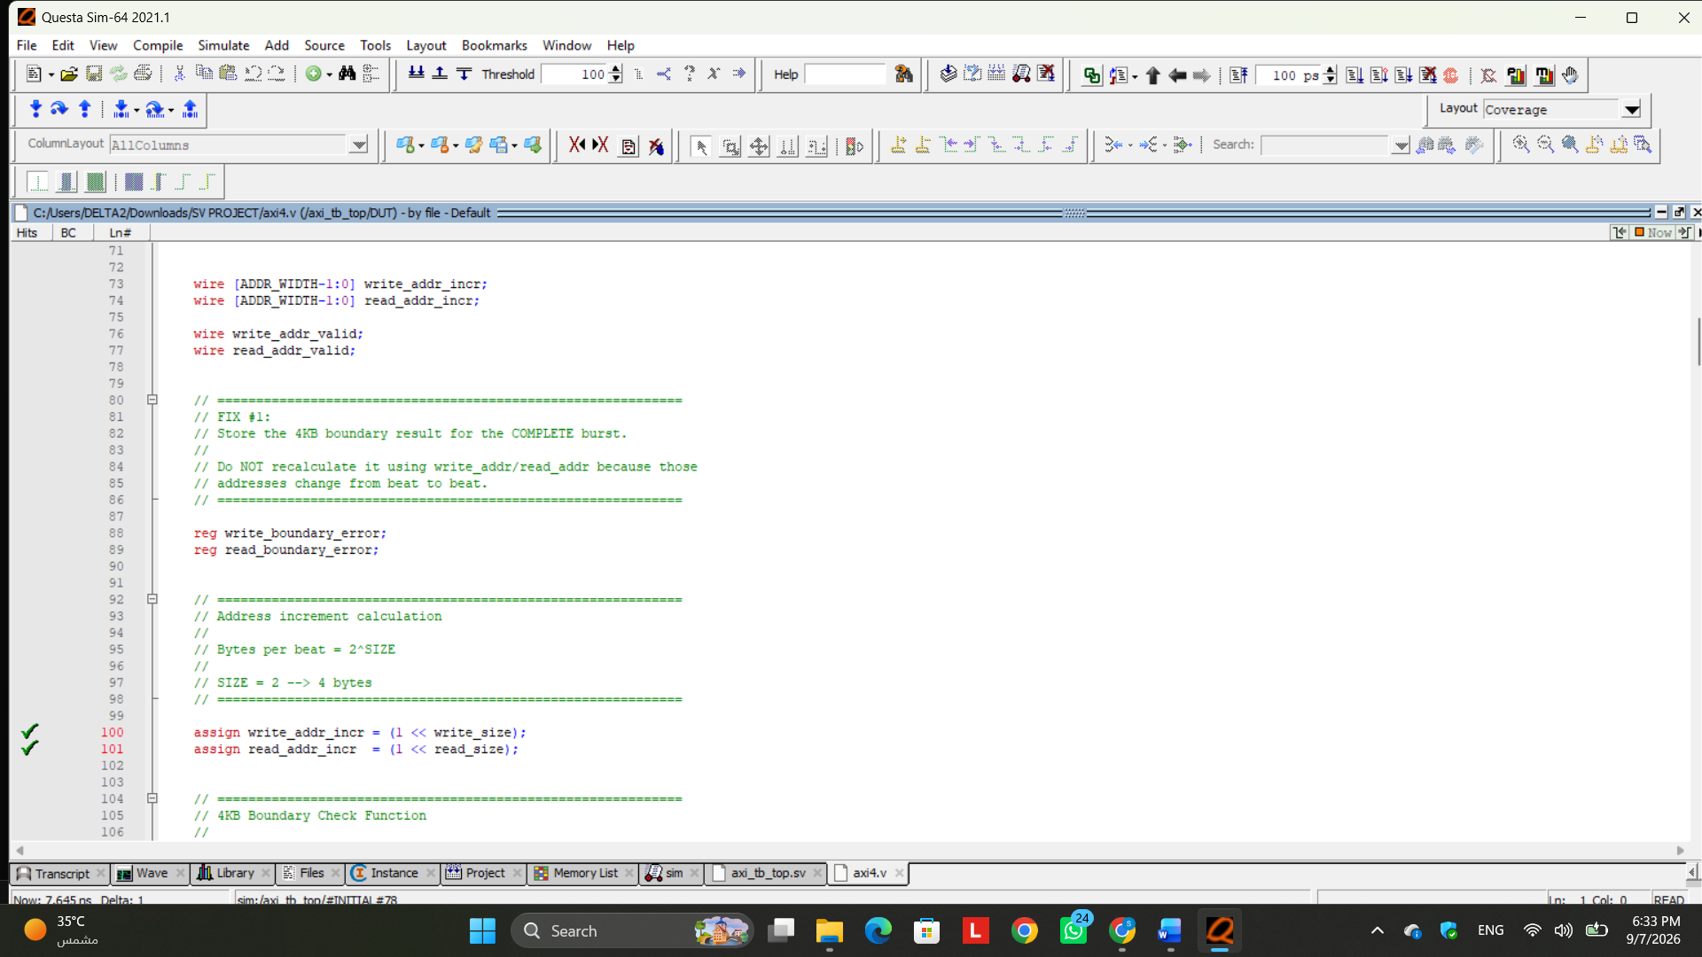
Figure 1. RTL correction evidence for the AXI4 DUT.
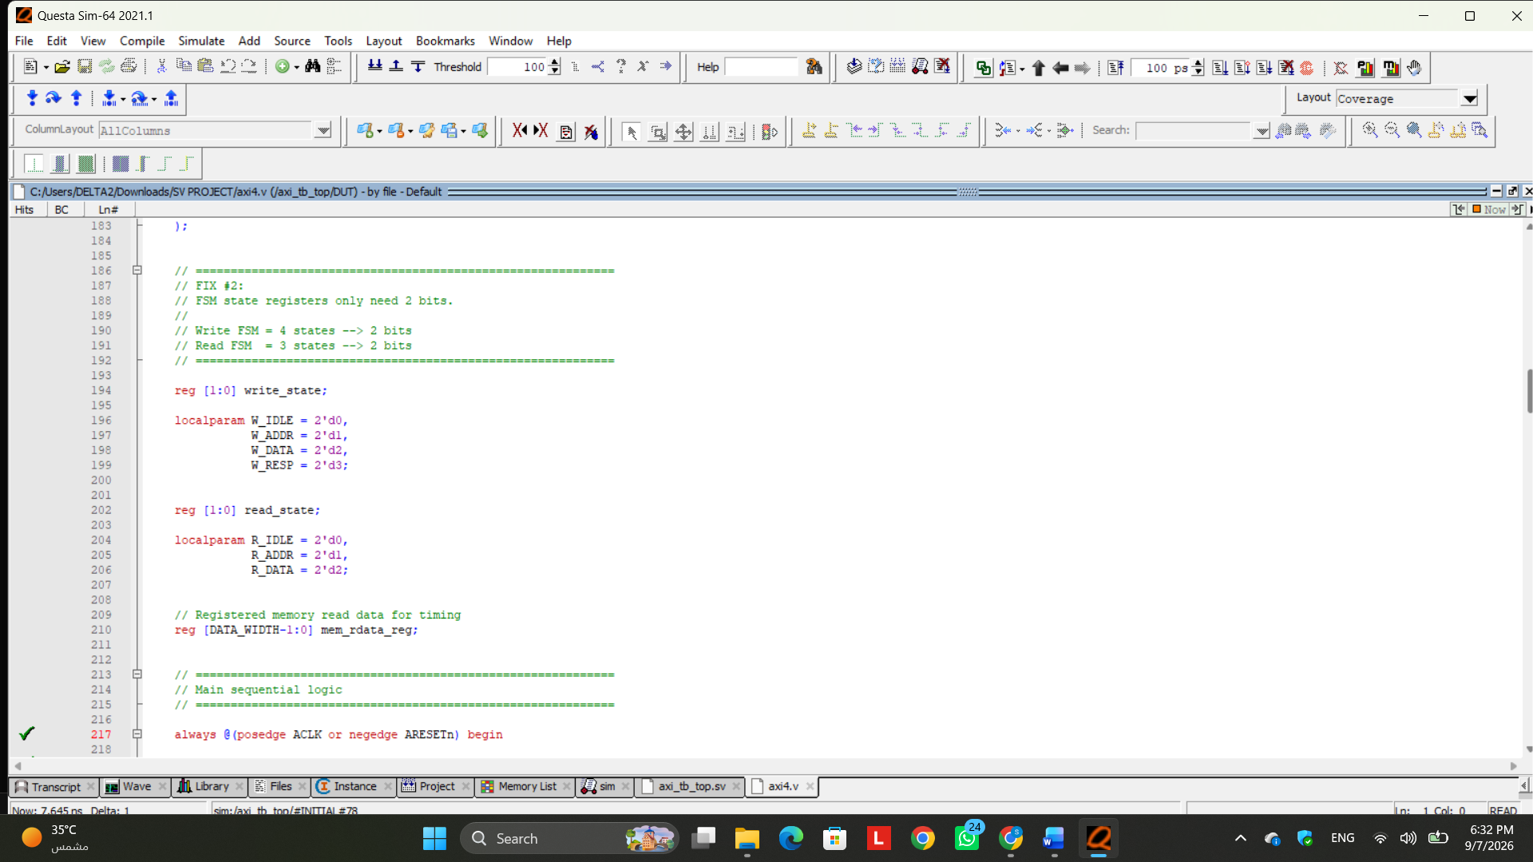
Figure 2. RTL/FSM correction evidence for the AXI4 DUT.

Technical Analysis
During the review of the AXI4 RTL design, two implementation issues were identified and corrected based on the verification results and TA feedback.

1. Incorrect 4KB Boundary Check
The original design performed the 4KB boundary check using write_addr and read_addr. These addresses are incremented after every beat of a burst, meaning that the boundary condition was continuously recalculated using a changing address rather than the original burst starting address.
To correct this issue, the boundary condition is now calculated once when the AXI address transaction is accepted, using the original AWADDR or ARADDR. The complete burst size is calculated from the number of beats (AxLEN + 1) and the number of bytes per beat (2^AxSIZE). The final byte address of the burst is then determined and compared with the starting address to verify that both remain within the same 4KB region. The result is stored for the entire transaction and is no longer affected by the address increment between beats.
This modification ensures that the 4KB boundary check represents the complete AXI burst rather than being incorrectly recalculated for each individual beat.

2. Extra Bit in Read and Write FSM State Registers
The original write and read FSM state registers were both declared as 3-bit registers. The write FSM requires four states (W_IDLE, W_ADDR, W_DATA, and W_RESP), and the final corrected read FSM also uses four states (R_IDLE, R_ADDR, R_WAIT, and R_DATA). Therefore, two bits are sufficient to encode each FSM.
The state registers were consequently changed from:
reg [2:0] write_state;
reg [2:0] read_state;
to:
reg [1:0] write_state;
reg [1:0] read_state;
The associated state encodings were also changed from 3-bit to 2-bit values. This removes the unnecessary state bit and provides a more appropriate and efficient representation of the implemented FSMs.

Verification After Modification
After applying both RTL corrections, the updated axi4.v compiled successfully in QuestaSim with 0 errors and 0 warnings. QuestaSim also recognized the two FSMs during design optimization, confirming that the modified state machines were successfully compiled.
An intermediate simulation after the first RTL corrections completed all 52 generated transactions and retained 100% functional coverage, but the scoreboard still reported 47 passing and 5 failing transactions. These failures were read-data mismatches and were used to isolate the separate memory reset/addressing and synchronous read-timing issues described in the following sections. After those issues were corrected, the final regression achieved 52 passing transactions and zero failures.
The first two RTL issues were therefore corrected successfully. The remaining intermediate read-data failures were not treated as acceptable final behavior; they directly motivated the memory and read-path timing investigations documented next.

2. AXI Memory Module Corrections
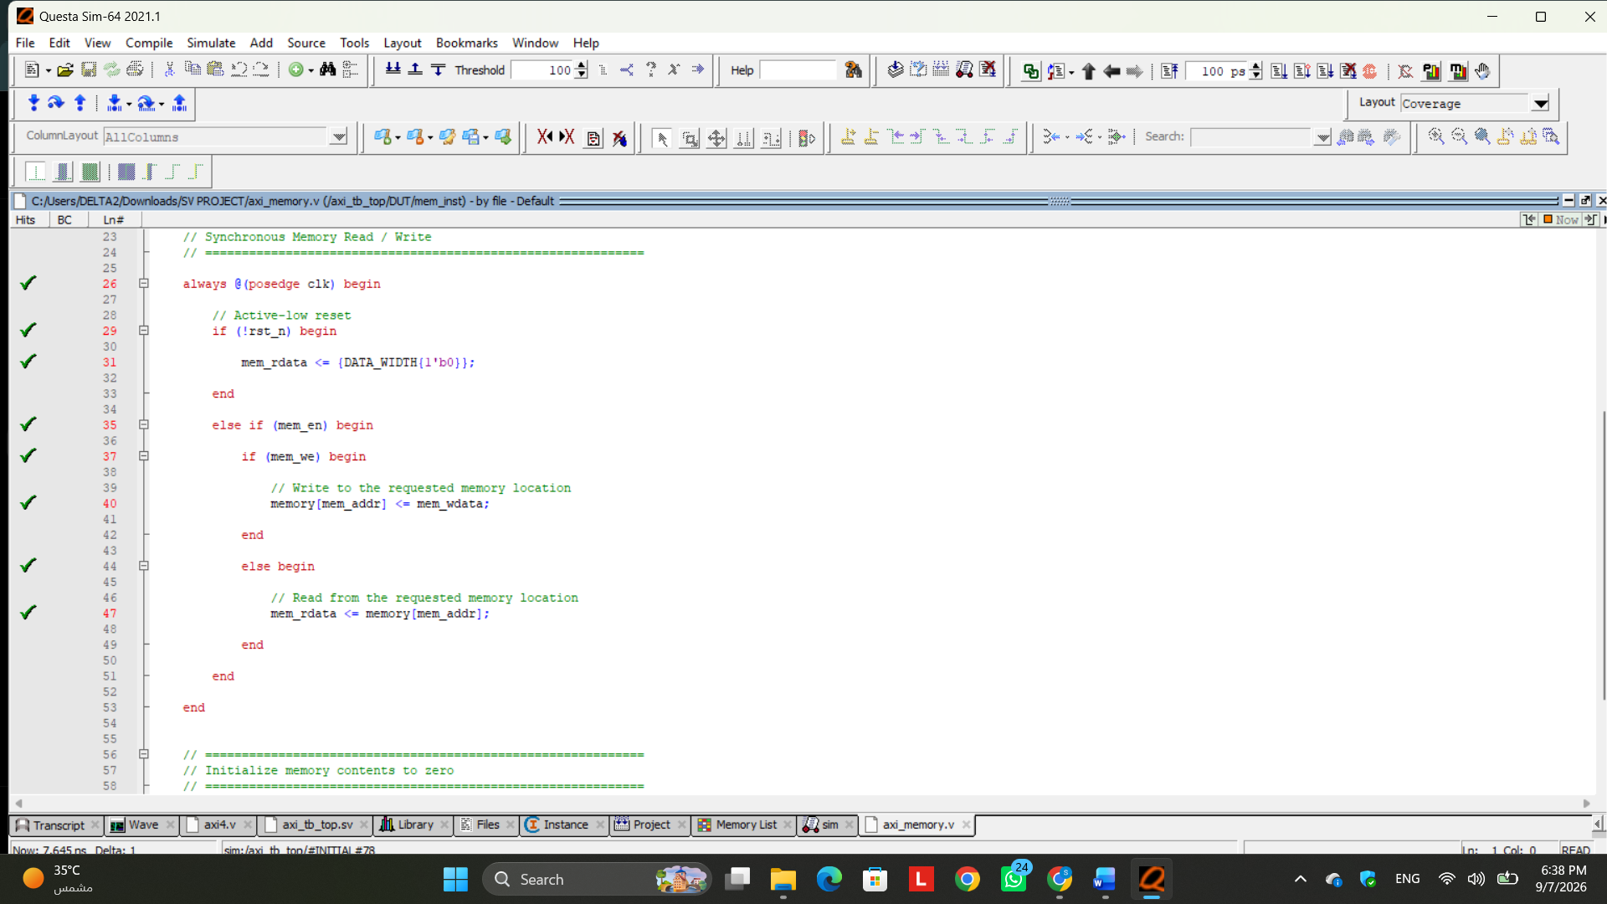
Figure 3. AXI memory correction and verification evidence.

Technical Analysis
A bug was found in the axi4_memory module that caused read transactions to return incorrect data, mostly 0x00000000.
The original memory logic used the following reset condition:
if (rst_n)
mem_rdata <= 0;
Since rst_n is an active-low reset, this condition was incorrect. During normal operation, rst_n = 1, so mem_rdata was being cleared to zero on every positive clock edge. As a result, the memory read operation was effectively blocked.
The condition was corrected to:
if (!rst_n)
mem_rdata <= 0;
so that mem_rdata is cleared only when reset is actually asserted.
A second issue was also found in the read address:
mem_rdata <= memory[mem_addr+1];
This caused the memory to read from the location after the requested address. It was corrected to:
mem_rdata <= memory[mem_addr];
so that the data is read from the exact memory location requested by the AXI controller.
After these fixes, single read-after-write transactions started returning the correct stored value. For example, a write of 0xA5A51234 to address 0x0020 was later read back successfully as 0xA5A51234.
However, burst reads still showed a one-beat data delay, indicating a separate synchronous-memory timing issue in the AXI read FSM. Therefore, the memory addressing and reset bugs were fixed successfully, while the remaining burst-read problem requires an additional timing correction in axi4.v.

3. Synchronous Read-Path Timing Correction
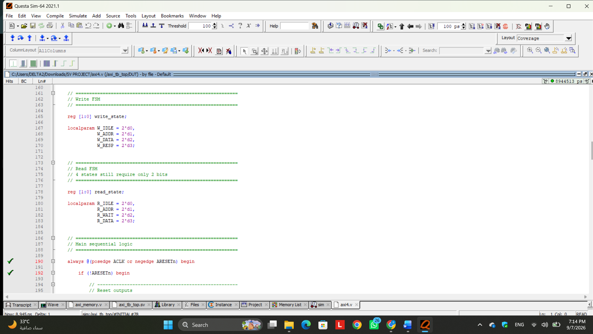
Figure 4. Read-path timing correction and R_WAIT verification evidence.

Technical Analysis
A read timing issue was identified in the AXI4 read path due to the use of a synchronous memory. In the original implementation, the AXI controller issued the memory read request in the R_ADDR state and then moved directly to R_DATA, where mem_rdata was assigned to RDATA.
Because the memory updates mem_rdata only on a clock edge, the value was not yet available when the controller entered R_DATA. This caused each burst read beat to return the previous memory value, creating a one-beat delay. For example, the first beat of a burst returned data from the previous transaction, while each following beat returned the data expected for the beat before it.
To fix this issue, a new read state called R_WAIT was added between R_ADDR and R_DATA. The updated read flow became:
R_IDLE -> R_ADDR -> R_WAIT -> R_DATA
R_ADDR now issues the synchronous memory read request, R_WAIT allows one clock cycle for mem_rdata to update, and R_DATA then presents the correct value on the AXI RDATA signal. The same waiting state is also used between consecutive burst beats.
After applying this modification, the burst read data became correctly aligned with the requested addresses.

4. Final Verification and Coverage Results
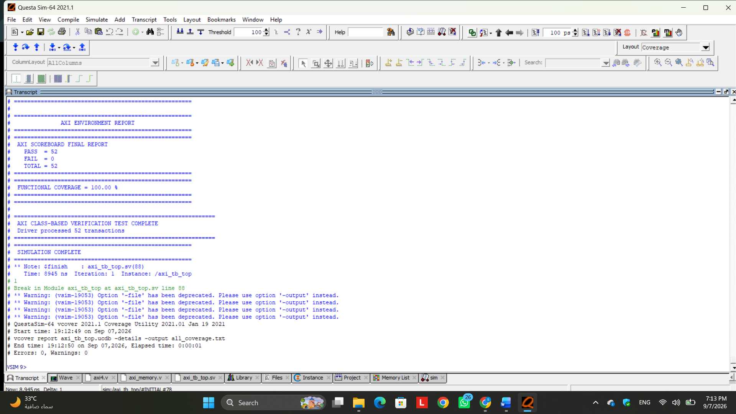
Figure 5. Final functional regression result.

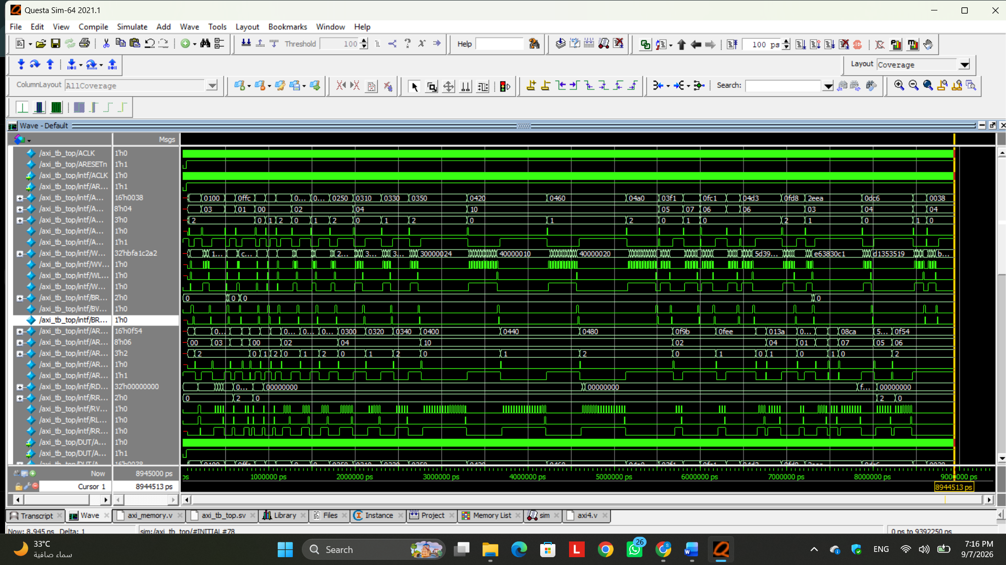
Figure 6. Final coverage summary in QuestaSim.
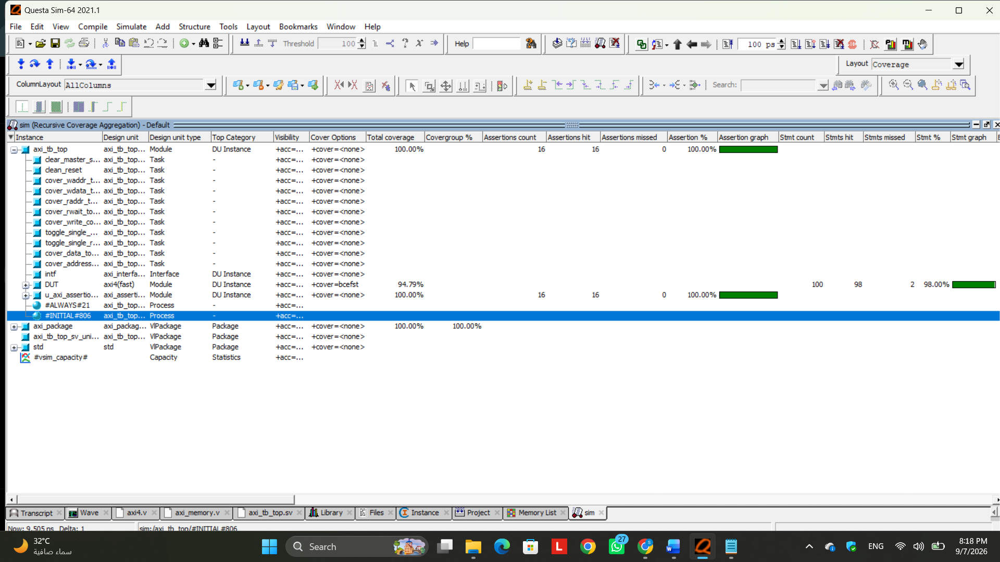
Figure 7. Detailed coverage result used for coverage closure.

Technical Analysis

5. Coverage Results Analysis
The final verification results demonstrate strong coverage closure while maintaining correct DUT functionality. All 52 generated transactions passed successfully with zero failures, confirming that the additional coverage-directed scenarios did not compromise the functional behavior of the design. Functional coverage and assertion coverage both reached 100%, while the remaining code-coverage gaps were analyzed and found to correspond mainly to structurally unreachable RTL conditions or non-functional implementation artifacts.

Functional Coverage — 100%
Functional coverage achieved 100%, with all 44 out of 44 coverage bins successfully hit. The testbench exercised both READ and WRITE operations, valid and invalid addresses, normal and 4-KB boundary-crossing transactions, all supported transfer sizes, different burst-length ranges, OKAY and SLVERR responses, and the required cross-coverage combinations.
The final run contained 28 write transactions and 24 read transactions. It also exercised 46 valid-address transactions, 6 invalid-address transactions, and 2 boundary-crossing cases. All defined crosses, including operation versus response, operation versus burst length, length versus transfer size, address validity versus response, and boundary status versus response, were covered. Therefore, no functional coverage bins remained untested.
Result: 100% — Fully Covered and Acceptable.

Assertion Coverage — 100%
Assertion coverage achieved 100%, with all 16 assertions exercised and zero assertion failures. Directed backpressure scenarios were introduced to ensure that VALID and associated payload signals remained stable when READY was deasserted.
This allowed the verification environment to exercise AWVALID, WVALID, ARVALID, BVALID and RVALID stability behavior, as well as address, burst length, transfer size, write data, WLAST, RLAST and reset-related properties. The final assertion report confirms that all 16 assertions received successful passes and none recorded a failure.
Result: 100% — Fully Covered and Acceptable.

FSM Coverage — 100%
FSM coverage achieved 100% for both states and transitions. All 8 states across the write and read state machines were exercised, and all 13 recognized FSM transitions were covered.
Normal transactions naturally exercised the main functional paths, while additional directed reset scenarios were used to exercise reset/recovery transitions such as W_ADDR → W_IDLE, W_DATA → W_IDLE, R_ADDR → R_IDLE, and R_WAIT → R_IDLE. As a result, no FSM state or transition remained uncovered.
FSM State Coverage: 8/8 = 100%
FSM Transition Coverage: 13/13 = 100%

Expression Coverage — 100%
Expression coverage achieved 4/4 = 100%. Directed valid, invalid, burst and boundary-crossing transactions allowed both required outcomes of the important RTL expressions to be exercised.
This includes the 4-KB boundary comparison, write/read address-validity checks, and the read burst-counter completion expression. Therefore, all measurable expression-coverage targets were successfully reached.
Result: 100% — Fully Covered and Acceptable.

Statement Coverage — 97.84%
Statement coverage reached 91 out of 93 statements, or 97.84%. Only two statements remained uncovered: the default branches of the write and read FSMs at lines 411 and 580 of axi4.v.
These statements are structurally unreachable during normal operation because both FSM state registers are 2 bits wide and all four possible binary values are already assigned to valid states. Therefore, there is no unused legal binary encoding capable of naturally entering either default branch. Exercising these statements would require artificial corruption or forcing of an internal state rather than normal AXI stimulus.
Result: 97.84% — Acceptable with justified exclusions.

Branch Coverage — 94.44%
Branch coverage achieved 34 out of 36 branches, or 94.44%. All functional if/else branches were exercised, including valid and invalid addresses, burst termination, error responses, handshakes and read/write processing.
The only two uncovered branches are again the default branches of the write and read FSM case statements. Since every possible 2-bit state encoding corresponds to a valid FSM state, these default cases cannot be naturally entered.
Therefore, the remaining branch-coverage gap does not indicate missing functional stimulus.
Result: 94.44% — Acceptable with justified exclusions.

Condition Coverage — 90.47%
Condition coverage reached 19 out of 21 condition terms, or 90.47%. Almost all compound RTL conditions were completely exercised, including AW and AR handshakes, valid/invalid address combinations, boundary-error conditions, WLAST/burst-counter behavior, read handshakes and burst completion.
Only two condition terms remained uncovered.
For (WVALID && WREADY) at line 334, the missing case is WREADY=0 while WVALID=1 at the point where this condition is evaluated. Due to the RTL FSM sequencing, WREADY is asserted before the FSM begins executing the W_DATA state. Therefore, this missing condition cannot naturally occur at this evaluation point.
For (BREADY && BVALID) at line 396, the missing case is BVALID=0 while BREADY=1. BVALID is asserted as the FSM transitions into W_RESP, and it is cleared when the response handshake causes the FSM to leave that state. Consequently, the required BVALID=0 condition cannot naturally occur while the condition is being evaluated in W_RESP.
Result: 90.47% — Acceptable with two structurally unreachable condition exclusions.

DUT Toggle Coverage — 90.06%
DUT toggle coverage reached 580 out of 644 toggle bins, or 90.06%. Directed coverage scenarios were added to toggle addresses, burst lengths and data patterns, significantly increasing the number of signals that experienced both 0→1 and 1→0 transitions.
After these tests, the remaining uncovered DUT toggles are limited to:
AWSIZE[2], ARSIZE[2], write_size[2], read_size[2], BRESP[0], RRESP[0], and upper bits [3:15] of the internal read/write address increment signals.
These are expected constants under the supported configuration. Transfer SIZE is restricted to 0, 1 and 2, so bit 2 never becomes 1. The implemented responses are OKAY (2'b00) and SLVERR (2'b10), so response bit 0 remains zero. Similarly, the address increment is based on 1 << SIZE; with supported sizes 0, 1 and 2, the increments are only 1, 2 and 4 bytes, leaving increment bits [3:15] permanently zero.
Result: 90.06% — Acceptable after excluding constant-by-design signals.

Memory Toggle Coverage — 70.90%
Memory toggle coverage reached 156 out of 220 bins, or 70.90%. The remaining uncovered toggle bins are associated with the 32-bit loop variable j[31:0] used during memory initialization. The report shows that this variable accounts for the remaining untoggled nodes, while the functional memory signals have been exercised.
Since j is an implementation variable used by the initialization loop rather than a functional DUT interface or datapath signal, its toggle coverage does not represent missing AXI functionality.
Result: 70.90% raw toggle coverage — Acceptable with the initialization-loop variable treated as a justified exclusion.

6. Overall Coverage Conclusion
The final verification campaign achieved 100% functional coverage, 100% assertion coverage, 100% FSM state and transition coverage, and 100% expression coverage, while all 52/52 functional transactions passed with zero failures. The remaining gaps in statement, branch, condition and toggle coverage were individually analyzed rather than simply ignored.
The uncovered items correspond to FSM default branches that cannot be reached using the available state encodings, condition combinations prevented by the RTL sequencing, constant protocol/control bits under the supported configuration, and a non-functional memory initialization loop variable. Therefore, these remaining items are considered justified coverage exclusions rather than untested functional behavior.
The final filtered overall coverage reported by the tool is 96.52%, representing a strong coverage-closure result while preserving full functional correctness.

Transition Status: CLASS-BASED SYSTEMVERILOG BASELINE COMPLETE — READY FOR UVM MIGRATION

