AXI4 UVM Verification Project
Sondos Ahmed 480
Final Status: 100% AXI Functional Coverage | 100% Memory Functional Coverage | 100% Assertion Coverage | 39/39 Scoreboard PASS | 0 UVM Errors

1. Verification Architecture
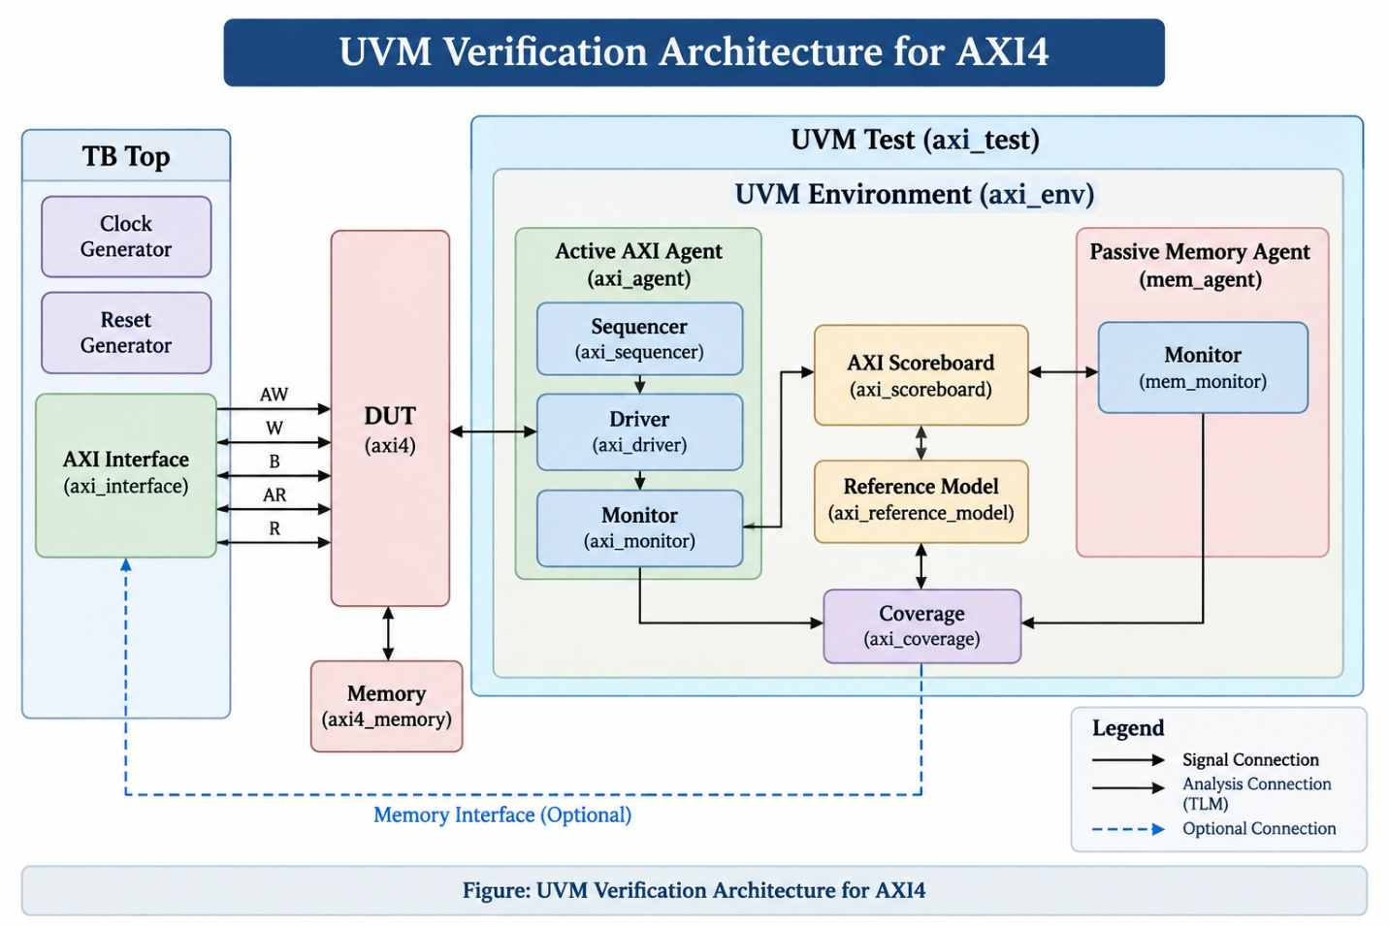
Figure 1. Verification project evidence / implementation snapshot

AXI Sequence Item
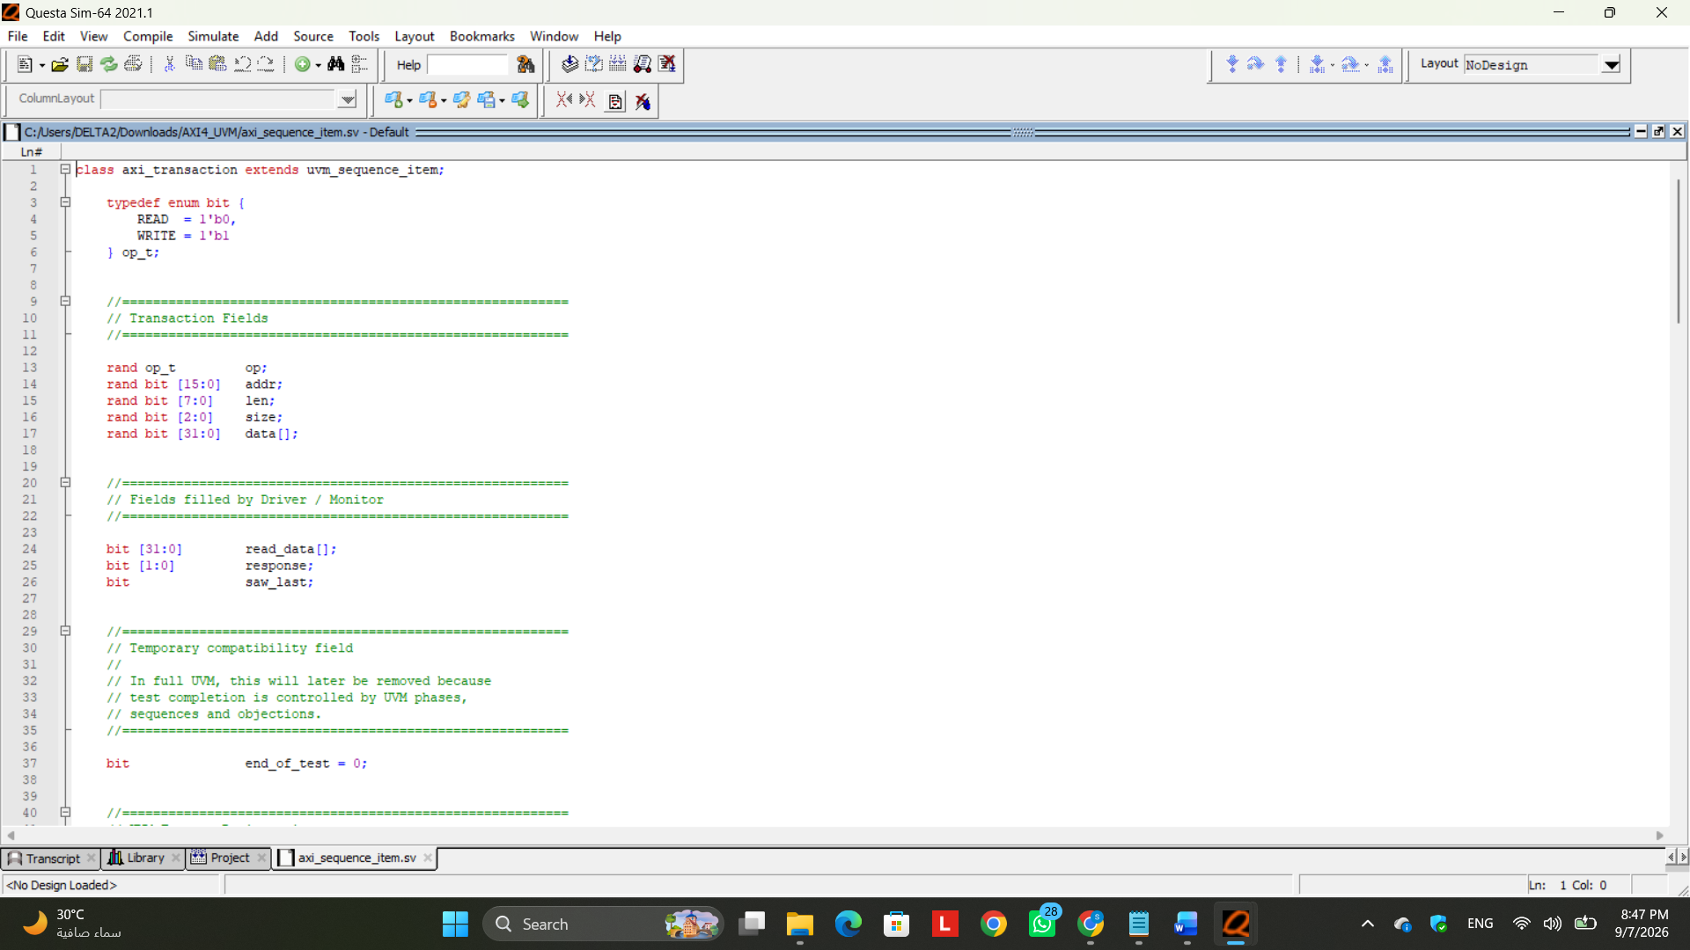
Figure 2. Verification project evidence / implementation snapshot

Technical Commentary
The axi_sequence_item.sv file defines the AXI transaction object used throughout the UVM verification environment. The class axi_transaction extends uvm_sequence_item, which allows each AXI operation to be represented as a standard UVM transaction and passed between the sequence, sequencer, driver, monitor, scoreboard, and coverage components.
The sequence item contains all information required to describe a complete AXI transaction, including the operation type (READ or WRITE), address, burst length, transfer size, write data, read data, response, and last-beat indication. The transaction also includes constraints to generate supported transfer sizes, reasonable burst lengths, properly aligned addresses, and mostly valid memory addresses while still allowing some invalid-address scenarios for error testing.
The class is registered with the UVM Factory using the uvm_object_utils macros. This enables standard UVM object operations such as creation, printing, copying, comparison, recording, and future factory overrides.
The helper function beats() converts the AXI LEN field into the actual number of beats using:
Number of beats = LEN + 1
A custom display() function is also provided using the UVM reporting mechanism. It prints the main transaction information and the transferred write or read data, which helps during simulation debugging.
In the overall verification flow, the sequence item acts as the high-level representation of an AXI request. The UVM sequence creates and configures the transaction, the sequencer passes it to the driver, and the driver converts its contents into real AXI interface signals for the DUT. On the receive side, the monitor reconstructs observed signal activity into the same transaction format so that the scoreboard and coverage components can process it.
Therefore, axi_sequence_item.sv forms the basic data structure of the UVM environment and provides the common transaction format used for stimulus generation, monitoring, checking, and coverage collection.

AXI Sequences
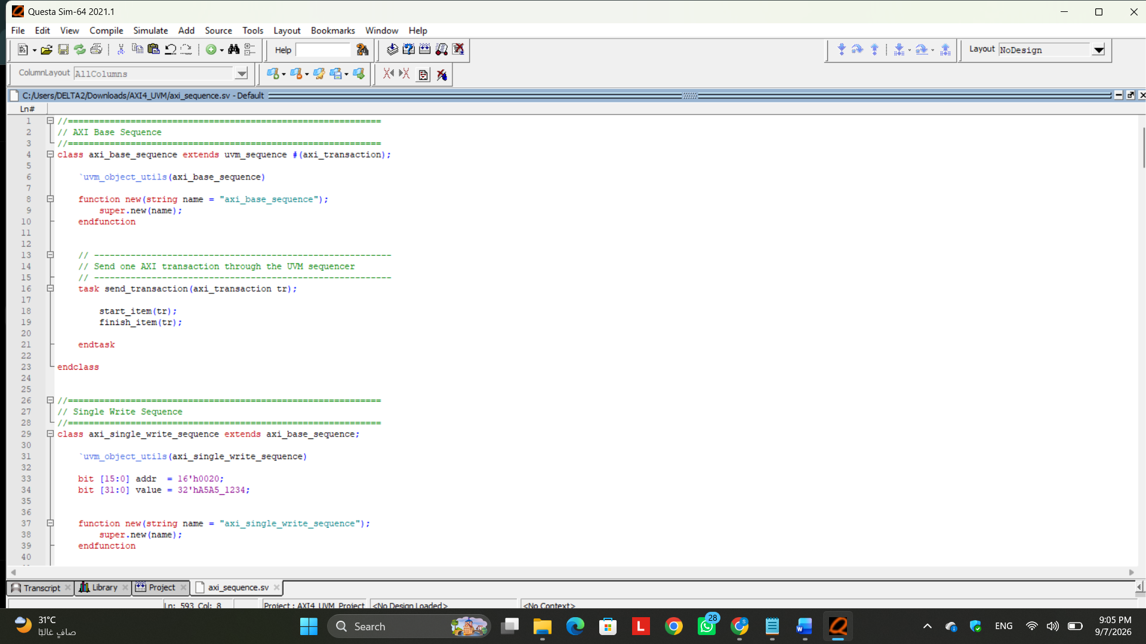
Figure 3. Verification project evidence / implementation snapshot

Technical Commentary
The axi_sequence.sv file defines the UVM stimulus scenarios used to generate AXI transactions for the DUT. While the axi_sequence_item defines the structure and fields of a single AXI transaction, the sequences determine which transactions are generated, their values, and the order in which they are sent.
All sequences extend axi_base_sequence, which itself extends:
uvm_sequence #(axi_transaction)
This establishes axi_transaction as the sequence item type used by the AXI sequences.
The previous class-based implementation used a mailbox (gen2drv) to transfer transactions toward the driver. During the UVM migration, this manual communication mechanism was replaced by the standard UVM sequence protocol:
start_item(tr);
finish_item(tr);
The transaction objects are also created through the UVM Factory using type_id::create() rather than directly using new(), allowing the environment to support factory-based customization and overrides.
Several directed sequences were preserved from the original verification environment, including single write, single read, burst write, burst read, invalid-address, 4 KB boundary-crossing, and coverage-closure sequences. Therefore, the previously developed verification scenarios are retained while their implementation is migrated to the standard UVM methodology.
Each sequence implements its stimulus inside the UVM body() task. For example, a write sequence creates an axi_transaction, configures its operation, address, length, size, and data fields, and then submits the transaction for execution. The sequence itself does not drive AXI interface signals; signal-level protocol activity will be handled later by the UVM driver.
Overall, axi_sequence.sv provides the stimulus-generation layer of the UVM environment. It converts the required verification scenarios into organized AXI transaction streams that will be passed through the sequencer to the driver and eventually applied to the DUT.

AXI Sequencer
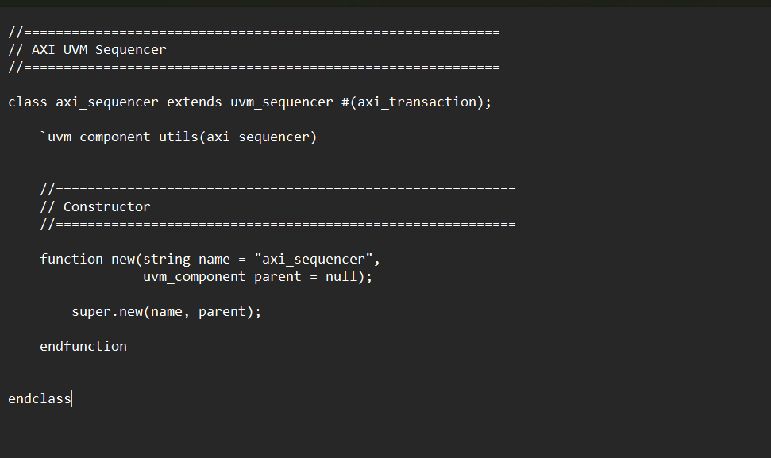
Figure 4. Verification project evidence / implementation snapshot

Technical Commentary
The axi_sequencer.sv file defines the UVM sequencer responsible for managing the flow of AXI transactions between the sequences and the driver. The axi_sequencer class extends:
uvm_sequencer #(axi_transaction)
This specifies that the sequencer handles transactions of type axi_transaction, which was previously defined as the AXI UVM sequence item.
The sequencer acts as an intermediate coordination layer between stimulus generation and signal-level execution. The sequence creates AXI transactions and determines their contents and order, while the sequencer organizes their delivery to the driver. The driver can then retrieve each transaction and convert it into the corresponding AXI interface signals.
The class is registered with the UVM Factory using:
`uvm_component_utils(axi_sequencer)
Unlike the sequence item and sequence, the sequencer is registered as a UVM component because it becomes part of the UVM testbench hierarchy and will later be instantiated inside the active AXI agent.
No additional transaction-management logic is required inside the class because the standard uvm_sequencer base class already provides the required communication and arbitration mechanisms.
Therefore, axi_sequencer.sv provides the standard UVM communication path:
Sequence → Sequencer → Driver → DUT
and replaces the manual mailbox-based transaction transfer used in the previous class-based verification environment.

AXI Driver
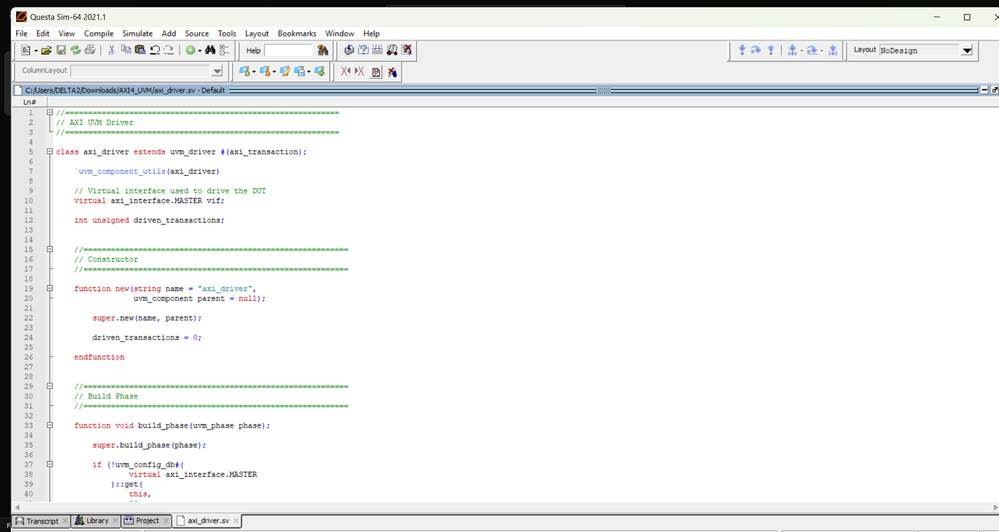
Figure 5. Verification project evidence / implementation snapshot

Technical Commentary
The axi_driver.sv file defines the UVM driver responsible for converting high-level AXI transactions into actual signal-level activity on the DUT interface. It receives axi_transaction objects from the UVM sequencer and drives the appropriate AXI channels based on whether the transaction is a READ or WRITE.
The driver extends:
uvm_driver #(axi_transaction)
which specifies that it handles transactions of type axi_transaction. The class is also registered with the UVM Factory using uvm_component_utils, allowing it to be created and overridden through the standard UVM factory mechanism.
The driver obtains the AXI virtual interface through uvm_config_db during the build_phase. This replaces the manual constructor-based interface passing used in the previous class-based environment and follows the standard UVM configuration approach.
For WRITE transactions, the driver controls the AXI write address, write data, and write response channels. It drives AWADDR, AWLEN, AWSIZE, and AWVALID, then sends each write-data beat using WDATA, WVALID, and WLAST. Finally, it asserts BREADY and captures the returned BRESP.
For READ transactions, the driver controls the read address and read data channels. It drives ARADDR, ARLEN, ARSIZE, and ARVALID, then asserts RREADY and collects every returned RDATA beat together with RRESP and RLAST.
The driver uses the standard UVM sequencer-driver handshake:
seq_item_port.get_next_item(tr);
to obtain a transaction, and after completing the AXI operation it calls:
seq_item_port.item_done();
to notify the sequencer that the transaction has been fully executed.
The previous mailbox-based communication and explicit end-of-test sentinel mechanism were therefore removed, since UVM provides its own transaction flow and phase-based test control.
This version is intentionally implemented as a basic UVM driver first, while the additional delay and backpressure behavior from the previous verification environment can later be added through the required axi_driver_delay factory override.
Overall, axi_driver.sv forms the connection between the transaction-level UVM environment and the signal-level AXI interface:
Sequence → Sequencer → Driver → AXI Signals → DUT
and is responsible for executing each generated AXI transaction correctly according to the protocol handshakes.

AXI Monitor
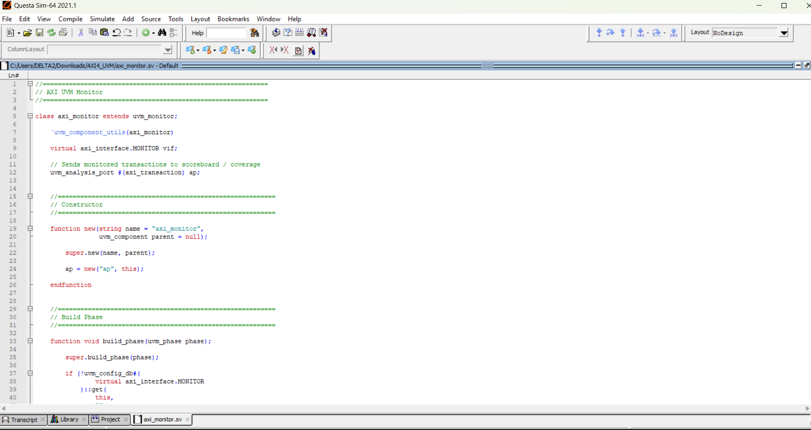
Figure 6. Verification project evidence / implementation snapshot

Technical Commentary
The axi_monitor.sv file defines the UVM monitor responsible for observing AXI activity on the interface and reconstructing the observed signal-level behavior into axi_transaction objects.
Unlike the driver, the monitor does not drive any DUT signals. Instead, it passively watches the AXI handshakes on the write and read channels. For WRITE transactions, it captures the AW handshake, collects all WDATA beats, checks the correct position of WLAST, and finally captures BRESP. For READ transactions, it captures the AR handshake, collects all returned RDATA beats, checks RLAST, and stores the final RRESP.
The class extends:
uvm_monitor
and is registered with the UVM Factory using:
`uvm_component_utils(axi_monitor)
The monitor receives the virtual AXI interface through uvm_config_db during the build_phase, following the standard UVM configuration mechanism.
A major change from the previous class-based environment is the replacement of the two manual mailboxes used for the scoreboard and coverage components. Instead, the UVM version uses a single analysis port:
uvm_analysis_port #(axi_transaction) ap;
After a complete AXI transaction is observed, the monitor publishes it using:
ap.write(tr);
This allows multiple UVM components, such as the scoreboard and coverage collector, to receive the same monitored transaction without the monitor needing to know their implementation directly.
The monitor also performs basic protocol checks related to WLAST and RLAST, including detecting an early LAST signal or a missing LAST on the final expected beat. Any detected issue is reported using the UVM reporting mechanism through uvm_error.
Overall, axi_monitor.sv performs the reverse operation of the driver. The driver converts transactions into AXI signals, while the monitor observes AXI signals and converts them back into transaction-level objects for checking and coverage:
Driver → AXI Signals → DUT
↓
Monitor
↓
axi_transaction
↙ ↘
Scoreboard Coverage
This makes the monitor a key observation point in the UVM environment and provides the actual DUT behavior required for verification.

AXI Agent
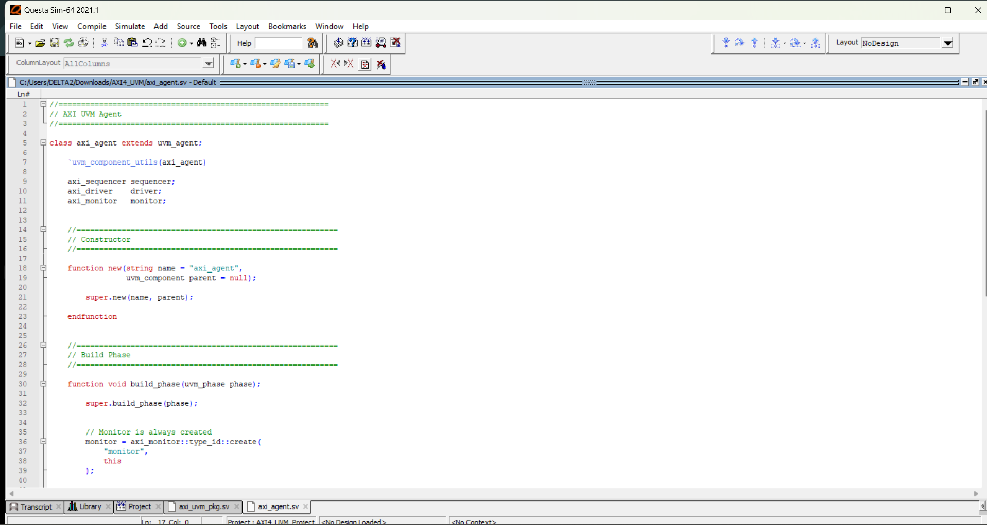
Figure 7. Verification project evidence / implementation snapshot

Technical Commentary
The axi_agent.sv file defines the UVM AXI agent, which groups the main AXI verification components into one reusable verification block. The agent contains the AXI sequencer, driver, and monitor, and can operate in either active or passive mode.
The class extends:
uvm_agent
and is registered with the UVM Factory using:
`uvm_component_utils(axi_agent)
The monitor is always created because it is required to observe AXI activity regardless of whether the agent is active or passive.
When the agent is configured as UVM_ACTIVE, the sequencer and driver are also created:
if (get_is_active() == UVM_ACTIVE)
This allows the agent to generate and drive AXI transactions while also monitoring the DUT behavior.
In active mode, the agent structure is:
AXI Agent
│
├── Sequencer
├── Driver
└── Monitor
In passive mode, only the monitor is created:
AXI Agent
│
└── Monitor
The connect_phase connects the driver to the sequencer using:
driver.seq_item_port.connect(
sequencer.seq_item_export
);
This connection allows sequence items generated by AXI sequences to pass through the sequencer and reach the driver for execution on the DUT interface.
Overall, axi_agent.sv provides a clean and reusable container for the AXI verification components. In this project, the AXI agent is intended to operate as an active agent, allowing the environment to generate READ and WRITE stimulus, drive it to the DUT, and simultaneously monitor the resulting AXI activity.

AXI Reference Model
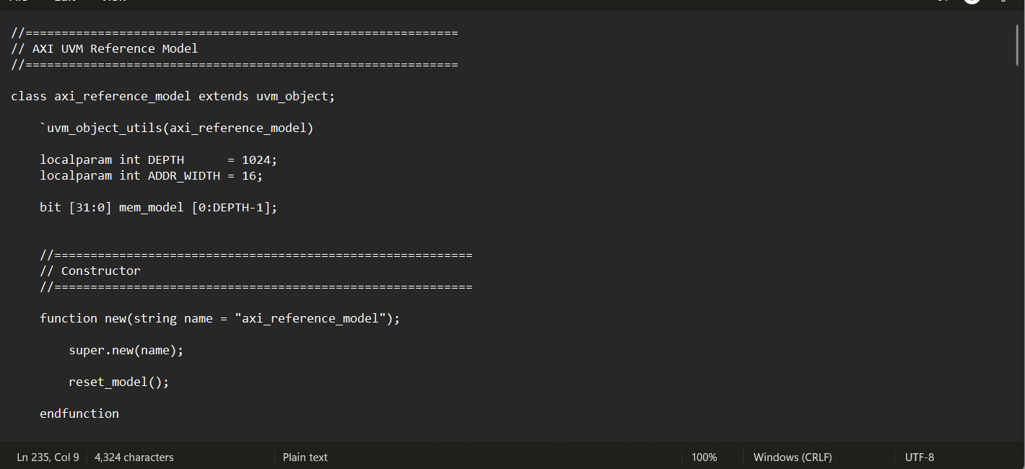
Figure 8. Verification project evidence / implementation snapshot

Technical Commentary
The axi_reference_model.sv file defines the UVM reference model used to predict the expected behavior of the AXI memory system. It maintains an internal software representation of the memory and calculates the expected data and response for every monitored READ and WRITE transaction.
The class extends:
uvm_object
and is registered with the UVM Factory using:
`uvm_object_utils(axi_reference_model)
The reference model is implemented as a UVM object rather than a UVM component because it does not require independent phases or hierarchy. Instead, it is created and used by the scoreboard as a prediction mechanism.
The internal memory model is defined as:
bit [31:0] mem_model [0:DEPTH-1];
with a depth of 1024 words, matching the 4 KB memory organization used in the DUT. The model is initialized to zero using the reset_model() function.
The is_valid() function checks whether a transaction is valid by verifying both the implemented memory address range and the AXI 4 KB boundary requirement. The total number of transferred bytes is calculated from the burst length and transfer size, allowing the model to determine whether the complete transaction remains within the permitted address region.
For WRITE transactions, the predict_write() function updates the internal reference memory when the transaction is valid and predicts an OKAY response. If the address or burst is invalid, the memory is not modified and an error response is predicted.
For READ transactions, the predict_read() function generates the expected read-data array from the internal memory model and predicts the corresponding response. Invalid accesses produce zero-valued expected data together with the appropriate error response.
The reference model also provides the expected_addr_sequence() function, which calculates the expected sequence of addresses for all beats of a transaction based on the starting address and AXI transfer size.
Overall, the reference model acts as the golden behavioral model used by the scoreboard:
Monitored Transaction
↓
Reference Model
↓
Expected Data / Response
↓
Scoreboard
↕
Actual DUT Result
This allows the verification environment to independently determine the correct expected behavior and compare it against the actual results observed from the DUT.

AXI Scoreboard
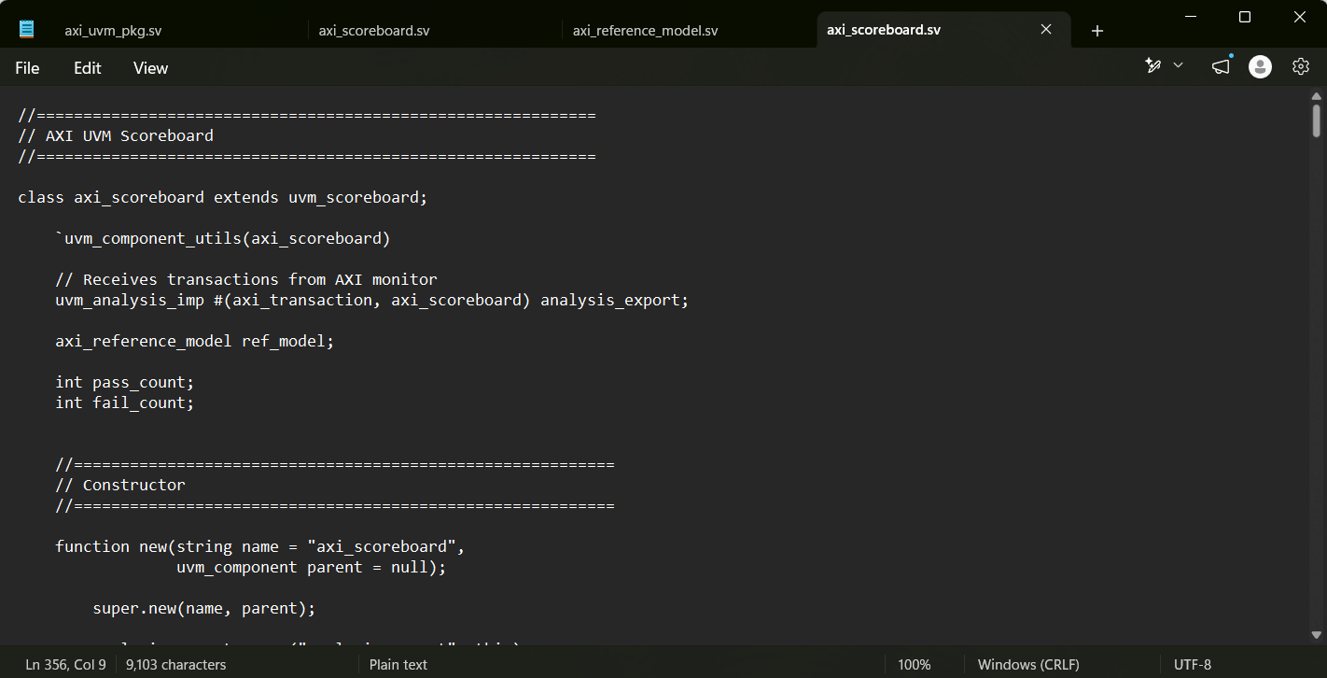
Figure 9. Verification project evidence / implementation snapshot

Technical Commentary
The axi_scoreboard.sv file defines the UVM scoreboard, which is responsible for checking the correctness of the AXI transactions observed by the monitor. It acts as the main comparison component between the actual DUT behavior and the expected behavior generated by the reference model.
The scoreboard extends:
uvm_scoreboard
and is registered with the UVM Factory using:
`uvm_component_utils(axi_scoreboard)
Instead of using the mailbox-based communication from the previous class-based environment, the UVM scoreboard receives transactions from the AXI monitor through:
uvm_analysis_imp #(axi_transaction, axi_scoreboard) analysis_export;
Whenever the monitor publishes a transaction using ap.write(tr), the scoreboard's write() function is automatically called and passes the received transaction to check_transaction().
For WRITE transactions, the scoreboard verifies the number of received data beats, checks that WLAST was correctly observed on the final beat, and compares the actual BRESP returned by the DUT against the expected response generated by the reference model.
For READ transactions, the scoreboard verifies the burst length and correct RLAST behavior. Each received RDATA beat is compared against the expected data generated by the reference model, including the expected address associated with each beat. The actual RRESP is also compared against the predicted response.
Any mismatch is reported using the standard UVM uvm_error reporting mechanism, while correctly completed transactions increment the PASS counter. The scoreboard maintains both PASS and FAIL counters and prints the final verification results during the UVM report_phase.
Overall, the scoreboard provides the main functional checking path of the AXI UVM environment:
AXI Monitor
↓
Observed Transaction
↓
Scoreboard
↕
Reference Model
↓
Expected vs. Actual
↓
PASS / FAIL
This ensures that the DUT is verified not only for correct AXI handshaking and burst structure, but also for correct memory data and response behavior.

AXI Functional Coverage
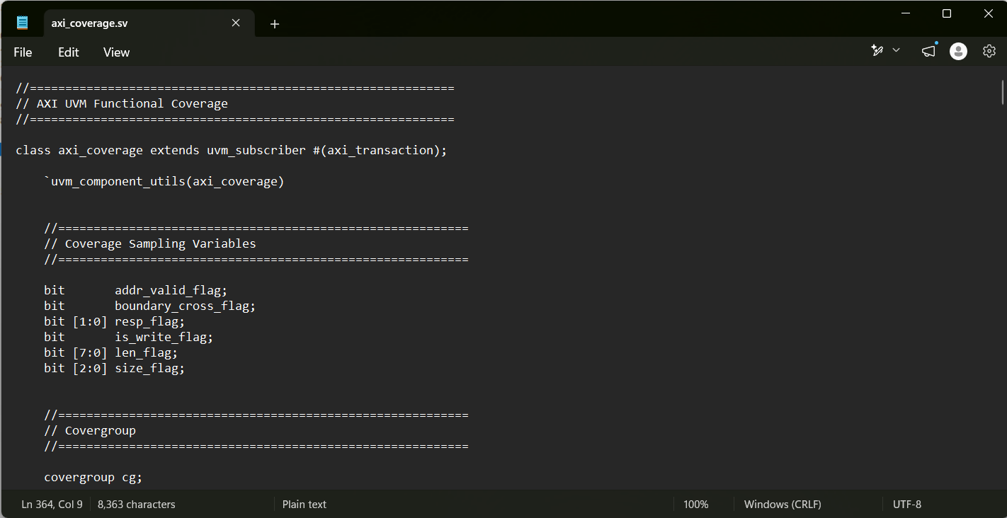
Figure 10. Verification project evidence / implementation snapshot

Technical Commentary
The axi_coverage.sv file defines the UVM functional coverage component used to measure how thoroughly the AXI verification environment exercises the required transaction scenarios.
The class extends:
uvm_subscriber #(axi_transaction)
which allows it to receive axi_transaction objects directly from the AXI monitor through the UVM analysis mechanism.
The coverage model contains coverpoints for the main AXI transaction characteristics, including READ/WRITE operation, address validity, 4 KB boundary crossing, burst length, transfer size, and AXI response. Cross coverage is also used to verify important combinations such as operation versus response, operation versus burst length, and burst length versus transfer size.
Unsupported transfer sizes are defined as illegal_bins, while combinations that are structurally unreachable by the implemented design are excluded using ignore_bins. For example, a valid transaction cannot produce SLVERR, and a transaction crossing the 4 KB boundary cannot produce an OKAY response.
The previous mailbox-based communication has been replaced by the standard UVM subscriber mechanism. Whenever the AXI monitor publishes a transaction, the coverage component automatically receives it through the write() function, extracts the relevant transaction properties, and samples the covergroup using:
cg.sample();
The is_valid_addr() and crosses_4kb() functions are used to classify each monitored transaction according to the implemented memory range and AXI 4 KB boundary requirements.
Finally, the report_phase reports the achieved functional coverage percentage using the standard UVM reporting mechanism.
Overall, the component provides the functional coverage path:
AXI Monitor
↓
Observed Transaction
↓
AXI Coverage
↓
Coverpoints + Crosses
↓
Functional Coverage %
This ensures that the UVM environment measures whether the important AXI operations, transfer configurations, responses, valid and invalid accesses, and boundary conditions have been adequately exercised.

UVM Environment
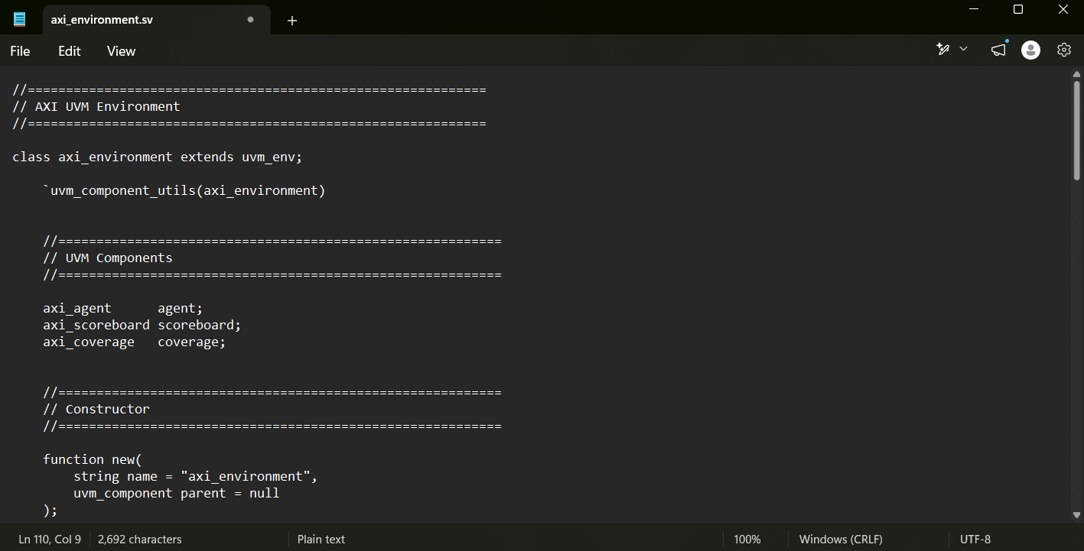
Figure 11. Verification project evidence / implementation snapshot

Technical Commentary
The axi_environment.sv file defines the UVM environment that integrates the main AXI verification components into a single structured verification hierarchy.
The class extends:
uvm_env
and is registered with the UVM Factory using:
`uvm_component_utils(axi_environment)
During the build_phase, the environment creates the main verification components: the AXI agent, scoreboard, and functional coverage collector. The AXI agent itself contains the sequencer, driver, and monitor, while the scoreboard internally uses the reference model to generate expected results.
The previous class-based environment relied on several mailboxes such as gen2drv, mon2scb, and mon2cov. In the UVM implementation, these manual communication channels are removed and replaced by standard UVM mechanisms. Sequence items are transferred from the sequencer to the driver through the sequencer-driver connection, while monitored transactions are distributed through analysis ports.
During the connect_phase, the AXI monitor is connected to both the scoreboard and the coverage component:
agent.monitor.ap.connect(
scoreboard.analysis_export
);

agent.monitor.ap.connect(
coverage.analysis_export
);
This allows every transaction observed by the monitor to be sent simultaneously to the scoreboard for functional checking and to the coverage component for functional coverage sampling.
The previous manual run() task is no longer required because UVM automatically manages the execution of each component through its standard phases. Similarly, the environment no longer manually starts the driver, monitor, scoreboard, or coverage components.
Overall, axi_environment.sv provides the main integration layer of the UVM verification architecture:
UVM Environment
│
├── AXI Agent
│ ├── Sequencer
│ ├── Driver
│ └── Monitor
│
├── Scoreboard
│ └── Reference Model
│
└── Functional Coverage
The environment therefore organizes the verification components, establishes their communication paths, and provides a reusable top-level verification structure for the AXI DUT.

UVM Test
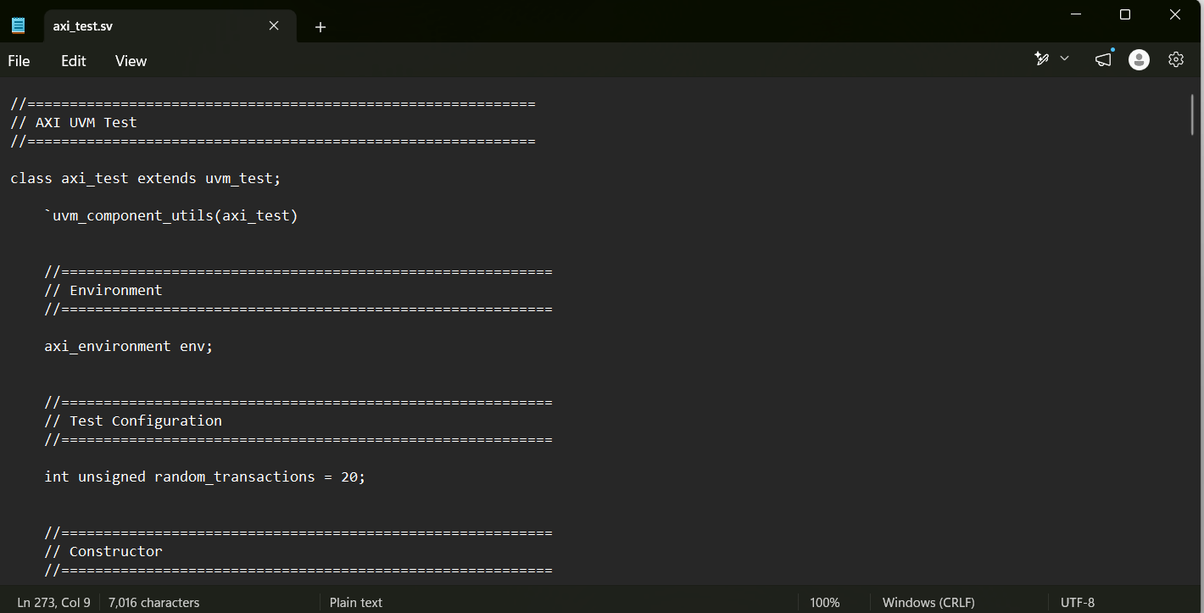
Figure 12. Verification project evidence / implementation snapshot

Technical Commentary
The axi_test.sv file defines the top-level UVM test responsible for creating the verification environment and controlling the execution of the AXI stimulus sequences.
The class extends:
uvm_test
and is registered with the UVM Factory using:
`uvm_component_utils(axi_test)
During the build_phase, the test creates the axi_environment through the UVM Factory. The environment then builds the AXI agent, scoreboard, coverage component, and all related verification sub-components.
The main test execution occurs inside the run_phase. At the beginning of this phase, the test raises a UVM objection using:
phase.raise_objection(this);
This prevents the UVM simulation from ending while stimulus generation is still in progress.
The test waits until reset is released before starting traffic. It then creates and starts several AXI sequences on the agent sequencer, including single write, single read, burst write, burst read, invalid-address, 4 KB boundary-crossing, and coverage-closure sequences.
Each sequence is started using the standard UVM sequence mechanism:
sequence.start(env.agent.sequencer);
This replaces the manual generator-based stimulus flow used in the previous class-based environment. The new UVM flow is therefore:
UVM Test
↓
Sequence
↓
Sequencer
↓
Driver
↓
DUT
The previous implementation called env.run() and env.report() manually. These calls are no longer required because UVM automatically manages component execution through its standard phases. The scoreboard and coverage components also generate their final results through their own report_phase() methods.
After all sequences complete, the test waits for a short number of clock cycles to allow the monitor, scoreboard, and coverage collector to process the final transaction. It then reports the total number of transactions processed by the driver.
Finally, the test drops its objection using:
phase.drop_objection(this);
allowing the UVM run phase to terminate normally.
Overall, axi_test.sv acts as the main verification scenario controller, coordinating reset synchronization, sequence execution, test completion, and overall UVM simulation lifetime.

AXI Testbench Top
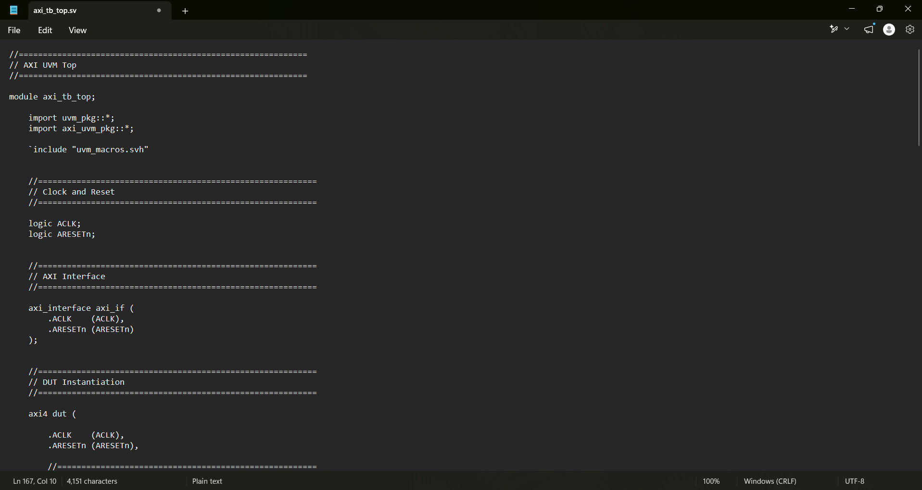
Figure 13. Verification project evidence / implementation snapshot

Technical Commentary
The axi_tb_top.sv file represents the top-level SystemVerilog module that connects the UVM verification environment to the AXI DUT.
Unlike the other verification files, axi_tb_top.sv is a Verilog/SystemVerilog module rather than a UVM class. Its main responsibility is to instantiate the DUT and AXI interface, generate the clock and reset signals, provide the virtual interface handles to the UVM components, and start the UVM test.
The module instantiates the AXI interface and connects its signals directly to the corresponding DUT ports. This creates the physical connection between the verification environment and the design under test.
The testbench top also generates the AXI clock and active-low reset signal. The reset is initially asserted and then released after several clock cycles to ensure that the DUT and verification components start from a known state.
A key function of the top module is the configuration of the virtual interfaces using uvm_config_db. The physical AXI interface instance is passed to the UVM driver through the MASTER modport and to the UVM monitor through the MONITOR modport.
For example:
uvm_config_db#(
virtual axi_interface.MASTER
)::set(
null,
"uvm_test_top.env.agent.driver",
"vif",
axi_if
);
This allows the driver to access and control the AXI master-side signals without directly referencing the top-level interface instance.
Similarly, the monitor receives its interface handle using:
uvm_config_db#(
virtual axi_interface.MONITOR
)::set(
null,
"uvm_test_top.env.agent.monitor",
"vif",
axi_if
);
The simulation is started using:
run_test("axi_test");
This call activates the UVM framework, creates the specified test through the UVM Factory, and begins the normal UVM phase execution.
The overall connection established by axi_tb_top.sv can be represented as:
axi_tb_top
│
├── Clock / Reset
│
├── AXI Interface
│ │
│ ├── DUT
│ │
│ ├── Driver
│ │
│ └── Monitor
│
└── run_test("axi_test")
↓
UVM Test
↓
UVM Environment
↓
AXI Agent
Overall, axi_tb_top.sv acts as the bridge between the static SystemVerilog design hierarchy and the dynamic UVM class-based verification environment. It provides the physical DUT connectivity, simulation timing signals, virtual interface configuration, and entry point required to launch the complete UVM verification testbench.

UVM Package
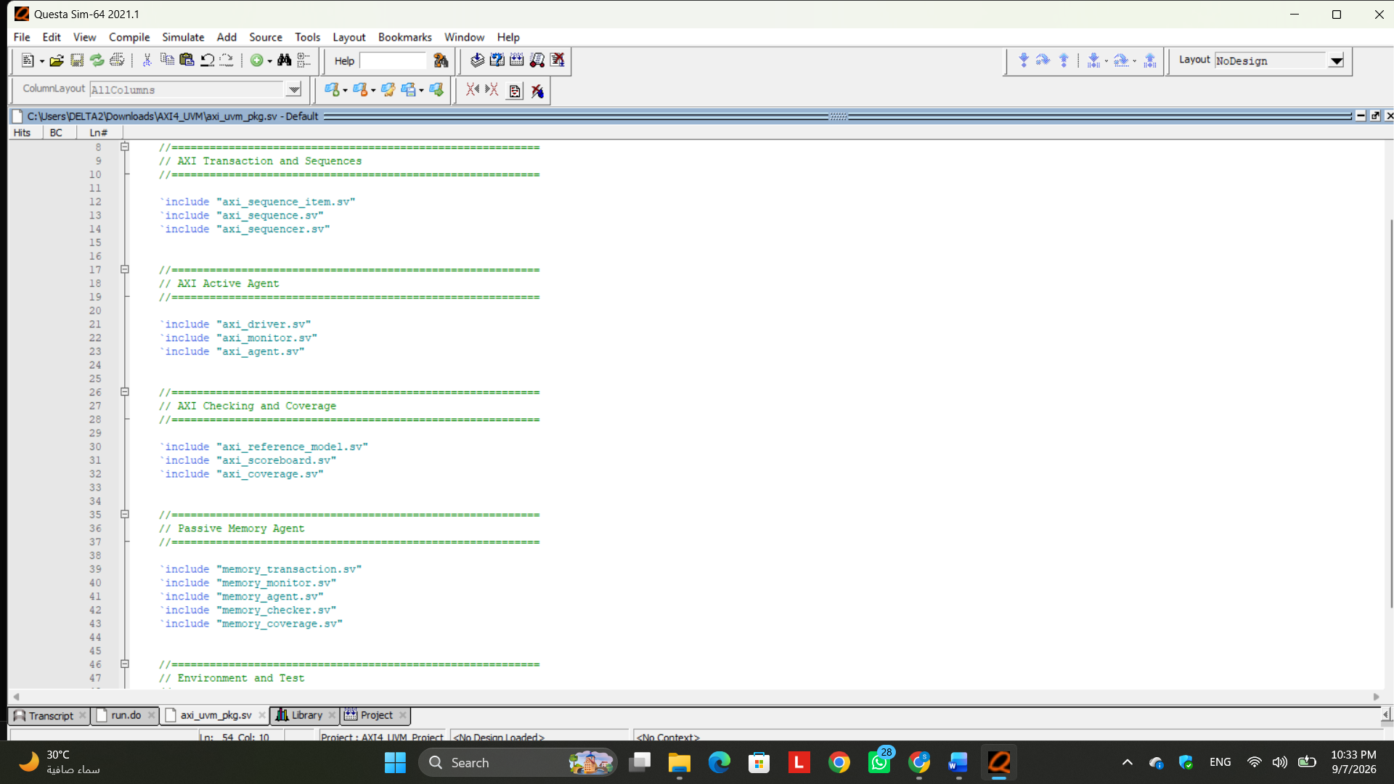
Figure 14. Verification project evidence / implementation snapshot

Technical Commentary
The axi_uvm_pkg.sv file acts as the central UVM package for the complete verification environment. It imports the UVM library and includes all AXI and memory verification classes in dependency-safe order. The package contains the AXI transaction, sequences, sequencer, driver, monitor, active agent, reference model, scoreboard, and AXI coverage components. It was extended to also include the passive memory verification components, including the memory transaction, monitor, agent, checker, and coverage class. Finally, the environment and test classes are included after all dependent components. This organization allows the complete verification architecture to be compiled and imported as a single reusable UVM package.

Migration Note

Reuse of Existing AXI Design and Verification Files
The transition from the original class-based verification environment to UVM does not require rebuilding the complete AXI project from the beginning. The main objective of this stage is to migrate the verification architecture to the UVM methodology while reusing the already verified RTL design and interface-level verification files.
The project implements an AXI4-based memory system, where an AXI master communicates with a memory through the AXI design under test (DUT). The verification environment is responsible for generating AXI read and write transactions, driving them to the DUT, monitoring the resulting bus activity, checking the DUT behavior against an expected reference model, collecting functional coverage, and verifying protocol behavior using assertions.
During the previous class-based verification stage, several RTL bugs were identified and corrected. These included issues related to the 4 KB boundary-crossing calculation, FSM state representation, memory reset behavior, memory read addressing, and synchronous read timing. After these corrections, the design was successfully re-verified and used as the stable RTL baseline for the UVM migration.
Therefore, the following existing files are reused rather than rewritten:
axi4.v
axi_memory.v
axi_interface.sv
axi_assertions.sv
The axi4.v and axi_memory.v files represent the corrected DUT and memory implementation. Since the purpose of the UVM migration is to improve the verification methodology rather than redesign the DUT, these RTL files remain unchanged after the previously identified bugs were fixed.
Similarly, axi_interface.sv does not need to be rewritten. The AXI interface already defines the required AXI signals and appropriate interface views/modports used to connect the DUT with the verification environment. In the UVM implementation, the same physical interface is reused and passed to the UVM driver and monitor as a virtual interface through uvm_config_db.
The existing axi_assertions.sv file is also reused. Assertions operate directly on the AXI interface signals and verify protocol-level behavior independently of whether the surrounding verification environment is implemented using traditional SystemVerilog classes or UVM. Therefore, migrating the testbench to UVM does not require rewriting the previously developed protocol assertions.
The main modification in this stage is consequently focused on the class-based verification components. The previous generator, driver, monitor, scoreboard, coverage, environment, and test architecture is reorganized into standard UVM components using sequences, sequencers, agents, UVM phases, factory registration, configuration mechanisms, and analysis ports.
The migration can therefore be summarized as:
Existing Corrected RTL / Interface / Assertions
│
│ Reused
↓
┌─────────────────────────┐
│ AXI4 DUT │
│ AXI Memory │
│ AXI Interface │
│ Assertions │
└─────────────────────────┘
↑
│
New UVM Architecture
│
┌─────────────────────────┐
│ Sequence / Sequencer │
│ Driver / Monitor │
│ Agent │
│ Reference Model │
│ Scoreboard │
│ Coverage │
│ Environment │
│ Test │
└─────────────────────────┘
Accordingly, the UVM stage should be considered a migration and restructuring of the verification environment, rather than a complete redevelopment of the AXI project. This approach preserves the previously validated DUT functionality while allowing the verification environment to benefit from UVM features such as reusability, standardized phasing, factory-based component creation, configurable agents, analysis-port communication, and improved testbench scalability.

Simulation Script (run.do)
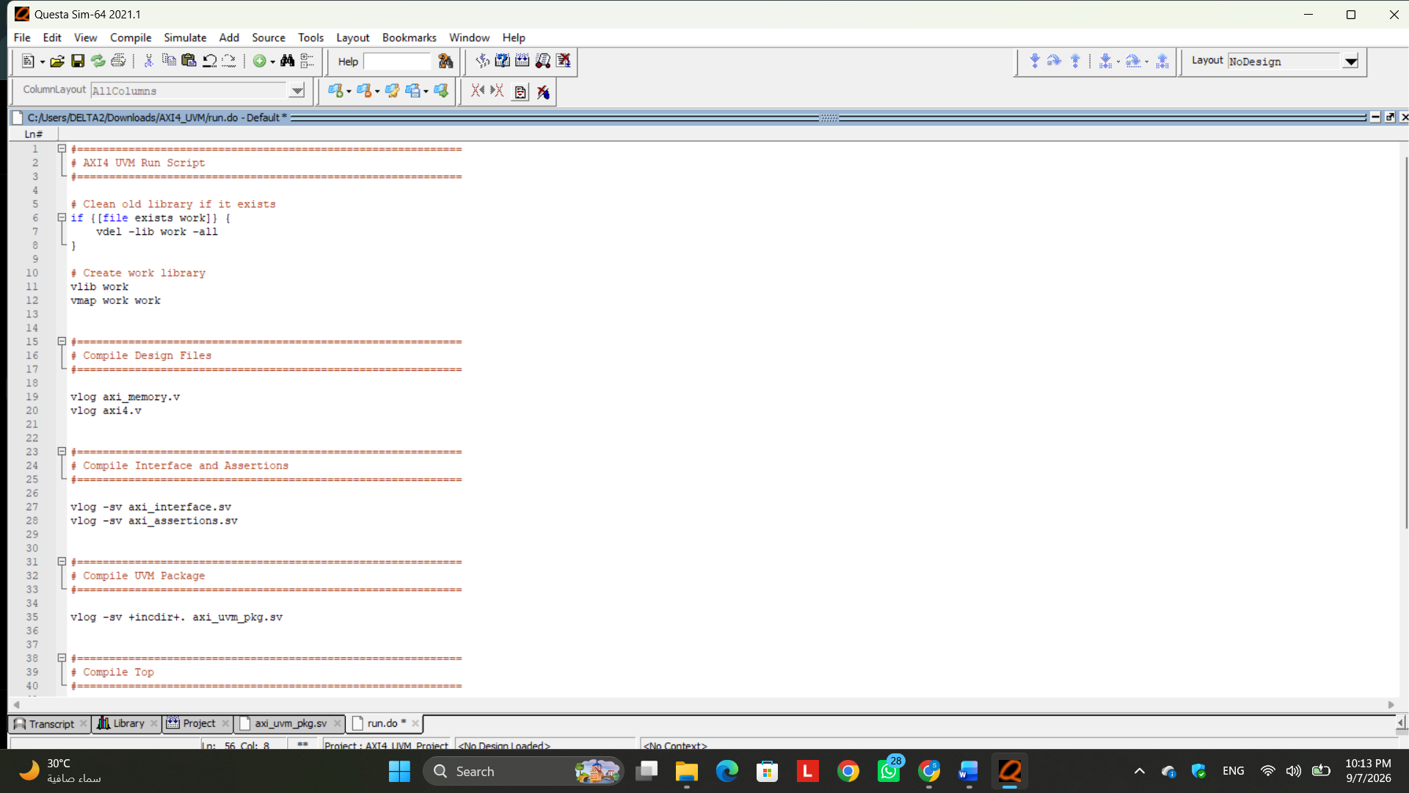
Figure 15. Verification project evidence / implementation snapshot

Simulation Results - Initial UVM Regression
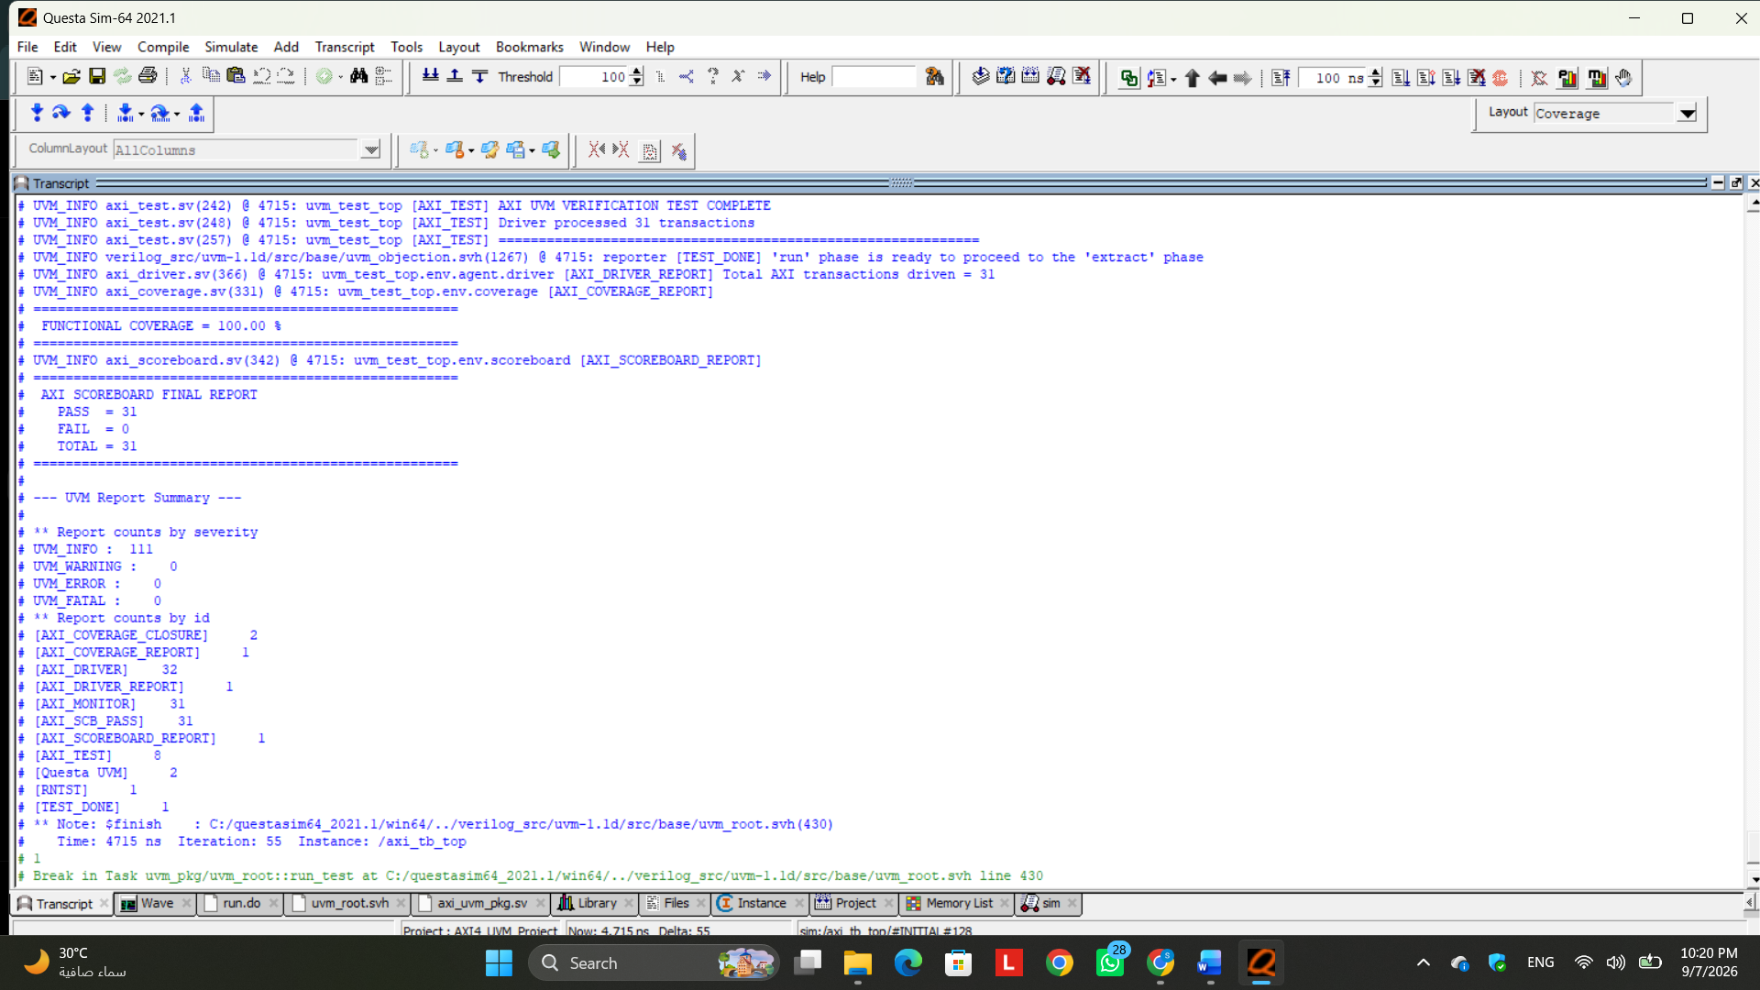
Figure 16. Verification project evidence / implementation snapshot

Technical Commentary
The final UVM regression completed successfully with 31 AXI transactions, all of which passed the scoreboard with 31 PASS, 0 FAIL, and 31 TOTAL. Functional coverage reached 100%, with all 44 out of 44 defined coverage bins successfully exercised. The previous coverage gap in the READ × SLVERR cross was closed by adding an invalid-address read transaction, allowing the environment to exercise and verify the expected error response for both read and write operations. All coverpoints and cross-coverage targets consequently achieved 100% coverage. No UVM warnings, errors, or fatal messages were reported, confirming correct end-to-end operation of the current UVM verification environment.

Memory Interface
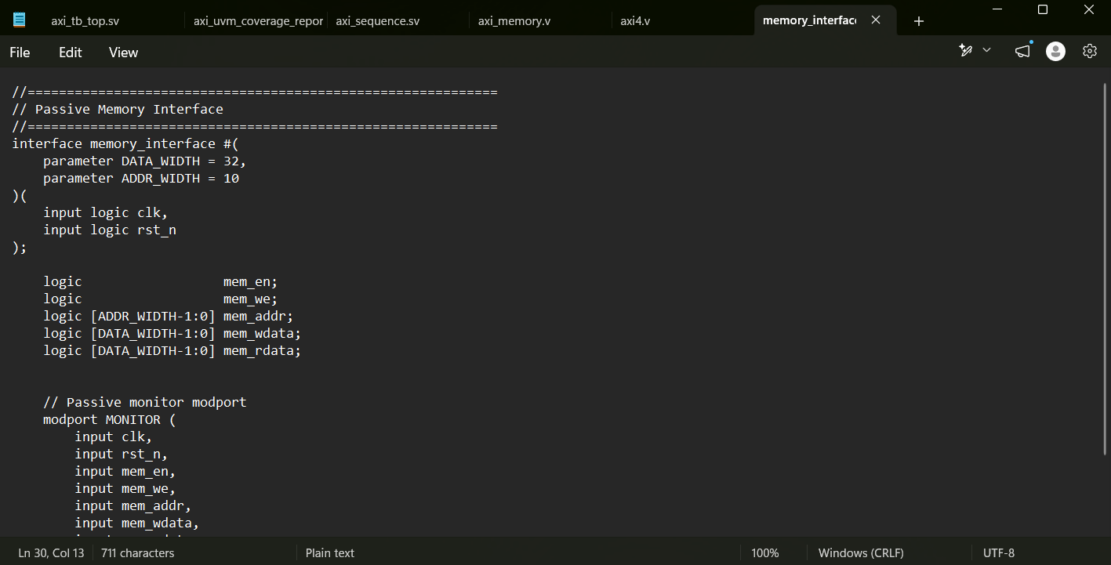
Figure 17. Verification project evidence / implementation snapshot

Technical Commentary
The memory_interface.sv file was added to provide a clean observation point for the internal memory-side signals of the DUT. It contains the memory enable, write enable, address, write data, and read data signals, in addition to the clock and reset. Since the memory verification agent is passive, the interface includes a MONITOR modport that only allows observation of these signals. The interface does not drive the DUT and is used only to connect the internal DUT memory signals to the UVM memory monitor through a virtual interface.

Memory Transaction
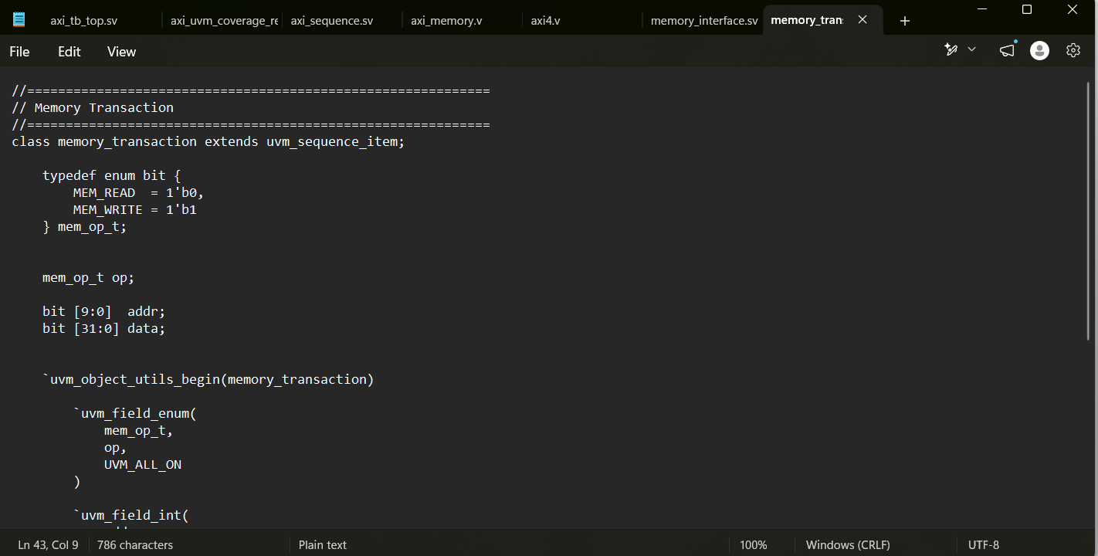
Figure 18. Verification project evidence / implementation snapshot

Technical Commentary
The memory_transaction.sv file defines the transaction object used by the passive memory verification components. It extends uvm_sequence_item and represents a single memory access. Each transaction contains the operation type, memory address, and associated data. The operation is represented using an enumeration that distinguishes between memory read and memory write operations. The class is registered with the UVM factory to allow standard UVM object creation and future factory-based customization.

Memory Monitor
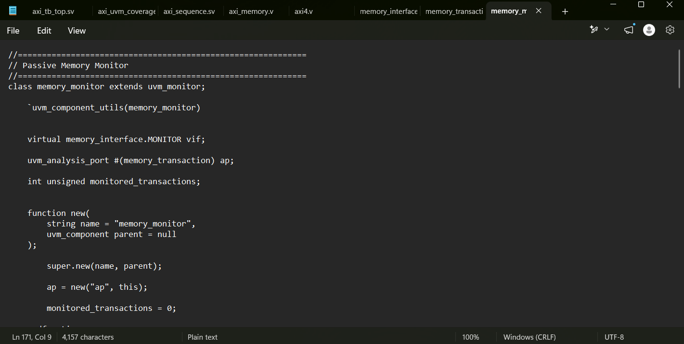
Figure 19. Verification project evidence / implementation snapshot

Technical Commentary
The memory_monitor.sv file implements a passive UVM monitor for the internal memory interface. It observes mem_en, mem_we, mem_addr, mem_wdata, and mem_rdata without driving any signal. Whenever a valid memory access is detected, the monitor reconstructs the operation into a memory_transaction object and sends it through a UVM analysis port. For write accesses, the address and write data are captured directly. For read accesses, the monitor accounts for the synchronous memory behavior by sampling the read data after the memory output has been updated. The generated transactions are then distributed to the memory checker and memory coverage components.

Memory Agent
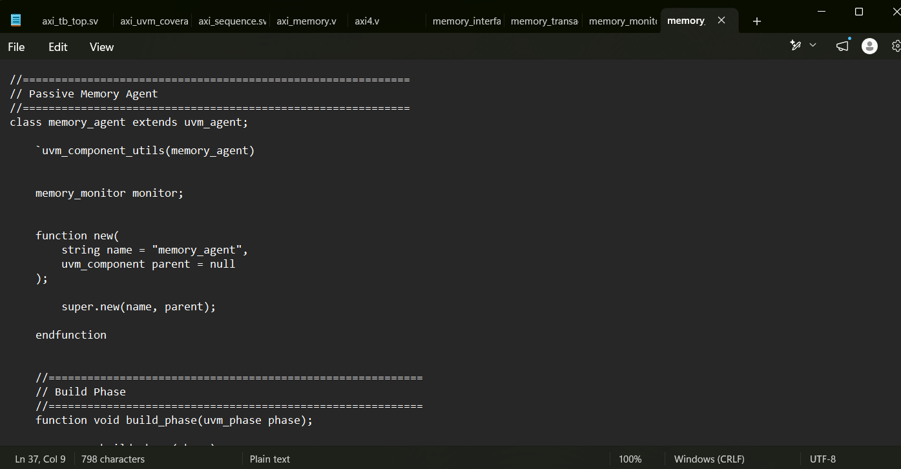
Figure 20. Verification project evidence / implementation snapshot

Technical Commentary
The memory_agent.sv file defines the passive memory UVM agent. Unlike the active AXI agent, this agent does not require a sequencer or driver because it does not generate stimulus. Its only purpose is to contain and manage the memory_monitor. This structure follows the standard UVM passive-agent architecture and allows the internal DUT-to-memory activity to be monitored independently from the AXI bus activity.

Memory Checker
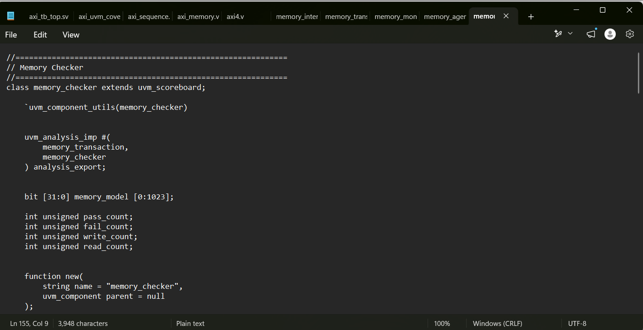
Figure 21. Verification project evidence / implementation snapshot

Technical Commentary
The memory_checker.sv file implements the checking mechanism for internal memory operations. It maintains a reference memory model that mirrors the expected content of the DUT memory. Whenever a write transaction is received, the corresponding location in the reference model is updated with the written data. Whenever a read transaction is received, the actual data observed from the DUT memory is compared with the expected value stored in the reference model. The checker maintains separate counters for reads, writes, passed comparisons, and failed comparisons, and reports the final results during the UVM report_phase.

Memory Functional Coverage
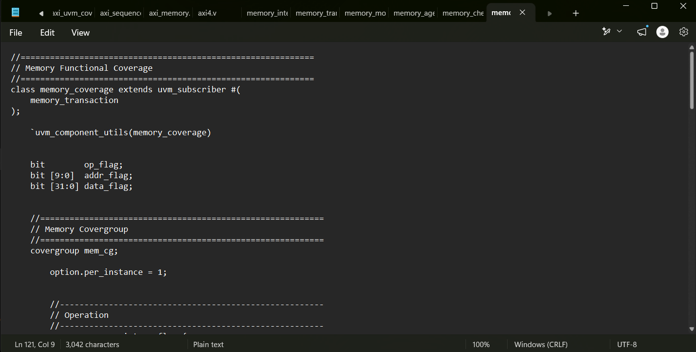
Figure 22. Verification project evidence / implementation snapshot

Technical Commentary
The memory_coverage.sv file provides functional coverage for the internal memory operations. It extends uvm_subscriber and receives transactions directly from the passive memory monitor. The covergroup tracks the type of memory operation, different address regions, and representative data categories such as zero, all ones, and other values. It also includes cross coverage between the operation type and the memory address region. This coverage component verifies that memory reads and writes are exercised across different portions of the memory space and provides a final coverage percentage during the UVM report_phase.

Memory Coverage Closure Results
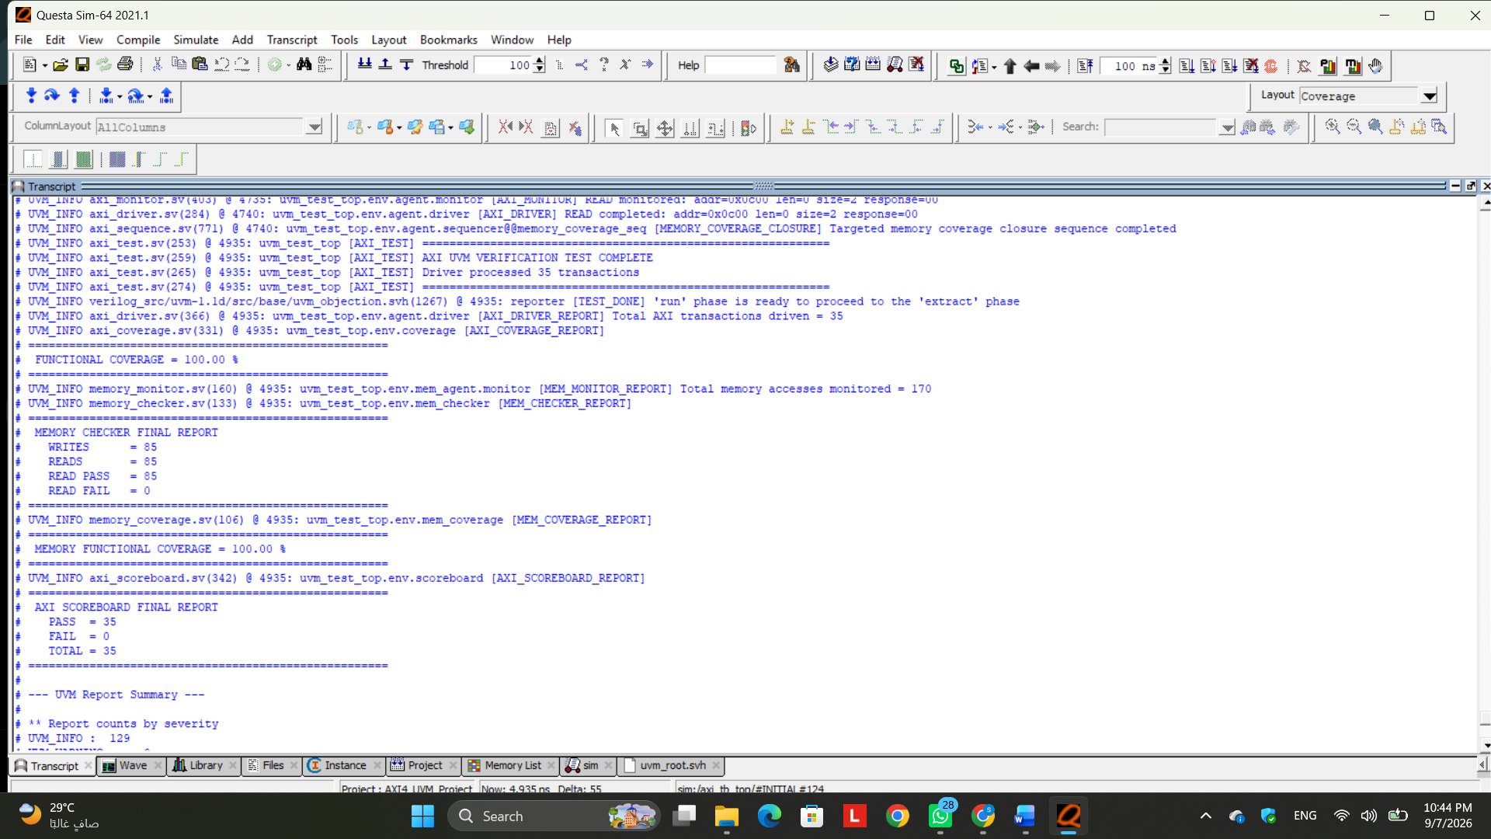
Figure 23. Verification project evidence / implementation snapshot
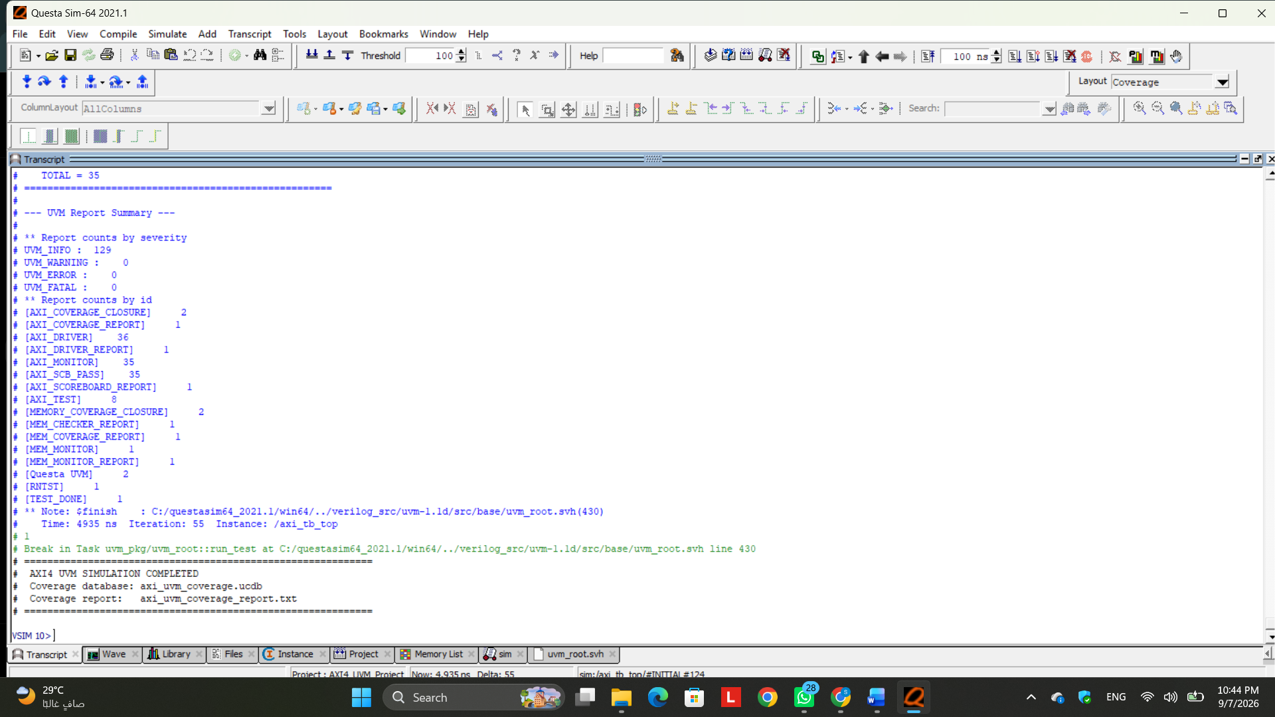
Figure 24. Verification project evidence / implementation snapshot

Technical Commentary
The final UVM regression was completed successfully after adding the directed memory coverage closure sequence. The AXI driver processed a total of 35 transactions, and all transactions were verified successfully by the AXI scoreboard with 35 PASS, 0 FAIL, and 35 TOTAL. The AXI functional coverage remained at 100%, confirming that the previously achieved protocol-level coverage was preserved after extending the environment.
The passive memory verification environment also operated correctly. The memory monitor observed 170 internal memory accesses, consisting of 85 writes and 85 reads. The memory checker successfully verified all read operations, reporting 85 READ PASS and 0 READ FAIL, which confirms that the internal memory contents and read-back behavior matched the expected reference model for every monitored access.
The additional directed transactions targeting the previously uncovered MID2 and HIGH memory address regions, together with the 0xFFFF_FFFF data pattern, successfully closed the remaining memory coverage gaps. As a result, the Memory Functional Coverage reached 100%.
The final UVM report also showed 0 warnings, 0 errors, and 0 fatal messages, confirming that the complete verification environment was executed cleanly. These results demonstrate successful end-to-end verification of both the external AXI interface and the internal memory behavior, with full functional coverage achieved for both verification domains.

Delayed AXI Driver and Factory Override
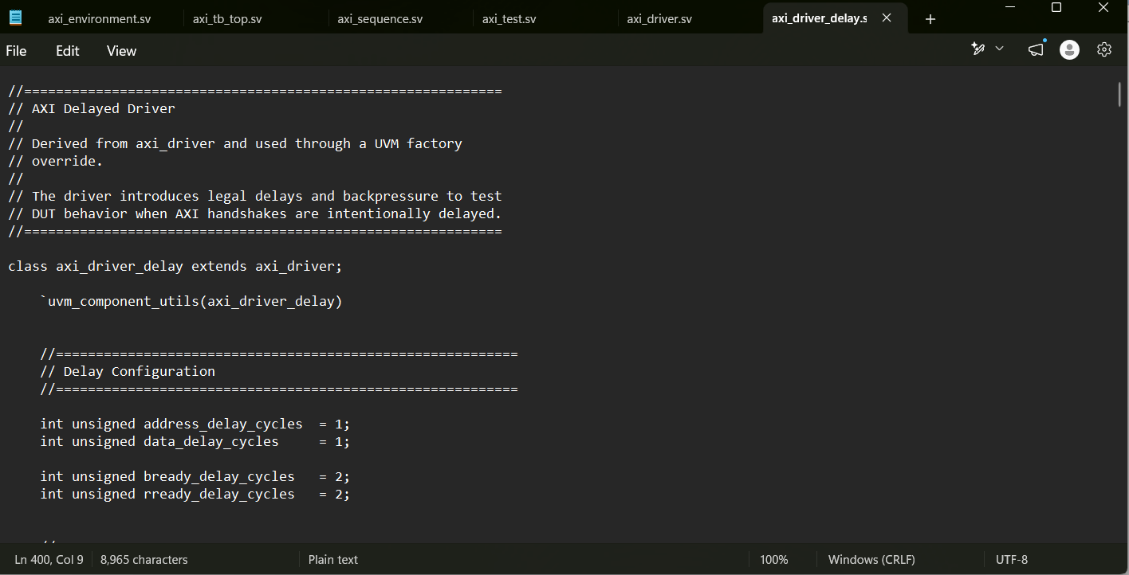
Figure 25. Verification project evidence / implementation snapshot

Technical Commentary
The axi_driver_delay.sv file implements a derived UVM driver that extends the original axi_driver and is selected through a UVM factory override. Its purpose is to introduce intentional and protocol-legal delays into AXI transactions in order to verify DUT behavior under delayed handshake and backpressure conditions.
For write transactions, the delayed driver inserts configurable latency before the write-address phase and between write-data beats. It also intentionally keeps BREADY low for several clock cycles after BVALID is asserted, forcing the DUT to hold the write response stable until the handshake is completed.
For read transactions, the driver inserts address delay and intentionally holds RREADY low after the DUT asserts RVALID. This creates read-channel backpressure and verifies that RVALID, RDATA, RRESP, and RLAST remain stable while the receiver is not ready.
The class overrides the virtual drive_write() and drive_read() tasks of the base driver while reusing the existing UVM sequencing and transaction flow. Using this driver through the UVM factory demonstrates component replacement without modifying the AXI agent itself and provides additional stress testing for AXI stability and backpressure behavior.

Delayed Driver Regression Results
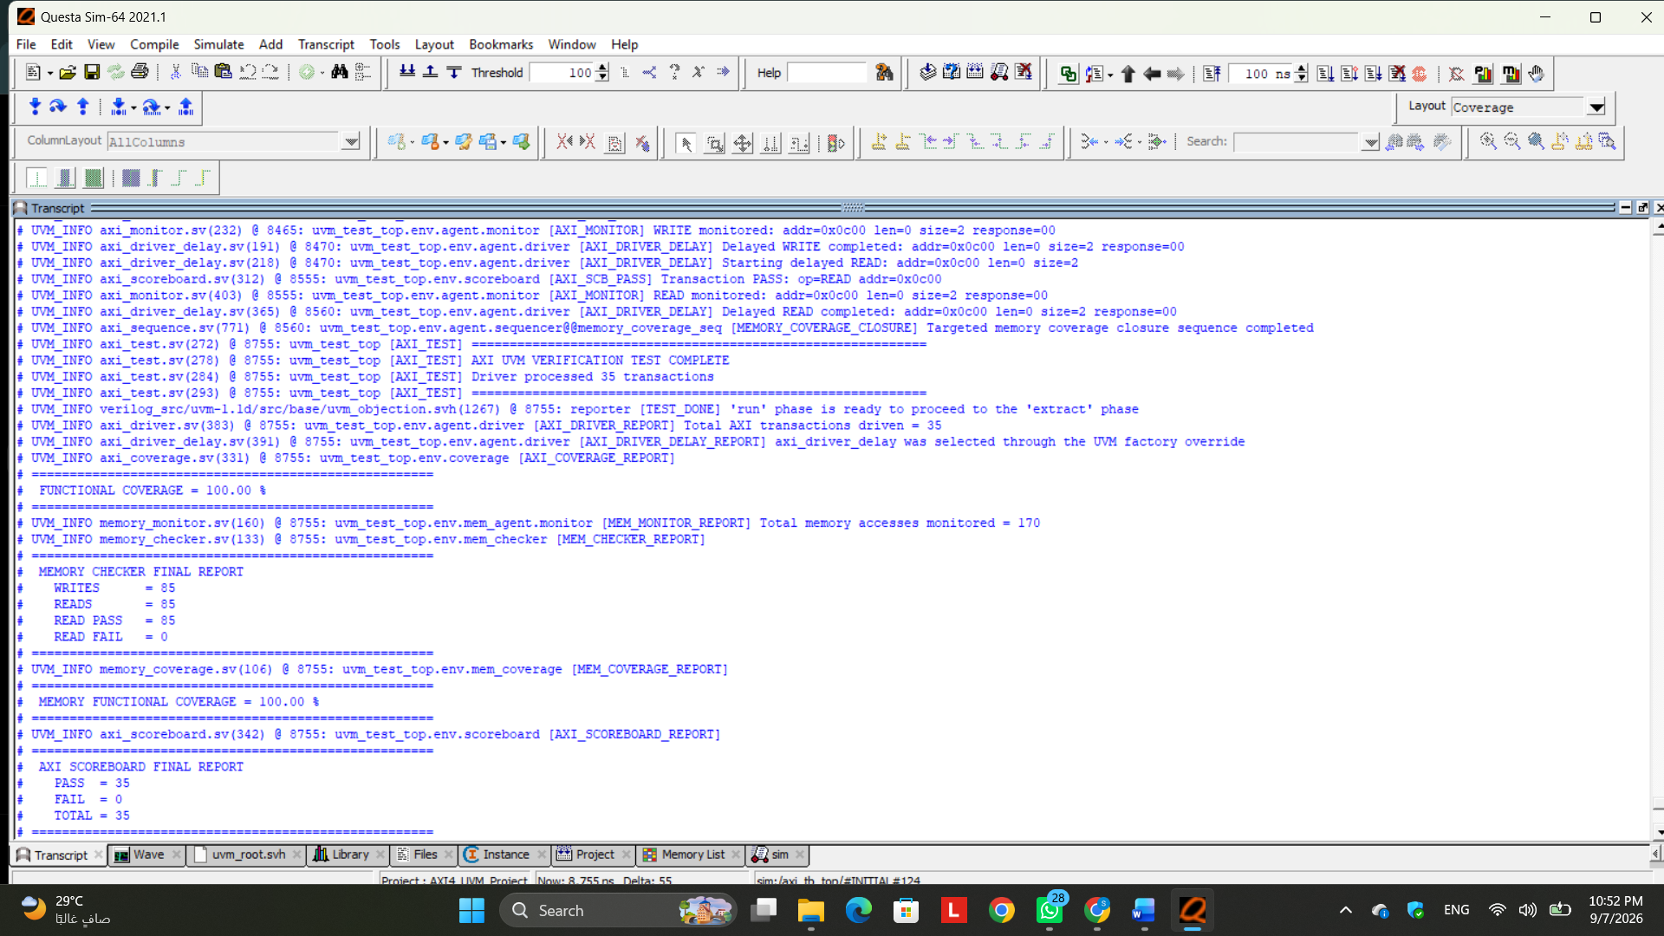
Figure 26. Verification project evidence / implementation snapshot
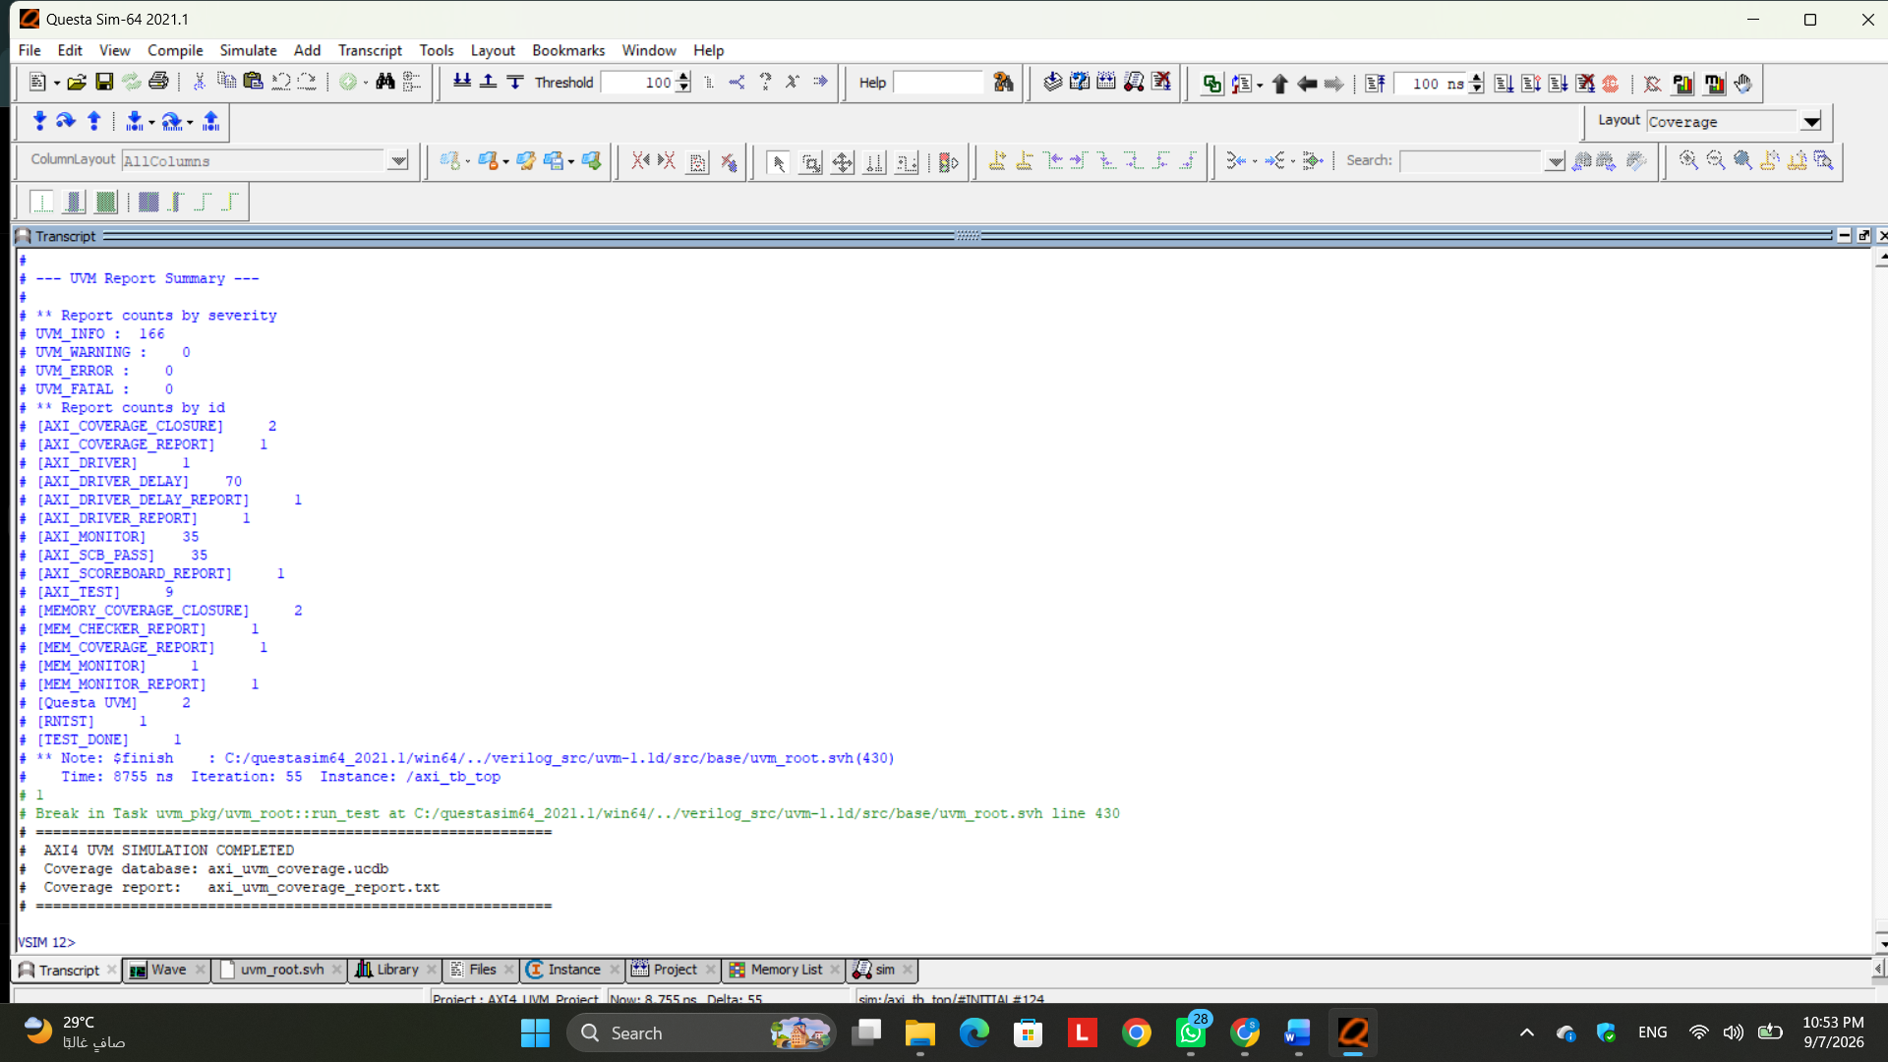
Figure 27. Verification project evidence / implementation snapshot

Technical Commentary
The final simulation confirms that the axi_driver_delay was successfully integrated and activated using the UVM factory override. The report explicitly confirms that the delayed driver was selected instead of the original axi_driver, demonstrating that component substitution was achieved without modifying the AXI agent architecture.
The delayed driver successfully applied the additional timing delays and legal AXI backpressure while executing the complete regression. Despite these additional stress conditions, the driver completed all 35 AXI transactions, and the AXI scoreboard reported 35 PASS, 0 FAIL, and 35 TOTAL, confirming that the DUT continued to operate correctly under the delayed handshake conditions.
The AXI functional coverage remained at 100%, while the passive memory environment monitored 170 memory accesses. The memory checker reported 85 writes, 85 reads, 85 successful read comparisons, and 0 failures, and the Memory Functional Coverage remained at 100%.
Finally, the UVM report summary showed 0 warnings, 0 errors, and 0 fatal messages. These results confirm that the factory override and delayed-driver implementation were successfully introduced without affecting the previously achieved verification results, while providing additional stress testing of the DUT under controlled AXI delay and backpressure conditions.

Final Verification Closure Results
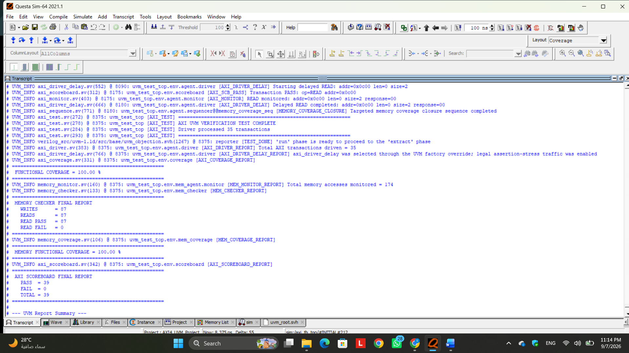
Figure 28. Verification project evidence / implementation snapshot
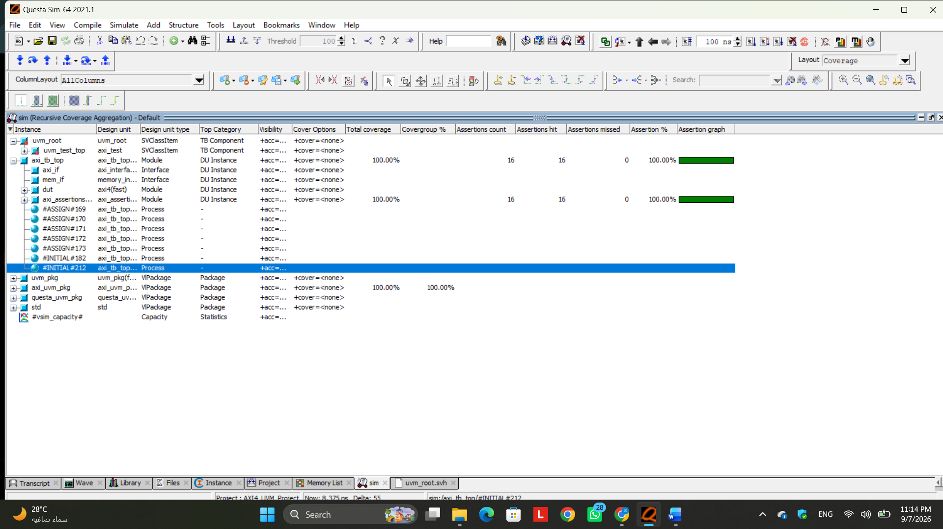
Figure 29. Verification project evidence / implementation snapshot

Technical Commentary
The final UVM regression demonstrates successful verification closure of the AXI4 design. The delayed driver, selected through the UVM factory override, introduced legal assertion-stress traffic and controlled backpressure conditions to exercise protocol scenarios that were previously vacuous.
The Assertion Coverage reached 100% (16/16 assertions) with zero assertion failures. In particular, the previously uncovered AW, W, and AR stability properties were successfully exercised. The AW stability assertions recorded 7 successful non-vacuous passes, the W stability assertions recorded 20 passes, and the AR stability assertions recorded 8 passes. This confirms that the driver successfully generated valid stall conditions while maintaining VALID and the associated payload signals stable until the corresponding handshake could complete. The B and R channel stability assertions were also fully exercised through controlled BREADY and RREADY backpressure.
The complete regression also maintained 100% AXI functional coverage, covering all 44/44 AXI coverage bins, and 100% memory functional coverage, covering all 16/16 memory coverage bins. The AXI scoreboard reported 39 PASS, 0 FAIL, and 39 TOTAL transactions. The increase from 35 sequence-driven transactions to 39 monitored transactions is expected because four additional legal AXI transactions were generated by the assertion-stress phase. The memory checker also reported 87 writes, 87 reads, 87 successful read comparisons, and 0 failures.
Finally, the UVM report completed with 0 warnings, 0 errors, and 0 fatal messages. Therefore, the final results confirm that the AXI4 UVM environment achieved complete functional and assertion coverage while maintaining correct DUT behavior under normal operation, delayed handshakes, and protocol-legal backpressure conditions.

