**Text-to-Speech**

• Sign in to the [Azure portal](https://portal.azure.com/) using your Microsoft account.

• Select Create a resource at the top left of the portal. If you do not see Create a resource, you can always find it by selecting the collapsed menu in the upper left corner of the screen.

• In the New window, type "speech" in the search box and press ENTER.

• In the search results, select Speech.

Note: Select your region (East US, West US 2, South Central US, Southeast Asia, UK South, West Europe, Australia East) to be able to use Custom Neural Voice features

After filling your data click on create.

Go to Your resource and from resource management select Keys and Endpoint and save your keys (anyone of them) and region to use them in your code later

First you will need to install Speech SDK:

pip install azure-cognitiveservices-speech

Import the required libraries

from azure.cognitiveservices.speech import AudioDataStream, SpeechConfig, SpeechSynthesizer, SpeechSynthesisOutputFormat

from azure.cognitiveservices.speech.audio import AudioOutputConfig

save your key and region into variables



Create your SpeechConfig object



If you are going to get the audios for multiple languages and you have saved each language in a text file you need to know your Neural Voice for that language

Note: the default voice is the English one so if your text is in English you can skip this step.



Here I am going to read an Egyptian Arabic text from a file so I need an Egyptian Arabic voice

To know your voice name (Male/Female) for any language you will need to open Speech Studio <https://speech.microsoft.com/> and sign in

From Text-to-speech select Voice Gallery and select your Resource or you can create a new one from here too

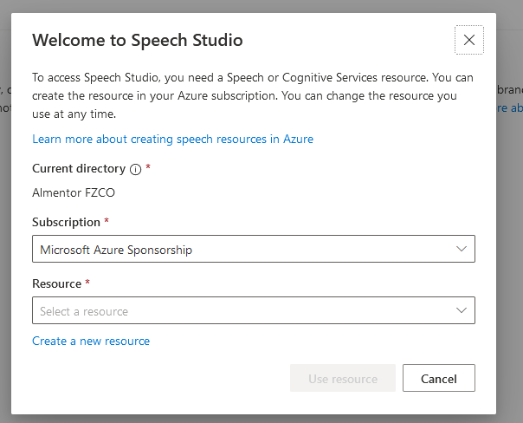

After choosing/creating your Resource You will find All The available voices and you can filter them by Gender/Language

Back To our CODE !!

Create your audio object that will create the audio for you



Note: WAV, PCM, 16bit, 8kHz/16kHz mono or stereo. MP3, PCM, 16-bit, 8kHz/16kHz mono or stereo 🡪 These are the available formats for your audio feel free to use anyone of them

Then you will need to create synthesizer object that will use your SpeechConfig object and audio object

Use speak_text_async method to convert text into audio

