Hospital Computerized Maintenance Management System (CMMS)

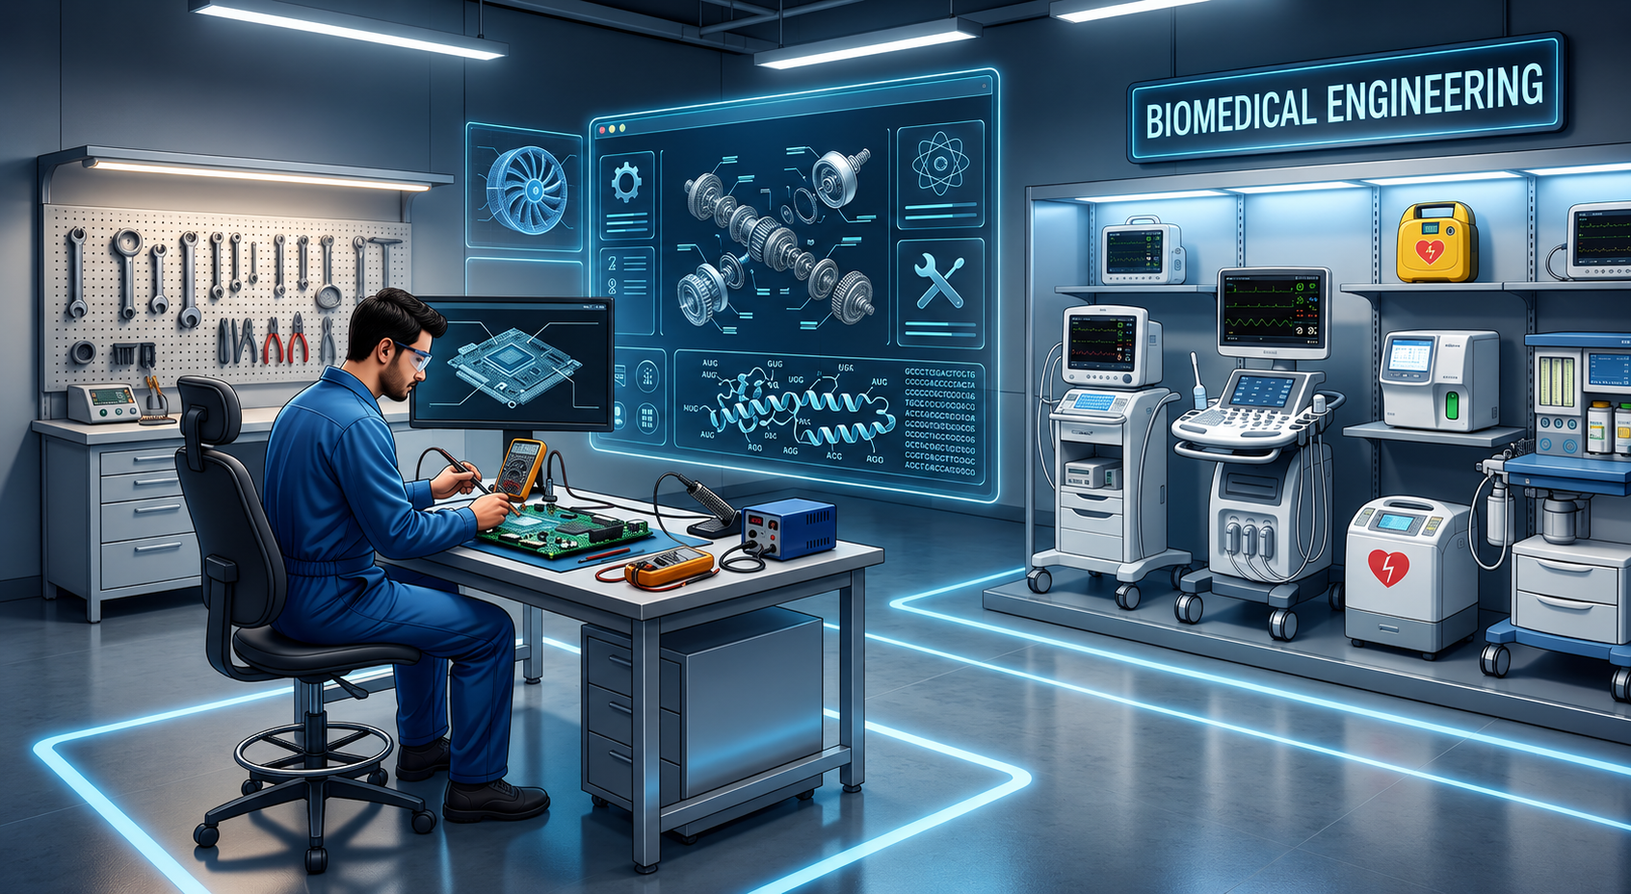

Supervised by Eng. Ezz Eldeen
Made By Sondos mohammed

1. Abstract
Hospitals rely on medical equipment to provide safe and effective healthcare services. This project presents a web-based Hospital Computerized Maintenance Management System (CMMS) that digitalizes maintenance requests, work orders, device management, and maintenance tracking using the MERN stack.

2. Introduction
Medical equipment maintenance is critical for patient safety. Traditional manual workflows cause delays and poor tracking. The proposed CMMS centralizes maintenance operations for doctors, nurses, biomedical engineers, technicians, and administrators.

3. Problem Definition
Current maintenance processes are often paper-based and inefficient. The system provides secure authentication, device management, maintenance requests, work orders, notifications, dashboards, and reporting.

4. System Architecture & Technologies
React Frontend
│
REST API (Express)
│
Node.js Backend
│
MongoDB

4.3 User Roles
The system supports four different user roles.

Staff (Doctor/Nurse)
- Login
- Submit maintenance requests
- Track request status
- Receive notifications

Biomedical Engineer
- Review maintenance requests
- Create work orders
- Assign technicians
- Manage devices

Technician
- View assigned work orders
- Perform maintenance
- Update maintenance status

Admin
- Manage users
- Manage roles
- View reports
- Configure system

4.4 Database Design
The database consists of the following collections:

Users
- userID
- name
- email
- password
- role

Devices
- deviceID
- name
- serialNumber
- manufacturer
- supplier
- status
- priority
- purchaseDate

Departments
- departmentID
- name
- location

Maintenance Requests
- requestID
- requestDate
- issueDescription
- priority
- status

Work Orders
- workOrderID
- assignedDate
- completionDate
- status

4.6 Technologies Used

Layer | Technology
Frontend | React.js
Backend | Node.js
Framework | Express.js
Database | MongoDB
Authentication | JWT
Password Encryption | bcrypt
API Testing | Postman
Version Control | Git & GitHub
UI Styling | Tailwind CSS

5. Implementation & Dependencies

Backend
Implemented using:
- Node.js
- Express.js
- MongoDB
- Mongoose
- JWT Authentication
- bcrypt
- dotenv
- cors
- multer

Main APIs
- Authentication API
- Users API
- Devices API
- Maintenance Requests API
- Work Orders API
- Notifications API

Frontend
Developed using React.
Implemented pages include:
- Login
- Register
- Dashboard
- Devices
- Work Orders
- Reports
- Notifications
- User Management
- Settings

6. Achievements & Progress
- Authentication,
- Role-based access,
- Device Management,
- Maintenance Requests,
- Dashboard UI,
- Work Orders,
- REST APIs,
- Database Integration,
- Responsive Design,
- Real-time notifications,
- QR codes,
- preventive maintenance scheduling,
- AI-based maintenance prediction,
- PDF/Excel reports,
- cloud deployment.
- Chatbot
- live chat

7. Future Work

Mobile App

8. References
- MongoDB Documentation — https://www.mongodb.com/docs/
- React Documentation — https://react.dev/
- Express.js Documentation — https://expressjs.com/
- Node.js Documentation — https://nodejs.org/
- Mongoose Documentation — https://mongoosejs.com/
- JWT Documentation — https://jwt.io/
- Tailwind CSS Documentation — https://tailwindcss.com/
- Chart.js Documentation — https://www.chartjs.org/
- GitHub Repository:
https://github.com/sondosmohammed0100-cmyk/Graduation_Proj

UML Class Diagram
