1. What is Boolean ?

* A Boolean value is either true or false.

Expression 1: 6 == (2+4) => true

6 == 2 => false

Expression2: t = “ th”

T + “anks” == “thanks” => true

Expression3: 3 x 3 == 9 => true

1. What is a flow chart ?

* Flowchart is a diagram of the sequence of movements or actions of people or things involved in a complex system or activity

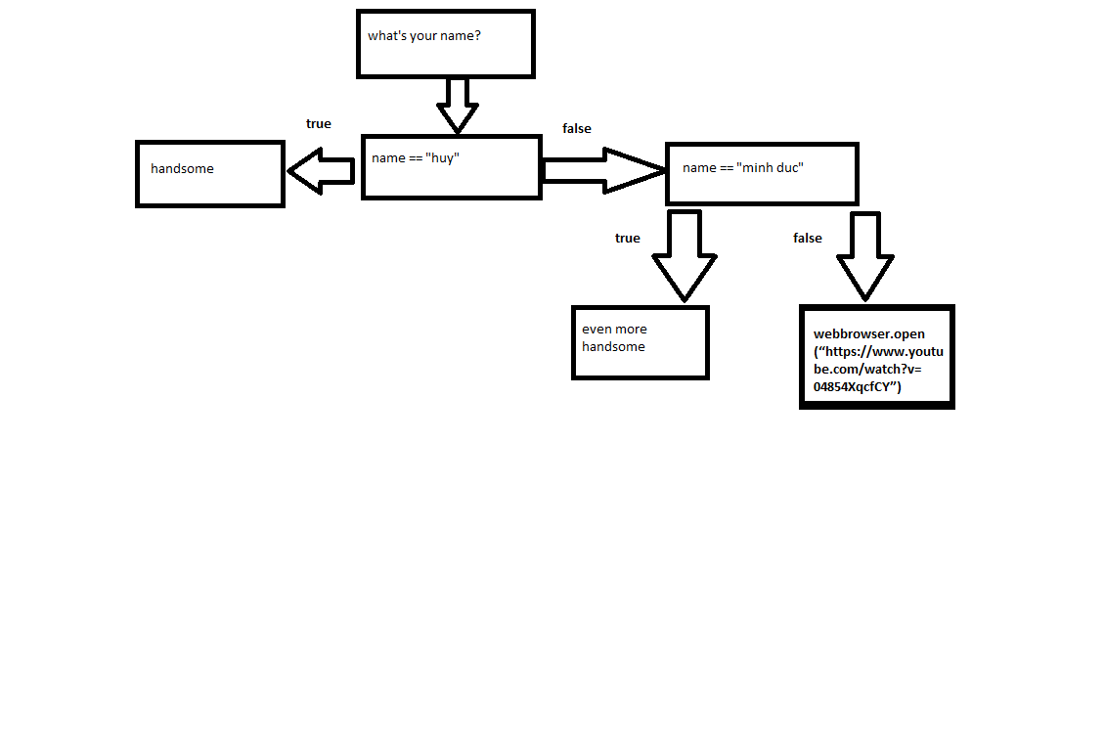

1. What is nested conditional ?

* Nested conditional is a conditional that nested within another

Example:

if x > y:

Print(“x is bigger than y”)

Else:

If x < y:

Print(“x is smaller than y”)

Else:

Print(“x and y are equals”)