EDFApplication – Sample Usage and Tutorial – Modify/Create EDF File with selected Signals/Channels.
Requirements:
- EDFChecker from http://www.edfplus.info/downloads/software/edfchecker.zip
- And the Solution File for EDFApplication from http://www.codeplex.com/edf

The ability to Load an EDF File, select some of its channels/signals and save it as a new EDF File.
Here is the original/source EDF File as seen in EDF Checker. Notice the NrSignals is 22, because there are 22 signals/channels in the file. (please note: because the 22 signal EDF file was over 60Mb; I was not able to commit it to SVN on codePlex, you will find a 5 signal EDF file example for which you can extract and save the Body and SpO2 channel/signals: PG123456_A0002338_5.edf).
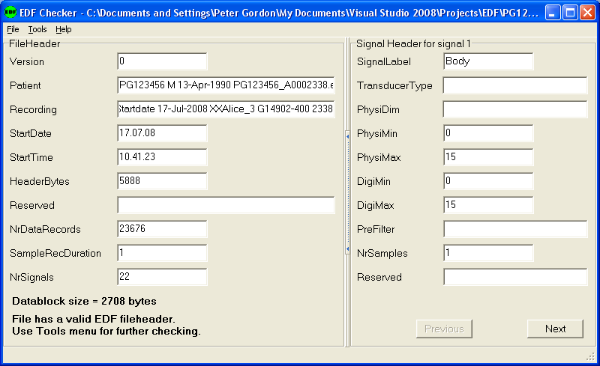

This shows the first script, and preparation for Opening an EDF file by selecting File | Open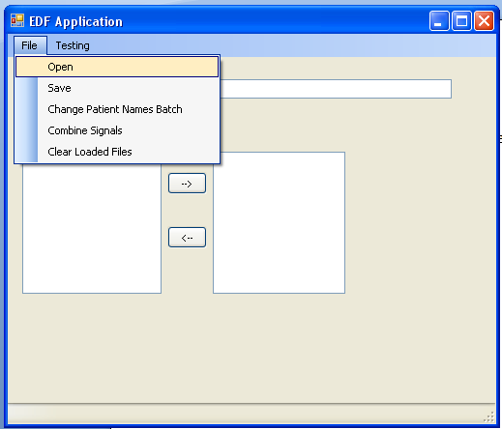
It takes about 10 seconds to Open a complete Polysomnography with 22 channels/signals recorded over night ~8 hours.

After opening an EDF file, the channels/signals in the EDF file show on the left side.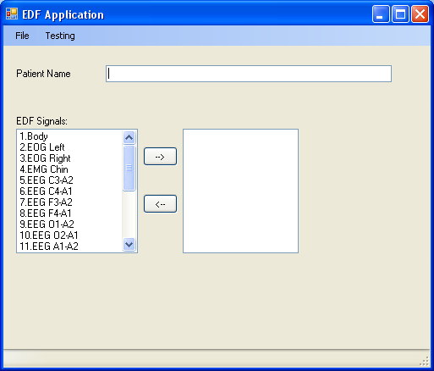

Select channels/signals and move/copy them to the right side (output EDF File channel/signals)
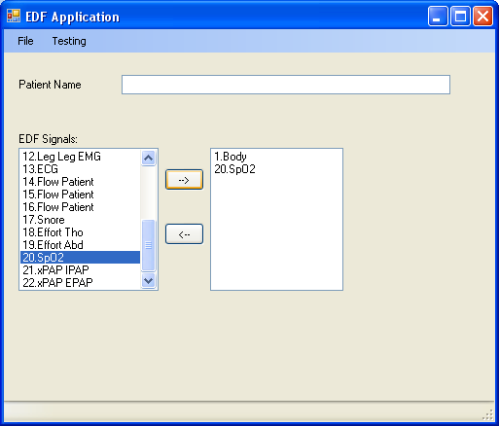

Select File | Save to save the output file with only the two channels.
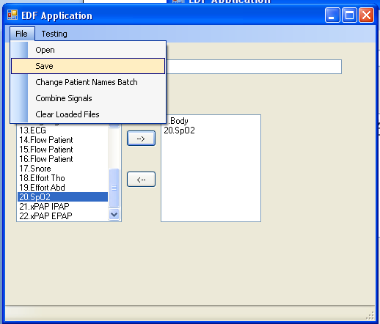
After the new File has been saved, here is the newly saved file opened in EDFChecker showing it as only containing the two channels (Body and SpO2).