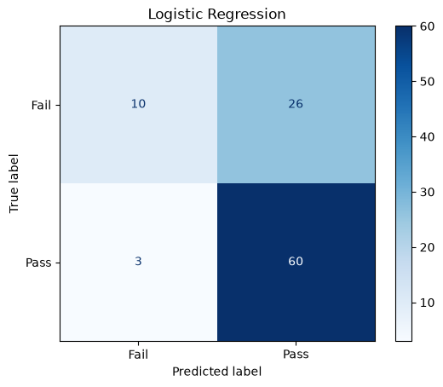
Task 1:
This I the accuary
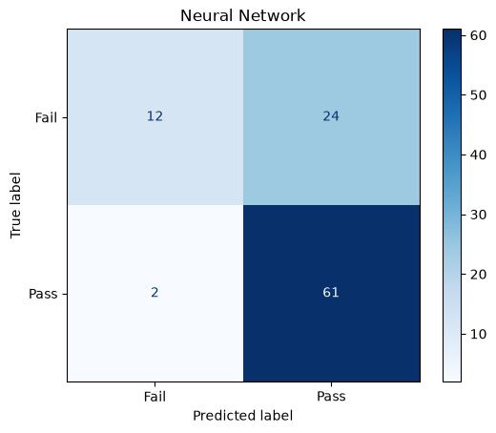
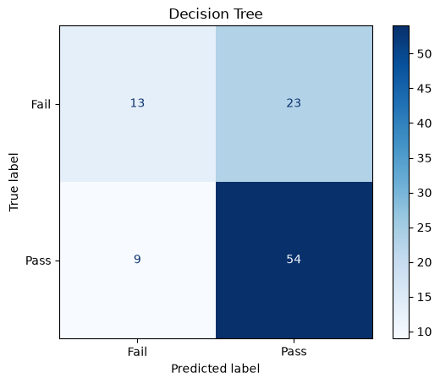
Logistic Regression: 0.7070707070707071
Decision Tree: 0.6767676767676768
Neural Network: 0.7373737373737373

The three models had fairly similar accuracy. Logistic Regression achieved an accuracy of 0.707, the Decision Tree achieved 0.677, and the Neural Network achieved 0.737. This means that the Neural Network performed best on this particular test set. However, the difference between each model is only around 3 percentage points, so the improvement is relatively small. The difference between the best and worst model is about 6 percentage points.
Looking at the confusion matrices gives more information about how the models performed. The Neural Network correctly predicted 61 students who passed and only incorrectly predicted 2 passing students as failing. Logistic Regression correctly predicted 60 passing students and incorrectly classified 3 of them. The Decision Tree performed slightly worse for this group, correctly predicting 54 and incorrectly predicting 9.
However, all three models had more difficulty predicting students who actually failed. Possibly because the dataset includes more examples of failing students. The Neural Network, for example, correctly predicted 12 failing students but incorrectly classified 24 of them as passing. This shows that the accuracy score does not tell the whole story.
The Neural Network is the most complex of the three models and did achieve the highest accuracy, but only by a small margin. Therefore, these results do not necessarily mean that a Neural Network is generally better. The result is based on one particular train/test split, and performance could be different with another split or dataset.

Task 2
For this experiment, I changed the neural network architecture from (8,) to (8, 4). The original network had one hidden layer with 8 neurons, while the new network has two hidden layers, with 8 neurons in the first layer and 4 in the second. Everything else, including the predictors and train/test split, was kept the same.
The original neural network had an accuracy of 73.7%, while the new architecture achieved approximately 72.7%. This is a decrease of about one percentage point. The difference is therefore quite small, but adding another hidden layer did not improve the model in this experiment.
One possible explanation is that the additional complexity was not useful for this dataset. The model only uses three features: study time, previous failures, and absences. The relationship between these features and whether a student passes may not be complex enough to benefit from an additional hidden layer. A more complex network can learn more complicated patterns, but that does not necessarily mean that it will make better predictions.
This result does not clearly prove that the (8,) architecture is generally better. The difference is very small and the result is based on one particular dataset and train/test split. A different split or dataset could produce different results.

