1. How Magento auto load class? Where is the auto loading implementation? Path finding and naming convention?

* Magento use functions to implement autoloading are “__autoload()” and “spl_autoload_register()”.
* There are two main files in magento for auto loading

- “Varien_Autoload” class located at “lib\Varien\Autoload.php”.

- Mage.php file located at ‘app/Mage.php’.

2. How to use magic method in Magneto? Where do Magento set/get data when calling magic method?

* Magento use magic method through the use of the Varien_Object class. It accesses or manipulates the protected $_data array within the object, get fetches the data, set sets new data in the key, uns unsets data from that key, and has returns a boolean value on whether or not that key exists in the array. It manipulate with data through _underscore() method.

3. Where will Magento store log detail when an exception happens?

* If a fatal error occurs, a report is created in var/report (and an email is sent - depending on configuration) and on other occasions an error message is logged in var/log/exception.log.

4. Difference between namespace and traditional include/require ?

* Namespaces are not just for autoloading classes. They also prevent naming conflicts. Include/require is not prevents naming conflicts.

5. How cookie and session work and transfer between server and client?

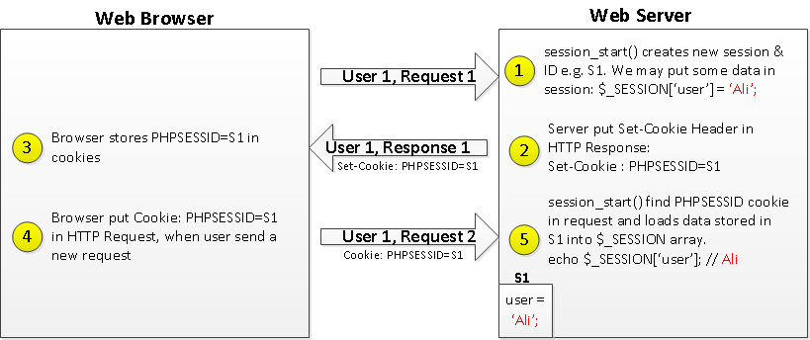

* Firstly PHP creates a 16-byte long unique identifier number (stored as a string of 32 hexadecimal characters, e.g a86b10aeb5cd56434f8691799b1d9360) for an individual session.
* PHPSESSID cookie passes that unique identification number to users' browser to save that number.
* A new file is created on the server with the same name of unique identification number with sess_ prefix (ie sess_a86b10aeb5cd56434f8691799b1d9360.)
* The browser sends that cookie to the server with each request.
* If PHP gets that unique identification number from PHPSESSID cookie (on each request), then PHP searches in the temporary directory and compares that number to the file name. If both are the same, then it retrieves the existing session, otherwise it creates a new session for that user.

6. List some AMD modules you see in Magento 2

* AMD modules are Requiresjs, knockoutjs.

7. What method can be used to debug in PHP? Where is PHP errr log in your local setup? How many PHP error level?

* Method debug in PHP: die(), echo, var_dump();
* File log in my local setup is /var/log/apache2/error.log
* There are 16 level PHP errors;

8. What information/features do we have in JS debugger built in browsers?

* The JavaScript Debugger enables step through JavaScript code and examine or modify its state to help track down bugs.