Check list
1. How do we decide when to use Magento Simple product type with custom options AND Magento configurable product ?

It’s up to you to decide whether to use custom options or configurable product.
Both approaches are aimed at creating customizable products on web shop. However, there is the difference in the outcome you get.

Characteristics | custom options of simple products | configurable product with associated products
Inventory Management | Inventory of custom option variants cannot be managed | Inventory management possibilities, since each variation is basically separate simple product with its inventory
Level of control | No control of variations in case you have several custom options like color and size | Flexibility and control over all variations including pricing, sku, etc
Easier to work in case you have... | Limited number of variants - for example only few colors | Big amount of product variations
Ability to sell each variation separately | No | Yes
SEO-friendly | No | Yes
Filtering/Search | Not available | Available
Complexity | Easy to create such products | Creating configurable product is quite complex task, and requires specific data to be added
From the first sight, Magento configurable product doesn’t seem to be an attractive solution, since it brings lots of work. From this point of view, custom options are easier to configure, but do not rush to conclusions too quickly, as configurable product has its own advantages that make the process totally worth efforts.
Using configurable product you will be able to create different product variations and sell them as a part of configurable products as well as independently. Each variation is basically separate product with its own SKU. So this is great approach from SEO viewpoint, as all your simple products will be indexed by the search engines.
With configurables you can track inventory for your product combinations, so in case you are running out of dress size S color white, that variant will automatically become not available for purchase. So this way you can avoid backorders and unsatisfied clients.
Magento custom options do not allow to set quantity of combinations. They are good for online merchants selling items with an unlimited stock number, for example, warranty or other services.
2. How to show product attributes on product view? Take a screenshot of what you have tested.
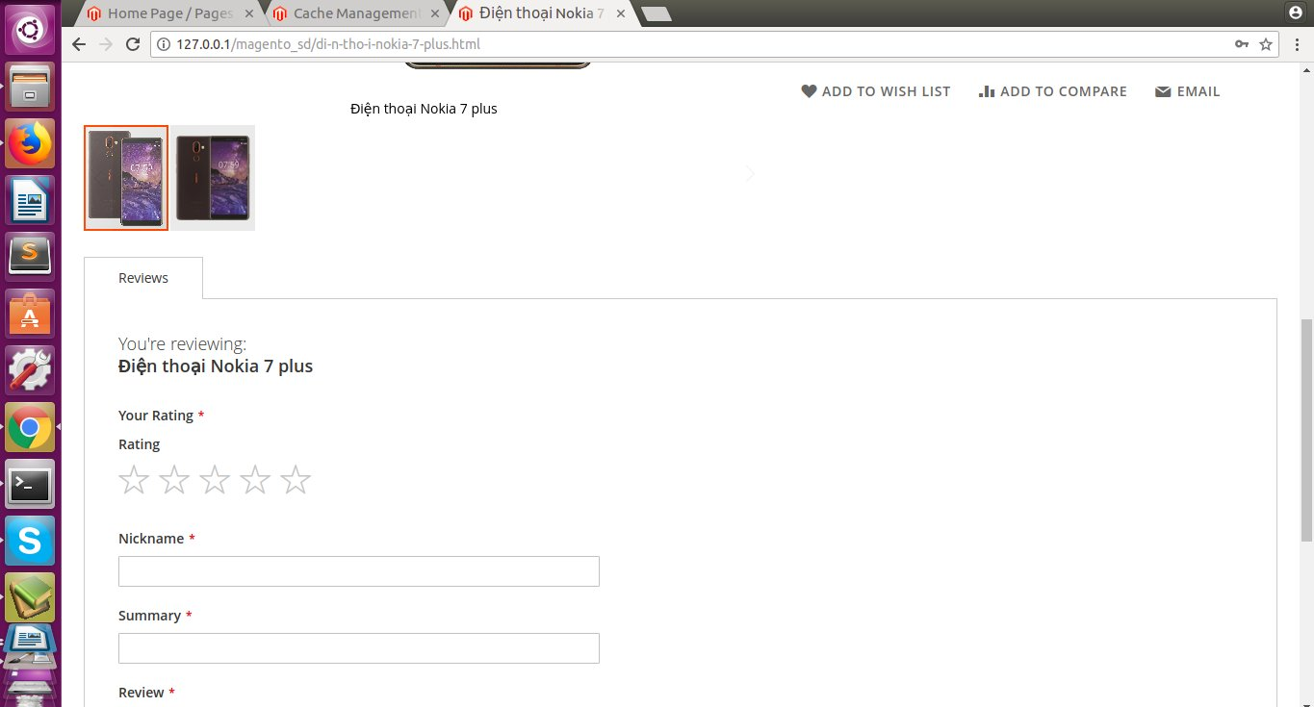
Image 1: hide “chất liệu” attribute
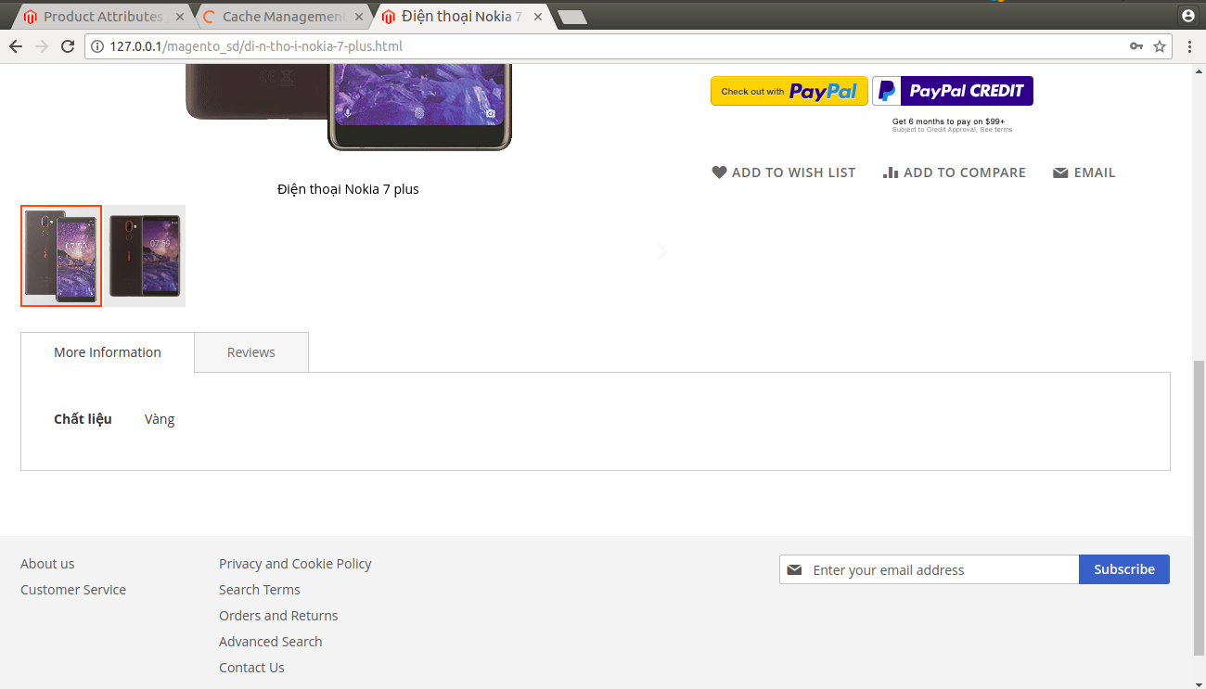
Image 2: show “chất liệu” attribute
Image 2:
First Go to Admin panel,
Click on Stores -> Attributes -> Product from left side menu.
Click on Attribute you want to display inside details page.
Now click on “Storefront Properties” tab from left sidebar, Set “Yes on Visible on Catalog Pages on Storefront”.
3. Please configure a layered navigation with a few attributes like size, color, genders and take a screenshot:
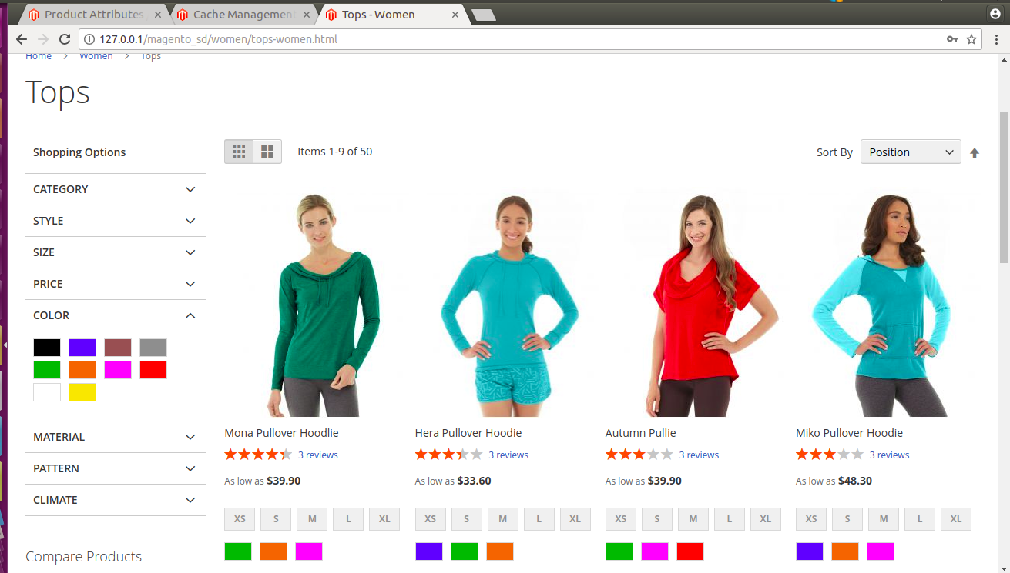
4. Setup color swatches on a sample configurable product and take a screenshot
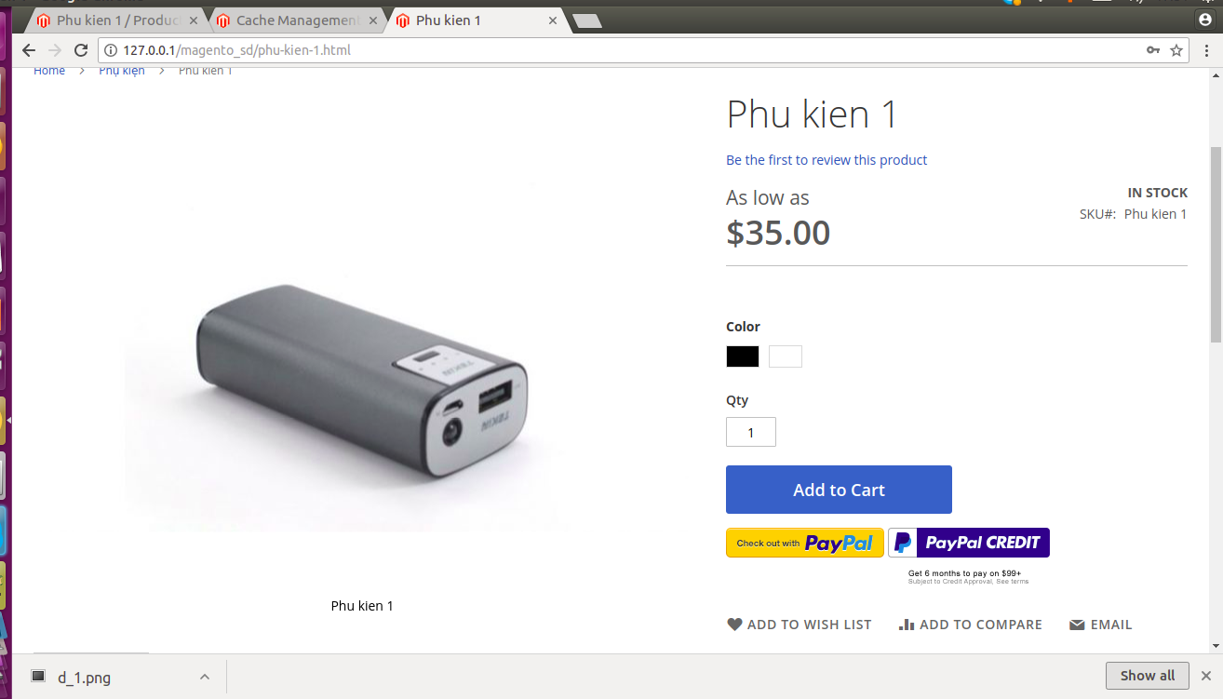
5. Take a screenshot of the CSV you have tested with table rate
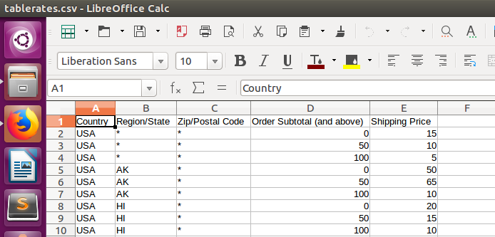
6. Explain information you get in Paypal debug log
'AMT' => '80.50': money of order;
'CURRENCYCODE' => 'USD': currency;
'INVNUM' => '000000007': order code;
'L_NAME0' => 'Teton Pullover Hoodie': name of first product;
'L_QTY0' => 1: quantity of first product;
'L_AMT0' => '49.00': price of first product;
'L_NAME1' => 'Push It Messenger Bag':
'L_QTY1' => 1: quantity of second product;
'L_AMT1' => '31.50': second product;

7. Difference between Order Status and Order states
An order state is a position of an order in an order processing flow. Magento has the following pre-defines order states:
- New
- Pending Payment
- Processing
- Complete
- Closed
- Canceled
- On Hold
- Payment Review
Each Magento order state can have one or more order statuses assigned to it. This makes order processing easier and helps to add some flexibility to it.
For example, a “Pending Payment” order state can have the following order statuses:
- Pending Payment Paypal
- Pending Payment Card
- Pending Payment Store Credit
8. What is invoice? What is shipment? What is credit memo? When will these document be generated ?
- An invoice is a document issued by a seller to the buyer that indicates the quantities and costs of the products or services provider by the seller.
- The physical moving of good from one point to another, such as the moving of merchandise from the warehouse to the customer.
- A credit memo is a document that shows the amount that is due the customer for a full or partial refund. These document are generated when customers paid for product, products is shipped, customers refund products.
9. Please setup VAT tax rate 10% for Vietnam and take a screenshot of your testing tax rate applied correctly on front-end
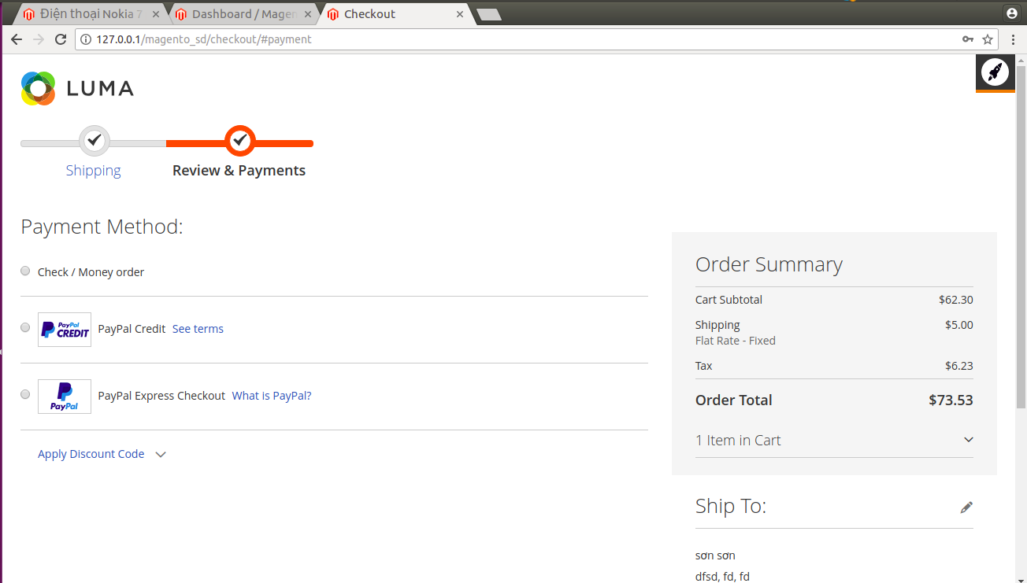
10. How do setup tax when product price without tax is same for all countries ?
- On the Admin sidebar, tap Catalog. Then choose Product.
- Open a product from your catalog in edit mode.
- Under Product Details, set Tax Class to “None”.
12. How do setup tax when product price with tax is same for all countries ?
Magento requires a country when adding a new tax rate. Generally, I will only need to collect sales tax in countries or regions where I have a business presence.

13. What is confiugration scoppe in admin? How do we set diffrent configuration option for each store/website ?
Confiugration scope in admin is where we can set our configuration setting for just a specific website, store or view. We set diffrent configuration option for each store/website in confiugration scope in admin.
14. What directive did you use in your practice ? Take screenshot of result on front-end

15. How to embed a static block into a CMS page?

16. How to show products on home page ?
- Go to the Admin panel of your store and navigate to CONTENT → Pages.
- Now click on Edit from the Select dropdown of homepage.
- Unfold the Content section and then click on Insert Widget from the homepage editor.
- Now select Catalog Products List from Widget Type dropdown and fill all the details according to your requirements. After providing all the details, go to Conditions attribute, select Category - option and just select the category of your choice that you want to show. At last, click on Insert Widget.
- Now just click on Save Page.

17. How to setup a Magento store with different product name for each language ? Take a screenshot of what you have done

18. How to edit an email template via admin ?
- In the Magento Admin, navigate to MARKETING > Communications > Email Templates
- Click Add New Template.
- If want to use a default template as a starting point, in the Load default template section, choose - the template and click Load Template. The path to the configuration settings for each default - template displays in the Currently Used For field in the Template Information section.
- In Template Name, enter a name to identify the template in the Magento Admin.
- In Template Subject, add plain text to use as the Subject of the emails sent using the template you create. This field can contain system variables.
- Customize template content.
- In Template Styles, optionally add CSS styles for the template. These styles are added inside of a <style> tag in the <head> of the email.
- Click Save Template
19. Describe purpose of each Magento cache
Magento 2 has twelve default cache types. These are:
- Configuration – generally, the system collects configuration info from all module/config.xml files and stocks it all together in the configuration cache; this setting lets you manage specific website and Store View cache type.
- Layouts – this setting embraces the compiled page layout from all components; in case you implement some changes to your layout files, flush this cache type.
- Blocks HTML output – comprises HTML page fragments per block; should be flushed after making updates to a store view layer.
- Collections Data – contains the whole chain of database queries; gets cleaned automatically by the system.
- Reflection Data – embraces any reflection data for API interfaces.
- Database DDL operations – contains database schema.
- Entity attribute value (EAV) — comprises metadata for EAV attributes (for instance, store labels, site search settings, links to certain pieces of PHP code, etc.).
- Integrations Configuration and Integrations API Configuration – the former caches the compiled integrations while the latter — Compiled integration APIs.
- Page Cache – HTML page code; should be flushed every time after making changes to the website HTML structure.
- Translations – merged translations from any modules.
- Web Services Configuration – basically, this is the cache Web API Structure of a website.

