CHECK LIST
1. When/where the layout loaded and parse in Magento?
- When loading a theme, Magento reads the configuration of all the available modules, and checks which layout files should be loaded. For each file, Magento tries to load it from your theme. If it exists in your theme, it loads it and parses the XML files and merges them into one. If the file doesn't exist in your theme, it tries to load it from the base/default theme. After, Magento parses the XML files and merges them into one.
2. How do Magento locate the controller/action to be excuted?
- Controller is a class located in module Controller folder, responsible for specific Url or group of Url’s. For every action we have one controller class with execute method. Execute method is “first” called when router matches controller action class. All controllers are extending \Magento\Framework\App\Action\Action class which has dispatch method which will call execute method in controller.
Controllers are structured in a specific way so they can be matched. Url structure for matching is:
www.inchoomagento2.net/frontName/action path/action class/
- frontName – it’s set in routes.xml configuration, and has unique value which will be matched by router
- action path – folder name inside Controller folder, default is index
- action class – our action class which we call Controller, default is index
3. How do Magento process from friendly URL to controller/action ? Where is the code implementation?
- The following process recognizes the home page path, and translates that to a data structure consisting of 3 elements: moduleFrontName, actionPath, actionName.
- Code implementation at: magento/framework/App/Router/Base.php.
4. What does each table in Magento do? How does Magento store product, customers in databse ?
Magento’s database is designed follow EAV database(Entity-Attribute-Value).

Entity
The entity represents Magento data items such as products, categories, customers and orders. Each entity (product, category etc) will have it's own entity record in the database.

Attribute
The attributes represent data items that belong to an entity. For example, the product entity has attributes such as name, price, status and many more.

Value
The value is the simplest to understand as it is simply a value linked to an attribute.
Magento store product in tables:
- catalog_product_entity - this one is the main product table. It contains the id, sku, attribute set and a few other details
- catalog_product_entity_int|varchar|text|datetime|decimal - these tables contain attribute values. Each attribute has a type and based on that type the value is inserted in the right table.
- catalog_product_website - this table contains the association of products on websites (product id, website id). If you don't add the products to at least a website nothing will be inserted here.
- catalog_category_product - this table contains the association between products and categories (product id, category id). if you don't assign products to categories nothing will be inserted here
- catalog_category_product_index - this tables also holds the association between products and categories but it is populated after reindexing.
- catalog_product_entity_gallery, catalog_product_entity_media_gallery, catalog_product_entity_media_gallery_value - these hold references to images assigned to products
- catalog_product_link this holds the links between products: cross-sells, up-sells, related products, child products of configurable & grouped products
- catalog_product_link_attribute, catalog_product_link_attribute_decimal|int|varchar, hold the positions and other attribute values that might be related to the links above for the related products up-sells and cross-sells
- catalog_product_entity_tier_price contains the tier prices for the products
- catalog_product_option holds the product custom options
- catalog_product_option_price holds the custom options prices
- catalog_product_option_title holds the custom options titles
- catalog_product_option_type_value holds the custom options type values
- catalog_product_option_type_price holds the custom options price types
- catalog_product_relation holds a kind of redundant parent-child relation for configurable products
- catalog_product_index_* hold values for product attributes after reindexing
- catalog_product_bundle_* hold relations and options for bundle products
- donwloadable_* - hold data related to downloadable products
Customer database in Magento is stored under EAV model includes some following tables:
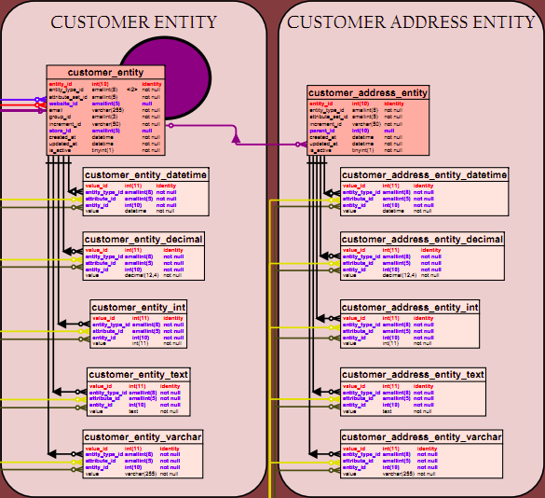
Of which, the table customer_entity is the one storing. Customer_entity table is where to store main information about customer including following fields:
- entity_id: primary key
- email: customer’s email
- create_at, update_at: time created, time last updated for customer
- is_active: active status
- website_id, store_id, group_id: foreign keys linking to corresponding tables: core_website, core_store_id, customer_group.
- entity_type_id: primary key of table eav_entity_type
- attribute_set_id: primary key of table eav_attribute_set
Tables customer_entity_datetime, customer_entity_decimal, customer_entity_int, customer_entity_text, customer_entity_varchar contains value of the attributes categorized by corresponding data type. In this table, these are some noteworthy fields:
- entity_type_id: primary key of table eav_entity_type
- attribute_id: primary key of table eav_attribute.
- entity_id: primary key of table customer_entity
The tables for customer address have a similar storage method with customer_address_entity as the primary table, moreover there is the field parent_id to make a link to table customer_entity.
5. Purpose of each indexer?
Catalog Search Index
You can search for products by many attribute values. Some of them may not be included in the flat tables generated by the flat indexer. This index fills in a table with the searchable attribute values for products so it's easier to look for them based on keywords. Having all the info in one table (or one field) makes it possible to use Full text search and get relevant results.
Product Prices.
The price of a product can be affected by many variables. For example, customer group, website, catalog discount rules.
Same as above, getting the products with their prices will mean a lot of joins or multiple selects. IN addition bundle products have a strange pricing system. This indexer aggregates the data in some tables (catalog_product_index_price_*) and makes the selects (sorting and filtering) much easier.
Catalog url Rewrites
This cleans up the url rewrite rules by setting which url corresponds to which product or category. It's easier this way for the url management internal system to decide which page should you view when calling a non-standard url. Instead of searching through all the product and categories URL keys it just searches in one table.
Category Products
In Magento you can set a category attribute named 'Is Anchor' to true or false. If it's true it means that the category in question will list all the products from it's child categories. Again, determining this realtime it will take more resources than just reading one table. This indexer creates the association between products and categories based on the associations you set in the backend and the 'Is Anchor' flag on the categories.
Stock Status
For simple products it's easy. They can be in stock or out of stock, but for configurable, grouped and bundle is not that easy. They can be in stock or out of stock depending on the child products associated to the main product. Again (I'm just repeating my self here) getting their status real time would mean a lot of queries.
Product Attributes.
This one collects all attributes that can be used in the layered navigation for same reason. Having all of them in one place for faster reading.
6. Purpose of flat tables ?
- Flat tables help we easily handle data to display on frontend.
7. Observer and plugin comparison?
- Plugin intercepts the method calls and runs the code before, after or around the original method. Plugin can not access code inside.
- Observer can access code inside.
8. How to use an event like this
$this->_eventManager->dispatch($this->_eventPrefix. '_move_before', $eventParams);
- Step 1: Dispatch event
- Step 2: Create events.xml file to catch the event
- Step 3: Create Observer file to catch event
8. When do we have a conflict happen? And what happen when we have a conflict?
- We have a conflict happen when we replace a class implementation by many classes implementation. When we have a conflict, magento will use one of classes which replaced old class.

