CHECK LIST
1. What is the best environment configuration for development ?
- Enable developer mode with the command bin/magento deploy:mode:set developer.
- Magento recommends installing and using the latest supported version of PHP 7 to increase performance.
- Turned on cache, only page cache and block cache should be turned off for development and turned back on when testing.
2. Describe role and purpose of each part in a Magento module
- API: declare data interface and service interface to make other modules easily to call without worrying about changing implemention. API help easily public to web service.
- Block as a class represents a set of methods to manipulate with Magento UI blocks.
- Console: performs both installation and configuration tasks.
- Controller : controller and its action method handles incoming browser requests, retrieves necessary model data and returns appropriate responses.
- Model: Magento Model is handle all logical operation with database. Magento Resource Model: Magento’s resource simply connect with the database. Magento Collection Model:
Collection referees the collection of models.it contains many models.When we want results based on different model then we need to create collection or we can use existing collection.
- Helper: contain utility classes.
- i18n: use for translate content for multi language.
- Observer contains classes that can influence general behavior, performance, or change logic.
- Setup: working with database.
- Plugin: modifies the behavior of public class functions by intercepting a function call and running code before, after, or around that function call.
- etc: define configuration files.
- view contains templates.
3. Difference between extending and overriding layout? When we can't use extending ?
- Extending: extend layout file by create an extending layout file that contains the changes.
- Overwrite: add a layout file with the same name in custom theme. This means that the new file that you place in the theme will be used instead of the parent theme layout file of base layout file.
- If the amount of customizations is large, we should use extending.
4. What is the chain of theme fallback/overriding in Magento 2 ?
- If a view file is not found in the current theme, the system searches in the ancestor themes, module view files or library.
5. Where to look at when the page is blank or have fatal error ?
- Check in files: debug.log, system.log, exception.log
6. Where to look at when we have a Magento error message?
- Check in var/report.
7. Take a screenshot of the back trace data you got when you print magento back trace.
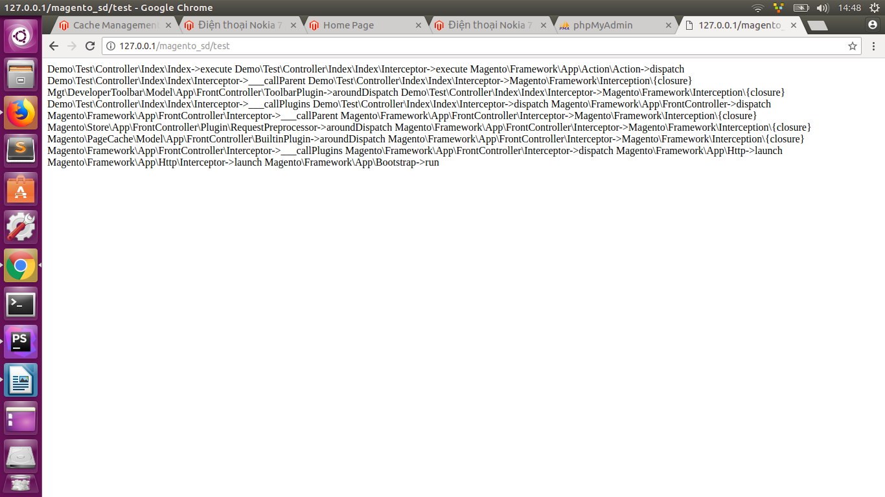
8. How to display all object data in Magento ? Can var_dump() the object ?
- Use var_dump() to display all object data in Magento.
- We can var_dump() the object. Because of the injection dependencies, data of object is large. We can use var_dump (object→getData()).

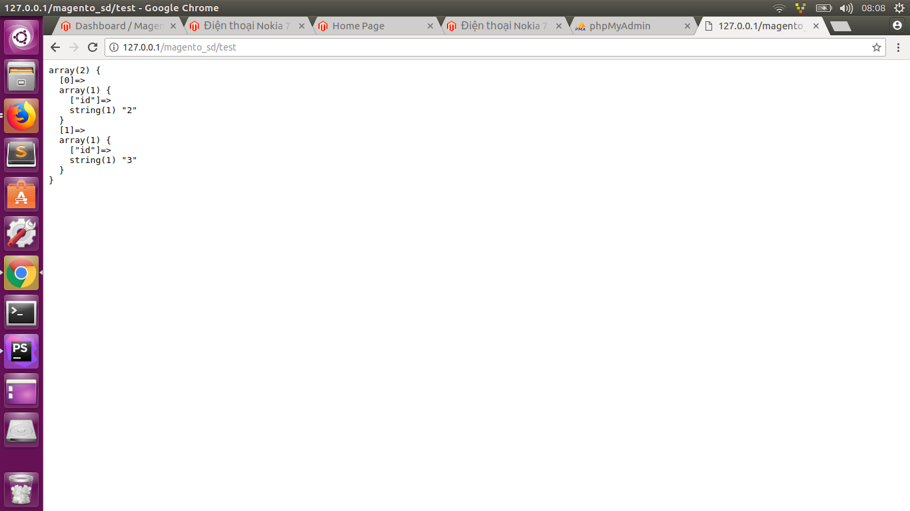
9. How to use a class (dependency injection) in another class (block, contro
ller, model)?
- To use a class (dependency injection) in another class (block, controller, model), we declare that class in another class’s constructor method.

