ARKON
Enterprise AI Knowledge Base

Architecture and operations guide

Version: 1.0 | May 2026

Chapter 1 — System architecture
Arkon is an enterprise AI knowledge-base platform. It turns documents (PDF, DOCX, URL) into a structured wiki through the MRP (Map-Reduce-Prompt) pipeline and provides semantic search plus Claude integration via MCP.

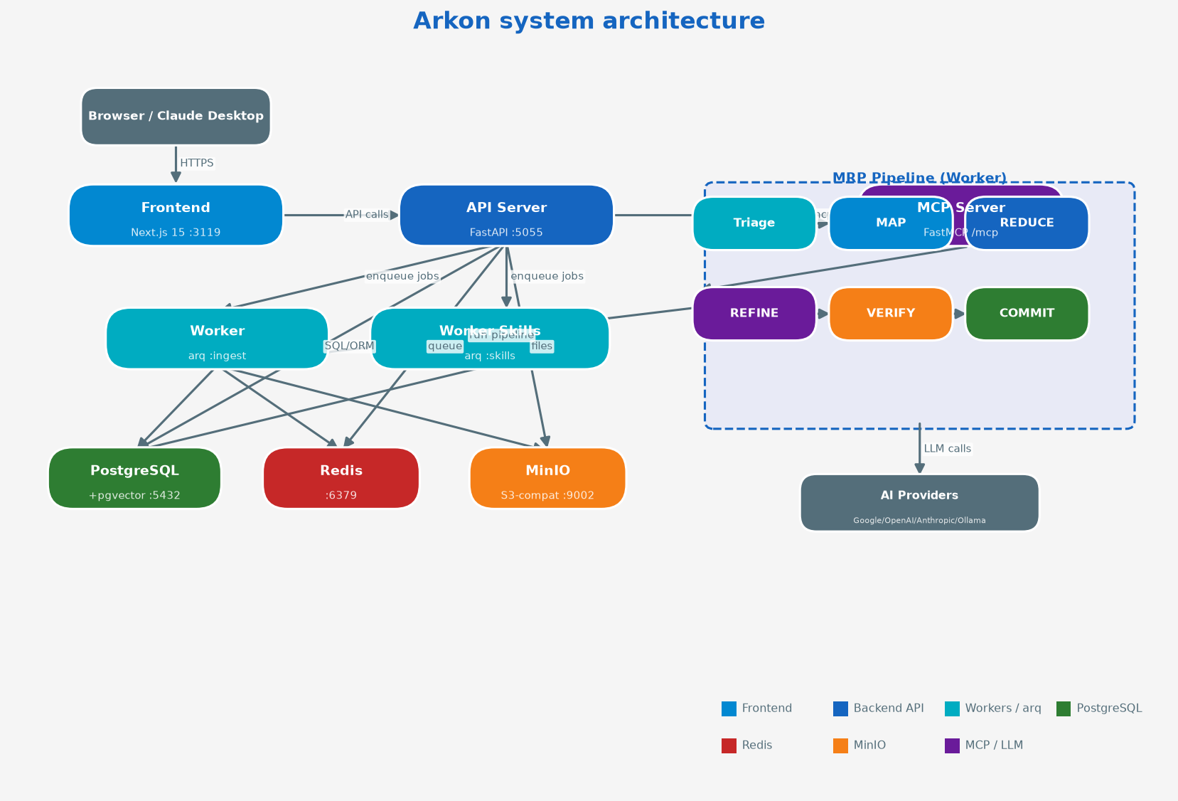
Figure 1.1 — Overall architecture: 7 services running in Docker Compose

Main components
- Frontend (Next.js 15 :3119): Web UI for users. Server Components, App Router. Talks to the backend over API calls. File upload bypasses the Next.js proxy and goes straight to port 5055 to avoid size limits.
- API Server (FastAPI :5055): REST API backend. Handles authentication (JWT), file upload, wiki CRUD, settings, workspace management. Mounts FastMCP at /mcp. Runs Alembic migrations on startup.
- Worker (arq): Background task queue. Runs the MRP pipeline (Triage→MAP→REDUCE→REFINE→VERIFY→COMMIT). Uses advisory locks to avoid races. Stores pipeline_phase after each phase → resumes after a crash.
- Worker Skills (arq): Processes skill packages (.zip) separately so they do not block document ingestion. A skill is a package of instructions that lets Claude perform custom actions.
- PostgreSQL + pgvector: Primary database. 23 ORM tables. pgvector stores multi-dimension embeddings (768d, 1024d, 1536d, 3072d) with an HNSW index for semantic search.
- Redis (arq queue): Job queue for background tasks. Stores job state and intermediate pipeline results.
- MinIO (S3-compatible :9002): Object storage for original files (PDF, DOCX) and images extracted from PDFs. Image proxy at /api/wiki/images/{uuid} serves images with authentication.

Chapter 2 — MRP Pipeline
MRP (Map-Reduce-Prompt) is a 6-phase pipeline that turns documents into wiki pages. Each phase is run by a worker, using the configured LLM provider.

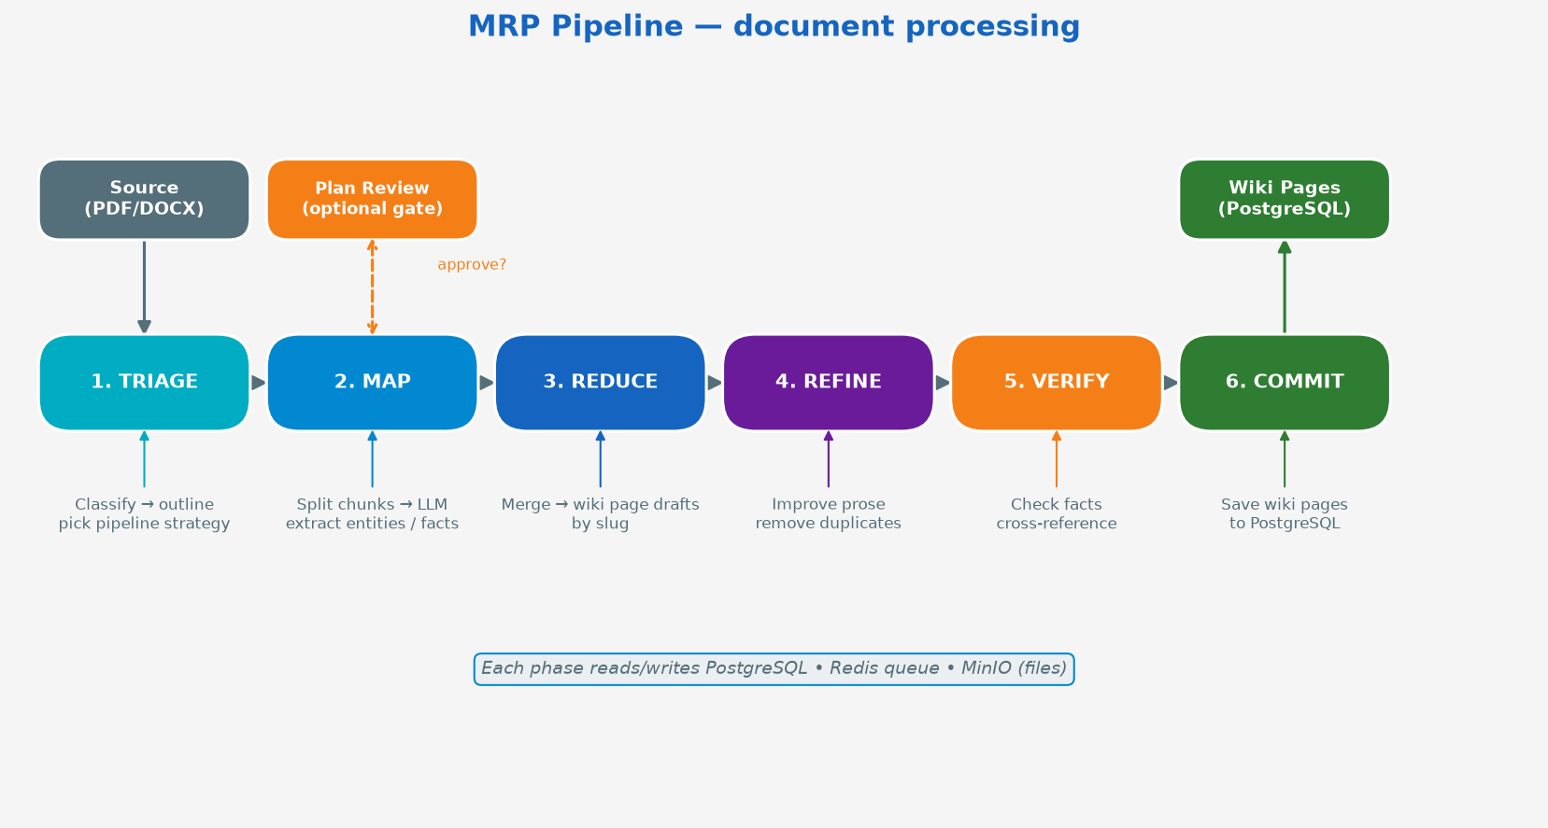
Figure 2.1 — MRP Pipeline: 6 phases from raw document to wiki pages

Phase descriptions
1. TRIAGE LLM analyzes the document, builds an outline, and picks a pipeline strategy (standard / large_document / multi_topic). Result: outline_json.
2. MAP Split the document into chunks, send each chunk to the LLM to extract entities, facts, concepts. Runs concurrently. Result: a list of wiki page drafts.
3. REDUCE Merge drafts that share a slug. Build a complete wiki page for each unique slug. Result: wiki_page objects.
4. REFINE LLM improves the prose, removes duplicates, and normalizes Markdown. Applies the knowledge-type description for the right format.
5. VERIFY Checks cross-references and fact accuracy. Ensures there is no wrong or contradictory information across wiki pages.
6. COMMIT Upsert wiki pages into PostgreSQL (slug uniqueness). Enqueue the embedding task for semantic search. Set source.status = ready.

Plan Review Gate
When MRP_AUTO_APPROVE_PLAN=false, the pipeline stops after TRIAGE and waits for admin review. The admin inspects outline_json and approve/rejects before MAP starts. Set MRP_AUTO_APPROVE_PLAN=true to skip this step.

Chapter 3 — Upload and document processing flow

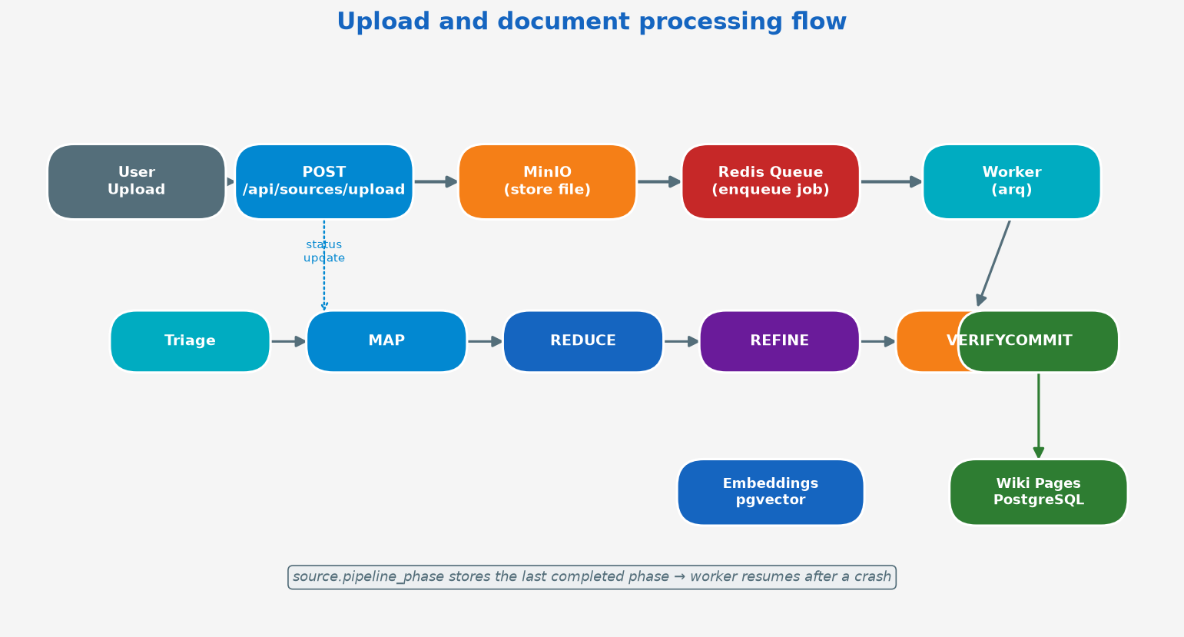
Figure 3.1 — Upload flow from user to wiki pages

Resume after a crash
source.pipeline_phase stores the last completed phase. When the worker restarts (crash or manual), the system reads pipeline_phase and continues from the next phase — it does not start over. To reset by hand: POST /api/sources/{id}/retry.

Supported document types
- PDF: Uses pymupdf — extracts text and images
- DOCX: Uses python-docx + mammoth — tables, headings
- URL: Crawl and extract content from a web page
- YouTube: Transcript extraction from video
- Plain Text: Processed directly

Chapter 4 — Access control (Dual-Realm RBAC)

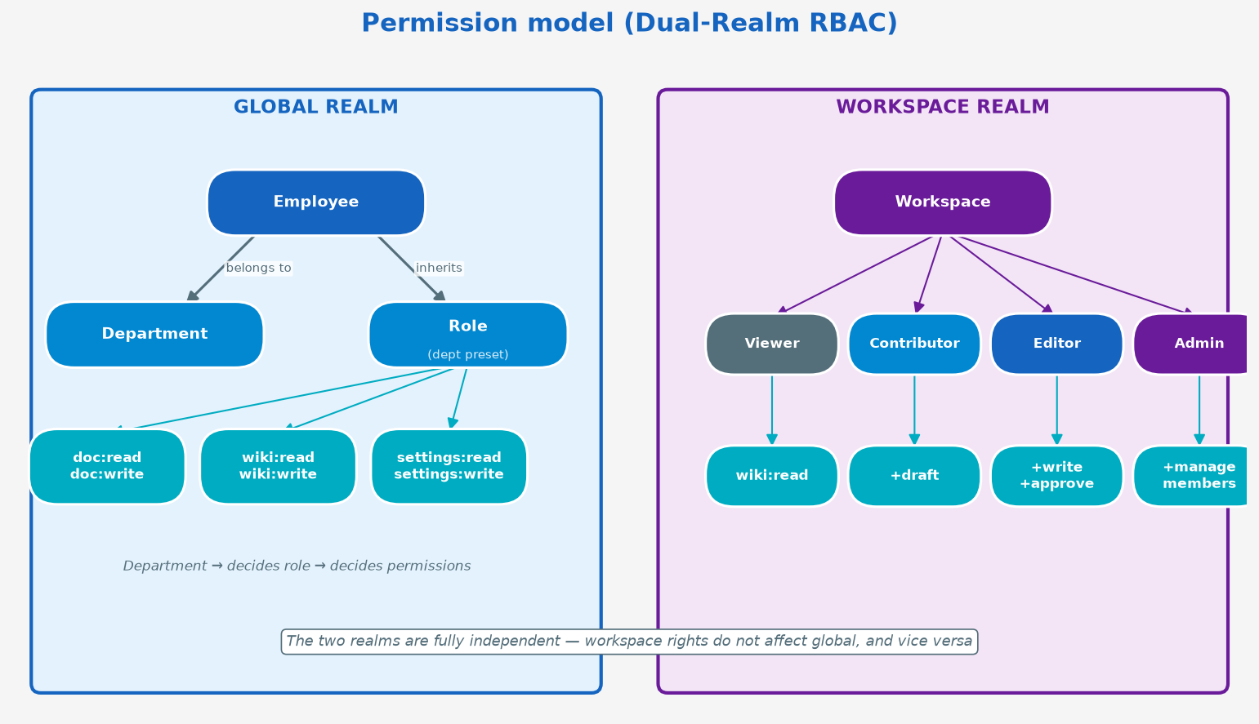
Figure 4.1 — Dual-realm permission model: Global and Workspace

Global Realm
System-wide rights follow Department → Role → Permissions. Each department has a preset role with a fixed permission set. A Custom Role can be created for finer-grained permissions.
Permission | Description
doc:read / doc:write | Read/upload documents
wiki:read / wiki:write:all | Read/edit wiki
settings:read / settings:write | View/change system settings
admin:users | Manage employees
admin:workspaces | Manage workspaces

Workspace Realm
A workspace is a separate working space. Members have a workspace role (Viewer/Contributor/Editor/Admin) fully independent of the global role. A system admin always has full access without being a member.

Chapter 5 — Database schema

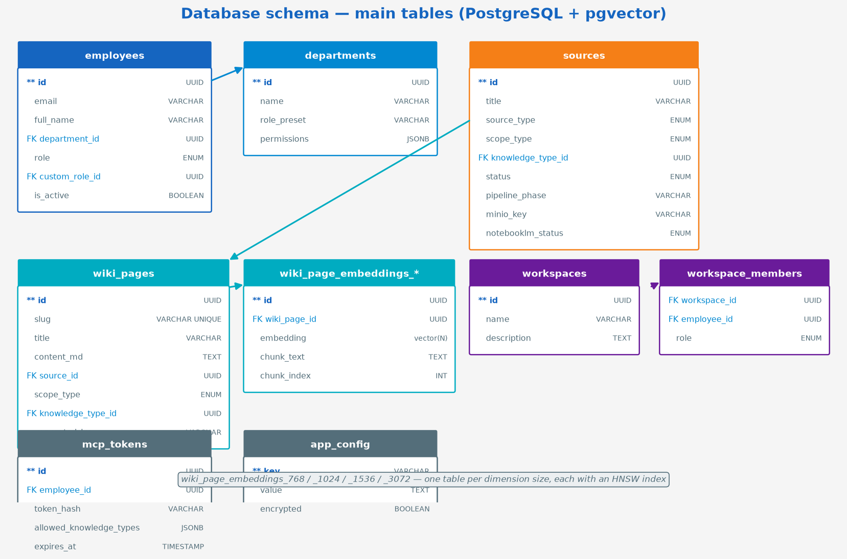
Figure 5.1 — Main tables in PostgreSQL

pgvector — Semantic Search
The system uses pgvector with 4 embedding tables, one per dimension: wiki_page_embeddings_768, _1024, _1536, _3072. Each table has an HNSW index (migration 015) for fast vector search. Changing the embedding model does not lose data — just Re-embed all pages to populate the new table.

Chapter 6 — MCP Server (Claude integration)

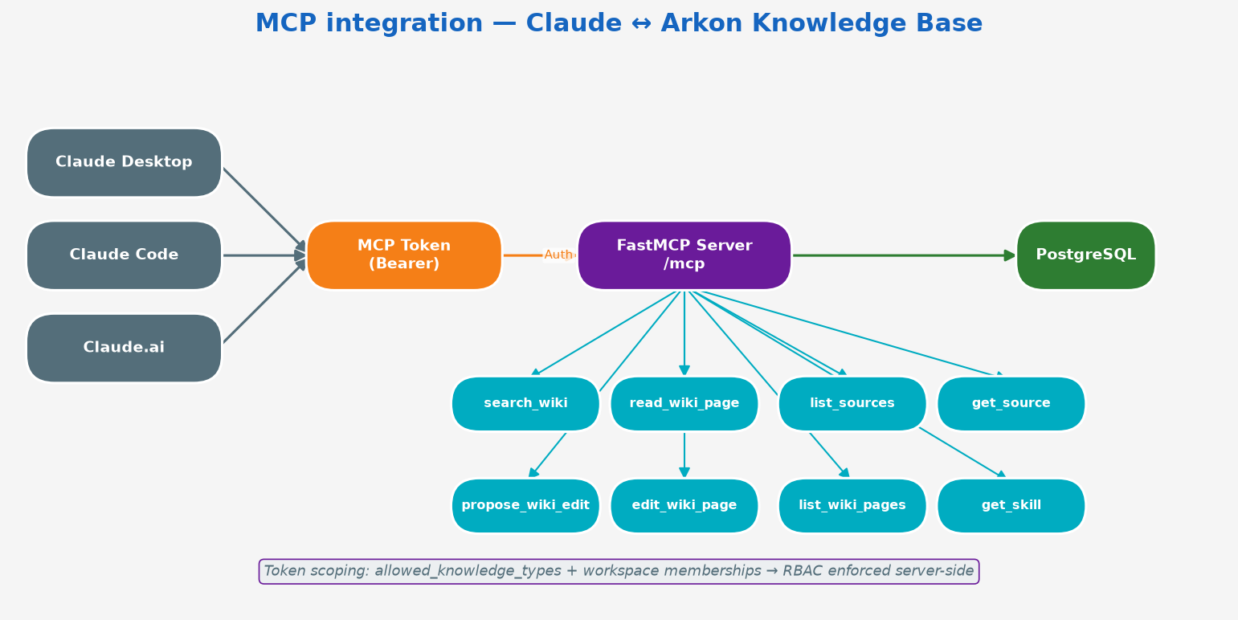
Figure 6.1 — Claude Desktop/Code integration via the MCP protocol

14 MCP Tools
Tool | Description
search_wiki | Search the wiki with semantic search
read_wiki_page | Read a wiki page by slug
list_wiki_pages | List wiki pages with filters
list_sources | List source documents
get_source | Read metadata for one document
propose_wiki_edit | Propose a wiki edit (creates a draft)
edit_wiki_page | Edit directly (Editor+)
get_skill | Read a skill package
list_skills | List skills
get_wiki_graph | Fetch the knowledge graph
list_knowledge_types | List knowledge types
get_workspace | Read workspace info
list_workspaces | List workspaces
get_mcp_context | Current token information

Chapter 7 — NotebookLM integration (plan)
NotebookLM integration lets users upload documents to Google NotebookLM, generate a detailed study guide/report, and sync it back into the Arkon wiki. This is an enrichment layer on top of the current MRP pipeline.

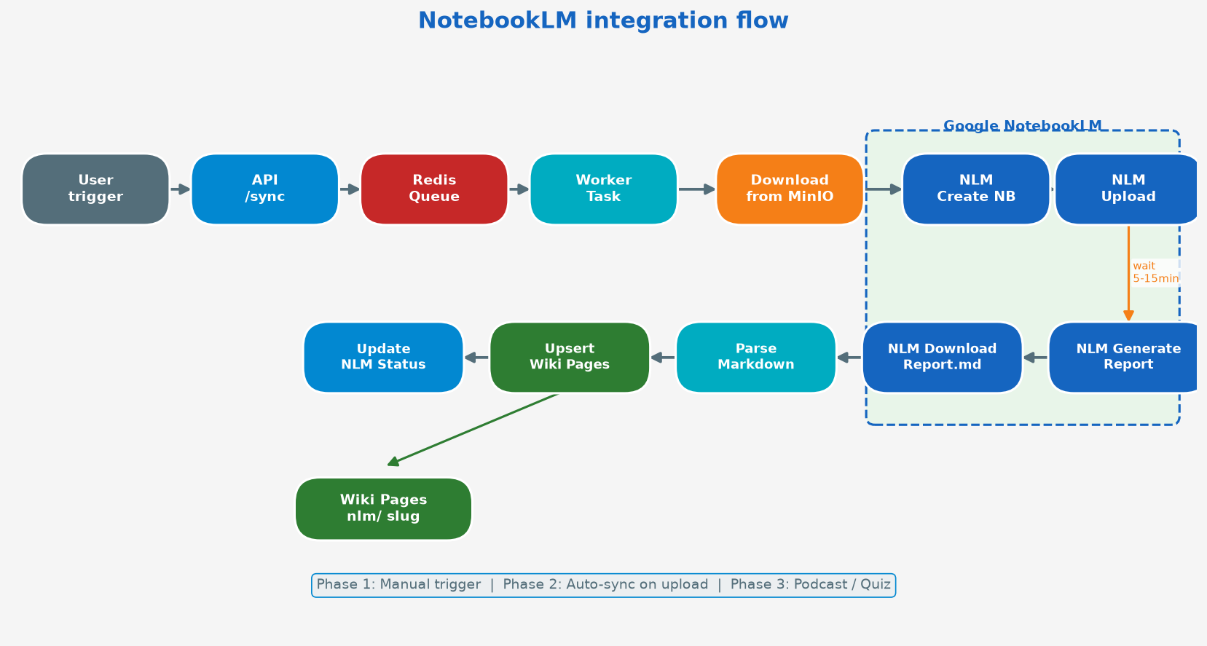
Figure 7.1 — NotebookLM integration flow (3 phases)

3 rollout phases
- Phase 1 — Manual Trigger: An admin can trigger a sync by hand from the Knowledge table dropdown. The NotebookLM service runs as an arq background task. Wiki pages are created with a distinct nlm/ slug prefix.
- Phase 2 — Auto-sync on upload: The upload dialog has a 'Sync to NotebookLM' checkbox. After ingest_file_task finishes, notebooklm_sync_task is enqueued automatically.
- Phase 3 — Podcast / Quiz: Extend to generate an audio podcast, quiz JSON, and PPTX slide deck. Store artifacts in MinIO and play them in the UI.

New components to add
- app/services/notebooklm_service.py — CLI wrapper subprocess
- app/workers/notebooklm_tasks.py — arq background task
- app/routers/notebooklm.py — /api/notebooklm/* endpoints
- Migration 020 — add 5 columns to the sources table
- Frontend: dropdown action, status badge, Settings panel

Chapter 8 — Quick start
Get a working Arkon on your machine in about 20 minutes.
Need production hardening, TLS, or a public hostname? Use [SETUP.md](SETUP.md) after this.

1. What you need
- Docker Engine + Docker Compose v2
- About 4 GB RAM free
- An API key from one of: Google AI Studio, OpenAI, Anthropic — or a local [Ollama](https://ollama.com) install

2. Clone and create the Docker network
git clone https://github.com/sondt99/arkon-nlm.git
cd arkon-nlm
# Compose joins this network as an *external* network. Create it once.
docker network create arkon_default
If you skip the network, docker compose up fails with “network arkon_default declared as external, but could not be found”.

3. Write your secrets
cp .env.docker.example .env.docker
Open .env.docker and set these. Do not leave the change-me-… values.
SECRET_KEY= # python -c "import secrets; print(secrets.token_urlsafe(32))"
DEFAULT_ADMIN_EMAIL=admin@yourcompany.com
DEFAULT_ADMIN_PASSWORD= # strong password
POSTGRES_PASSWORD= # strong password
REDIS_PASSWORD= # strong password
MINIO_ACCESS_KEY= # NOT "minioadmin" — see below
MINIO_SECRET_KEY= # strong password, not minioadmin123
DATABASE_URL=postgresql+asyncpg://arkon:<POSTGRES_PASSWORD>@postgres:5432/arkon
Every one of those is checked at startup, and the API refuses to boot on a known-weak value
rather than running with it. That includes MINIO_ACCESS_KEY=minioadmin, which the template still
ships — change it too, or the API exits with MINIO_ACCESS_KEY is a known default.
Leave these as they are for a local Docker run:
CORS_ORIGINS=
NEXT_PUBLIC_API_URL=
MINIO_PUBLIC_ENDPOINT=localhost
MINIO_SECURE=false
NGINX_PORT=3119
CORS_ORIGINS empty is correct: the browser talks to nginx on one origin, so the API does not need a CORS wildcard.
**File download links do not work on a non-80 port.** `MINIO_PUBLIC_ENDPOINT` goes straight into
the presigned-URL signature, and nginx forwards `Host $host` — which strips the port. With
`NGINX_PORT=3119` you get one of two failures and no third option: `localhost` produces links to
port 80, where nothing is listening, and `localhost:3119` produces links that reach nginx and
then fail MinIO's signature check with `SignatureDoesNotMatch`. Everything else on this page
works either way; only downloading an uploaded file is affected. If you need it locally, set
`NGINX_PORT=80` and keep `MINIO_PUBLIC_ENDPOINT=localhost` (then read the portal at
`http://localhost` instead of `:3119`). Wiki **images** are unaffected — they are proxied through
the API, not presigned.

4. Start the stack
Always pass --env-file .env.docker. Without it, Compose substitutes empty passwords and the containers cannot talk to each other.
docker compose --env-file .env.docker up -d --build
docker compose --env-file .env.docker ps
Migrations are applied by a one-shot migrate service that api waits on
(depends_on: {migrate: {condition: service_completed_successfully}}), so up -d
handles them and they cannot be skipped. They no longer run from every container's
entrypoint, which is what previously made restart worker re-migrate production.
This fails closed. If a pending revision would destroy data, migrate refuses and
exits 1, api never starts, and the schema is left untouched — verified against a
database at revision 013, which yielded migrate exit=1, api state=created, and
the schema still at 013. The API is never served against a stale schema.
To run the migration alone — to read the pre-flight output, or to pass
ALLOW_DESTRUCTIVE_MIGRATIONS=1:
docker compose --env-file .env.docker run --rm migrate
See DOCKER.md for the override and the backup command it prints.
Wait until arkon_api, arkon_frontend, and arkon_nginx are healthy (about 30–60 seconds).
Check the API through nginx:
curl http://localhost:3119/api/health
You want "api": "healthy" and "database": "healthy".
The endpoint answers 503 — not 200 — when a dependency is unreachable, so an
orchestrator or uptime check can rely on the status code alone. If you have a monitor
asserting 200, it will now correctly alert on a half-broken stack instead of passing.

5. Sign in
Open http://localhost:3119
Email and password = the DEFAULT_ADMIN_* values you set.
The default admin is created only when no admin exists yet. Changing the env vars later does not reset the password.

6. Configure AI
Go to Settings. You need at least embedding + LLM.

Google (good default)
Slot | Provider | Typical model
Embedding | Google | `text-embedding-004`
LLM | Google | `gemini-2.5-flash` or `gemini-2.5-pro`
Vision (optional) | Google | `gemini-2.0-flash`

Paste the same Google AI Studio key into each slot you use. Click Test on each.

OpenAI / Anthropic
Same idea: pick the provider, pick a model, paste the key, test.
Anthropic has no embedding model — keep embedding on Google, OpenAI, Ollama, or 9Router.

Ollama (offline)
On the host:
ollama pull nomic-embed-text
ollama pull qwen2.5:14b
In Settings, provider Ollama, base URL http://host.docker.internal:11434/v1, then Fetch Models.

7. Create a category and upload a file
- Knowledge Types → New — e.g. SOP / slug sop.
- Documents → Upload — drop a PDF or DOCX, pick that knowledge type, scope Global.
- Watch the status: pending → processing → plan_ready or ready.
If it sits on pending, the worker is not running: docker compose --env-file .env.docker logs worker.
If you see Review Plan, open it and Approve. That is the MRP plan-review step. After approval the writer runs and the wiki pages appear.

8. Read the wiki
Open Wiki. Search or browse the pages that were just written.

9. Connect Claude (optional)
- Profile → MCP token (or Employees → [you] → Generate token).
- Copy the ark_… value. It is shown once.
- Add this to Claude Desktop claude_desktop_config.json:
{
"mcpServers": {
"arkon": {
"url": "http://localhost:3119/mcp",
"headers": {
"Authorization": "Bearer ark_xxxxxxxx"
}
}
}
}
Restart Claude Desktop. Ask: “Search the Arkon wiki for [something in your file].”
Details: [MCP.md](MCP.md).

Checklist
- [ ] arkon_default network exists
- [ ] .env.docker has unique secrets (not the example strings, and not minioadmin)
- [ ] docker compose --env-file .env.docker ps shows healthy
- [ ] Login works at http://localhost:3119
- [ ] Embedding + LLM tests pass
- [ ] One document reached ready (or you approved its plan)
- [ ] Wiki shows at least one page

Next
Goal | Doc
Deploy on a server | [SETUP.md](SETUP.md)
Add people and roles | [ADMIN-GUIDE.md](ADMIN-GUIDE.md)
Understand the compiler | [WIKI.md](WIKI.md)
Something failed | [TROUBLESHOOTING.md](TROUBLESHOOTING.md)

Chapter 9 — Admin guide
For accounts with role=admin. That flag is a system override — it is not the same thing as “workspace Admin.”
Portal: http://localhost:3119 after [QUICKSTART.md](QUICKSTART.md).

What only a system admin can do
- Skip every permission check
- Create / delete workspaces
- Manage departments, employees, roles
- Change AI provider keys
- See the full audit log
- Connect or disconnect the NotebookLM Google session
Everyone else is limited by their custom Role plus workspace membership. See [ACCESS-CONTROL.md](ACCESS-CONTROL.md).

First hour
- Change the admin password (Profile) if you used a temporary one.
- Settings — embedding + LLM, click Test on each.
- Departments — IT, HR, …
- Knowledge Types — at least one category you will upload into.
- Roles — keep the presets or clone them.
- Employees — create people, assign department + role, mint MCP tokens as needed.
- Upload one document and confirm the wiki page appears.

Departments
Departments → New. Name is enough.
A document or skill with no department is global. With departments, *:own_dept only matches employees in one of those departments.
Deleting a department unassigns it; it does not delete the people.

Employees
Employees → New
Field | Notes
Name, email, password | Email is the login
Department | Used by `own_dept`
Custom role | Empty = the default contributor-ish set

Toggle active to lock someone out without deleting them. JWT and MCP tokens then fail.
Generate token creates an ark_… MCP / gateway / export credential. Shown once. Revoke from the same row or from the employee’s Profile.

Roles
Roles lists every permission as a checkbox grouped by resource. Presets: Viewer, Contributor, Department Admin, Knowledge Admin.
Do not try to encode workspace access here. Workspaces have their own member roles.

Settings (AI)
Five slots, each with provider + model + key (or base URL):
Slot | Required | Used by
Embedding | Yes | Search, MRP dedup, chat RAG
LLM | Yes | MRP, plan, verify
Vision | No | PDF image captions
Chatbot | No | Falls back to LLM
Claude Code gateway | No | `/api/claude-gateway`

Supported providers: Google, OpenAI, Anthropic (no embeddings), Ollama, 9Router.
Ollama / 9Router: set the base URL, Fetch Models, pick one, Test.
Keys are stored encrypted (SECRET_KEY → Fernet). Changing SECRET_KEY later makes old keys unreadable.

Embedding dimension
Models live at 768 / 1024 / 1536 / 3072 dimensions. Switching to a different size starts a re-embed job. Wait for it before you trust search.

Documents
Documents is the source library.
- Upload file, ZIP, or URL
- Pick knowledge type + scope (global / workspace)
- Watch status: pending → processing → plan_review / ready / error
- Review Plan when MRP wants approval
- Retry on error
- Send to NotebookLM if that integration is connected
Large PDFs take minutes. Worker logs: docker compose --env-file .env.docker logs -f worker.

Wiki
Wiki — search, tree, graph, history, rollback.
Drafts submitted by contributors show a banner. Approve / Reject there or via MCP (list_pending_drafts).
Do not hand-edit _index / _log unless you know why — COMMIT regenerates them.

Workspaces
Only you can create them. Then add members with a workspace role. Guide: [WORKSPACES.md](WORKSPACES.md).

Skills
Upload a ZIP, wait for worker_skills, assign scope. Review contributions under Skill contributions. Guide: [SKILLS.md](SKILLS.md).

Chatbot
Chatbot is RAG over the wiki the current user can see. Optional dedicated provider. Add to Wiki turns a thread into a page (still permission-checked).

NotebookLM
Connect the Google session once ([notebooklm-auth.md](notebooklm-auth.md)). After that, anyone with access to the page can manage notebooks; you remain the person who can tear the session down.

Audit log
Audit Log — who did what, with filters. Needs org:audit:read.

Care and feeding
docker compose --env-file .env.docker ps
curl -s http://localhost:3119/api/health
docker compose --env-file .env.docker logs --tail=100 worker
# after git pull
docker compose --env-file .env.docker up -d --build
docker exec arkon_api alembic current
Backups = Postgres dump + MinIO volume (or mc mirror) + notebooklm_data if you use NotebookLM.
Never commit .env.docker. Rotate SECRET_KEY only if you are ready to re-enter every provider key.

Chapter 10 — Knowledge types
A knowledge type is a category with instructions. It tells the compiler what kind of document this is, and it is one of the levers MCP uses to hide content from a token.
Knowledge Types are edited from the Documents area. Creating one needs doc:create; editing needs doc:edit; deleting needs doc:delete. Any signed-in user can list them.

Fields
Field | Who reads it | What to put there
`name` | People | “SOP”, “HR Policy”, “Pentest”
`slug` | URLs, MCP, filters | `sop`, `hr-policy`, `pentest`
`description` | UI + a short LLM label | One or two sentences
`extraction_hints` | The MRP prompts | Keep/drop rules, extra entity types, slug conventions
`color` | UI badge | `#6366f1`

description is a label. extraction_hints is an instruction manual. When they conflict, hints win.

Why it matters
- Extraction quality — an SOP wants steps; a policy wants conditions; a pentest report wants commands and CVEs, not a paraphrase.
- Page shape — procedures become lists, comparisons become tables.
- Slug convention — topic/… vs entity/… vs concept/…-linux.
- MCP scope — a token can be limited to certain slugs. search_wiki then simply does not return the rest.

When you need `extraction_hints`
Write them if the default compiler would “helpfully” generalize away the thing you care about:
- Security / pentest / red team
- Medical or legal wording that must stay exact
- Platform-specific flags, versions, payloads
Ordinary SOPs and product briefs usually need only a clear description.

A useful hints template
Documents in this type contain [domain].
**Keep (verbatim):**
- KEEP [thing] — do not generalize
- KEEP platform, version, and flags with the command
**Drop:**
- DROP [noise that never belongs on the wiki page]
**Extra entity types:**
- `technique` — …
- `cve` — …
**Slugs:**
- concept/<technique>-<platform> for each variant
Security types also trigger deterministic artifact recovery (commands, payloads, CVE / ATT&CK IDs). See [WIKI.md](WIKI.md).

Defaults
On first boot Arkon seeds a small set (General, SOP, Product, Project, Customer, plus security types with hints). You can rename, reorder, or add your own. Do not delete a type that pages still reference without a plan for retagging.

API
Method | Path
`GET` | `/api/knowledge-types`
`POST` | `/api/knowledge-types`
`PUT` | `/api/knowledge-types/{id}`
`DELETE` | `/api/knowledge-types/{id}`
`PATCH` | `/api/knowledge-types/reorder`

Chapter 11 — Workspaces
A workspace (also called a project in the API) is a private room: its files and wiki pages are visible only to members.
System admins create and delete workspaces. Everyone else joins as a member.

Global vs workspace
 | Global | Workspace
Who sees files / wiki | People with the matching `doc:` / `wiki:` permission | Members only
Access model | Department RBAC | Membership role
Typical content | Company SOPs, HR policy | One client, one engagement, one product squad

The two realms do not leak. Being Knowledge Admin globally does not open a workspace you are not in. Being workspace Admin does not grant org:settings:manage.
System admin accounts can see every workspace without a membership row.

Create
Workspaces → New
Give it a name and, optionally, a type / description. Only a system admin can do this (POST /api/projects).

Members
Workspaces → [name] → Members
Role | Can
Viewer | Read wiki, files, member list
Contributor | + open wiki drafts
Editor | + edit wiki, review drafts, upload / attach / detach sources
Admin | + add/remove members, change roles, rename, archive

The last Admin cannot be removed or demoted.

Files
Two ways in:
- Documents → Upload, scope = Project, pick the workspace
- Inside the workspace, Sources → Upload or Attach an existing global source
Attached sources stay in the workspace’s list; membership still gates who sees them.

Wiki
Workspace pages are compiled the same way as global pages (see [WIKI.md](WIKI.md)). They live under the workspace scope (scope_type=project, scope_id=<workspace>).
The workspace screen embeds the wiki tree, a page reader, and a mini graph so you do not have to bounce to the global Wiki.
Draft rules follow the workspace role, not the global wiki:write:* permission.

MCP
Tools automatically hide workspace pages from tokens whose employee is not a member. Admins see all.

API (short)
Method | Path
`GET/POST` | `/api/projects`
`PUT/DELETE` | `/api/projects/{id}`
`GET/POST` | `/api/projects/{id}/members`
`PATCH/DELETE` | `/api/projects/{id}/members/{employee_id}`
`GET/POST/DELETE` | `/api/projects/{id}/sources`
`POST` | `/api/projects/{id}/sources/upload`
`POST` | `/api/projects/{id}/sources/url`
`GET` | `/api/projects/{id}/wiki`
`GET` | `/api/projects/{id}/wiki/index`
`GET` | `/api/projects/{id}/wiki/graph`

Chapter 12 — Troubleshooting
Work top-down: Compose status → health → the service log that is actually failing.
docker compose --env-file .env.docker ps
curl -s http://localhost:3119/api/health
docker compose --env-file .env.docker logs --tail=80 api
docker compose --env-file .env.docker logs --tail=80 worker
In the default Docker setup the API is not on localhost:5055. Use nginx on 3119, or docker exec.
docker exec arkon_api python -c "import urllib.request; print(urllib.request.urlopen('http://localhost:5055/health').read())"

Start-up

`network arkon_default declared as external`
docker network create arkon_default
docker compose --env-file .env.docker up -d

Container exits immediately
docker compose --env-file .env.docker logs api
Message | Cause
`SECRET_KEY is still the default value` | You copied the example and did not change it
`DEFAULT_ADMIN_PASSWORD is a weak default` | Same — pick a real password
`MINIO_ACCESS_KEY is a known default` | `MINIO_ACCESS_KEY=minioadmin` is refused — the template still ships it
`MINIO_SECRET_KEY is a known default` | Checked independently of the access key; change both
`REDIS_PASSWORD is unset or a known default` | Must be non-empty and match Compose's `--requirepass`
`DATABASE_URL still embeds a default password` | Still contains `arkon_secret` or `change-me-postgres-password`
`CORS_ORIGINS is '*'` | Leave it empty behind nginx, or set explicit origins
password authentication failed | `POSTGRES_PASSWORD` ≠ password in `DATABASE_URL`
Redis `NOAUTH` / `invalid password` | `REDIS_PASSWORD` empty in env but Compose started Redis with `--requirepass`

Always start with --env-file .env.docker.

`port is already allocated`
Something else owns 3119. Set NGINX_PORT=3120 in .env.docker and recreate nginx.

Health is `degraded`
GET /api/health reports api, database, worker.
Field | Look at
`database: error` | `docker compose --env-file .env.docker logs postgres` — usually a password mismatch
`worker: error` | Redis password, or Redis not healthy yet

Login

“Too many login attempts”
Nginx + Redis rate-limit the login path. Wait 5 minutes or:
docker exec arkon_redis redis-cli -a "$REDIS_PASSWORD" --no-auth-warning KEYS 'arkon:login_attempts:*'

Admin password in `.env.docker` does nothing
The env password is used only to seed the first admin. After that, change the password in Profile.

Cannot reach the UI from another machine
nginx binds 127.0.0.1:3119 by default. Use SSH tunnel, change the bind in docker-compose.yml, or put another proxy on the arkon_default network.

Uploads and the wiki

Status stays `pending`
The document worker is down or cannot see Redis.
docker compose --env-file .env.docker logs worker
docker compose --env-file .env.docker ps worker

Status `error`
Open the source row and read the error. Typical causes:
- Embedding or LLM not configured / test failed
- Provider quota or invalid key
- File is empty, encrypted, or a scan-only PDF with no extractable text and no vision model
Retry: Documents → ⋯ → Retry.

Stuck on **Review Plan**
That is expected when auto-approve is off. Open the plan and Approve or Reject. To skip review on a trusted pipeline, set MRP_AUTO_APPROVE_PLAN=true and recreate the worker.

Wiki pages missing after `ready`
Check worker logs for COMMIT. A failed commit rolls back the whole batch. Also confirm you are looking at the same scope (global vs a workspace) and knowledge type your user can see.

Images broken in the wiki
Presigned URLs use MINIO_PUBLIC_ENDPOINT. On Docker it must be a host the browser can open, and nginx must serve /arkon-files/. After changing it, recreate api (and rebuild frontend only if you also changed NEXT_PUBLIC_API_URL).

Settings / AI

Test LLM fails
- Key prefix: Google AIza…, OpenAI sk-…, Anthropic sk-ant-…
- Ollama URL from inside Docker is http://host.docker.internal:11434/v1, not localhost
- 9Router: click Fetch Models after setting the base URL

Changed embedding model, search is empty or errors
Dimension must match a table (768 / 1024 / 1536 / 3072). The Settings UI starts a re-embed job. Watch Settings → Embeddings until it finishes.

MCP / Claude
Symptom | Fix
Tools do not appear | Restart Claude Desktop after editing the config
Connection refused | URL must be reachable from the client. Docker: `http://localhost:3119/mcp`
Authentication required | Header is `Authorization: Bearer ark_…` (include `Bearer `)
Invalid or inactive token | Generate a new one under Profile or Employees
Empty search results | Employee’s `doc:read` scope or workspace membership excludes those sources
404 on `/mcp` | Old setups without the nginx `/mcp` location — update and recreate nginx

NotebookLM
Symptom | Fix
Import verifies `false` | Cookies went stale. Re-export and paste within a few minutes. See [notebooklm-auth.md](notebooklm-auth.md)
Works then dies after hours | Import a master token (preferred) so the worker can mint fresh cookies
Session lost after recreate | Volume `notebooklm_data` was wiped

Frontend

UI loads, every API call fails
NEXT_PUBLIC_API_URL was set to http://localhost:5055 and the API port is not published. Clear it, then:
docker compose --env-file .env.docker up -d --build frontend

CORS error in the browser
You are hitting the API on a different origin than the UI. Either:
- Use nginx (same origin), CORS_ORIGINS= empty, or
- Set CORS_ORIGINS to the exact UI origin (scheme + host + port).

Chapter 13 — API reference (summary)

Authentication
Endpoint | Description
POST /api/auth/login | Sign in → JWT token
POST /api/auth/refresh | Refresh token
GET /api/auth/me | Current user info

Sources (documents)
Endpoint | Description
POST /api/sources/upload | Upload a new file
GET /api/sources | List documents (filter/pagination)
GET /api/sources/{id} | One document's details
POST /api/sources/{id}/retry | Retry ingest from the start
DELETE /api/sources/{id} | Delete document

Wiki
Endpoint | Description
GET /api/wiki/pages | List wiki pages
GET /api/wiki/pages/{slug} | Read a wiki page
PUT /api/wiki/pages/{slug} | Update a wiki page (Editor+)
GET /api/wiki/search | Semantic search
GET /api/wiki/images/{uuid} | Authenticated image proxy

Admin
Endpoint | Description
GET /api/employees | List employees
POST /api/employees | Create an employee
GET /api/departments | List departments
GET /api/workspaces | List workspaces
POST /api/workspaces | Create a workspace

Settings & MCP
Endpoint | Description
GET /api/settings | Read system settings
PUT /api/settings | Update settings
POST /api/settings/test-llm | Test LLM provider
GET /api/mcp/tokens | List MCP tokens
POST /api/mcp/tokens | Create a new MCP token
/mcp | FastMCP endpoint (SSE)

