**Course One**

# Foundations of Data Science



# Instructions

Use this PACE strategy document to record decisions and reflections as you work through this end-of-course project. You can use this document as a guide to consider your responses and reflections at different stages of the data analytical process. Additionally, the PACE strategy documents can be used as a resource when working on future projects.

# Course Project Recap

Regardless of which track you have chosen to complete, your goals for this project are:

* Complete the PACE Strategy Document to plan your project while considering your audience members, teammates, key milestones, and overall project goal.
* Create a project proposal for the data team.

# Relevant Interview Questions

Completing this end-of-course project will empower you to respond to the following interview topics:

* As a new member of a data analytics team, what steps could you take to get 'up to speed' with a current project? What steps would you take? Who would you like to meet with?
* How would you plan an analytics project?
* What steps would you take to translate a business question to an analytical solution?
* Why is actively managing data an important part of a data analytics team's responsibilities?
* What are some considerations you might need to be mindful of when reporting results?

**Reference Guide**

This project has three tasks; the following visual identifies how the stages of PACE are incorporated across those tasks.

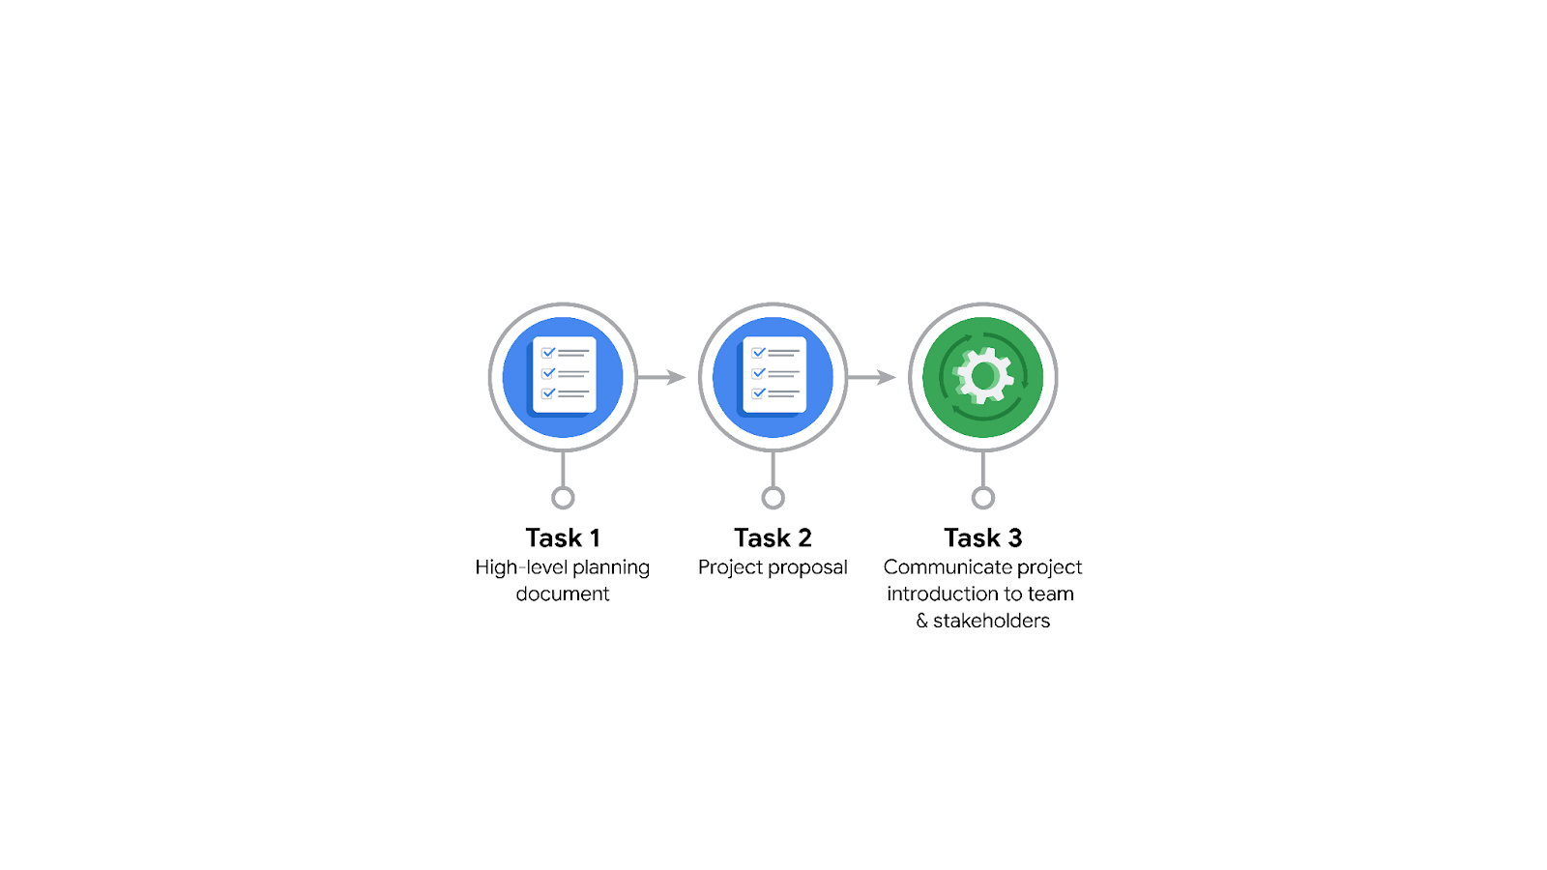

**Data Project Questions & Considerations**

**PACE: Plan Stage**

* Who is your audience for this project?

Data analysts and human resources working within Tiktok

* What are you trying to solve or accomplish? And, what do you anticipate the impact of this work will be on the larger needs of the client?

you are working on the development of a predictive model that

can be used to determine whether a video contains a claim or whether it offers an opinion.

* What questions need to be asked or answered?

What types and how can I access data sets? Which models can I use? How can I train the model? Which libraries can I use to model my model?

* What resources are required to complete this project?

To complete this project, I will need the project dataset, Python notebook, and input from stakeholders.

* What are the deliverables that will need to be created over the course of this project?

the deliverables include a dataset scrubbed for exploratory data analysis,

visualizations, statistical model, regression analysis and/or machine learning model.

## 

## **THE PACE WORKFLOW**

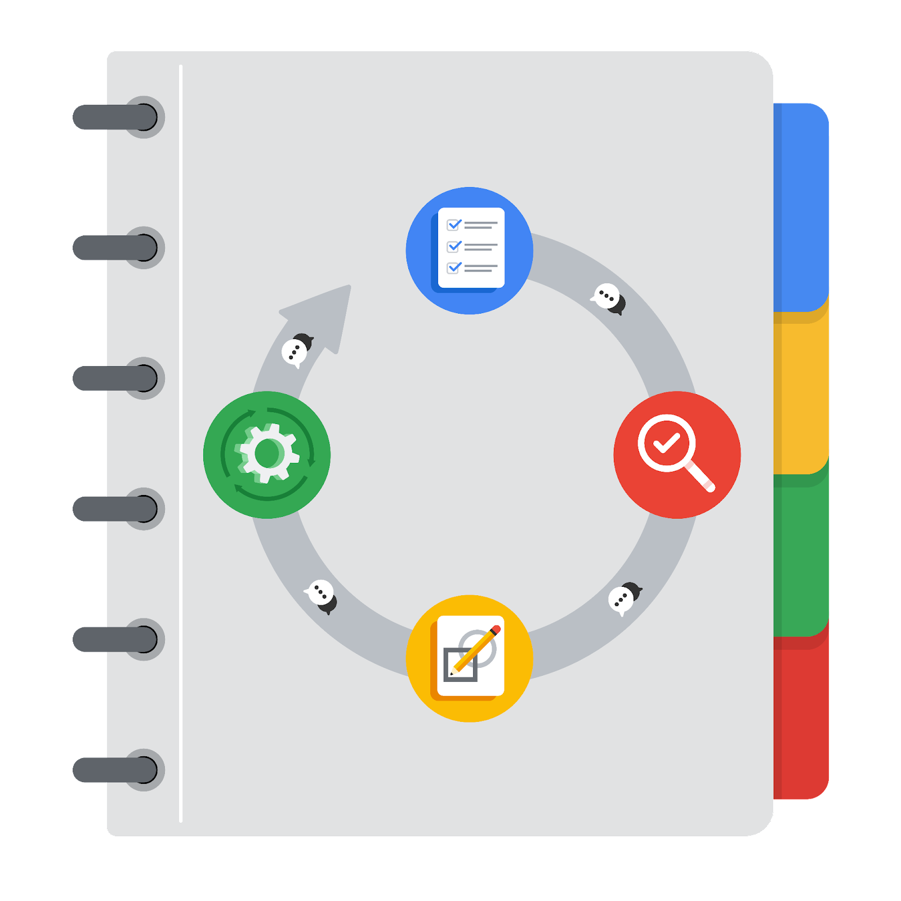

**[Alt-text: The PACE Workflow with the four stages in a circle: plan, analyze, construct, and execute.]**

You have been asked to demonstrate for the company's data team how you would use the PACE workflow to organize and classify tasks for the upcoming project. Select a PACE stage from the dropdown buttons. A few tasks involve more than one stage of the PACE workflow. Additionally, not every workplace scenario will require every task. Refer back to the Course 1 end-of-course portfolio project overview reading if you need more information about the tasks within the project.

### 

### **Project tasks**

Following are a group of tasks your company’s data team has determined need to be completed within this project. The data analysis manager has asked you to organize these tasks in preparation for the project proposal document. First, identify which stage of the PACE workflow each task would best fit under using the drop down menu. Next, give an explanation of why you selected the stage for each task. Review the following readings to help guide your selections and explanation: The PACE stages and Communicate objectives with a project proposal. You will later reorder these tasks within a project proposal.

1. **Evaluating the model: Execute**

Why did you select this stage for this task?

Because in this step we will analyze our work according to the project objectives and steps.

1. **Conduct hypothesis testing: Construct** **and** **Analyze**

Why did you select these stages for this task?

During the analyzing stage, it is determined that a statistical test will be used. During the construction phase, the test is carried out.

1. **Begin exploring the data: Analyze**

Why did you select this stage for this task?

I chose analysis because in this section we will analyze and visualize the data and gain a deeper understanding

1. **Data exploration and cleaning: Analyze** **and Plan**

Why did you select these stages for this task?

Planning takes place when I first make a choice about the methods needed. The cleaning process then takes place in the analysis phase.

1. **Establish structure for project workflow (PACE): Plan**

Why did you select this stage for this task?

Because this step is used to plan the workflow and other things

1. **Communicate final insights with stakeholders: Execute**

Why did you select this stage for this task?

In this step we will analyze our model according to our goals and plans

1. **Compute descriptive statistics: Analyze**

Why did you select this stage for this task?

The examination of statistics in the data takes place during analysis.

1. **Visualization building: Construct and Analyze**

Why did you select these stages for this task?

Visualization starts with data assessment and is created in the construction step.

1. **Write a project proposal: Plan**

Why did you select this stage for this task?

A project proposal is the initial document used to define a project.

1. **Build a regression model: Construct and Execute**

Why did you select this stage for this task?

In the analysis phase, the model is examined in detail. The construction of the regression model will take place in the construction phase.

1. **Compile summary information about the data: Analyze**

Why did you select this stage for this task?

The examination of a dataset to compile information will take place in the analysis phase.

1. **Build machine learning model: Construct**

Why did you select this stage for this task?

The creation of a data model will take place during the construction phase.