Simulation and Optimisation Analysis of KFC Calton Queuing System
Introduction
Today with the rapid expansion of the fast-food industry in today's society especially in busy cities and around campuses, the problem of long queues has become a key factor affecting customer satisfaction. KFC Carlton receives a large number of customers every day, and the queuing phenomenon at the front counter is particularly serious during peak hours. Long queues not only lead to loss of customers, but also affect the operational efficiency of the restaurant, which in turn reduces revenue.
In order to analyse the current situation of the queuing system and to propose a proven improvement solution, I will build a simulation model of the queuing system based on Anylogic software, which serves to simulate a series of customer behaviours such as arriving, ordering, and picking up food. Through simulation, we are able to identify the limits in the system in order to test different improvement scenarios and ultimately come up with an optimisation strategy that is suitable for the restaurant.
Analysis of existing systems
- System description:
The KFC Calton restaurant service system consists of the following core components:
- Customer arrival rate: customers enter the restaurant according to a certain arrival rate, the arrival rate is mainly affected by the restaurant's opening hours and customers' dining habits. The frequency of customer arrivals increases significantly during the lunch and dinner peaks.
- Ordering Mode: Customers can choose between two ordering modes - electronic ordering or front-of-house ordering. Electronic ordering is done through self-service equipment provided by the restaurant, where customers select their meal and wait for it in the seating area, while front-of-house ordering requires customers to wait in the queue for the waiter to take their order and complete payment.
- Meal preparation and pick-up: When the customer finishes ordering, the order will be passed to the back kitchen. The kitchen staff will prepare the meal according to the order and notify the customer to pick up the meal when the preparation is completed. The process of picking up the meal is usually done by the customer himself, that is, the customer picks up the meal at the pick-up window.
- Service Window and Back Kitchen Resources: Resource allocation within the restaurant is one of the key factors in the efficiency of the system, and the restaurant is equipped with three front counter windows and two back kitchen stations. The front windows are responsible for taking orders and processing customer payments, while the back kitchen is responsible for the production of meals. Each front counter window has a limited processing capacity, while the production capacity of the back kitchen determines how long customers wait for their meals.
- Data collection：
To construct an accurate simulation model, data will be obtained by observation and research: firstly, there is a significant difference between customer arrival rates during peak and off-peak hours. According to the data statistics, about 200 customers enter the restaurant per hour during peak hours, while the off-peak hours are relatively less, about 60 customers per hour. Secondly, the average service time for ordering at the front counter is 2 minutes, covering the whole process of ordering, paying and confirming the order, while the average time for picking up a meal is 5 minutes, with customers queuing to collect their meal after it has been prepared. Finally, the system capacity is a key factor affecting the efficiency of the restaurant, which currently has 60 seats, 3 front service windows and 2 back kitchen workstations. These data provide the necessary inputs for the construction and running of the simulation model and play a key role in the subsequent simulation analysis.
Simulation model construction
In order to analyse the system performance in depth I will be constructing a simulation model using Anylogic software. The model simulates customer behaviour through agents and systematically reflects the whole process of customers from entering the restaurant to leaving.
Firstly, the model architecture is carried out, the model is divided into two main parts: the electronic ordering mode and the front counter ordering mode. The model allows to set the ordering mode and queuing method of customers according to different needs. Let's take a look at electronic ordering. Customers enter the restaurant and first look for a free seat and complete their order through the self-service ordering device. After ordering, customers wait for the meal in the seating area, and when the meal is ready, customers will go to the pick-up area to get the meal. Next is the front desk ordering, customers enter the restaurant directly to the front desk queue ordering. After ordering, the customer waits for the notification to collect the meal. The simulation model contains several dynamic variables, such as customer arrival rate, service time, number of front windows, number of back-of-house stations, and so on. These variables allow the user to customise the settings prior to running the simulation in order to simulate restaurant operations under different scenarios.

The next step is to create the simulation. Firstly, an agent named ‘Person’ or ‘Customers’ is created in the simulation model to represent the customer. The model is set up so that 200 customers enter the restaurant every hour, and the customers choose to order electronically or at the front counter according to a set probability. Using the Population Generator tool, customer arrivals can be simulated over a period. Then it's time to draw a state diagram, where each customer's state includes ‘arriving’, ‘queuing’, ‘ordering’, ‘waiting’, ‘picking up’ and ‘leaving’. waiting’, “picking up” and “leaving”. In the electronic ordering mode, the customer enters the restaurant and first looks for a seat, and then orders at the seat (actually in front of the electronic ordering machine); while in the front counter ordering mode, the customer needs to queue up and wait for the front counter staff to take the order.
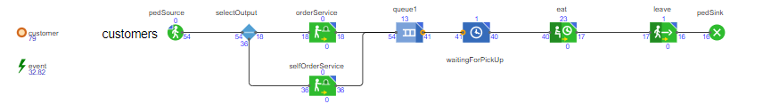

The code base of anylogic becomes internal, writing the appropriate trigger conditions for each state. For example, after a customer enters the queue, the waiting time is directly related to the number of front windows and the processing speed; when the number of customers is too high, the queuing time will increase significantly, affecting customer satisfaction. The state transition logic is implemented by writing code and adjusting the customer's behaviour according to different conditions.
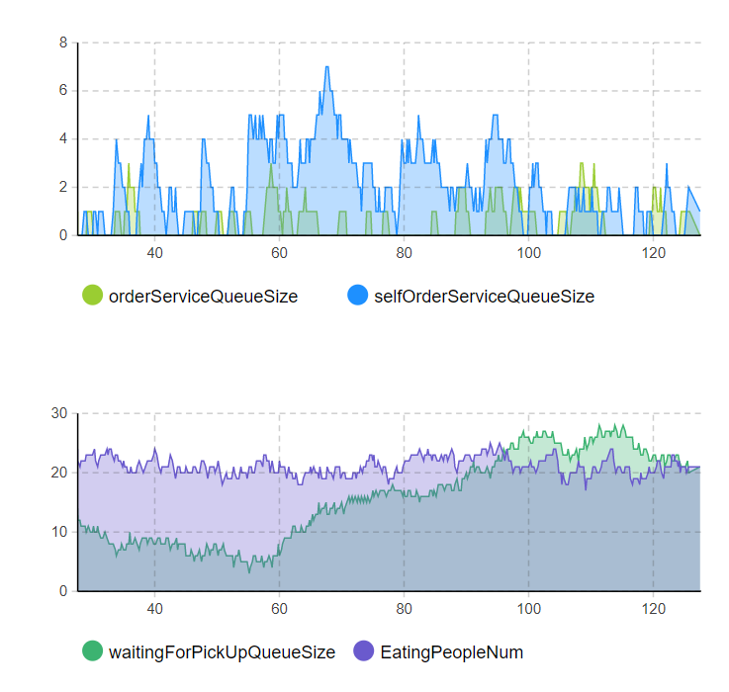
When the simulation is running, the operation of the system is displayed through visualisation tools such as time charts and bar charts. For example, it shows the number of queues at different time periods, the waiting time of customers, and the processing efficiency of the system. The simulation model is also able to adjust various parameters in real time to observe the changes of the system in different contexts.
Analysis of simulation results
The following key results can be derived from the simulation runs during peak and off-peak hours:
- The simulation results show that the average waiting time of customers is 12 minutes during peak hours and the front desk window becomes the bottleneck of the system. Due to the high arrival rate of customers, the front desk window cannot handle all customers in time, resulting in customers consuming a lot of time in queuing. In contrast, during off-peak hours, the average waiting time for customers is 5 minutes, and the restaurant's service efficiency is relatively high.
- The results show that the main bottlenecks of the system are the limited number of front counter windows and the lack of reasonable scheduling of back-of-house resources. During peak hours, although the proportion of customers ordering food electronically is high, the queue at the front window is still relatively serious, which affects the overall waiting time of customers. At the same time, the back kitchen also suffers from insufficient meal production efficiency during peak hours, resulting in customers waiting for a longer period in the food pick-up section.
- For the front counter ordering mode, the simulation model simulates two different queuing modes: straight line queuing and serpentine queuing. The simulation results show that the serpentine queuing can effectively reduce the queuing pressure of customers during the peak period, because the customers in this mode are more mobile and can be distributed to each window more evenly, which reduces the queuing congestion.
Model verification
To ensure the accuracy of the simulation model, the model went through several verification and validation steps. Firstly, the validation of the conceptual model was carried out by comparing the behavioural logic of the real system and the simulation model. The customer arrival rates, service times and queuing behaviours in the model were consistent with the performance of the real system, which verified that the assumptions and design of the model were reasonable, e.g. the randomness of the customer arrivals conformed to the Poisson distribution, while the times of ordering and picking up food conformed to the exponential distribution. Secondly, operational validity validation is carried out by comparing the data with the actual system. The outputs of the simulation model are highly similar to the real system, e.g., the average waiting time of the customers during the peak period is in line with the queuing time observed in the real world, which verifies the operational validity of the model. Finally, data validity validation ensures the accuracy and consistency of the simulation input data. During the model construction process, all data were cleaned and processed to ensure their accuracy, especially the customer arrival rate, front counter service time and back kitchen preparation time, which were based on actual observed data, which ensured the realism of the model results.
Suggestions for improvement:
Based on the results of the simulation, I have several options for improvement:
- Increase the number of front windows: The front desk window is the main bottleneck affecting customer waiting times. It is therefore proposed to increase the number of front desk windows from the current three to five to cope with the high volume of customer arrivals during peak hours.
- Increase in self-service ordering equipment: Self-service food ordering can effectively divert customers queuing at the front counter and reduce the pressure on the front counter. It is therefore recommended that the number of self-ordering kiosks be increased to encourage more customers to use electronic ordering, especially during peak hours.
- Optimise the pick-up process: Customers may experience congestion at the pick-up point. By redesigning the customer pickup path, congestion can be reduced and pickup efficiency can be improved.
Improved simulation results
After applying the above improvement scheme in the simulation model, the results show that the overall efficiency of the system has been significantly improved. Firstly, after adding front counter windows, the average waiting time of customers during peak hours was reduced from 12 minutes to 8 minutes, which significantly improved the queuing experience of customers. Secondly, with the addition of self-service equipment, the proportion of customers using electronic ordering increased to 60%, effectively easing queuing pressure at the front counter. In addition, by optimising the pick-up process, customers' pick-up time was reduced by 25%, significantly reducing congestion in the pick-up area. Overall, these improvement programmes have significantly enhanced the service capacity during peak hours and improved the operational efficiency of the system.
Comparative Systems Thinking
KFC's queuing system shares many similarities with a manufacturing system in terms of resource scheduling and process optimisation, both of which rely on the rational allocation of resources (e.g., front counter staff, back of house equipment) in order to maximise system efficiency. The production line in a manufacturing system is similar to the front counter window in a service system, where the processing capacity of each workstation directly affects the overall output of the system. To improve efficiency, both manufacturing and service systems need to minimise bottlenecks and optimise process design. However, there are significant differences between the two. Firstly, customer arrival patterns in KFC's service system are more uncertain, whereas order demand in the manufacturing system is usually predictable. In addition, the production process in the manufacturing system is highly standardised, whereas the individual customer needs in the service system are complex and varied, leading to potentially large fluctuations in service times. Finally, bottlenecks in manufacturing systems are usually found in equipment or workstations, whereas bottlenecks in service systems are more likely to come from human resource constraints.
Conclusion
Through detailed analysis and simulation modelling of the queuing system in KFC Calton restaurant, we identified the main problems in the current system and proposed targeted improvement solutions. The simulation results show that increasing the front counter window, adding self-service ordering devices and optimising the pick-up process can effectively improve customers' queuing experience and reduce waiting time. Future research can further focus on the change of customer arrival rate, especially the customer behaviour during special periods (e.g. during holidays or promotional activities). In addition, with the advancement of technology, the introduction of smart ordering devices and automated meal preparation equipment may also become an important means to improve service efficiency in the future.

