销售额分组聚类分析报告

# 1. 聚类数量评估

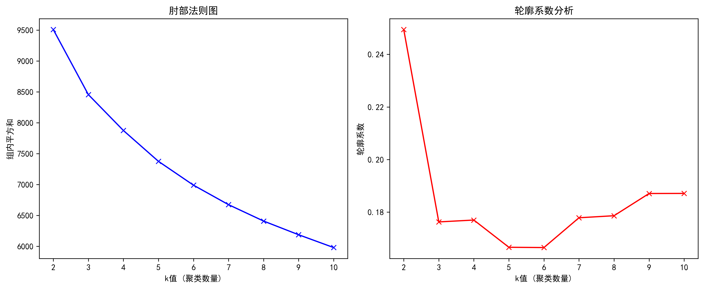

## 1.1 评估图解释

|  |  |
| --- | --- |
| 肘部法则图解释 | 轮廓系数解释 |
| 1. 肘部法则通过观察组内平方和（WCSS）的变化来评估聚类效果。 2. WCSS表示组内样本与其质心之间的距离平方和，值越小表示聚类越紧密。 3. 当增加聚类数量时，WCSS会持续下降。 4. 在某个K值处，WCSS的下降速率会显著减缓，形成"肘部"。 5. 这个"肘部"位置通常被认为是较好的聚类数量选择。 | 1. 轮廓系数评估聚类的内聚度和分离度，取值范围为[-1, 1]。 2. 值越接近1，表示样本与自己所在的组更相似，与其他组更不相似。 3. 值越接近0，表示样本位于组的边界。 4. 值越接近-1，表示样本可能被分配到了错误的组。 5. 一般认为轮廓系数大于0.5表示聚类效果较好。 |

# 2. 不同K值的聚类分析

## 2.1 K=6的聚类分析

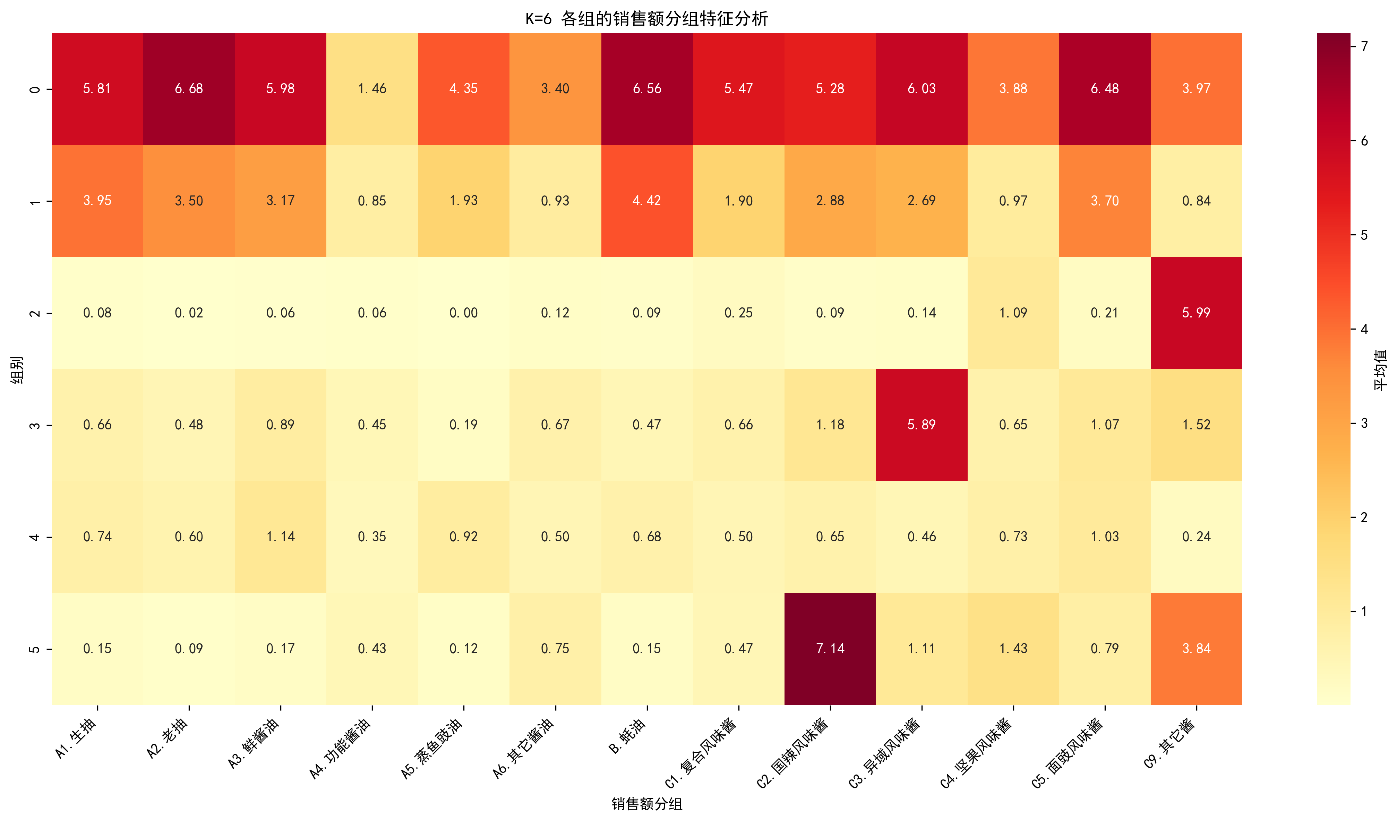

|  |  |  |  |  |  |  |  |  |  |  |  |  |  |  |
| --- | --- | --- | --- | --- | --- | --- | --- | --- | --- | --- | --- | --- | --- | --- |
| **聚类** | **店数占比** | **A1.生抽** | **A2.老抽** | **A3.鲜酱油** | **A4.功能酱油** | **A5.蒸鱼豉油** | **A6.其它酱油** | **B.蚝油** | **C1.复合风味酱** | **C2.国辣风味酱** | **C3.异域风味酱** | **C4.坚果风味酱** | **C5.面豉风味酱** | **C9.其它酱** |
| 聚类0 | 11% | 17% | 17% | 23% | 8% | 5% | 14% | 16% | 17% | 33% | 100% | 16% | 28% | 34% |
| 聚类1 | 31% | 26% | 23% | 33% | 10% | 23% | 13% | 26% | 17% | 28% | 24% | 17% | 33% | 11% |
| 聚类2 | 11% | 85% | 92% | 84% | 24% | 68% | 57% | 93% | 81% | 88% | 87% | 71% | 94% | 76% |
| 聚类3 | 10% | 2% | 0% | 1% | 1% | 0% | 2% | 2% | 3% | 3% | 3% | 14% | 3% | 100% |
| 聚类4 | 21% | 75% | 71% | 63% | 17% | 40% | 21% | 85% | 41% | 64% | 60% | 25% | 72% | 27% |
| 聚类5 | 13% | 3% | 2% | 4% | 5% | 2% | 10% | 4% | 8% | 100% | 20% | 20% | 13% | 58% |

**调味品销售额分组占比（本类别中有销售额分组的店数/本类别的总店数）**

聚类0的菜系和餐厅档次分布：

|  |  |  |
| --- | --- | --- |
| **类型** | **名称** | **占比** |
| 菜系 | C中式快餐 | 29% |
| 菜系 | A6粤菜 | 18% |
| 菜系 | B大而全 | 10% |
| 餐厅档次 | 中高档 | 59% |
| 餐厅档次 | 大众 | 41% |

聚类1的菜系和餐厅档次分布：

|  |  |  |
| --- | --- | --- |
| **类型** | **名称** | **占比** |
| 菜系 | C中式快餐 | 20% |
| 菜系 | A5湘菜 | 17% |
| 菜系 | A6粤菜 | 14% |
| 餐厅档次 | 中高档 | 60% |
| 餐厅档次 | 大众 | 40% |

聚类2的菜系和餐厅档次分布：

|  |  |  |
| --- | --- | --- |
| **类型** | **名称** | **占比** |
| 菜系 | C中式快餐 | 18% |
| 菜系 | A1川菜 | 15% |
| 菜系 | B大而全 | 15% |
| 餐厅档次 | 中高档 | 75% |
| 餐厅档次 | 大众 | 25% |

聚类3的菜系和餐厅档次分布：

|  |  |  |
| --- | --- | --- |
| **类型** | **名称** | **占比** |
| 菜系 | C中式快餐 | 51% |
| 菜系 | A1川菜 | 14% |
| 菜系 | E火锅 | 10% |
| 餐厅档次 | 大众 | 64% |
| 餐厅档次 | 中高档 | 36% |

聚类4的菜系和餐厅档次分布：

|  |  |  |
| --- | --- | --- |
| **类型** | **名称** | **占比** |
| 菜系 | A6粤菜 | 17% |
| 菜系 | A1川菜 | 15% |
| 菜系 | C中式快餐 | 13% |
| 餐厅档次 | 中高档 | 71% |
| 餐厅档次 | 大众 | 29% |

聚类5的菜系和餐厅档次分布：

|  |  |  |
| --- | --- | --- |
| **类型** | **名称** | **占比** |
| 菜系 | C中式快餐 | 58% |
| 菜系 | D单品店 | 13% |
| 菜系 | A1川菜 | 8% |
| 餐厅档次 | 大众 | 68% |
| 餐厅档次 | 中高档 | 32% |

## 2.2 K=7的聚类分析

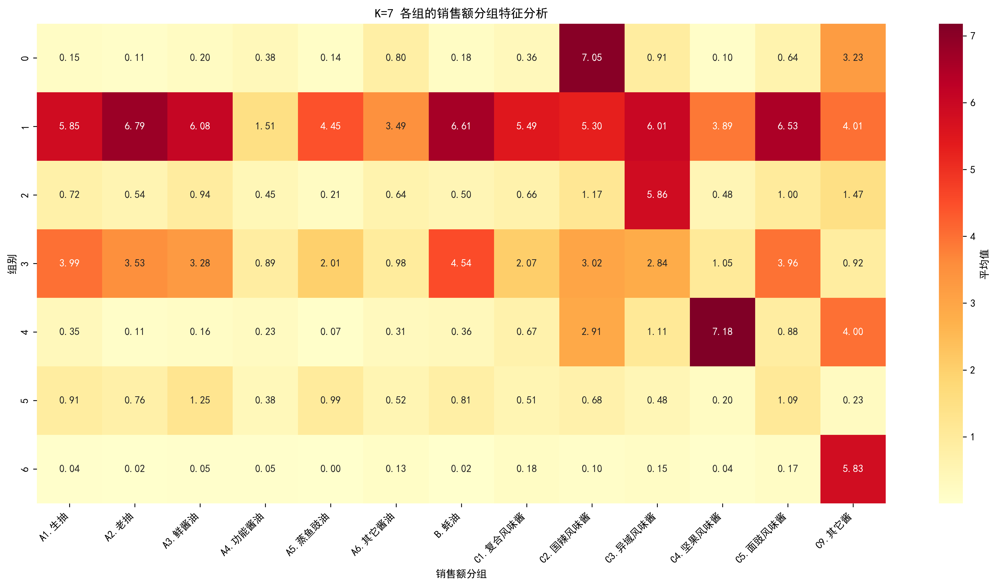

|  |  |  |  |  |  |  |  |  |  |  |  |  |  |  |
| --- | --- | --- | --- | --- | --- | --- | --- | --- | --- | --- | --- | --- | --- | --- |
| **聚类** | **店数占比** | **A1.生抽** | **A2.老抽** | **A3.鲜酱油** | **A4.功能酱油** | **A5.蒸鱼豉油** | **A6.其它酱油** | **B.蚝油** | **C1.复合风味酱** | **C2.国辣风味酱** | **C3.异域风味酱** | **C4.坚果风味酱** | **C5.面豉风味酱** | **C9.其它酱** |
| 聚类0 | 6% | 8% | 3% | 4% | 3% | 1% | 4% | 8% | 10% | 44% | 19% | 100% | 14% | 63% |
| 聚类1 | 11% | 18% | 18% | 23% | 8% | 6% | 14% | 16% | 17% | 33% | 100% | 14% | 27% | 33% |
| 聚类2 | 10% | 3% | 2% | 4% | 5% | 2% | 11% | 5% | 6% | 100% | 18% | 3% | 11% | 50% |
| 聚类3 | 29% | 30% | 27% | 36% | 10% | 25% | 14% | 30% | 18% | 29% | 25% | 9% | 35% | 11% |
| 聚类4 | 11% | 85% | 93% | 85% | 25% | 69% | 58% | 93% | 81% | 88% | 86% | 71% | 94% | 77% |
| 聚类5 | 9% | 1% | 0% | 1% | 1% | 0% | 2% | 0% | 2% | 3% | 3% | 0% | 3% | 100% |
| 聚类6 | 20% | 74% | 71% | 65% | 17% | 41% | 22% | 86% | 44% | 67% | 63% | 27% | 76% | 29% |

**调味品销售额分组占比（本类别中有销售额分组的店数/本类别的总店数）**

聚类0的菜系和餐厅档次分布：

|  |  |  |
| --- | --- | --- |
| **类型** | **名称** | **占比** |
| 菜系 | C中式快餐 | 47% |
| 菜系 | E火锅 | 18% |
| 菜系 | D单品店 | 15% |
| 餐厅档次 | 大众 | 65% |
| 餐厅档次 | 中高档 | 35% |

聚类1的菜系和餐厅档次分布：

|  |  |  |
| --- | --- | --- |
| **类型** | **名称** | **占比** |
| 菜系 | C中式快餐 | 28% |
| 菜系 | A6粤菜 | 19% |
| 菜系 | B大而全 | 10% |
| 餐厅档次 | 中高档 | 59% |
| 餐厅档次 | 大众 | 41% |

聚类2的菜系和餐厅档次分布：

|  |  |  |
| --- | --- | --- |
| **类型** | **名称** | **占比** |
| 菜系 | C中式快餐 | 61% |
| 菜系 | A1川菜 | 8% |
| 菜系 | D单品店 | 7% |
| 餐厅档次 | 大众 | 65% |
| 餐厅档次 | 中高档 | 35% |

聚类3的菜系和餐厅档次分布：

|  |  |  |
| --- | --- | --- |
| **类型** | **名称** | **占比** |
| 菜系 | A5湘菜 | 18% |
| 菜系 | C中式快餐 | 18% |
| 菜系 | A6粤菜 | 15% |
| 餐厅档次 | 中高档 | 62% |
| 餐厅档次 | 大众 | 38% |

聚类4的菜系和餐厅档次分布：

|  |  |  |
| --- | --- | --- |
| **类型** | **名称** | **占比** |
| 菜系 | C中式快餐 | 18% |
| 菜系 | A1川菜 | 16% |
| 菜系 | B大而全 | 15% |
| 餐厅档次 | 中高档 | 74% |
| 餐厅档次 | 大众 | 26% |

聚类5的菜系和餐厅档次分布：

|  |  |  |
| --- | --- | --- |
| **类型** | **名称** | **占比** |
| 菜系 | C中式快餐 | 50% |
| 菜系 | A1川菜 | 17% |
| 菜系 | D单品店 | 9% |
| 餐厅档次 | 大众 | 66% |
| 餐厅档次 | 中高档 | 34% |

聚类6的菜系和餐厅档次分布：

|  |  |  |
| --- | --- | --- |
| **类型** | **名称** | **占比** |
| 菜系 | A6粤菜 | 18% |
| 菜系 | A1川菜 | 15% |
| 菜系 | C中式快餐 | 13% |
| 餐厅档次 | 中高档 | 72% |
| 餐厅档次 | 大众 | 28% |

## 2.3 K=8的聚类分析

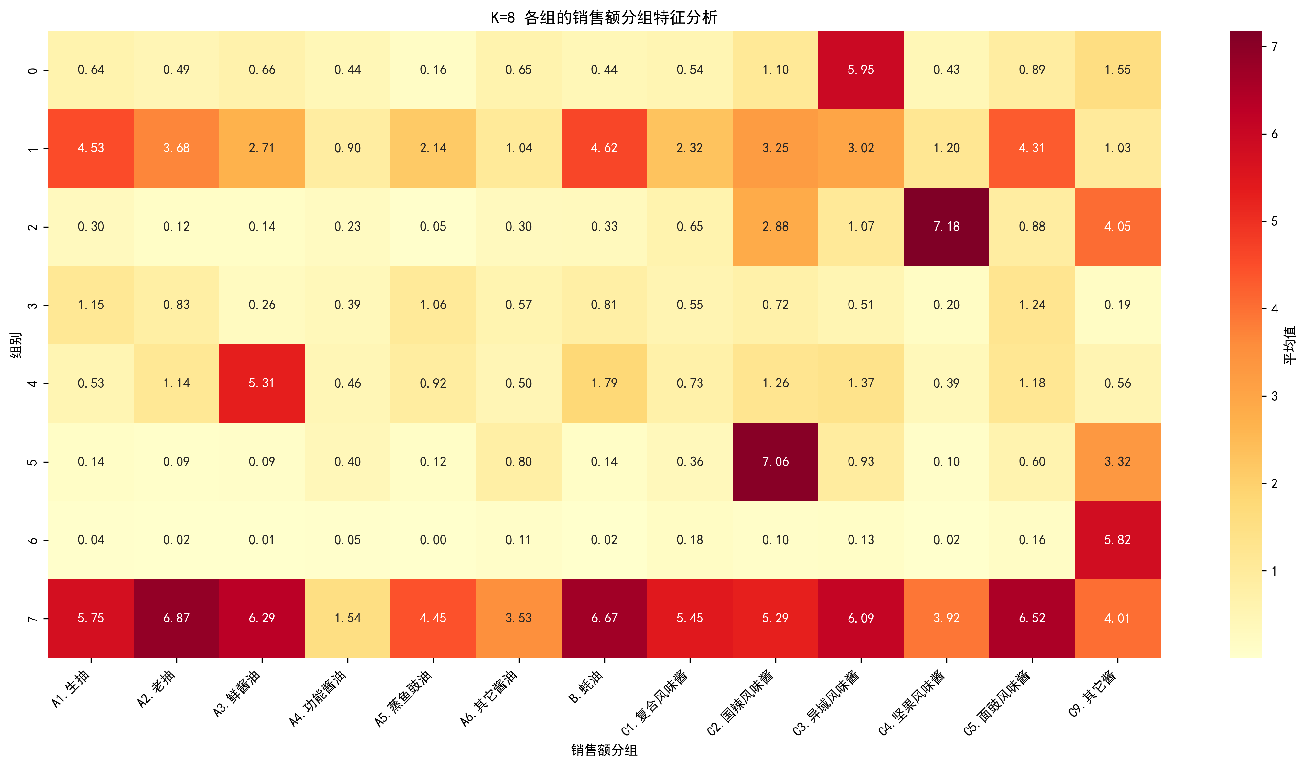

|  |  |  |  |  |  |  |  |  |  |  |  |  |  |  |
| --- | --- | --- | --- | --- | --- | --- | --- | --- | --- | --- | --- | --- | --- | --- |
| **聚类** | **店数占比** | **A1.生抽** | **A2.老抽** | **A3.鲜酱油** | **A4.功能酱油** | **A5.蒸鱼豉油** | **A6.其它酱油** | **B.蚝油** | **C1.复合风味酱** | **C2.国辣风味酱** | **C3.异域风味酱** | **C4.坚果风味酱** | **C5.面豉风味酱** | **C9.其它酱** |
| 聚类0 | 10% | 16% | 35% | 100% | 11% | 23% | 13% | 50% | 21% | 33% | 39% | 11% | 34% | 20% |
| 聚类1 | 24% | 37% | 28% | 17% | 10% | 26% | 15% | 29% | 19% | 32% | 25% | 9% | 40% | 9% |
| 聚类2 | 17% | 82% | 72% | 59% | 17% | 43% | 22% | 86% | 46% | 70% | 65% | 30% | 80% | 31% |
| 聚类3 | 10% | 17% | 17% | 20% | 8% | 4% | 14% | 14% | 15% | 31% | 100% | 13% | 25% | 34% |
| 聚类4 | 10% | 3% | 2% | 3% | 5% | 2% | 10% | 4% | 6% | 100% | 18% | 3% | 10% | 50% |
| 聚类5 | 6% | 7% | 3% | 3% | 3% | 0% | 4% | 7% | 10% | 43% | 19% | 100% | 14% | 64% |
| 聚类6 | 11% | 84% | 93% | 87% | 26% | 70% | 59% | 94% | 81% | 88% | 87% | 72% | 94% | 77% |
| 聚类7 | 8% | 1% | 0% | 0% | 1% | 0% | 2% | 0% | 2% | 3% | 3% | 1% | 2% | 100% |

**调味品销售额分组占比（本类别中有销售额分组的店数/本类别的总店数）**

聚类0的菜系和餐厅档次分布：

|  |  |  |
| --- | --- | --- |
| **类型** | **名称** | **占比** |
| 菜系 | A4京鲁菜 | 19% |
| 菜系 | C中式快餐 | 19% |
| 菜系 | B大而全 | 10% |
| 餐厅档次 | 中高档 | 69% |
| 餐厅档次 | 大众 | 31% |

聚类1的菜系和餐厅档次分布：

|  |  |  |
| --- | --- | --- |
| **类型** | **名称** | **占比** |
| 菜系 | A5湘菜 | 21% |
| 菜系 | C中式快餐 | 17% |
| 菜系 | A6粤菜 | 16% |
| 餐厅档次 | 中高档 | 61% |
| 餐厅档次 | 大众 | 39% |

聚类2的菜系和餐厅档次分布：

|  |  |  |
| --- | --- | --- |
| **类型** | **名称** | **占比** |
| 菜系 | A6粤菜 | 19% |
| 菜系 | A1川菜 | 15% |
| 菜系 | C中式快餐 | 12% |
| 餐厅档次 | 中高档 | 72% |
| 餐厅档次 | 大众 | 28% |

聚类3的菜系和餐厅档次分布：

|  |  |  |
| --- | --- | --- |
| **类型** | **名称** | **占比** |
| 菜系 | C中式快餐 | 29% |
| 菜系 | A6粤菜 | 18% |
| 菜系 | B大而全 | 10% |
| 餐厅档次 | 中高档 | 58% |
| 餐厅档次 | 大众 | 42% |

聚类4的菜系和餐厅档次分布：

|  |  |  |
| --- | --- | --- |
| **类型** | **名称** | **占比** |
| 菜系 | C中式快餐 | 62% |
| 菜系 | A1川菜 | 8% |
| 菜系 | D单品店 | 7% |
| 餐厅档次 | 大众 | 66% |
| 餐厅档次 | 中高档 | 34% |

聚类5的菜系和餐厅档次分布：

|  |  |  |
| --- | --- | --- |
| **类型** | **名称** | **占比** |
| 菜系 | C中式快餐 | 47% |
| 菜系 | E火锅 | 17% |
| 菜系 | D单品店 | 15% |
| 餐厅档次 | 大众 | 65% |
| 餐厅档次 | 中高档 | 35% |

聚类6的菜系和餐厅档次分布：

|  |  |  |
| --- | --- | --- |
| **类型** | **名称** | **占比** |
| 菜系 | C中式快餐 | 19% |
| 菜系 | A1川菜 | 15% |
| 菜系 | B大而全 | 15% |
| 餐厅档次 | 中高档 | 74% |
| 餐厅档次 | 大众 | 26% |

聚类7的菜系和餐厅档次分布：

|  |  |  |
| --- | --- | --- |
| **类型** | **名称** | **占比** |
| 菜系 | C中式快餐 | 50% |
| 菜系 | A1川菜 | 17% |
| 菜系 | D单品店 | 9% |
| 餐厅档次 | 大众 | 66% |
| 餐厅档次 | 中高档 | 34% |

## 2.4 K=9的聚类分析

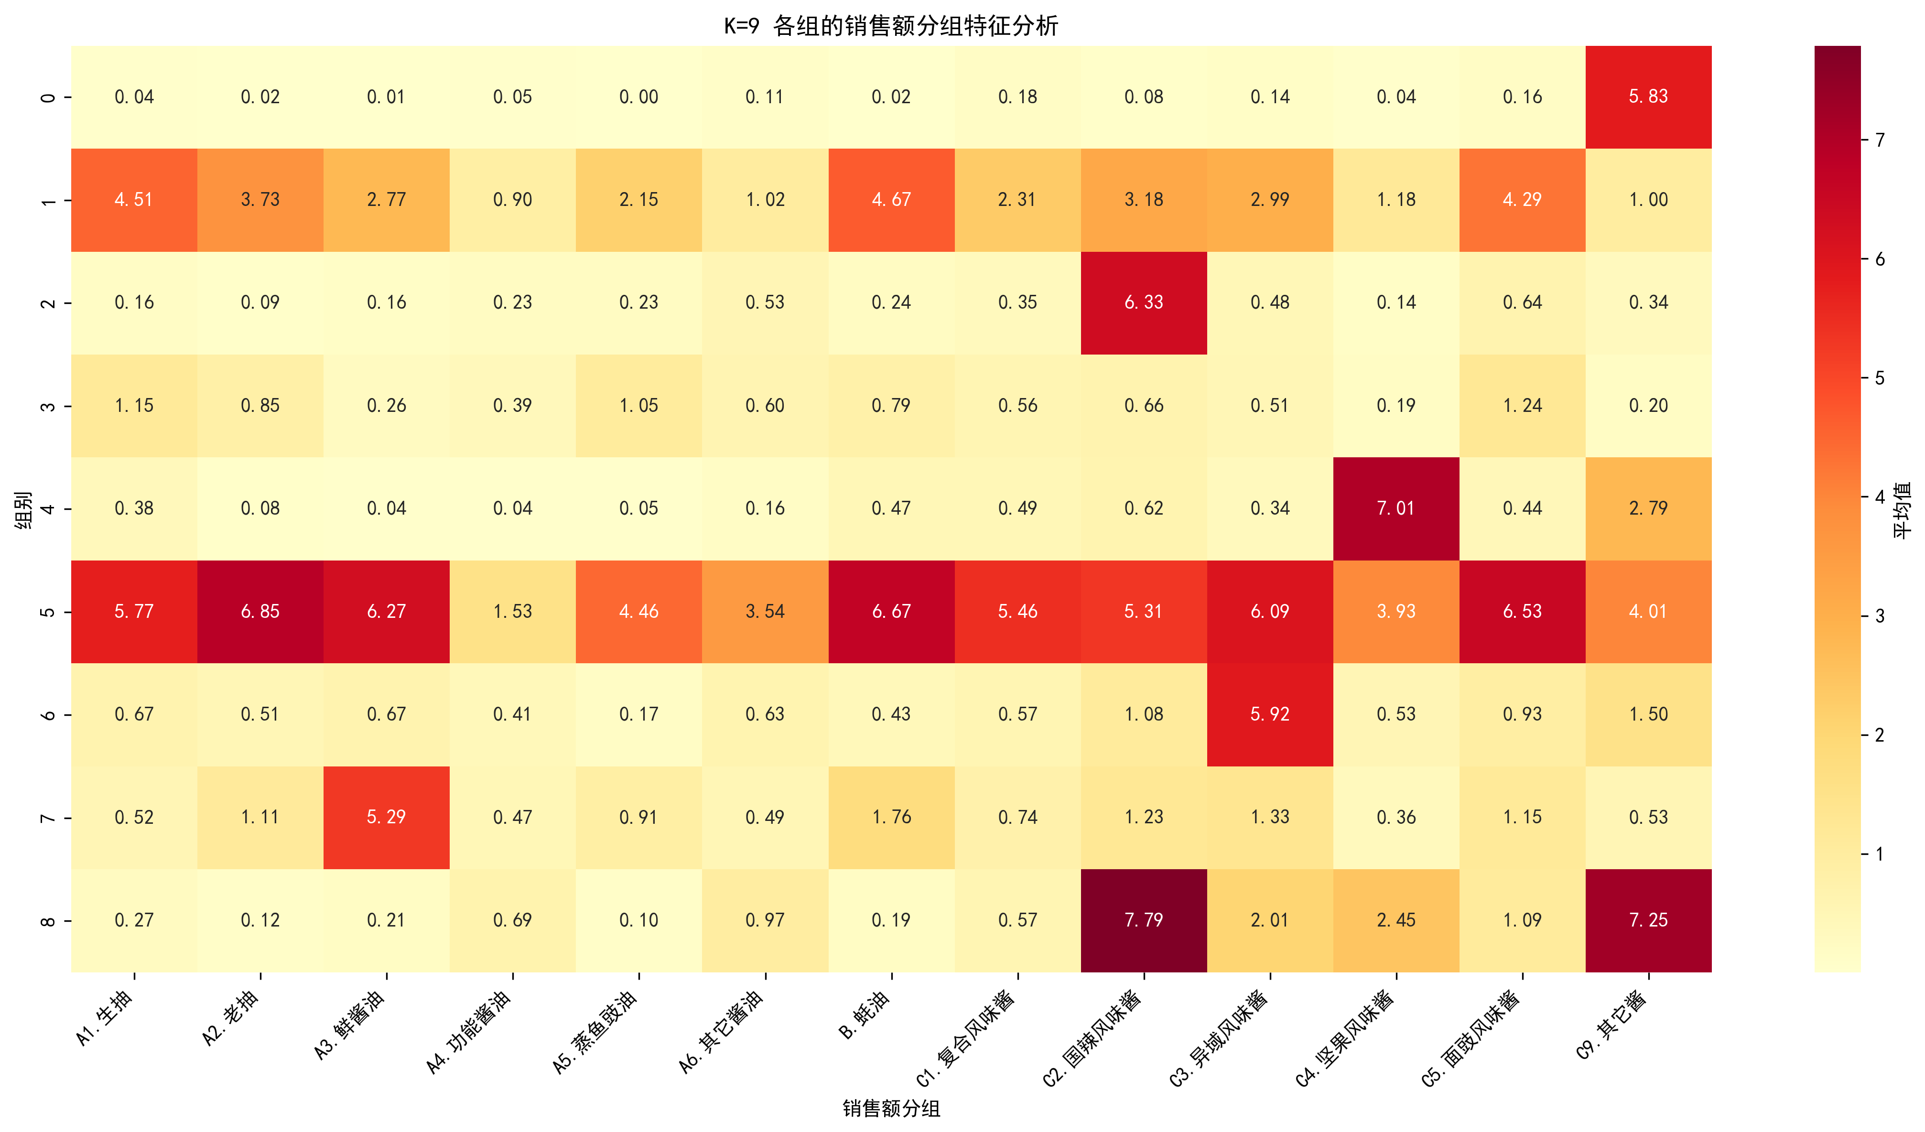

|  |  |  |  |  |  |  |  |  |  |  |  |  |  |  |
| --- | --- | --- | --- | --- | --- | --- | --- | --- | --- | --- | --- | --- | --- | --- |
| **聚类** | **店数占比** | **A1.生抽** | **A2.老抽** | **A3.鲜酱油** | **A4.功能酱油** | **A5.蒸鱼豉油** | **A6.其它酱油** | **B.蚝油** | **C1.复合风味酱** | **C2.国辣风味酱** | **C3.异域风味酱** | **C4.坚果风味酱** | **C5.面豉风味酱** | **C9.其它酱** |
| 聚类0 | 9% | 13% | 32% | 100% | 10% | 22% | 12% | 47% | 18% | 30% | 32% | 9% | 30% | 17% |
| 聚类1 | 6% | 6% | 2% | 1% | 2% | 0% | 3% | 7% | 8% | 40% | 15% | 100% | 11% | 62% |
| 聚类2 | 13% | 95% | 70% | 45% | 14% | 36% | 16% | 80% | 33% | 59% | 48% | 19% | 64% | 18% |
| 聚类3 | 9% | 14% | 14% | 19% | 8% | 3% | 14% | 10% | 14% | 27% | 100% | 11% | 21% | 31% |
| 聚类4 | 10% | 3% | 2% | 2% | 5% | 1% | 10% | 4% | 5% | 100% | 18% | 3% | 9% | 50% |
| 聚类5 | 8% | 1% | 0% | 0% | 1% | 0% | 2% | 0% | 2% | 3% | 3% | 0% | 2% | 100% |
| 聚类6 | 8% | 93% | 93% | 84% | 26% | 76% | 63% | 96% | 84% | 91% | 82% | 72% | 96% | 75% |
| 聚类7 | 22% | 32% | 26% | 18% | 11% | 27% | 16% | 27% | 20% | 33% | 27% | 10% | 42% | 11% |
| 聚类8 | 11% | 56% | 73% | 81% | 21% | 45% | 34% | 82% | 64% | 77% | 94% | 51% | 87% | 60% |

**调味品销售额分组占比（本类别中有销售额分组的店数/本类别的总店数）**

聚类0的菜系和餐厅档次分布：

|  |  |  |
| --- | --- | --- |
| **类型** | **名称** | **占比** |
| 菜系 | C中式快餐 | 20% |
| 菜系 | A4京鲁菜 | 19% |
| 菜系 | B大而全 | 10% |
| 餐厅档次 | 中高档 | 67% |
| 餐厅档次 | 大众 | 33% |

聚类1的菜系和餐厅档次分布：

|  |  |  |
| --- | --- | --- |
| **类型** | **名称** | **占比** |
| 菜系 | C中式快餐 | 48% |
| 菜系 | E火锅 | 17% |
| 菜系 | D单品店 | 15% |
| 餐厅档次 | 大众 | 67% |
| 餐厅档次 | 中高档 | 33% |

聚类2的菜系和餐厅档次分布：

|  |  |  |
| --- | --- | --- |
| **类型** | **名称** | **占比** |
| 菜系 | A6粤菜 | 18% |
| 菜系 | C中式快餐 | 17% |
| 菜系 | A1川菜 | 15% |
| 餐厅档次 | 中高档 | 64% |
| 餐厅档次 | 大众 | 36% |

聚类3的菜系和餐厅档次分布：

|  |  |  |
| --- | --- | --- |
| **类型** | **名称** | **占比** |
| 菜系 | C中式快餐 | 30% |
| 菜系 | A6粤菜 | 18% |
| 菜系 | B大而全 | 10% |
| 餐厅档次 | 中高档 | 58% |
| 餐厅档次 | 大众 | 42% |

聚类4的菜系和餐厅档次分布：

|  |  |  |
| --- | --- | --- |
| **类型** | **名称** | **占比** |
| 菜系 | C中式快餐 | 62% |
| 菜系 | A1川菜 | 8% |
| 菜系 | D单品店 | 7% |
| 餐厅档次 | 大众 | 66% |
| 餐厅档次 | 中高档 | 34% |

聚类5的菜系和餐厅档次分布：

|  |  |  |
| --- | --- | --- |
| **类型** | **名称** | **占比** |
| 菜系 | C中式快餐 | 50% |
| 菜系 | A1川菜 | 17% |
| 菜系 | D单品店 | 9% |
| 餐厅档次 | 大众 | 66% |
| 餐厅档次 | 中高档 | 34% |

聚类6的菜系和餐厅档次分布：

|  |  |  |
| --- | --- | --- |
| **类型** | **名称** | **占比** |
| 菜系 | C中式快餐 | 20% |
| 菜系 | B大而全 | 16% |
| 菜系 | A1川菜 | 14% |
| 餐厅档次 | 中高档 | 73% |
| 餐厅档次 | 大众 | 27% |

聚类7的菜系和餐厅档次分布：

|  |  |  |
| --- | --- | --- |
| **类型** | **名称** | **占比** |
| 菜系 | A5湘菜 | 21% |
| 菜系 | A6粤菜 | 17% |
| 菜系 | C中式快餐 | 15% |
| 餐厅档次 | 中高档 | 63% |
| 餐厅档次 | 大众 | 37% |

聚类8的菜系和餐厅档次分布：

|  |  |  |
| --- | --- | --- |
| **类型** | **名称** | **占比** |
| 菜系 | A6粤菜 | 19% |
| 菜系 | A1川菜 | 15% |
| 菜系 | C中式快餐 | 12% |
| 餐厅档次 | 中高档 | 77% |
| 餐厅档次 | 大众 | 23% |

## 2.5 K=10的聚类分析

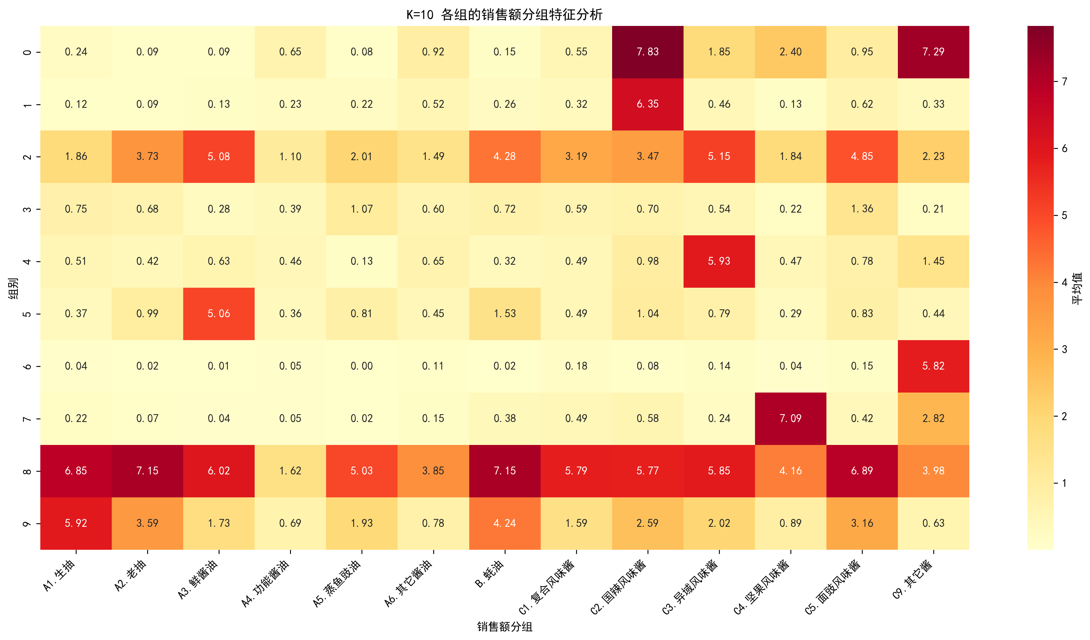

|  |  |  |  |  |  |  |  |  |  |  |  |  |  |  |
| --- | --- | --- | --- | --- | --- | --- | --- | --- | --- | --- | --- | --- | --- | --- |
| **聚类** | **店数占比** | **A1.生抽** | **A2.老抽** | **A3.鲜酱油** | **A4.功能酱油** | **A5.蒸鱼豉油** | **A6.其它酱油** | **B.蚝油** | **C1.复合风味酱** | **C2.国辣风味酱** | **C3.异域风味酱** | **C4.坚果风味酱** | **C5.面豉风味酱** | **C9.其它酱** |
| 聚类0 | 8% | 13% | 31% | 100% | 10% | 20% | 12% | 46% | 16% | 28% | 30% | 10% | 26% | 16% |
| 聚类1 | 22% | 32% | 26% | 18% | 11% | 26% | 16% | 27% | 20% | 32% | 26% | 10% | 42% | 10% |
| 聚类2 | 8% | 93% | 93% | 83% | 26% | 74% | 62% | 96% | 83% | 92% | 83% | 74% | 96% | 76% |
| 聚类3 | 10% | 52% | 73% | 85% | 21% | 48% | 34% | 84% | 64% | 75% | 90% | 44% | 88% | 55% |
| 聚类4 | 6% | 3% | 2% | 5% | 3% | 3% | 7% | 7% | 6% | 100% | 14% | 3% | 12% | 13% |
| 聚类5 | 9% | 14% | 14% | 18% | 8% | 4% | 14% | 10% | 14% | 28% | 100% | 13% | 22% | 32% |
| 聚类6 | 4% | 6% | 2% | 1% | 0% | 0% | 2% | 8% | 7% | 14% | 8% | 100% | 8% | 46% |
| 聚类7 | 13% | 97% | 70% | 44% | 14% | 36% | 16% | 79% | 33% | 59% | 50% | 21% | 63% | 20% |
| 聚类8 | 8% | 1% | 0% | 0% | 1% | 0% | 2% | 0% | 2% | 3% | 3% | 1% | 2% | 100% |
| 聚类9 | 6% | 4% | 2% | 2% | 8% | 1% | 12% | 3% | 8% | 100% | 28% | 33% | 12% | 100% |

**调味品销售额分组占比（本类别中有销售额分组的店数/本类别的总店数）**

聚类0的菜系和餐厅档次分布：

|  |  |  |
| --- | --- | --- |
| **类型** | **名称** | **占比** |
| 菜系 | C中式快餐 | 21% |
| 菜系 | A4京鲁菜 | 19% |
| 菜系 | B大而全 | 10% |
| 餐厅档次 | 中高档 | 66% |
| 餐厅档次 | 大众 | 34% |

聚类1的菜系和餐厅档次分布：

|  |  |  |
| --- | --- | --- |
| **类型** | **名称** | **占比** |
| 菜系 | A5湘菜 | 20% |
| 菜系 | A6粤菜 | 17% |
| 菜系 | C中式快餐 | 15% |
| 餐厅档次 | 中高档 | 63% |
| 餐厅档次 | 大众 | 37% |

聚类2的菜系和餐厅档次分布：

|  |  |  |
| --- | --- | --- |
| **类型** | **名称** | **占比** |
| 菜系 | C中式快餐 | 19% |
| 菜系 | B大而全 | 16% |
| 菜系 | A1川菜 | 15% |
| 餐厅档次 | 中高档 | 74% |
| 餐厅档次 | 大众 | 26% |

聚类3的菜系和餐厅档次分布：

|  |  |  |
| --- | --- | --- |
| **类型** | **名称** | **占比** |
| 菜系 | A6粤菜 | 19% |
| 菜系 | A1川菜 | 15% |
| 菜系 | D单品店 | 12% |
| 餐厅档次 | 中高档 | 78% |
| 餐厅档次 | 大众 | 22% |

聚类4的菜系和餐厅档次分布：

|  |  |  |
| --- | --- | --- |
| **类型** | **名称** | **占比** |
| 菜系 | C中式快餐 | 51% |
| 菜系 | A1川菜 | 9% |
| 菜系 | E火锅 | 8% |
| 餐厅档次 | 大众 | 59% |
| 餐厅档次 | 中高档 | 41% |

聚类5的菜系和餐厅档次分布：

|  |  |  |
| --- | --- | --- |
| **类型** | **名称** | **占比** |
| 菜系 | C中式快餐 | 30% |
| 菜系 | A6粤菜 | 18% |
| 菜系 | B大而全 | 9% |
| 餐厅档次 | 中高档 | 58% |
| 餐厅档次 | 大众 | 42% |

聚类6的菜系和餐厅档次分布：

|  |  |  |
| --- | --- | --- |
| **类型** | **名称** | **占比** |
| 菜系 | C中式快餐 | 52% |
| 菜系 | E火锅 | 23% |
| 菜系 | A1川菜 | 8% |
| 餐厅档次 | 大众 | 60% |
| 餐厅档次 | 中高档 | 40% |

聚类7的菜系和餐厅档次分布：

|  |  |  |
| --- | --- | --- |
| **类型** | **名称** | **占比** |
| 菜系 | A6粤菜 | 18% |
| 菜系 | C中式快餐 | 17% |
| 菜系 | A1川菜 | 15% |
| 餐厅档次 | 中高档 | 64% |
| 餐厅档次 | 大众 | 36% |

聚类8的菜系和餐厅档次分布：

|  |  |  |
| --- | --- | --- |
| **类型** | **名称** | **占比** |
| 菜系 | C中式快餐 | 50% |
| 菜系 | A1川菜 | 17% |
| 菜系 | D单品店 | 9% |
| 餐厅档次 | 大众 | 66% |
| 餐厅档次 | 中高档 | 34% |

聚类9的菜系和餐厅档次分布：

|  |  |  |
| --- | --- | --- |
| **类型** | **名称** | **占比** |
| 菜系 | C中式快餐 | 64% |
| 菜系 | D单品店 | 18% |
| 菜系 | A1川菜 | 7% |
| 餐厅档次 | 大众 | 75% |
| 餐厅档次 | 中高档 | 25% |