**算法对接方案**

1. **算法对接方案**

**运行流程：**

1. **前端页面点击调用一种算法，发送请求访问java接口。**
2. **java接口整合参数后请求python接口（下面附带请求代码示例）。**
3. **python再调用相对应的算法方法。**
4. **算法处理数据完成后，将生成的csv、tif、png等文件成果保存在服务器（192.168.1.8）上面的地址以json的格式（下面示例）上传到RabbitMq上面。**
5. **java接口轮询RabbitMq的信息，解析数据入库。**
6. **前端页面展示入库数据信息。**

**Json格式示例{"taskType":"1","csvFilePath":"xx","tifFilePath":"xxx","pngFilePath":"xxx","dataTime":"xxxx"}**

**Python集成RabbitMq示例网站如下：**

**https://blog.csdn.net/weixin_43810267/article/details/123914324?ops_request_misc=%257B%2522request%255Fid%2522%253A%2522171826242916800222845835%2522%252C%2522scm%2522%253A%252220140713.130102334..%2522%257D&request_id=171826242916800222845835&biz_id=0&utm_medium=distribute.pc_search_result.none-task-blog-2~all~sobaiduend~default-1-123914324-null-null.142^v100^pc_search_result_base2&utm_term=python%E9%9B%86%E6%88%90rabbitmq&spm=1018.2226.3001.4187**

**Java请求python代码示例**

**Java代码：**

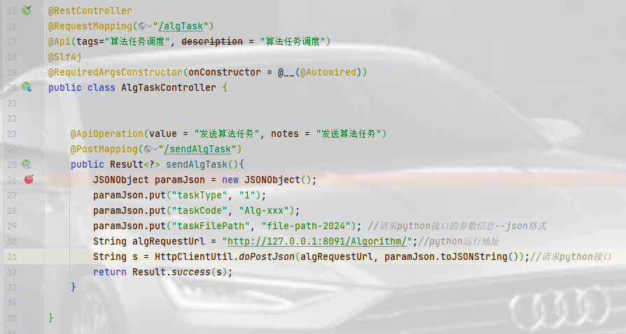

**Python代码**

import asyncio  
import os  
import sys  
from sanic import Sanic  
from sanic.response import json

defdir = os.path.dirname(__file__)  
sys.path.append(os.path.join(defdir[:defdir.find('Python')], 'Python'))  
  
app = Sanic(name="ZJAMDPAMapp")

async def runAgricMeteorolTask(request):  
 loop = asyncio.get_event_loop()  
 #fut = loop.run_in_executor(None, runAlgorithmTask, request)  
 print("123456")  
 runAlgorithmTask(request);  
def runAlgorithmTask(request):  
 """"""  
 par_dict = request.json  
 taskType = par_dict["taskType"]  
 taskCode = par_dict["taskCode"]

#根据taskType的值调用不同的算法方法  
 try:  
 if taskType == "3":  
 print("3")  
 # mainGridClassifyStatistic(**par_dict)  
  
 elif taskType == "2":  
 # gridStat(**par_dict)  
 print("2")  
  
 elif taskType == "1":  
  
 print("1")  
 elif taskType == "4":  
 print("4")  
 else:  
 print("error")  
  
 except Exception as error:  
 print("error-1")  
  
@app.route('/Algorithm/', methods=['POST'])  
async def runAM(request):  
 request.app.add_task(runAgricMeteorolTask(request))  
 return json({'msg': 'Algorithm task runs success!'})

if __name__ == '__main__':  
 app.run(host='127.0.0.1', port=8091, workers=4, debug=False)