ReadMe

makefile

lanch ./a.out
correct.pascal
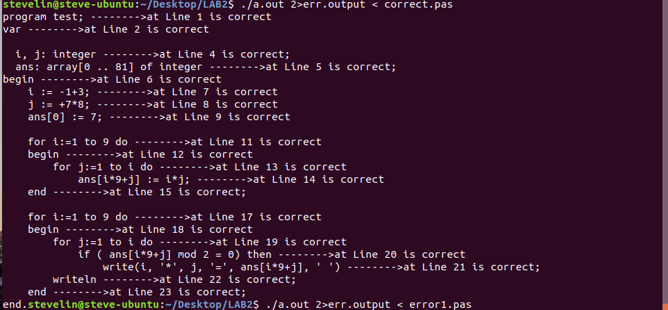
error.pascal
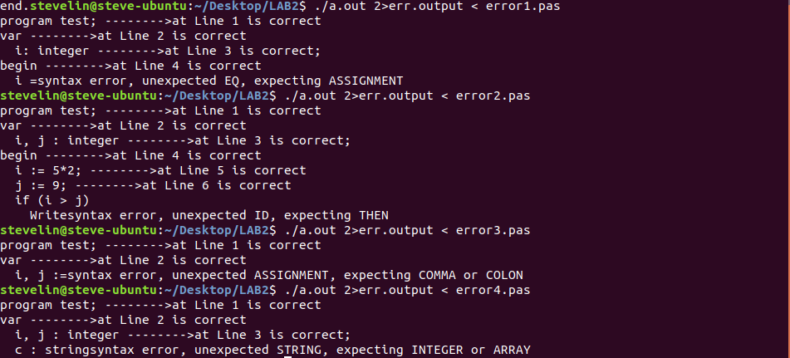

why use std_errror ???
it’s not only std_error, bison offer a excellent option function that give you detail of the process how bison compile yacc file. By reading the output of std_error generate by bison, we can easily grasp the bug at alance.
