1. 错误: 找不到或无法加载主类 @C:\Users\Administrator\AppData\Local\Temp\idea_arg_file1088762970

解决方案:

重新创建项目

1. 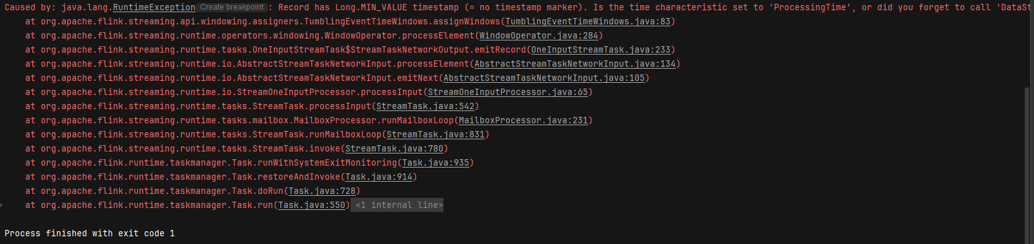

Caused by: java.lang.RuntimeException: Record has Long.MIN_VALUE timestamp (= no timestamp marker). Is the time characteristic set to 'ProcessingTime', or did you forget to call 'DataStream.assignTimestampsAndWatermarks(...)'?

解决方案:

重构assignTimestampsAndWatermarks 方法