Language Reference

CONTENTS

Cypress Enable Scripting Language Elements
Comments
Numbers
Variable and Constant Names
Variable Types
Other Data Types
Control Structures
Subroutines and Functions
ByRef and ByVal
Calling Procedures in DLLs
File Input/Output
Arrays
User Defined Types
Dialog Support
OLE Automation
Accessing an object
What is an OLE Object?
OLE Fundamentals
OLE Automation and Word 6.0 example:
Making Applications Work Together
The Registration database
The Regedit Program
Scripting Language Overview
Quick reference of the Functions and Statements available
Language Reference A - Z
Abs Function
AppActivate Statement
Asc Function
Atn Function
Beep Statement
Call Statement
CDbl Function
ChDir Statement
ChDrive Statement
CheckBox
Chr, Chr$ Function
CInt Function
CLng Function
Close Statement
Const Statement
Cos Function
CreateObject Function
CSng Function
CStr Function
CVar Function
CurDir, CurDir$ Function
Date Function
Declare Statement
Dialog, Dialog Function
Dim Statement
Dir$ Function
DlgEnable Statement
DlgText Statement
DlgVisible Statement
Do...Loop Statement
End Statement
EOF Function
Erase Statement
Exit Statement
Exp
FileCopy Function
FileLen Function
Fix Function
For...Next Statement
Format, Format$ Function
Function Statement
Global Statement
GoSub...Return Statement
GoTo Statement
Hex, Hex$
Hour Function
If...Then...Else Statement
Input, Input$ Function
InputBox, InputBox$
InStr
Int Function
IsDate
IsEmpty
IsNull
IsNumeric
Kill Statement
LBound Function
LCase, LCase$ Function
Left, Left$
Len
Let Statement
Line Input # Statement
Log
Mid Function
Minute Function
MkDir
Month Function
MsgBox Function MsgBox Statement
Name Statement
Now Function
Oct
OKButton
On Error
Open Statement
Option Base Statement
Option Explicit Statement
Print # Statement
Print Method
Rem Statement
Right, Right$ Function
RmDir Statement
Rnd Function
Second Function
Seek Function
Select Case Statement
SendKeys Function
Set Statement
Shell Function
Sin Function
Space Function
Sqr Function
Static Statement
Stop Statement
Str, Str$ Function
StrComp Function
String, String$ Function
Sub Statement
Tan Function
Text Statement
TextBox Statement
Time, Time$ Function
TimeSerial - Function
TimeValue - Function
Trim, Trim$,LTrim, LTrim$, RTrim, Rtrim$ Functions
Type Statement
UBound Function
UCase, UCase$ Function
Val
VarType
While...Wend Statement
Write # - Statement
Year Function

Cypress Enable Scripting Language Elements
In this Section, the general elements of the Enable language are described. Enable scripts can include comments, statements, various representations of numbers, six variable types, and multiple flow of control structures. Enable is also extendable by calling external DLL’s or calling functions back in your applications .exe file.

Comments

Comments are non-executed lines of code which are included for the benefit of the programmer. Comments can be included virtually anywhere in a script. Any text following an apostrophe or the word Rem is ignored by Enable. Rem and all other keywords and most names in Enable are not case sensitive

' This whole line is a comment
rem This whole line is a comment
REM This whole line is a comment
Rem This whole line is a comment

Comments can also be included on the same line as executed code:

MsgBox Msg ' Display message.

Everything after the apostrophe is a comment.

Statements:

In Enable there is no statement terminator. More than one statement can be put on a line if they are separated by a colon.

X.AddPoint( 25, 100) : X.AddPoint( 0, 75)

Which is equivalent to:

X.AddPoint( 25, 100)
X.AddPoint( 0, 75)

Line Continuation Character:

The underscore is the line continuation character in Enable. There must be a space before and after the line continuation character.

X.AddPoint _
( 25, 100)

Numbers

Cypress Enable supports three representations of numbers: Decimal, Octal and Hexadecimal. Most of the numbers used in this manual are decimal or base 10 numbers. However, if you need to use Octal (base 8) or hexadecimal (base 16) numbers simply prefix the number with &O or &H respectively.

Variable and Constant Names

Variable and Constant names must begin with a letter. They can contain the letters A to Z and a to z, the underscore “_”, and the digits 0 to 9. Variable and constant names must begin with a letter, be no longer than 40 characters. and cannot be reserved words. For a table of reserved words, see the Language Overview section of this manual. One exception to this rule is that object member names and property names may be reserved words.

Variable Types

Variant

As is the case with Visual Basic, when a variable is introduced in Cypress Enable, it is not necessary to declare it first (see option explicit for an exception to this rule). When a variable is used but not declared then it is implicitly declared as a variant data type. Variants can also be declared explicitly using "As Variant" as in Dim x As Variant. The variant data type is capable of storing numbers, strings, dates, and times. When using a variant you do not have to explicitly convert a variable from one data type to another. This data type conversion is handled automatically.

Sub Main
Dim x 'variant variable
x = 10
x = x + 8
x = "F" & x
print x 'prints F18
End Sub

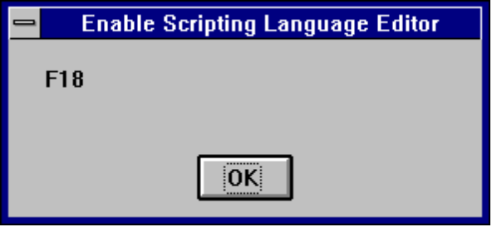

A variant variable can readily change its type and its internal representation can be determined by using the function VarType. VarType returns a value that corresponds to the explicit data types. See VarType in A-Z Reference for return values.

When storing numbers in variant variables the data type used is always the most compact type possible. For example, if you first assign a small number to the variant it will be stored as an integer. If you then assign your variant to a number with a fractional component it will then be stored as a double.

For doing numeric operations on a variant variable it is sometimes necessary to determine if the value stored is a valid numeric, thus avoiding an error. This can be done with the IsNumeric function.

Variants and Concatenation

If a string and a number are concatenated the result is a string. To be sure your concatenation works regardless of the data type involved use the & operator. The & will not perform arithmetic on your numeric values it will simply concatenate them as if they were strings.

The IsEmpty function can be used to find out if a variant variable has been previously assigned.

Other Data Types

The six data types available in Cypress Enable are shown below:

Data Types

Variable Type Declaration Size
String $ Dim Str_Var As String 0 to 65,500 char
Integer % Dim Int_Var As Integer 2 bytes
Long & Dim Long_Var As Long 4 bytes
Single ! Dim Sing_Var As Single 4 bytes
Double # Dim Dbl_Var As Double 8 bytes
Variant Dim X As Any
Currency (Currency datatype is not supported)

Scope of Variables

Cypress Enable scripts can be composed of many files and each file can have many subroutines and functions in it. Variable names can be reused even if they are contained in separate files. Variables can be local or global.

Declaration of Variables

In Cypress Enable variables are declared with the Dim statement. To declare a variable other than a variant the variable must be followed by As or appended by a type declaration character such as a % for Integer type.

Sub Main
Dim X As Integer
Dim Y As Double
Dim Name$, Age% ' multiple declaration on one line Dim v

End Sub

Control Structures

Cypress Enable has complete process control functionality. The control structures available are Do loops, While loops, For loops, Select Case, If Then , and If Then Else. In addition, Cypress Enable has two branching statements: GoTo and GoSub. The Goto Statement branches to the label specified in the Goto Statement.

Goto label1
.
.
.

label1:

The program execution jumps to the part of the program that begins with the label "Label1:".

The GoSub statement also requires a label to be specified like the GoTo statement. The difference between the Goto and the GoSub is that the GoSub statement returns to its original position in the code after executing a return statement.

GoSub Label2
.
.
.

Label2:
.
.
.

Return

Loop Structures

Do Loops
The Do...Loop allows you to execute a block of statements an indefinite number of times. The variations of the Do...Loop are Do While, Do Until, Do Loop While, and Do Loop Until.

Do While condition
Statement(s)...
Loop

Do Until condition
Statement(s)...
Loop

Do
Statements...
Loop While condition

Do
statements...
Loop Until condition

Do While and Do Until check the condition before entering the loop, thus the block of statements inside the loop are only executed when those conditions are met. Do Loop While and Do Loop Until check the condition after having executed the block of statements thereby guaranteeing that the block of statements is executed at least once.

While Loop
The While...Wend loop is similar to the Do While loop. The condition is checked before executing the block of statements comprising the loop.

While condition
statements...
Wend

For ... Next Loop
The For...Next loop has a counter variable and repeats a block of statements a set number of times. The counter variable increases or decreases with each repetition through the loop. The counter default is one if the Step variation is not used.

For counter = beginning value To ending value [Step increment]
statements...
Next

If and Select Statements
The If...Then block has a single line and multiple line syntax. The condition of an If statement can be a comparison or an expression, but it must evaluate to True or False.

If condition Then Statements... 'single line syntax

If condition Then 'multiple line syntax
statements...
End If

The other variation on the If statement is the If...Then...Else statement. This statement should be used when there is different statement blocks to be executed depending on the condition. There is also the If...Then...ElseIf... variation, these can get quite long and cumbersome, at which time you should consider using the Select statement.

If condition Then
statements...
ElseIf condition Then
statements...
Else

End If

The Select Case statement tests the same variable for many different values. This statement tends to be easier to read, understand and follow and should be used in place of a complicated If...Then...ElseIf statement.

Select Case variable to test
Case 1
statements...
Case 2
statements...
Case 3
statements...
Case Else
statements...
End Select

See Language Reference A - Z for exact syntax and code examples.

Subroutines and Functions

Naming conventions

Subroutine and Function names can contain the letters A to Z and a to z, the underscore “_” and digits 0 to 9. The only limitation is that subroutine and function names must begin with a letter, be no longer than 40 characters, and not be reserved words. For a list of reserved words, see the table of reserved words in the Language Overview section of this manual.

Cypress Enable allows script developers to create their own functions or subroutines or to make DLL calls. Subroutines are created with the syntax "Sub <subname> .... End Sub". Functions are similar "Function <funcname> As <type> ... <funcname> = <value> ... End Function.” DLL functions are declared via the Declare statement.

ByRef and ByVal

ByRef gives other subroutines and functions the permission to make changes to variables that are passed in as parameters. The keyword ByVal denies this permission and the parameters cannot be reassigned outside their local procedure. ByRef is the Enable default and does not need to be used explicilty. Because ByRef is the default all variables passed to other functions or subroutines can be changed, the only exception to this is if you use the ByVal keyword to protect the variable or use parentheses which indicated the variable is ByVal.

If the arguments or parameters are passed with parenthese around them, you will tell Enable that you are passing them ByVal

SubOne var1, var2, (var3)

The parameter var3 in this case is passed by value and cannot be changed by the subroutine SubOne.

Function R( X As String, ByVal n As Integer)

In this example the function R is receiving two parameters X and n. The second parameter n is passed by value and the contents cannot be changed from within the function R.

In the following code samples scalar variable and user defined types are passed by reference.

Scalar Variables

Sub Main
Dim x(5) As Integer
Dim i As Integer
for i = 0 to 5
x(i) = i
next i
Print i
Joe (i), x ‘ The parenthesis around it turn it into an expression which passes by value
print "should be 6: "; x(2), i
End Sub

Sub Joe( ByRef j As Integer, ByRef y() As Integer )
print "Joe: "; j, y(2)
j = 345
for i = 0 to 5
print "i: "; i; "y(i): "; y(i)
next i
y(2) = 3 * y(2)
End Sub

Passing Users Defined Types by Ref to DLL’s and Enable functions

' OpenFile() Structure
Type OFSTRUCT
cBytes As String * 1
fFixedDisk As String * 1
nErrCode As Integer
reserved As String * 4
szPathName As String * 128
End Type

' OpenFile() Flags
Global Const OF_READ = &H0
Global Const OF_WRITE = &H1
Global Const OF_READWRITE = &H2
Global Const OF_SHARE_COMPAT = &H0
Global Const OF_SHARE_EXCLUSIVE = &H10
Global Const OF_SHARE_DENY_WRITE = &H20
Global Const OF_SHARE_DENY_READ = &H30
Global Const OF_SHARE_DENY_NONE = &H40
Global Const OF_PARSE = &H100
Global Const OF_DELETE = &H200
Global Const OF_VERIFY = &H400
Global Const OF_CANCEL = &H800
Global Const OF_CREATE = &H1000
Global Const OF_PROMPT = &H2000
Global Const OF_EXIST = &H4000
Global Const OF_REOPEN = &H8000

Declare Function OpenFile Lib "Kernel" (ByVal lpFileName As String, lpReOpenBuff As OFSTRUCT, ByVal wStyle As Integer) As Integer

Sub Main
Dim ofs As OFSTRUCT
' Print OF_READWRITE
ofs.szPathName = "c:\enable\openfile.bas"
print ofs.szPathName
ofs.nErrCode = 5
print ofs.nErrCode
OpenFile "t.bas", ofs
print ofs.szPathName
print ofs.nErrCode
End Sub

Calling Procedures in DLLs

DLLs or Dynamic-link libraries are used extensively by Engineers to funtions and subroutines located there. There are two main ways that Enable can be extended, one way is to call functions and subroutines in DLLs and the other way is to call functions and subroutines located in the calling application. The mechanisms used for calling procedures in either place are similar. (See the Declare Statement for more deatils)

To declare a DLL procedure or a procedure located in your calling application place a declare statement in your declares file or outside the code area. All declarations in Enable are Global to the run and accesible by all subroutines and functions. If the procedure does not return a value, declare it as a subroutine. If the procedure does have a return value declare it as a function.

Declare Function GetPrivateProfileString Lib "Kernel32" (ByVal lpApplicationName As String, ByVal _ lpKeyName As String, ByVal lpDefault As String, ByVal lpReturnedString As String, ByVal nSize As _ Integer, ByVal lpFileName As String) As Integer

Declare Sub InvertRect Lib “User” (ByVal hDC AS Integer, aRect As Rectangle)

Notice the line extension character “-“ the underscore. If a piece of code is too long to fit on one line a line extension character can be used when needed.

Once a procedure is declared, you can call it just as you would another Enable Function.

It is important to note that Enable cannot verify that you are passing correct values to a DLL procedure. If you pass incorrect values, the procedure may fail.

Passing and Returning Strings

Cypress Enable maintains variable-length strings internally as BSTRs.
BSTRs are defined in the OLE header files as OLECHAR FAR *. An
OLECHAR is a UNICODE character in 32-bit OLE and an ANSI character in
16-bit OLE. A BSTR can contain NULL values because a length is also
maintained with the BSTR. BSTRs are also NULL terminated so they can
be treated as an LPSTR. Currently this length is stored immediately
prior to the string. This may change in the future, however, so you
should use the OLE APIs to access the string length.

You can pass a string from Cypress Enable to a DLL in one of two ways.
You can pass it "by value" (ByVal) or "by reference". When you pass a
string ByVal, Cypress Enable passes a pointer to the beginning of the
string data (i.e. it passes a BSTR). When a string is passed by
reference, Enable passes a pointer to a pointer to the string
data (i.e. it passes a BSTR *).

OLE API
SysAllocString/SysAllocStringLen
SysAllocString/SysAllocStringLen
SysFreeString
SysStringLen
SysReAllocStringLen
SysReAllocString

NOTE: The BSTR is a pointer to the string, so you don't need to
dereference it.

File Input/Output

Enable supports limited file I/O.
' File I/O Example

Sub FileIO_Example()
Dim Msg ' Declare variable.
Call Make3Files() ' Create data files.
Msg = "Several test files have been created on your disk. "
Msg = Msg & "Choose OK to remove the test files."
MsgBox Msg
For I = 1 To 3
Kill "TEST" & I ' Remove data files from disk.
Next I
End Sub

Sub Make3Files ()
Dim I, FNum, FName ' Declare variables.
For I = 1 To 3
FNum = FreeFile ' Determine next file number.
FName = "TEST" & FNum
Open FName For Output As FNum ' Open file.
Print #I, "This is test #" & I ' Write string to file.
Print #I, "Here is another "; "line"; I
Next I
Close ' Close all files.
End Sub

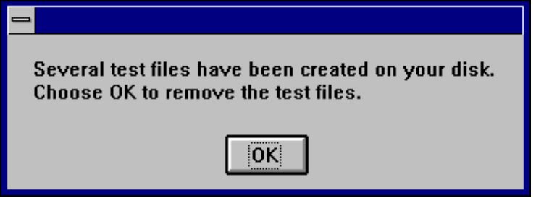

Arrays

Cypress Enable supports single and multi dimensional arrays. Using arrays you can refer to a series of variables by the same name each with a separate index. Arrays have upper and lower bounds. Enable allocates space for each index number in the array. Arrays should not be declared larger then necessary.

All the elements in an array have the same data type. Enable supports arrays of integers, singles, double and strings.

Ways to declare a fixed-size array:

- Global array, use the Dim statement outside the procedure section of a code module to declare the array.

- To create a local array, use the Dim statement inside a procedure.

Enable does not support Dynamic arrays.

Declaring an array. The array name must be followed by the upper bound in parentheses. The upper bound must be an integer.

Dim ArrayName (10) As Interger
Dim Sum (20) As Double

To create a global array, you simply use Global in place of Dim:

Global Counters (12) As Integer
Global Sums (26) As Double

The same declarations within a procedure use Static or Dim:

Static Counters (12) As Integer
Static Sums (26) As Double

The first declaration creates an array with 11 elements, with index numbers running from 0 to 10. The second creates an array with 21 elements. To change the default lower bound to 1 place an Option Base statement in the Declarations section of a module:

Option Base 1

Another way to specify lower bounds to provide it explicitly (as an integer, in the range -32,768 to 32,767) using the To key word:

Dim Counters (1 To 13) As Integer
Dim Sums (100 To 126) As String

In the preceding declarations, the index numbers of Counters run from 1 to 13, and the index numbers of Sums run from 100 to 126.

Note: Many other versions of Basic allow you to use an array without first declaring it. Enable Basic does not allow this; you must declare an array before using it.

Loops often provide an efficient way to manipulate arrays. For example, the following For loop initializes all elements in the array to 5:

Static Counters (1 To 20) As Integer
Dim I As Integer
For I = 1 To 20
Counter ( I ) = 5
Next I
…

MultiDimensional Arrays

Cypress Enable supports multidimensional arrays. For example the following example declares a two-dimensional array within a procedure.

Static Mat(20, 20) As Double

Either or both dimensions can be declared with explicit lower bounds.

Static Mat(1 to 10, 1 to 10) As Double

You can efficiently process a multidimensional array with the use of for loops. In the following statements the elemtents in a multidimensional array are set to a value.

Dim L As Integer, J As Integer
Static TestArray(1 To 10, 1 to 10) As Double
For L = 1 to 10
For J = 1 to 10
Matrix(L,J) = I * 10 + J
Next J
Next L

Arrays can be more than two dimensional. Enable does not have an arbitrary upper bound on array dimensions.

Dim ArrTest(5, 3, 2)

This declaration creates an arrray that has three dimensions with sizes 6 by 4, by 3 unless Option Base 1 is set previously in the code. The use of Option Base 1 sets the lower bound of all arrays to 1 instead of 0.

User Defined Types

Users can define their own types that are composites of other built-in or user defined types. Variables of these new composite types can be declared and then member variables of the new type can be accessed using dot notation. Variables of user defined types can not be passed to DLL functions expecting ‘C’ structures.

User Defined types are created using the type statement, which must be placed outside the procedure in your Enable Code. User defined types are global. The variables that are declared as user defined types can be either global or local.

Type type1
a As Integer
d As Double
s As String
End Type

Type type2
a As Integer
o As type1
End Type

Dim type2a As type2
Dim type1a As type1

Sub TypeExample ()
a = 5
type1a.a = 7472
type1a.d = 23.1415
type1a.s = "YES"
type2a.a = 43
type2a.o.s = "Hello There"
MsgBox type1a.a
MsgBox type1a.d
MsgBox type1a.s
MsgBox type2a.a
MsgBox type2a.o.s
MsgBox a
End Sub

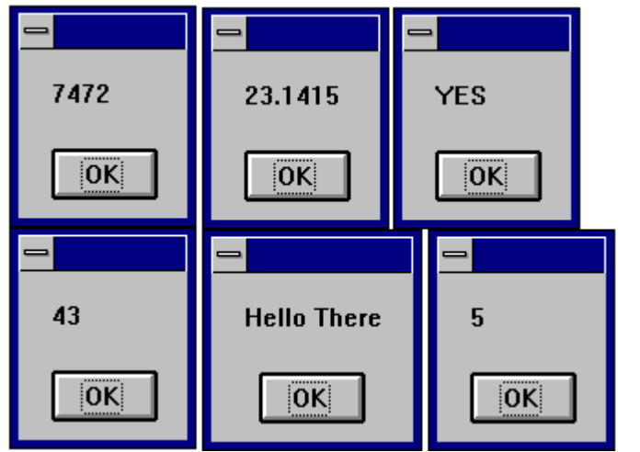

Dialog Support

Cypress Enable has support for custom dialogs. The syntax is similar to the syntax used in Microsoft Word Basic. The dialog syntax is not part of Microsoft Visual Basic or Microsoft Visual Basic For Applications (VBA). Enable has complete support for dialogs. The type of dialogs supported are outlined below.

Dialog Box controls

Enable Basic supports most of the standard Windows dialog box controls. This section introduces the controls available for custom dialog boxes and provides guidelines for using them.

OK and Cancel
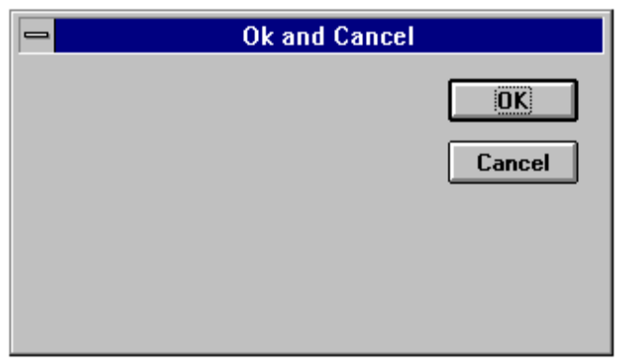

Sub Main
Begin Dialog ButtonSample 16,32,180,96,"OK and Cancel"
OKButton 132,8,40,14
CancelButton 132,28,40,14
End Dialog
Dim Dlg1 As ButtonSample
Button = Dialog (Dlg1)
End Sub

Every custom dialog box must contain at least one “command” button - a OK button or a Cancel button. Enable includes separate dialog box definition statements for each of these two types of buttons.

List Boxes, Drop-down List Boxes, and Combo Boxes 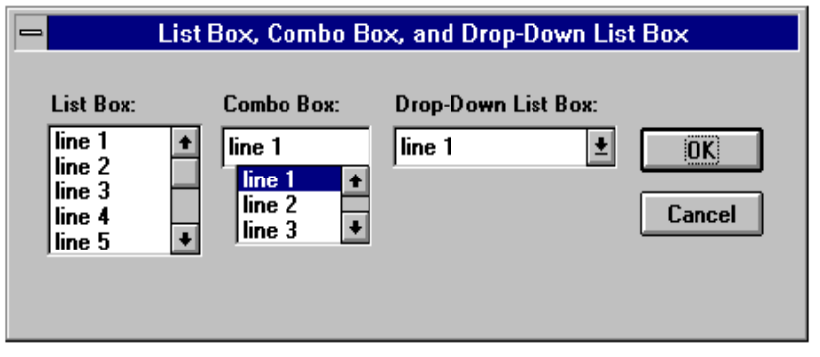

Sub Main
Dim MyList$ (5)
MyList (0) = "line Item 1"
MyList (1) = "line Item 2"
MyList (2) = "line Item 3"
MyList (3) = "line Item 4"
MyList (4) = "line Item 5"
MyList (5) = "line Item 6"

Begin Dialog BoxSample 16,35,256,89,"List Box, Combo Box, and Drop-Down List Box"
OKButton 204,24,40,14
CancelButton 204,44,40,14
ListBox 12,24,48,40, MyList$( ),.Lstbox
DropListBox 124,24,72,40, MyList$( ),.DrpList
ComboBox 68,24,48,40, MyList$( ),.CmboBox
Text 12,12,32,8,"List Box:"
Text 124,12,68,8,"Drop-Down List Box:"
Text 68,12,44,8,"Combo Box:"
End Dialog
Dim Dlg1 BoxSample
Button = Dialog ( Dlg1 )

End Sub

You can use a list box, drop-down list box, or combo box to present a list of items from which the user can select. A drop-down list box saves space (it can drop down to cover other dialog box controls temporarily). A combo box allows the user either to select an item from the list or type in a new item. The items displayed in a list box, drop-down list box, or combo box are stored in an array that is defined before the instructions that define the dialog box.

Check Boxes

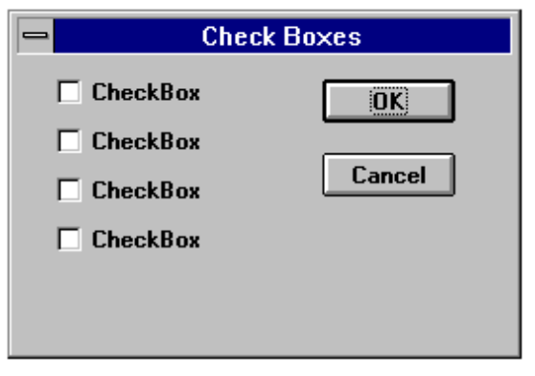

Sub Main
Begin Dialog CheckSample15,32,149,96,"Check Boxes"
OKButton 92,8,40,14
CancelButton 92,32,40,14
CheckBox 12,8,45,8,"CheckBox",.CheckBox1
CheckBox 12,24,45,8,"CheckBox",.CheckBox2
CheckBox 12,40,45,8,"CheckBox",.CheckBox3
CheckBox 12,56,45,8,"CheckBox",.CheckBox4
End Dialog
Dim Dlg1 As CheckSample
Button = Dialog ( Dlg1 )
End Sub

You use a check box to make a “yes or no” or “on or off” choice. for example, you could use a check box to display or hide a toolbar in your application.

Text Boxes and Text

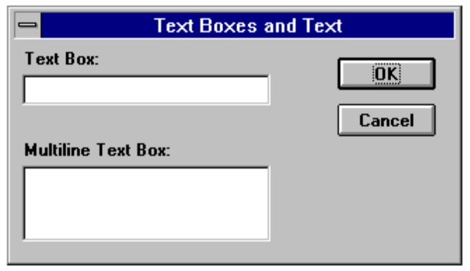

Sub Main
Begin Dialog TextBoxSample 16,30,180,96,"Text Boxes and Text"
OKButton 132,20,40,14
CancelButton 132,44,40,14
Text 8,8,32,8,"Text Box:"
TextBox 8,20,100,12,.TextBox1
Text 8,44,84,8,"Multiline Text Box:"
TextBox 8,56,100,32,.TextBox2
End Dialog
Dim Dlg1 As TextBoxSample
Button = Dialog ( Dlg1 )

End Sub

a text box control is a box in which the user can enter text while the dialog box is displayed. By default, a text box holds a single line of text. Enable does not support multiline text boxes in version 2.0 - this feature will be included in later versions.

Option Buttons and Group Boxes

You can have option buttons to allow the user to choose one option from several. Typically, you would use a group box to surround a group of option buttons, but you can also use a group box to set off a group of check boxes or any related group of controls.

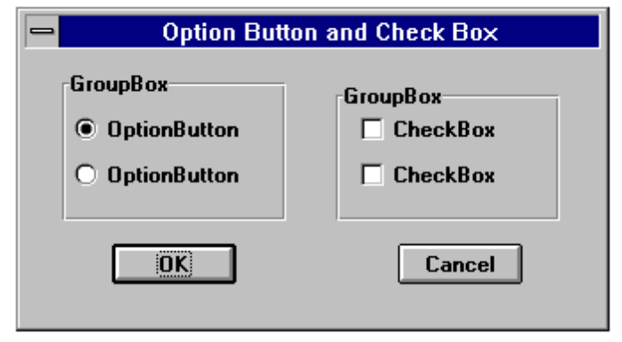

Begin Dialog GroupSample 31,32,185,96,"Option Button and Check Box"
OKButton 28,68,40,14
CancelButton 120,68,40,14
GroupBox 12,8,72,52,"GroupBox",.GroupBox1
GroupBox 100,12,72,48,"GroupBox",.GroupBox2
OptionGroup .OptionGroup1
OptionButton 16,24,54,8,"OptionButton",.OptionButton1
OptionButton 16,40,54,8,"OptionButton",.OptionButton2
CheckBox 108,24,45,8,"CheckBox",.CheckBox1
CheckBox 108,40,45,8,"CheckBox",.CheckBox2
End Dialog
Dim Dlg1 As GroupSample
Button = Dialog (Dlg1)
End Sub

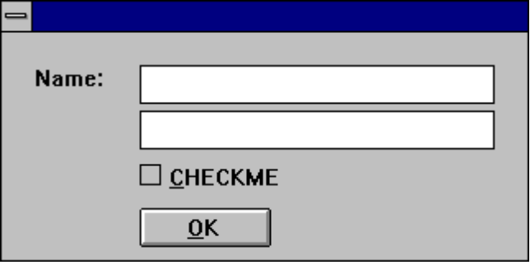
Sub Main
Begin Dialog DialogName1 60, 60, 160, 70
TEXT 10, 10, 28, 12, "Name:"
TEXTBOX 42, 10, 108, 12, .nameStr
TEXTBOX 42, 24, 108, 12, .descStr
CHECKBOX 42, 38, 48, 12, "&CHECKME", .checkInt
OKBUTTON 42, 54, 40, 12
End Dialog
Dim Dlg1 As DialogName1
Dialog Dlg1

MsgBox Dlg1.nameStr
MsgBox Dlg1.descStr
MsgBox Dlg1.checkInt
End Sub

The Dialog Function

Cypress Enable support the dialog function. This function is a user defined function that can be called while a custom dialog box is displayed. The dialog function makes nested dialog boxes possible and receives messages from the dialog box while it is still active.

When the function dialog() is called in Enable it displays the dialog box, and calls the dialog function for that dialog. Enable calls the dialog function to see if there are any commands to execute. Typical commands might be used are disabling or hiding a control. By default all dialog box controls are enabled. If you want a control to be hidden you must explicitly make is disabled during initialization. After initialization Enable displays the dialog box. When an action is taken by the user Enable calls the dialog function and passes values to the function that indicate the kind of action to take and the control that was acted upon.

The dialog box and its function are connected in the dialog definition. A “function name” argument is added to the Begin Dialog instruction, and matches the name of the dialog function located in your Enable program.

Begin Dialog UserDialog1 60,60, 260, 188, "3", .Enable

The Dialog Box Controls

A dialog function needs an identifier for each dialog box control that is acts on. The dialog function uses string identifiers. String identifiers are the same as the identifiers used in the dialog record.

CheckBox 8, 56, 203, 16, "Check to display controls",. Chk1

The control’s identifier and label are different. An identifier begins with a period and is the last parameter in a dialog box control instruction. In the sample code above “Check to display controls” is the label and .chk1 is the identifier.

The Dialog Function Syntax

The syntax for the dialog function is as follows:

Function FunctionName( ControlID$, Action%, SuppValue%)
Statement Block
FunctionName = ReturnValue
End Function

All parameters in the dialog function are required.

A dialog function returns a value when the user chooses a command button. Enable acts on the value returned. The default is to return 0 (zero) and close the dialog box. If a non zero is assigned the dialog box remains open. By keeping the dialog box open, the dialog function allows the user to do more than one command from the same dialog box. Dialog examples ship as part of the sample .bas programs and can be found in you install directory.

ControlID$ Receives the identifier of the dialog box control

Action Identifies the action that calls the dialog function. There are six possibilities, Enable supports the first 2.
Action 1 The value passed before the dialog becomes visible

Action 2 The value passed when an action is taken ( i.e. a button is pushed, checkbox is checked etc...) The controlID$ is the same as the identifier for the control that was chosen

SuppValue receives supplemental information about a change in a dialog box control. The information SuppValue receives depends on which control call the dialog function.

CheckBox, 0 if cleared, 1 if selected.

Option Button, number of option buttons selected, where zero is the first option button within a group.

Command button, A value identifying the button chosen. SuppValues for push Buttons are internal only.

OKButton, 1
Cancel Button, 2

The following dialog function uses a Select Case control structure to check the value of Action. The SuppValue is ignored in this function.

'This sample file outlines dialog capabilities, including nesting dialog boxes.

Sub Main

Begin Dialog UserDialog1 60,60, 260, 188, "3", .Enable
Text 8,10,73,13, "Text Label:"
TextBox 8, 26, 160, 18, .FText
CheckBox 8, 56, 203, 16, "Check to display controls",. Chk1
GroupBox 8, 79, 230, 70, "This is a group box:", .Group
CheckBox 18,100,189,16, "Check to change button text", .Chk2
PushButton 18, 118, 159, 16, "File History", .History
OKButton 177, 8, 58, 21
CancelButton 177, 32, 58, 21
End Dialog

Dim Dlg1 As UserDialog1
x = Dialog( Dlg1 )
End Sub

Function Enable( ControlID$, Action%, SuppValue%)

Begin Dialog UserDialog2 160,160, 260, 188, "3", .Enable
Text 8,10,73,13, "New dialog Label:"
TextBox 8, 26, 160, 18, .FText
CheckBox 8, 56, 203, 16, "New CheckBox",. ch1
CheckBox 18,100,189,16, "Additional CheckBox", .ch2
PushButton 18, 118, 159, 16, "Push Button", .but1
OKButton 177, 8, 58, 21
CancelButton 177, 32, 58, 21
End Dialog
Dim Dlg2 As UserDialog2
Dlg2.FText = "Your default string goes here"

Select Case Action%

Case 1
DlgEnable "Group", 0
DlgVisible "Chk2", 0
DlgVisible "History", 0
Case 2
If ControlID$ = "Chk1" Then
DlgEnable "Group"
DlgVisible "Chk2"
DlgVisible "History"
End If

If ControlID$ = "Chk2" Then
DlgText "History", "Push to display nested dialog"
End If

If ControlID$ = "History" Then
Enable =1
x = Dialog( Dlg2 )
End If

Case Else

End Select
Enable =1

End Function

OLE Automation

What is OLE Automation?

OLE Automation is an emerging standard, promoted by Microsoft, that applications use to expose their OLE objects to development tools, Enable Basic, and containers that support OLE Automation. A spreadsheet application may expose a worksheet, chart, cell, or range of cells all as different types of objects (Microsoft Excel 5.0 does this). A word processor might expose objects such as application, paragraph, sentence, bookmark, or selection (Microsoft Word 6.0 does this).

When an application supports OLE Automation, the objects it exposes can be accessed by Enable Basic. You can use Enable Basic to manipulate these objects by invoking methods on the object, or by getting and setting the objects properties, just as you would with the objects in Enable Basic. For example, if you created an OLE Automation object named MyObj, you might write code such as this to manipulate the object:

Sub Main
Dim MyObj As Object
Set MyObj = CreateObject ("Word.Basic")
MyObj.FileNewDefault
MyObj.Insert "Hello, world."
MyObj.Bold 1
End Sub

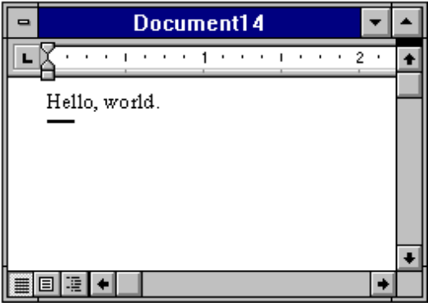

The following syntax is supported for the GetObject function:

Set MyObj = GetObject ("", class)

Where class is the parameter representing the class of the object to retrieve. The first parameter at this time must be an empty string.

The properties and methods an object supports are defined by the application that created the object. See the application's documentation for details on the properties and methods it supports.

Accessing an object

The following functions and properties allow you to access an OLE Automation object:

Name Description
CreateObject Function Creates a new object of a specified type.
GetObject Function Retrieves an object pointer to a running application.

What is an OLE Object?

An OLE Automation Object is an instance of a class within your application that you wish to manipulate programmatically, such as with Cypress Enable. These may be new classes whose sole purpose is to collect and expose data and functions in a way that makes sense to your customers.

The object becomes programmable when you expose those member functions. OLE Automation defines two types of members that you may expose for an object:

Methods are member functions that perform an action on an object. For example, a Document object might provide a Save method.

Properties are member function pairs that set or return information about the state of an object. For example, a Drawing object might have a style property.

For example, Microsoft suggests the following objects could be exposed by implementing the listed methods and properties for each object:

 | OLE Automation object |  | Methods | Properties
 |  | Application | Help | ActiveDocument
 |  |  | Quit | Application
 |  |  | Add Data | Caption
 |  |  | Repeat | DefaultFilePath
 |  |  | Undo | Documents
 |  |  |  | Height
 |  |  |  | Name
 |  |  |  | Parent
 |  |  |  | Path
 |  |  |  | Printers
 |  |  |  | StatusBar
 |  |  |  | Top
 |  |  |  | Value
 |  |  |  | Visible
 |  |  |  | Width

Document | Activate | Application
 | Close | Author
 | NewWindow | Comments
 | Print | FullName
 | PrintPreview | Keywords
 | RevertToSaved | Name
 | Save | Parent
 | SaveAs | Path
 |  | ReadOnly
 |  | Saved
 |  | Subject
 |  | Title
 |  | Value

To provide access to more than one instance of an object, expose a collection object. A collection object manages other objects. All collection objects support iteration over the objects they manage. For example, Microsoft suggests an application with a multiple document interface (MDI) might expose a Documents collection object with the following methods and properties:

Collection object | Methods | Properties
Documents | Add | Application
 | Close | Count
 | Item | Parent
 | Open

OLE Fundamentals

Object linking and embedding (OLE) is a technology that allows a programmer of Windows-based applications to create an application that can display data from many different applications, and allows the user to edit that data from within the application in which it was created. In some cases, the user can even edit the data from within their application.

The following terms and concepts are fundamental to understanding OLE.

OLE Object

An OLE object refers to a discrete unit of data supplied by an OLE application. An application can expose many types of objects. For example a spreadsheet application can expose a worksheet, macro sheet, chart, cell, or range of cells all as different types of objects. You use the OLE control to create linked and embedded objects. When a linked or embedded object is created, it contains the name of the application that supplied the object, its data (or, in the case of a linked object, a reference to the data), and an image of the data.

OLE Automation

Some applications provide objects that support OLE Automation. You can use Enable Basic to programmatically manipulate the data in these objects. Some objects that support OLE Automation also support linking and embedding. You can create an OLE Automation object by using the CreateObject function.

Class

An objects class determines the application that provides the objects data and the type of data the object contains. The class names of some commonly used Microsoft applications include MSGraph, MSDraw, WordDocument, and ExcelWorksheet.

OLE Automation and Word 6.0 example:

Sub OLEexample()
Dim word6 As Object
Dim myData As String

myData = 4 * Atn(1) ' Demonstrates Automatic type conversion
Set word6 = CreateObject("Word.Basic")
word6.FileNewDefault
word6.Insert "The following was computed in Cypress Enable: "
word6.Bold 1 ' Show value in boldface
word6.Insert myData
word6.Bold 0

MsgBox "Done"
End Sub

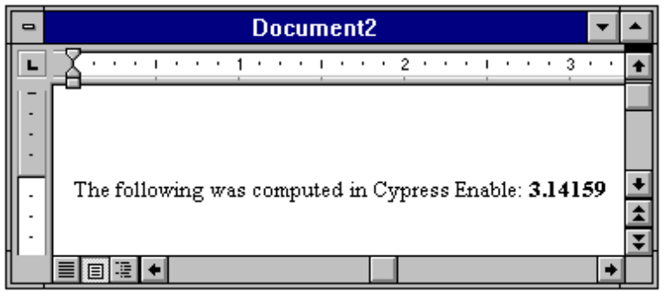

Making Applications Work Together

Operations like linking and object embedding need applications to work together in a coordinated fashion. However, there is no way that Windows can be set up, in advance, to accommodate all the applications and dynamic link libraries that can be installed. Even within an application, the user has the ability to select various components to install.

As part of the installation process, Windows requires that applications supporting DDE/OLE features register their support by storing information in several different locations. The most important of these to cypress enable is the registration database.

WIN.INI

The win.ini file contains a special section called [embedding] that contains information about each of three applications that operate as object servers.

The Registration Database.

Starting with Windows 3.1, Each Windows system maintains a registration database file that records details about the DDE and OLE functions supported by the installed applications. The database is stored in file called REG.DAT in the \ WINDOWS directory.

The Registration database

The registration database is a file called REG.DAT. The file is a database that contains information that controls a variety of activities relating to data integration using DDE and OLE. The information contained in the REG.DAT database can be divided into four basic categories.

Associations.

The table contains information that associates files with specific extensions to particular applications. This is essentially the same function performed by the [extensions] section of the WIN.INI.

Shell Operations.

Windows contains two programs that are refered to as Shell programs. The term Shell refers to a program that organizes basic operating system tasks, like running applications, opening files, and sending files to the printer. Shell programs use list, windows, menus, and dialog boxes to perform these operations. In contrast, command systems like DOS require the entry of explicit command lines to accomplish these tasks

OLE Object Servers.

The registration database maintains a highly structured database of the details needed by programs that operate as object servers. This is by far the most complex task performed by the database. There is no WIN.INI equivalent for this function.

DDE/OLE Automation.

The registration database contains the details and the applications that support various types of DDE/OLE Automation operations.

It is useful to appreciate the difference in structure between the WIN.INI file and the REG.DAT database. WIN.INI is simply a text document. There are no special structures other than headings (simply titles enclosed in brackets) that organize the information. If you want to locate an item in the WIN.INI file, you must search through the file for the specific item you want to locate. The registration database is a tree-like, structured database used for storing information relating to program and file operations, in particular, those that involve the use of DDE or OLE. The tree structure makes it easier to keep the complex set of instructions, needed to implement DDE and OLE operations, organized and accessible by the applications that need to use them. This is not possible when you are working with a text document like WIN.INI. The WIN.INI file records all sorts or information about the Windows system in a simple sequential listing.

The Regedit Program

The Regedit program, REGEDIT.EXE , is used to display and modify the contents of the registration database file, REG.DAT. The program is usually located in the \WINDOWS directory along with the standard Windows utility programs and accessory programs.

You can display the contents of the registration database by running the RegEdit program.

1. From the Program Manger, select File Run. Type Regedit and press [Enter].

The program automatically loads the data from the REG.DAT file, the result is initially a list of names, representing the records stored in the registration database, Each record contains information used for one of the purposes mentioned above (i.e., association of extensions with programs, program and file manager operations, and object server applications).

If the registration database record represents an OLE object server application, the name that appears in the Regedit list is the name that will appear in the Insert Object dialog box.

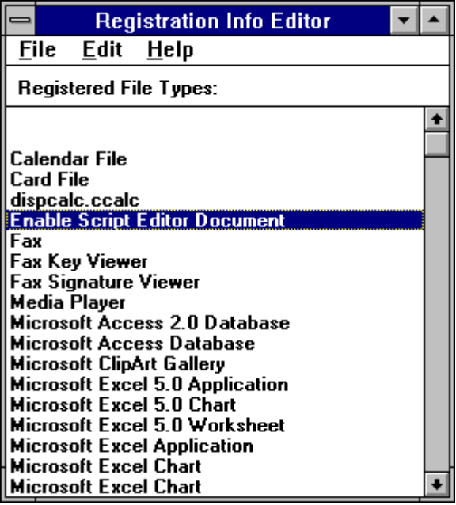
The main view of the Regedit program.

Keep in mind that not all the records in the registration database represent OLE object server applications. For example, Windows automatically installs records for accessory applications. These records appear on the registration database so that the file extensions can be associated with the applications.

Each of the records listed in the registration database can be expanded to display some of the details about an application in a dialog box by displaying the Modify File Type dialog box.

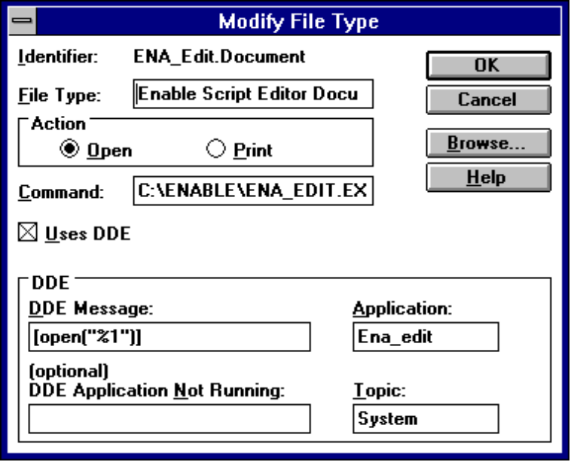
Registration information about the Enable Script Editor Document

The Registration illustrates how the registration database defines what happens when a file associated with the Enable Script Editor Document program is open from the File or Program Manager. The dialog box contains four items of information.

Identifier

This is the class name assigned to the application. In both the WIN.INI and registration database files, file extensions are associated with the class name of an application, in this example, Enable.

File Type

This item is the text that is used to identify the class. This name appears in the Associations dialog box displayed in the File Manager program. If the record represents an OLE Object Sever definition, the name also appears in the Insert Object dialog box within the client application.

Action

The registration database directly supports two actions that can be taken in the File and Program Managers. Open defines what action to take when a file is opened, and Print defines the action to take when a document is printed from the File Manager. Remember, the registration database can be used for other types of operations, only two actions are directly supported in the current registration database structure.

Command

This is the command line that actually carries out the action. As in DOS batch processing, the %1 is a placeholder for a specific name. In this case, the name of the selected file is inserted to complete the command line.

Scripting Language Overview

Quick reference of the Functions and Statements available

Type/Functions/Statements
______________________________________________________
Flow of Control

GoSub, Goto, End, Stop, Do...Loop, Exit Loop, For...Next, Exit For, If..Then..Else...End If, Return, Stop, While...Wend, Select Case
______________________________________________________
Converting

Chr$, Chr, Hex, Hex$, Oct, Oct$, Str, Str$, CDbl, CInt, Clng, Csng, Cstr, Cvar, Asc, Val, Date, DateSerial, DateValue, Format, Format$, CVDate, Fix, Int, Day, Weekday, Month, Year, Hour, Minute, Second, TimeSerial, TimeValue
________________________________________________________________
Dialog

Text, TextBox, CheckBox, OKButton, BeginDialog, EndDialog
______________________________________________________
File I/O

FileCopy, ChDir, ChDrive, CurDir, CurDir$, MkDir,RmDir, Open, Close, Print#, Kill, FreeFile, LOF
______________________________________________________
Math

Exp, Log, Sqr, Rnd, Abs, Sgn, Atn, Cos, Sin, Tan
______________________________________________________
Procedures

Call, Declare, Function, End Function, Sub, End Sub, Exit, Global
______________________________________________________
Strings

Let, Len,InStr,Left,Left$, Mid, Mid$, Asc, Chr,Chr$,Right, Right$, LCase, LCase$, InStr, LTrim, LTrim$, RTrim, RTrim$, Trim, Trim$, Option Compare, Len, Space, Space$, String, String$, Let StrComp
______________________________________________________
Variables and Constants

Dim, IsNull, IsNumericVarType, Const, IsDate, IsEmpty, IsNull, Option Explicit
______________________________________________________
DDE

DDEInitiate, DDEExecute, DDETerminate

______________________________________________________
Arrays

Option Base, Option Explicit, Static, Dim, Global, Lbound, Ubound, Erase

______________________________________________________
Miscellaneous

SendKeys, AppActivate, Shell, Beep, Rem, CreateObject, GetObject

Data Types

Variable Type Specifier usage
String $ Dim Str_Var As String
Integer % Dim Int_Var As Integer
Long & Dim Long_Var As Long
Single ! Dim Sing_Var As Single
Double # Dim Dbl_Var As Double
Variant Dim X As Any
Currency (Not currently supported)

Operators

Arithmetic Operators

Operator Function Usage
^ Exponentiation x% = y%^2
- Negation x% = -2
* Multiplication x% = 2 * 3
/ division x% = 10/2
Mod Modulo x% = y% Mod z%
+ Addition x% = 2 + 3
- Subtraction x% = 6 - 4

*Arithmetic operators follow mathematical rules of precedence
* '+' or '&' can be used for string concatenation.

_________________________________________________________

Operator Precedence

Operator Description Order
() parenthesis highest
^ exponentiation
- unary minus
/,* division/multplication
mod modulo
=,>,<,<=,>= relational
not negation
and and
or or lowest

Relational Operators

Operator Function Usage
< Less than x% < Y%
<= Less than or equal to x% <= %
= Equals x% = Y%
>= Greater than or equal to x% >= Y%
> Greater than x% > Y%
<> Not equal to x% <> Y%

Logical Operators

Operator Function Usage
Not Logical Negation If Not (x%)
And Logical And If (x% > y%) And (x% < Z%)
Or Logical Or if (x% = y%) Or (x% = z%)

Functions, Statements, Reserved words - Quick Reference
_______________________________________________

Abs, AppActivate, Asc, Atn, Append, As
Base, Beep, Begin, Binary, ByVal
Call, Case, ChDir, ChDrive, Chr, Const, Cos, CurDir, Ctype, CDbl, CInt, Clng, Csng, CStrg, Cvar, Close, CheckBox
Date$, Day, Declare, Dim, Dir, Do...Loop,Dialog, DDEInitiate
DDEExecute
End, Exit, Exp
FileCopy, FreeFile, For...Next, Format, Function
GoTo, Global
Hex$, Hour
If...Then...Else...[End If], InputBox, InStr, Int, IsNull, Integer, IsEmpty
IsNull, IsNumeric, IsDate
Kill
LBound, LCase, Left, Len, Let, Log, LTrim
Mid,MkDir, Month, MsgBox
Oct,Open, OKButton,Object, Option
Print
Rem, RmDir, Rnd, Return, Rtrim
SendKeys, Set, Second, Select, Shell, Sin, Sqr, Stop,Str
Tan,Text, TextBox, Time, Type, Trim, Trim$ To, Time, Then,Tan
UBound, UCase, UCase$,
Val, Variant, VarType

Language Reference A - Z

Abs Function

Abs (int number)

Returns the absolute value of a number.

The data type of the return value is the same as that of the number argument. However, if the number argument is a Variant of VarType (String) and can be converted to a number, the return value will be a Variant of VarType (Double). If the numeric expression results in a Null, _Abs returns a Null.

Example:

Sub Main

Dim Msg, X, Y

X = InputBox("Enter a Number:")
Y = Abs(X)

Msg = "The number you entered is " & X
Msg = Msg + ". The Absolute value of " & X & " is " & Y
MsgBox Msg 'Display Message.

End Sub

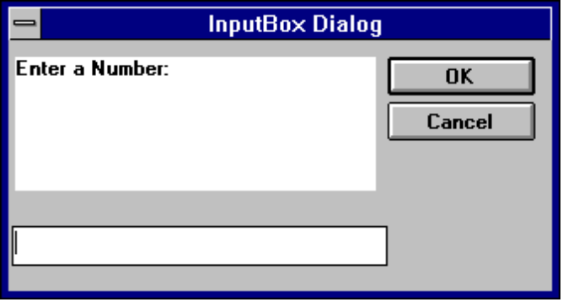

AppActivate Statement

AppActivate ( app)

Activates an application.

The parameter app is a string expression and is the name that appears in the title bar of the application window to activate.

Related Topics: Shell, SendKeys

Example:

Sub Main ()
AppActivate "Microsoft Word"
SendKeys “%F,%N,Cypress Enable”,True
Msg = “Click OK to close Word”
MsgBox Msg
AppActivate “Microsoft Word” ‘ Focus back to Word
SendKeys “%F,%C,N”, True ‘Close Word
End Sub

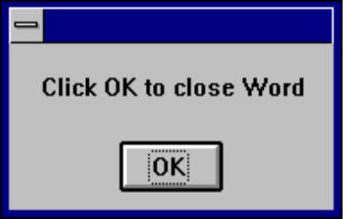

Asc Function

Asc ( str)

Returns a numeric value that is the ASCII code for the first character in a string.

Example:

Sub Main ()
Dim I, Msg ' Declare variables.
For I = Asc("A") To Asc("Z") ' From A through Z.
Msg = Msg & Chr(I) ' Create a string.
Next I
MsgBox Msg ' Display results.
End Sub

Atn Function

Atn (rad )

Returns the arc tangent of a number

The argument rad can be any numeric expression. The result is expressed in radians

Related Topics: Cos, Tan, Sin

Example:

Sub AtnExample ()
Dim Msg, Pi ' Declare variables.
Pi = 4 * Atn(1) ' Calculate Pi.
Msg = "Pi is equal to " & Str(Pi)
MsgBox Msg ' Display results.
End Sub

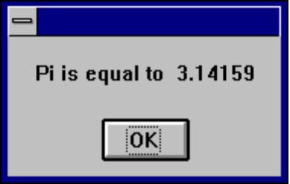

Beep Statement

Beep

Sounds a tone through the computer's speaker. The frequency and duration of the beep depends on hardware, which may vary among computers.

Example:

Sub BeepExample ()
Dim Answer, Msg ' Declare variables.
Do
Answer = InputBox("Enter a value from 1 to 3.")
If Answer >= 1 And Answer <= 3 Then ' Check range.
Exit Do ' Exit Do...Loop.
Else
Beep ' Beep if not in range.
End If
Loop
MsgBox "You entered a value in the proper range."
End Sub

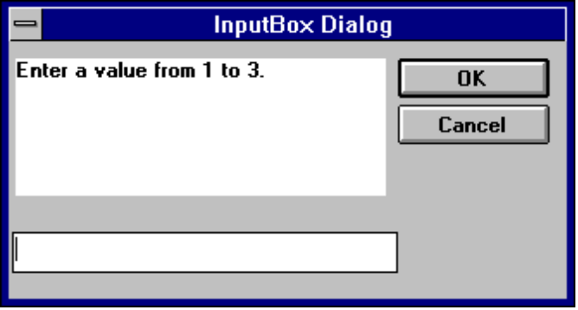

Call Statement

Call name [(parameter(s)]
or
name [parameter(s)]

Activates an Enable Subroutine called name or a DLL function with the name name. The first parameter is the name of the function or subroutine to call, and the second is the list of arguments to pass to the called function or subroutine.

You are never required to use the Call statement when calling an Enable subroutine or a DLL function. Parentheses must be used in the argument list if the Call statement is being used.

Example:

Sub Main ()
Call Beep
MsgBox "Returns a Beep"
End Sub

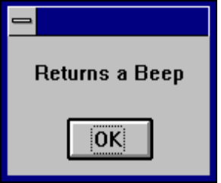

CDbl Function

CDbl (expression)

Converts expressions from one data type to a double. The parameter expression must be a valid string or numeric expression.

Example:

Sub Main ()
Dim y As Integer

y = 25
If VarType(y) = 2 Then
Print y
x = CDbl(y) 'Converts the integer value of y to a double value in x
Print x
End If

End Sub

ChDir Statement

ChDir pathname

Changes the default directory

Syntax: [drive:] [ \ ] dir[\dir]...

The parameter pathname is a string limited to fewer then 128 characters. The drive parameter is optional. The dir parameter is a directory name. ChDir changes the default directory on the current drive, if the drive is omitted.

Related Topics: CurDir, CurDir$, ChDrive, Dir, Dir$, MkDir, RmDir

Example:

Sub Main ()
Dim Answer, Msg, NL ' Declare variables.
NL = Chr(10) ' Define newline.
CurPath = CurDir() ' Get current path.
ChDir "\"
Msg = "The current directory has been changed to "
Msg = Msg & CurDir() & NL & NL & "Press OK to change back "
Msg = Msg & "to your previous default directory."
Answer = MsgBox(Msg) ' Get user response.
ChDir CurPath ' Change back to user default.
Msg = "Directory changed back to " & CurPath & "."
MsgBox Msg ' Display results.
End Sub

ChDrive Statement

ChDrive drivename

The parameter drivename is a string and must correspond to a an existing drive. If drivename contains more than one letter, only the first character is used.

Example:

Sub Main ()
Dim Msg, NL ' Declare variables.
NL = Chr(10) ' Define newline.
CurPath = CurDir() ' Get current path.
ChDir "\"
ChDrive "G:"
Msg = "The current directory has been changed to "
Msg = Msg & CurDir() & NL & NL & "Press OK to change back "
Msg = Msg & "to your previous default directory."
MsgBox Msg ' Get user response.
ChDir CurPath ' Change back to user default.
Msg = "Directory changed back to " & CurPath & "."
MsgBox Msg ' Display results.
End Sub

Related Topics: ChDir, CurDir, CurDir$, MkDir, RmDir

CheckBox

CheckButton starting x position, starting y position, width, Height

For selecting on or more in a series of choices

Example:

Sub Main ()
Begin Dialog DialogName1 60, 60, 160, 70, "ASC - Hello"
TEXT 10, 10, 28, 12, "Name:"
TEXTBOX 42, 10, 108, 12, .nameStr
TEXTBOX 42, 24, 108, 12, .descStr
CHECKBOX 42, 38, 48, 12, "&CHECKME", .checkInt
OKBUTTON 42, 54, 40, 12
End Dialog
Dim Dlg1 As DialogName1
Dialog Dlg1

MsgBox Dlg1.nameStr
MsgBox Dlg1.descStr
MsgBox Dlg1.checkInt
End Sub

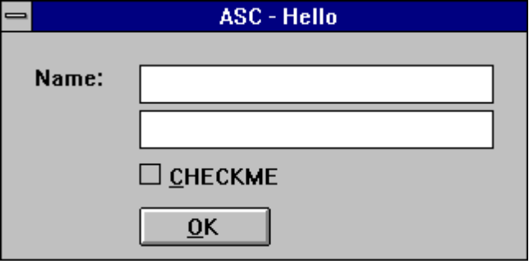

Chr, Chr$ Function

Chr[$](int )

Returns a one-character string whose ASCII number is the argument

Chr returns a Variant: Chr$ returns a String

Example:

Sub ChrExample ()
Dim X, Y, Msg, NL
NL = Chr(10)
For X = 1 to 2
For Y = Asc("A") To Asc("Z")
Msg = Msg & Chr(Y)
Next Y
Msg = Msg & NL
Next X
MsgBox Msg
End Sub

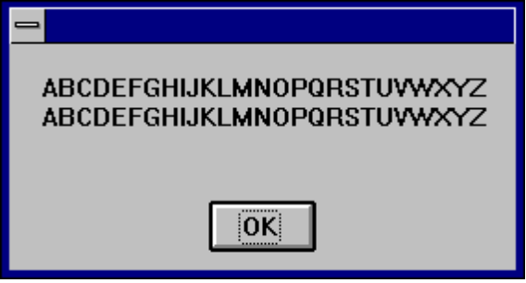

CInt Function

CInt (expression)

Converts any valid expression to a integer.

Example:

Sub Main ()
Dim y As Long

y = 25
If VarType(y) = 2 Then
Print y
x = CInt(y) 'Converts the long value of y to a integer value in x
Print x
End If

End Sub

CLng Function

CLng (expression)

Converts any valid expression into a long.

Example:

Sub Main ()
Dim y As Integer

y = 25
If VarType(y) = 2 Then
Print y
x = CLng(y) 'Converts the integer value of y to a long value in x
Print x
End If

End Sub

Close Statement

Close

Closes active file.

Example:

Sub Make3Files ()
Dim I, FNum, FName ' Declare variables.
For I = 1 To 3
FNum = FreeFile ' Determine next file number.
FName = "TEST" & FNum
Open FName For Output As FNum ' Open file.
Print #I, "This is test #" & I ' Write string to file.
Print #I, "Here is another "; "line"; I
Next I
Close ' Close all files.
End Sub

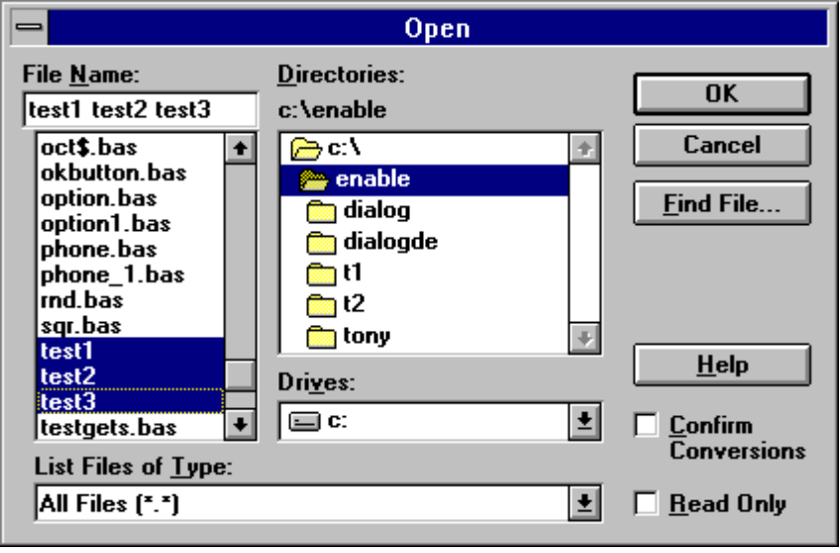

Const Statement

Const name = expression

Assigns a symbolic name to a constant value.

A constant must be defined before it is used.

The definition of a Const in Cypress Enable outside the procedure or at the module level is a global. The syntax Global Const and Const are used below outside the module level are identical.

A type declaration character may be used however if none is used Enable will automatically assign one of the following data types to the constant, long (if it is a long or integer), Double (if a decimal place is present), or a String ( if it is a string).

Example:

Global Const GloConst = 142 '
Const MyConst = 122 'Global to all procedures is a module
Sub Main ()
Dim Answer, Msg, NL ' Declare variables.
Const PI = 3.14159
NL = Chr(10) ' Define newline.
CurPath = CurDir() ' Get current path.
ChDir "\"
Msg = "The current directory has been changed to "
Msg = Msg & CurDir() & NL & NL & "Press OK to change back "
Msg = Msg & "to your previous default directory."
Answer = MsgBox(Msg) ' Get user response.
ChDir CurPath ' Change back to user default.
Msg = "Directory changed back to " & CurPath & "."
MsgBox Msg ' Display results.
myvar =myConst + PI + GloConst
Print MyVar
End Sub

Cos Function

Cos (rad)

Returns the cosine of an angle

The argument rad must be expressed in radians and must be a valid numeric expression.Cos will by default return a double unless a single or integer is specified as the return value.

Example:

Sub Main()
Dim J As Double
Dim I As Single ' Declare variables.
Dim K As Integer
For I =1 To 10 '
Msg = Msg & Cos(I) & ", " 'Cos function call
J=Cos(I)
Print J
K=Cos(I)
Print K
Next I
MsgBox Msg ' Display results.
MsgBox Msg1
End Sub

CreateObject Function

CreateObject (class)

Creates an OLE automation object.

Sub Command1_Click ()
Dim word6 As object
Set word6 = CreateObject("Word.Basic")
word6.FileNewDefault
word6.InsertPara
word6.Insert "Attn:"
word6.InsertPara
word6.InsertPara
word6.InsertPara
word6.Insert " Vender Name: "
word6.Bold 1
name = "Some Body"
word6.Insert name
word6.Bold 0
word6.InsertPara
word6.Insert " Vender Address:"
word6.InsertPara
word6.Insert " Vender Product:"
word6.InsertPara
word6.InsertPara
word6.Insert "Dear Vender:"
word6.InsertPara
word6.InsertPara
word6.Insert "The letter you are reading was created with Cypress Enable."
word6.Insert "Using OLE Automation Cypress Enable can call any other OLE _ enabled "
word6.Insert "application. Enable is a Basic Scripting Language for _ applications"
word6.InsertPara
word6.InsertPara
word6.Insert " Product Name: Cypress Enable"
word6.InsertPara
word6.Insert " Company Name: Cypress Software Inc."
word6.InsertPara

word6.InsertPara
MsgBox "You have just called Word 6.0 using OLE"
End Sub

Vender Name: Client Name
Vender Address:
Vender Product:

Dear Vender:

The letter you are reading was created with Cypress Enable.Using OLE Automation Cypress Enable can call any other OLE enabled application. Enable is a Basic Scripting Language for applications

Product Name: Cypress Enable
Company Name: Cypress Software Inc.

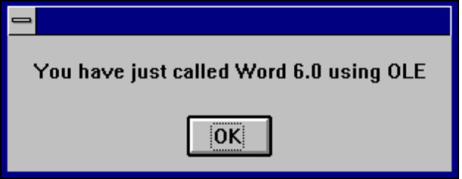

CSng Function

CSng (expression)

Converts any valid expression to a Single.
Example:

Sub Main ()
Dim y As Integer

y = 25
If VarType(y) = 2 Then
Print y
x = CSng(y) 'Converts the integer value of y to a single value in x
Print x
End If

End Sub

CStr Function
CStr(expression)

Converts any valid expression to a String.

CVar Function
(Not currently implemented)

CVar (expression)
Converts any valid expression to a Variant.

CurDir, CurDir$ Function

Returns the current path for the specified drive

CurDir[$] (drive)

CurDir returns a Variant; CurDir$ returns a String.

Example:

'Declare Function CurDir Lib "NewFuns.dll" () As String
Sub Form_Click ()
Dim Msg, NL ' Declare variables.
NL = Chr(10) ' Define newline.
Msg = "The current directory is: "
Msg = Msg & NL & CurDir()
MsgBox Msg ' Display message.
End Sub

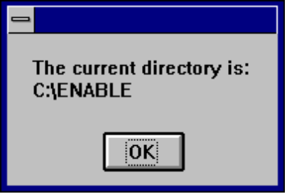

Date Function

Date, Date()

Returns the current system date

Date returns a Variant of VarType 8 (String) containing a date.

Example:

' Format Function Example
' This example shows various uses of the Format function to format values
' using both named and user-defined formats. For the date separator (/),
' time separator (:), and AM/ PM literal, the actual formatted output
' displayed by your system depends on the locale settings on which the code
' is running. When times and dates are displayed in the development
' environment, the short time and short date formats of the code locale
' are used. When displayed by running code, the short time and short date
' formats of the system locale are used, which may differ from the code
' locale. For this example, English/United States is assumed.

' MyTime and MyDate are displayed in the development environment using
' current system short time and short date settings.

Sub Main

MyTime = "08:04:23 PM"
MyDate = "03/03/95"
MyDate = "January 27, 1993"

SysDate = Date
MsgBox Sysdate,0,"System Date"

MsgBox Now,0,"Now"
MsgBox MyTime,0,"MyTime"

MsgBox Second( MyTime ) & " Seconds"
MsgBox Minute( MyTime ) & " Minutes"
MsgBox Hour( MyTime ) & " Hours"

MsgBox Day( MyDate ) & " Days"
MsgBox Month( MyDate ) & " Months"
MsgBox Year( MyDate ) & " Years"

' Returns current system time in the system-defined long time format.
MsgBox Format(Time, "Short Time") & " Short Time"
MsgBox Format(Time, "Long Time") & "Long Time"

' Returns current system date in the system-defined long date format.
MsgBox Format(Date, "Short Date") & " Short Date"
MsgBox Format(Date, "Long Date") & " Long Date"

' This section not yet supported
MsgBox = Format(MyTime, "h:m:s") ' Returns "17:4:23".
MsgBox = Format(MyTime, "hh:mm:ss AMPM")' Returns "05:04:23 PM".
MsgBox = Format(MyDate, "dddd, mmm d yyyy")' Returns "Wednesday, Jan 27 1993".

' If format is not supplied, a string is returned.
MsgBox Format(23) ' Returns "23".

' User-defined formats.
MsgBox Format(5459.4, "##,##0.00") ' Returns "5,459.40".
MsgBox Format(334.9, "###0.00") ' Returns "334.90".
MsgBox Format(5, "0.00%") ' Returns "500.00%".
MsgBox Format("HELLO", "<") ' Returns "hello".

MyDate = "30 December 91" ' use of European date
print Mydate

MsgBox MyDate,0,"MyDate International..."
MsgBox Day(MyDate),0,"day"
MsgBox Month(MyDate),0,"month"
MsgBox Year(MyDate),0,"year"

MyDate = "30-Dec-91" ' another of European date usage
print Mydate

MsgBox MyDate,0,"MyDate International..."
MsgBox Day(MyDate),0,"day"
MsgBox Month(MyDate),0," month"
MsgBox Year(MyDate),0,"year"

MsgBox Format("This is it", ">") ' Returns "THIS IS IT".

End Sub

Declare Statement

Declare Sub procedurename Lib Libname$ [Alias aliasname$][(argument list)]

Declare Function procedurename Lib Libname$ [Alias aliasname$] [(argument list)][As Type]

The Declare statement makes a reference to an external procedure in a Dynamic Link Library (DLL).

Cypress Enable extentions to the declare statement. The following syntax is not supported by Microsoft Visual Basic.

Declare Function procedurename App [Alias aliasname$] [(argument list)][As Type]

This form of the Declare statement makes a reference to a function located in the executable file located in the application where Enable is embedded.

Related Topics: Call

Example:

Declare Function GetFocus Lib "User" () As Integer
Declare Function GetWindowText Lib "User" (ByVal hWnd%, ByVal Mess$, ByVal cbMax%) As Integer

Sub Main
Dim hWindow%
Dim str1 As String *51
Dim str2 As String * 25

hWindow% = GetFocus()
print "GetWindowText returned: ", GetWindowText( hWindow%, str1,51 )
print "GetWindowText2 returned: ", GetWindowText( hWindow%, str2, 25)
print str1
print str2

End Sub

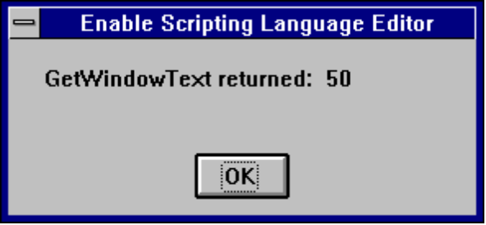

Dialog, Dialog Function

Dialog(Dialog Record )

Returns a value corresponding to the button the user chooses.

The Dialog() function is used to display the dialog box specified by DialogRecord . Dialogrecord is the name of the dialog and must be defined in a preceeding Dim statement.

The return value or button:
-1 = OK button
0 = Cancel button
> 0 A command button where 1 is the first PushButton in the definition of the dialog and 2 is the second and so on.

Example:

' This sample shows all of the dialog controls on one dialog and how to
' vary the response based on which PushButton was pressed.

Sub Main ()
Dim MyList$(2)
MyList(0) = "Banana"
MyList(1) = "Orange"
MyList(2) = "Apple"
Begin Dialog DialogName1 60, 60, 240, 184, "Test Dialog"
Text 10, 10, 28, 12, "Name:"
TextBox 40, 10,50, 12, .joe
ListBox 102, 10, 108, 16, MyList$(), .MyList1
ComboBox 42, 30, 108, 42, MyList$(), .Combo1
DropListBox 42, 76, 108, 36, MyList$(), .DropList1$
OptionGroup .grp1
OptionButton 42, 100, 48, 12, "Option&1"
OptionButton 42, 110, 48, 12, "Option&2"
OptionGroup .grp2
OptionButton 42, 136, 48, 12, "Option&3"
OptionButton 42, 146, 48, 12, "Option&4"
GroupBox 132, 125, 70, 36, "Group"
CheckBox 142, 100, 48, 12, "Check&A", .Check1
CheckBox 142, 110, 48, 12, "Check&B", .Check2
CheckBox 142, 136, 48, 12, "Check&C", .Check3
CheckBox 142, 146, 48, 12, "Check&D", .Check4
CancelButton 42, 168, 40, 12
OKButton 90, 168, 40, 12
PushButton 140, 168, 40, 12, "&Push Me 1"
PushButton 190, 168, 40, 12, "Push &Me 2"
End Dialog
Dim Dlg1 As DialogName1
Dlg1.joe = "Def String"
Dlg1.MyList1 = 1
Dlg1.Combo1 = "Kiwi"
Dlg1.DropList1 = 2
Dlg1.grp2 = 1
' Dialog returns -1 for OK, 0 for Cancel, button # for PushButtons
button = Dialog( Dlg1 )
'MsgBox "button: " & button 'uncomment for button return vale
If button = 0 Then Return

MsgBox "TextBox: "& Dlg1.joe
MsgBox "ListBox: " & Dlg1.MyList1
MsgBox Dlg1.Combo1
MsgBox Dlg1.DropList1
MsgBox "grp1: " & Dlg1.grp1
MsgBox "grp2: " & Dlg1.grp2
Begin Dialog DialogName2 60, 60, 160, 60, "Test Dialog 2"
Text 10, 10, 28, 12, "Name:"
TextBox 42, 10, 108, 12, .fred
OkButton 42, 44, 40, 12
End Dialog
If button = 2 Then
Dim Dlg2 As DialogName2
Dialog Dlg2
MsgBox Dlg2.fred
ElseIf button = 1 Then
Dialog Dlg1
MsgBox Dlg1.Combo1
End If
End Sub

Dim Statement

Dim variablename[(subscripts)][As Type][,name][As Type]]

Allocates storage for and declares the data type of variables and arrays in a module.

The types currently supported are integer, long, single, double and String

Example:

Sub Main
Dim x As Long
Dim y As Integer
Dim z As single
Dim a As double
Dim s As String
Dim v As Variant ' This is the same as Dim x or Dim x as any

Dir$ Function
(Not currentlyimplemented)

Dir[$] [(path,attributes)]

Returns a file/directory name that matches the given path and attributes.

DlgEnable Statement

DlgEnable “ControlName”, Value

This statement is used to enable or disable a particular control on a dialog box.

The parameter ControlName is the name of the control on the dialog box. The parameter Value is the value to set it to. 1 = Enable, 0 = Disable. On is equal to 1 in the example below. If the second parameter is omitted the status of the control toggles. The entire example below can be found in the dialog section of this manual and in the example .bas files that ship with Cypress Enable.

Related Topics: DlgVisible, DlgText

Example:

Function Enable( ControlID$, Action%, SuppValue%)
Begin Dialog UserDialog2 160,160, 260, 188, "3", .Enable
Text 8,10,73,13, "New dialog Label:"
TextBox 8, 26, 160, 18, .FText
CheckBox 8, 56, 203, 16, "New CheckBox",. ch1
CheckBox 18,100,189,16, "Additional CheckBox", .ch2
PushButton 18, 118, 159, 16, "Push Button", .but1
OKButton 177, 8, 58, 21
CancelButton 177, 32, 58, 21
End Dialog

Dim Dlg2 As UserDialog2
Dlg2.FText = "Your default string goes here"
Select Case Action%

Case 1
DlgEnable "Group", 0
DlgVisible "Chk2", 0
DlgVisible "History", 0
Case 2
If ControlID$ = "Chk1" Then
DlgEnable "Group", On
DlgVisible "Chk2"
DlgVisible "History"
End If

If ControlID$ = "Chk2" Then
DlgText "History", "Push to display nested dialog"
End If

If ControlID$ = "History" Then
Enable =1
Number = 4
MsgBox SQR(Number) & " The sqr of 4 is 2"
x = Dialog( Dlg2 )
End If

If ControlID$ = "but1" Then

End If

Case Else

End Select
Enable =1

End Function

DlgText Statement

DlgText “ControlName”, String

This statement is used to set or change the text of a dialog control.

The parameter ControlName is the name of the control on the dialog box. The parameter String is the value to set it to.

Related Topics: DlgEnable, DlgVisible

Example:

If ControlID$ = "Chk2" Then
DlgText "History", "Push to display nested dialog"
End If

DlgVisible Statement

DlgVisible “ControlName”, Value

This statement is used to hide or make visible a particular control on a dialog box.

The parameter ControlName is the name of the control on the dialog box. The parameter Value is the value to set it to. 1 = Visible, 0 = Hidden. On is equal to 1. If the second parameter is omitted the status of the control toggles. The entire example below can be found in the dialog section of this manual and in the example .bas files that ship with Cypress Enable.

Related Topics: DlgEnable, DlgText

Example:

If ControlID$ = "Chk1" Then
DlgEnable "Group", On
DlgVisible "Chk2"
DlgVisible "History"
End If

Do...Loop Statement

Do [While condition]
[statements]
[Exit Do]
Loop

Repeats a group of statements while a condition is true or until a condition is met.

Example:

Sub Main ()
Dim Value, Msg ' Declare variables.
Do
Value = InputBox("Enter a value from 5 to 10.")
If Value >= 5 And Value <= 10 Then ' Check range.
Exit Do ' Exit Do...Loop.
Else
Beep ' Beep if not in range.
End If
Loop

End Sub

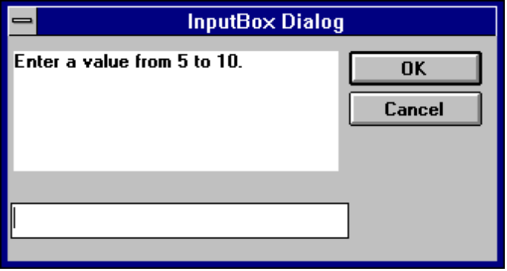

End Statement

End[{Function | If | Sub}]

Ends a program or a block of statements such as a Sub procedure or a function.

Related Topics: Exit, Function, If...Then...Else, Select Case, Stop

Example:

Sub Main()

Dim Var1 as String

Var1 = "hello"
MsgBox " Calling Test"
Test Var1
MsgBox Var1

End Sub

Sub Test(wvar1 as string)

wvar1 = "goodbye"
MsgBox "Use of End Statement"
End

End Sub

EOF Function

EOF(Filenumber)

Returns a value during file input that indicates whether the end of a file has been reached.

Related Topics: Open Statement

Example: ( Not currently implemented)

Erase Statement

Erase arrayname[,arrayname ]

Reinitializes the elements of a fixed arrays.

Related Topics: Dim

Example:

' This example demonstrates some of the features of arrays. The lower bound
' for an array is 0 unless it is specified or option base has set it as is
' done in this example.

Option Base 1

Sub Main
Dim a(10) As Double
MsgBox "LBound: " & LBound(a) & " UBound: " & UBound(a)
Dim i As Integer
For i = 0 to 3
a(i) = 2 + i * 3.1
Next i
Erase( a ) ' If this line is uncommented then the values will all be 0
Print a(0),a(1),a(2), a(3)
End Sub

Exit Statement

Exit {Do | For | Function | Sub }

Exits a loop or procedure

Related Topics End Statement, Stop Statement

Example:

' This sample shows Do ... Loop with Exit Do to get out.

Sub Main ()
Dim Value, Msg ' Declare variables.
Do
Value = InputBox("Enter a value from 5 to 10.")
If Value >= 5 And Value <= 10 Then ' Check range.
Exit Do ' Exit Do...Loop.
Else
Beep ' Beep if not in range.
End If
Loop

End Sub

Exp

Exp(num)

Returns the base of the natural log raised to a power (e ^ x).

The value of the constant e is approximately 2.71828.

Related Topics: Log

Example:

Sub ExpExample ()
' Exp(x) is e ^x so Exp(1) is e ^1 or e.
Dim Msg, ValueOfE ' Declare variables.
ValueOfE = Exp(1) ' Calculate value of e.
Msg = "The value of e is " & ValueOfE
MsgBox Msg ' Display message.
End Sub

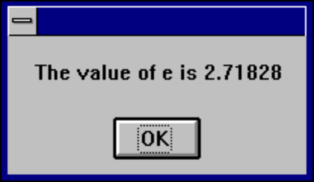

FileCopy Function

FileCopy( sourcefile, destinationfile)

Copies a file from source to destination.

The sourcefile and destinationfile parameters must be valid string expressions. sourcefile is the file name of the file to copy, destinationfile is the file name to be copied to.

FileLen Function

FileLen( filename )

Returns a Long integer that is the length of the file in bytes

Related Topics: LOF Function

Example:
(Not currently implemented)

Fix Function

Fix(number )

Returns the integer portion of a number

Related Topics: Int

For...Next Statement

For counter = expression1 to expression2 [Step increment]
[statements]
Next [counter]

Repeats the execution of a block of statements for a specified number of times.
Example:

Sub main ()

Dim x,y,z

For x = 1 to 5
For y = 1 to 5
For z = 1 to 5
Print "Looping" ,z,y,x
Next z
Next y
Next x
End Sub

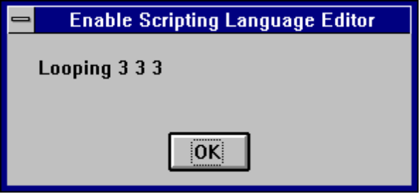

Format, Format$ Function

Format[$](expression [,fmt ] )

Formats a string, number or variant (date/time) datatype to a format expression.

Format returns a variant, Format$ returns a string

Part Description
expression Expression to be formatted.

fmt A string of characters that specify how the expression is to displayed. or the name of a commonly-used format that has been predefined in Enable Basic. Do not mix different type format expressions in a single fmt parameter.

if the fmt parameter is omitted or is zero-length and the expression parameter is a numeric, Format[$] provides the same functionality as the Str[$] function by converting the numeric value to the appropriate return data type, Positive numbers convert to strings using Format[$] lack the leading space reserved for displaying the sign of the value, whereas those converted using Str[$] retain the leading space.

To format numbers, you can use the commonly-used formats that have been predefined in Enable Basic or you can create user-defined formats with standard characters that have special meaning when used in a format expression.

Predefined numeric format names:

Format
Name Description

General Display the number as is, with no thousand Separators
Number

Fixed Display at least one digit to the left and two digits to the right of the decimal separator.

Standard Display number with thousand separator, if appropriate; display two digits to the right of the decimal separator.

Percent Display number multiplied by 100 with a percent sign (%) appended to the right’ display two digits to the right of the decimal separator.

Format
Name Description

Scientific Use standard scientific notation.

True/False Display False if number is 0, otherwise display True.

The following shows the characters you can use to create user-defined number formats.

Character Meaning

Null string Display the number with no formatting.

0 Digit placeholder.

Display a digit or a zero

If the number being formatted has fewer digits than there are zeros (on either side of the decimal) in the format expression, leading or trailing zeros are displayed. If the number has more digits to the right of the decimal separator than there are zeros to the right of the decimal separator in the format expression, the number is rounded to as many decimal places as there are zeros. If the number has more digits to left of the decimal separator than there are zeros to the left of the decimal separator in the format expression, the extra digits are displayed without modification.

# Digit placeholder.

Displays a digit or nothing. If there is a digit in the expression being formatted in the position where the # appears in the format string, displays it; otherwise, nothing is displayed.

. Decimal placeholder.

The decimal placeholder determines how many digits are displayed to the left and right of the decimal separator.

Character Meaning

% Percentage placeholder.

The percent character (%) is inserted in the position position where it appears in the format string. The expression is multiplied by 100.

, Thousand separator.

The thousand separator separates thousands from hundreds within a number that has four or more places to the left of the decimal separator.

Use of this separator as specified in the format statment contains a comma surrounded by digit placeholders(0 or #). Two adjacent commas or a comma immediately to the left of the decimal separator (whether or not a decimal is specified) means “scale the number by dividing it by 1000, rounding as needed.”

E-E+e-e+ Scientific format.

If the format expression contains at least one digit placeholder (0 or #) to the right of E-,E+,e- or e+, the number is displayed in scientific formatted E or e inserted between the number and its exponent. The number of digit placeholders to the right determines the number of digits in the exponent. Use E- or e- to place a minus sign next to negative exponents. Use E+ or e+ to place a plus sign next to positive exponents.

: Time separator.

The actual character used as the time separator depends on the Time Format specified in the International section of the Control Panel.

/ Date separator.

The actual character used as the date separator in the formatted out depends on Date Format specified in the International section of the Control Panel.

Character Meaning

- + $ ( ) Display a literal character.
space
To display a character other than one of those listed, precede it with a backslash (\).

\ Display the next character in the format string.

The backslash itself isn’t displayed. To display a backslash, use two backslashes (\\).

Examples of characters that can’t be displayed as literal characters are the date- and time- formatting characters (a,c,d,h,m,n,p,q,s,t,w,y, and /:), the numeric -formatting characters(#,0,%,E,e,comma, and period), and the string- formatting characters (@,&,<,>, and !).

“String” Display the string inside the double quotation marks.

To include a string in fmt from within Enable, you must use the ANSI code for a double quotation mark Chr(34) to enclose the text.

* Display the next character as the fill character.

Any empty space in a field is filled with the character following the asterisk.

Unless the fmt argument contains one of the predefined formats, a format expression for numbers can have from one to four sections separated by semicolons.

If you use The result is

One section The format expression applies to all values.
only

Two The first section applies to positive values, the second to negative sections values.

Three The first section applies to positive values, the second to negative sections values, and the third to zeros.

Four The first section applies to positive values, the second to negative section values, the third to zeros, and the fourth to Null values.

The following example has two sections: the first defines the format for positive values and zeros; the second section defines the format for negative values.

“$#,##0; ($#,##0)”

If you include semicolons with nothing between them. the missing section is printed using the format of the positive value. For example, the following format displays positive and negative values using the format in the first section and displays “Zero” if the value is zero.

“$#,##0;;\Z\e\r\o”

Some sample format expressions for numbers are shown below. (These examples all assume the Country is set to United States in the International section of the Control Panel.) The first column contains the format strings. The other columns contain the output the results if the formatted data has the value given in the column headings

Format (fmt) Positive 3 Negative 3 Decimal .3 Null

Null string 3 -3 0.3

0 3 -3 1

0.00 3.00 -3.00 0.30

#,##0 3 -3 1

#,##0.00;;;Nil 3.00 -3.00 0.30 Nil

$#,##0;($#,##0) $3 ($3) $1

$#,##0.00;($#,##0.00) $3.00 ($3.00) $0.30

0% 300% -300% 30%

0.00% 300.00% -300.00% 30.00%

0.00E+00 3.00E+00 -3.00E+00 3.00E-01

0.00E-00 3.00E00 -3.00E00 3.00E-01

Numbers can also be used to represent date and time information. You can format date and time serial numbers using date and time formats or number formats because date/time serial numbers are stored as floating-point values.

To format dates and times, you can use either the commonly used foamiest that have been predefined in Visual Basic or create user-defined time formats using standard meaning of each:

The following able shows the predefined data format names you can use and the meaning of each.

Format
Name Description

General Display a date and/or time. for real numbers, display a date and time.(e.g. 4/3/93 03:34 PM); If there is no fractional part, display only a date (e.g. 4/3/93); if there is no integer part, display time only (e.g. 03:34 PM).

Long Date Display a Long Date, as defined in the International section of the Control Panel.

Medium Display a date in the same form as the Short Date, as defined in the international section of the Control Panel, except spell out the month abbreviation.

Short Date Display a Short Date, as defined in the International section of the Control Panel.

Long Time Display a Long Time, as defined in the International section of the Control panel. Long Time includes hours, minutes, seconds.

Medium Display time in 12-hour format Time AM/PM designator.
Time

Short Time Display a time using the 24-hour format (e.g. 17:45)

This table shows the characters you can use to create user-defined date/time formats.

Character Meaning

c Display the date as dddd and display the time as ttttt. in the order.

d Display the day as a number without a leading zero (1-31).

dd Display the day as a number with a leading zero (01-31).

ddd Display the day as an abbreviation (Sun-Sat).

ddddd Display a date serial number as a complete date (including day , month, and year).

Character Meaning

w Display the day of the week as a number (1- 7 ).

ww Display the week of the year as a number (1-53).

m Display the month as a number without a leading zero !1-12). If m immediately follows h or hh, the minute rather than the month is displayed.

mm Display the month as an abbreviation (Jan-Dec).

mmmm Display the month as a full month name (January-December).

q display the quarter of the year as a number (1-4).

y Display the day of the year as a number (1-366).

yy Display the day of the year as a two-digit number (00-99)

yyyy Display the day of the year as a four-digit number (100-9999).

h Display the hour as a number without leading zeros (0-23).

hh Display the hour as a number with leading zeros (00-23).

n Display the minute as a number without leading zeros (0-59).

nn Display the minute as a number with leading zeros (00-59).

s Display the second as a number without leading zeros (0-59).

ss Display the second as a number with leading zeros (00-59).

ttttt Display a time serial number as a complete time (including hour, minute, and second) formatted using the time separator defined by the Time Format in the International section of the Control Panel. A leading zero is displayed if the Leading Zero option is selected and the time is before 10:00 A.M. or P.M. The default time format is h:mm:ss.

AM/PM Use the 12-hour clock and display an uppercase AM/PM

am/pm Use the 12-hour clock display a lowercase am/pm

Character Meaning

A/P Use the 12-hour clock display a uppercase A/P

a/p Use the 12-hour clock display a lowercase a/p

AMPM Use the 12-hour clock and display the contents of the 11:59 string (s1159) in the WIN.INI file with any hour before noon; display the contents of the 2359 string (s2359) with any hour between noon and 11:59 PM. AMPM can be either uppercase or lowercase, but the case of the string displayed matches the string as it exists in the WIN.INI file. The default format is AM/PM.

The Following are examples of user-defined date and time formats:

Format Display

m/d/yy 2/26/65

d-mmmm-yy 26-February-65

d-mmmm 26 February

mmmm-yy February 65

hh:mm AM/PM 06:45 PM

h:mm:ss a/p 6:45:15 p

h:mm:ss 18:45:15

m/d/yy/h:mm 2/26/65 18:45

Strings can also be formatted with Format[$]. A format expression for strings can have one section or two sections separated by a semicolon.

If you use The result is

One section only The format applies to all string data.

Two sections The first section applies to string data, the second to Null values and zero-length strings.

The following characters can be used to create a format expression for strings:

@ Character placeholder.

Character Meaning

@ Character placeholder.

Displays a character or a space. Placeholders are filled from right to left unless there is an ! character in the format string.

& Character placeholder. Display a character or nothing.

< Force lowercase.

> Force uppercase.

! Force placeholders to fill from left to right instead of right to left.

Related Topic: Str, Str$ Function..

Example:

' Format Function Example

' This example shows various uses of the Format function to format values
' using both named and user-defined formats. For the date separator (/),
' time separator (:), and AM/ PM literal, the actual formatted output
' displayed by your system depends on the locale settings on which the code
' is running. When times and dates are displayed in the development
' environment, the short time and short date formats of the code locale
' are used. When displayed by running code, the short time and short date
' formats of the system locale are used, which may differ from the code
' locale. For this example, English/United States is assumed.

' MyTime and MyDate are displayed in the development environment using
' current system short time and short date settings.

Sub Main

MyTime = "08:04:23 PM"
MyDate = "03/03/95"
MyDate = "January 27, 1993"

MsgBox Now
MsgBox MyTime

MsgBox Second( MyTime ) & " Seconds"
MsgBox Minute( MyTime ) & " Minutes"
MsgBox Hour( MyTime ) & " Hours"

MsgBox Day( MyDate ) & " Days"
MsgBox Month( MyDate ) & " Months"
MsgBox Year( MyDate ) & " Years"

' Returns current system time in the system-defined long time format.
MsgBox Format(Time, "Short Time")
MyStr = Format(Time, "Long Time")

' Returns current system date in the system-defined long date format.
MsgBox Format(Date, "Short Date")
MsgBox Format(Date, "Long Date")

' This section not yet supported
'MyStr = Format(MyTime, "h:m:s") ' Returns "17:4:23".
'MyStr = Format(MyTime, "hh:mm:ss AMPM")' Returns "05:04:23 PM".
'MyStr = Format(MyDate, "dddd, mmm d yyyy")' Returns "Wednesday, Jan 27 1993".

' If format is not supplied, a string is returned.
MsgBox Format(23) ' Returns "23".

' User-defined formats.
MsgBox Format(5459.4, "##,##0.00") ' Returns "5,459.40".
MsgBox Format(334.9, "###0.00") ' Returns "334.90".
MsgBox Format(5, "0.00%") ' Returns "500.00%".
MsgBox Format("HELLO", "<") ' Returns "hello".
MsgBox Format("This is it", ">") ' Returns "THIS IS IT".

End Sub

Function Statement

Function Fname [(Arguments)] [As type]
[statements]
Fname = expression
End Function

Declares and defines a procedure that can receive arguments and return a value of a specified data type.

Related Topics: Dim, End, Exit, Sub

Example:

Sub Main
For I = 1 to 10
Pront GetColor2(I)
Next I
End Sub
Function GetColor2( c% ) As Long
GetColor2 = c% * 25
If c% > 2 Then
GetColor2 = 255 ' 0x0000FF - Red
End If
If c% > 5 Then
GetColor2 = 65280 ' 0x00FF00 - Green
End If
If c% > 8 Then
GetColor2 = 16711680 ' 0xFF0000 - Blue
End If
End Function

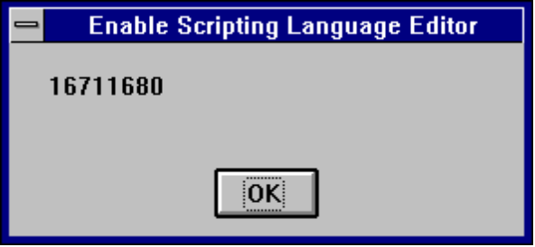

Global Statement

Global constant

The Global Statement must be outside the main section of the module. Global variables are available to all functions and subroutines in your program

Related Topics: Dim, Const and Type Statements

Example:

Global Const GloConst = 142 '
Const MyConst = 122 'Global to all procedures is a module
Sub Main ()
Dim Answer, Msg, NL ' Declare variables.
Const PI = 3.14159
NL = Chr(10) ' Define newline.
CurPath = CurDir() ' Get current path.
ChDir "\"
Msg = "The current directory has been changed to "
Msg = Msg & CurDir() & NL & NL & "Press OK to change back "
Msg = Msg & "to your previous default directory."
Answer = MsgBox(Msg) ' Get user response.
ChDir CurPath ' Change back to user default.
Msg = "Directory changed back to " & CurPath & "."
MsgBox Msg ' Display results.
myvar =myConst + PI + GloConst
Print MyVar
End Sub

GoSub...Return Statement

GoSub {linelabel }
.
.
linelabel:
.
.
Return

Branches to and returns from subroutines.

Related Topics: GoTo Statement, End Statement

Example:

Sub Main

x = 4
print x
print "hello"
Gosub fred
print "Joe"
Exit Sub
Fred:
print "there"
Return
End Sub

GoTo Statement

GoTo {Linelabel}

Branches unconditionally and without return to a specified line in a procedure.

Example:

Sub main ()

Dim x,y,z

For x = 1 to 5
For y = 1 to 5
For z = 1 to 5
Print "Looping" ,z,y,x
If y > 3 Then
GoTo Label1
End If
Next z
Next y
Next x
Label1:

End Sub

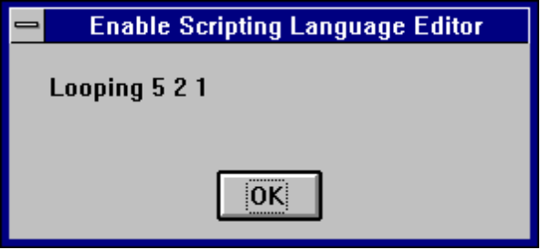

Hex, Hex$

Hex[$](num)

Returns the hexadecimal value of a decimal parameter.

Hex$ returns a string and Hex returns a Variant:

The parameter num can be any valid number. It is rounded to nearest whole number before evaluation.

Related Topics: Oct, Oct$

Example:

Sub Main ()

Dim Msg As String, x%
x% = 10
Msg =Str( x%) & " decimal is "
Msg = Msg & Hex(x%) & " in hex "
MsgBox Msg
End Sub

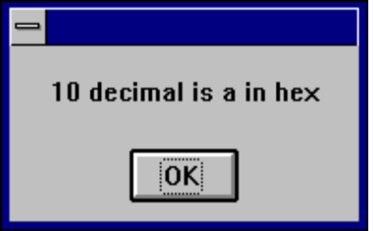

Hour Function

Hour(number )

The Hour Function returns an integer between 0 and 23 that is the hour of the day indicated in the parameter number.

The parameter number is any numberic expression that can represent a date and tome from January 1, 100 through December 31, 9999, where January 1, 1901 is 3.

Example:

' This example shows various uses of the Format function to format values
' using both named and user-defined formats. For the date separator (/),
' time separator (:), and AM/ PM literal, the actual formatted output
' displayed by your system depends on the locale settings on which the code
' is running. When times and dates are displayed in the development
' environment, the short time and short date formats of the code locale
' are used. When displayed by running code, the short time and short date
' formats of the system locale are used, which may differ from the code
' locale. For this example, English/United States is assumed.

' MyTime and MyDate are displayed in the development environment using
' current system short time and short date settings.

Sub Main

MyTime = "08:04:23 PM"
MyDate = "03/03/95"
MyDate = "January 27, 1993"

MsgBox Now
MsgBox MyTime

MsgBox Second( MyTime ) & " Seconds"
MsgBox Minute( MyTime ) & " Minutes"
MsgBox Hour( MyTime ) & " Hours"

MsgBox Day( MyDate ) & " Days"
MsgBox Month( MyDate ) & " Months"
MsgBox Year( MyDate ) & " Years"

' Returns current system time in the system-defined long time format.
MsgBox Format(Time, "Short Time")
MyStr = Format(Time, "Long Time")

' Returns current system date in the system-defined long date format.
MsgBox Format(Date, "Short Date")
MsgBox Format(Date, "Long Date")

' This section not yet supported
'MyStr = Format(MyTime, "h:m:s") ' Returns "17:4:23".
'MyStr = Format(MyTime, "hh:mm:ss AMPM")' Returns "05:04:23 PM".
'MyStr = Format(MyDate, "dddd, mmm d yyyy")' Returns "Wednesday, Jan 27 1993".

' If format is not supplied, a string is returned.
MsgBox Format(23) ' Returns "23".

' User-defined formats.
MsgBox Format(5459.4, "##,##0.00") ' Returns "5,459.40".
MsgBox Format(334.9, "###0.00") ' Returns "334.90".
MsgBox Format(5, "0.00%") ' Returns "500.00%".
MsgBox Format("HELLO", "<") ' Returns "hello".
MsgBox Format("This is it", ">") ' Returns "THIS IS IT".

End Sub

If...Then...Else Statement

If condition Then
.
.
.
ElseIf condition Then
.
.
.
Else
.
.
.
End If

Syntax 2
If conditional Then statement [Else...]

Allows conditional statements to be executed in you code.

Related Topics: Select Case

Example:
Sub Main ()
Dim MyList$(2)
MyList(0) = "Banana"
MyList(1) = "Orange"
MyList(2) = "Apple"
Begin Dialog DialogName1 60, 60, 240, 184, "Test Dialog"
Text 10, 10, 28, 12, "Name:"
TextBox 40, 10,50, 12, .joe
ListBox 102, 10, 108, 16, MyList$(), .MyList1
ComboBox 42, 30, 108, 42, MyList$(), .Combo1
DropListBox 42, 76, 108, 36, MyList$(), .DropList1$
OptionGroup .grp1
OptionButton 42, 100, 48, 12, "Option&1"
OptionButton 42, 110, 48, 12, "Option&2"
OptionGroup .grp2
OptionButton 42, 136, 48, 12, "Option&3"
OptionButton 42, 146, 48, 12, "Option&4"
GroupBox 132, 125, 70, 36, "Group"
CheckBox 142, 100, 48, 12, "Check&A", .Check1
CheckBox 142, 110, 48, 12, "Check&B", .Check2
CheckBox 142, 136, 48, 12, "Check&C", .Check3
CheckBox 142, 146, 48, 12, "Check&D", .Check4
GroupBox 132, 125, 70, 36, "Group2"
CancelButton 42, 168, 40, 12
OKButton 90, 168, 40, 12
PushButton 140, 168, 40, 12, "&Push Me 1"
PushButton 190, 168, 40, 12, "Push &Me 2"
End Dialog
Dim Dlg1 As DialogName1
Dlg1.joe = "Def String"
Dlg1.MyList1 = 1
Dlg1.Combo1 = "Kiwi"
Dlg1.DropList1 = 2
Dlg1.grp2 = 1
' Dialog returns -1 for OK, 0 for Cancel
‘button # for PushButtons - start w/ 1
button = Dialog( Dlg1 )
MsgBox "button: " & button
If button = 0 Then Return

'MsgBox joe
MsgBox "TextBox: "& Dlg1.joe
MsgBox "ListBox: " & Dlg1.MyList1
MsgBox Dlg1.Combo1
MsgBox Dlg1.DropList1
MsgBox "grp1: " & Dlg1.grp1
MsgBox "grp2: " & Dlg1.grp2
Begin Dialog DialogName2 60, 60, 160, 60, "Test Dialog 2"
Text 10, 10, 28, 12, "Name:"
TextBox 42, 10, 108, 12, .fred
OkButton 42, 44, 40, 12
End Dialog
If button = 2 Then
Dim Dlg2 As DialogName2
Dialog Dlg2
MsgBox Dlg2.fred
ElseIf button = 1 Then
Dialog Dlg1
MsgBox Dlg1.Combo1
End If
End Sub

Input, Input$ Function

Input[$](n , [ #] filenumber )

Input returns characters from a sequential file.

The input[$] function has two parameters n and filenumber. n is the number of bytes to be read from a file and filenumber is the number used in the open statement when the file was opened.

Example:
(Not currently implemented)

InputBox, InputBox$

InputBox[$](prompt[,[title][,[default][,xpos,ypos]]])

InputBox returns a Variant of Vartype (String); InputBox$ returns a String

Example:

Sub Main ()
Title$ = "Greetings"
Prompt$ = "What is your name?"
Default$ = ""
X% = 2000
Y% = 4000
N$ = InputBox$(Prompt$, Title$, Default$, X%, Y%)
End Sub 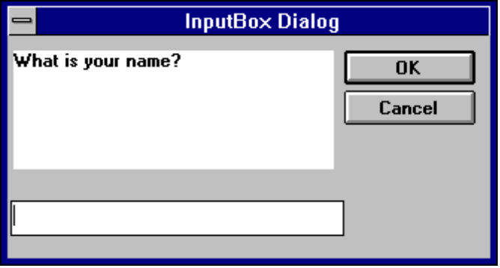

InStr

InStr(numbegin, string1, string2 [, comparecase])

Returns the character position of the first occurrence of string2 within string1.

The numbegin parameter is optional and sets the starting point of the search. numbegin must be a valid positive integer no greater than 65,535. If numbegin is omitted the search begins at the first character of string1. numbegin must be used if comparecase is used.

string1 is the string being searched and string2 is the string we are looking for. The comparecase parameter must be 0 or 1. If comparecase is omitted or is 0 the search is not case sensitive. If compasecase is 1 the string comparison is case sensitive.

Related Topics: Option Compare

Example:

Sub Main ()
B$ = "Good Bye"
A% = InStr(B$, "Bye")
C% = Instr(7, B$, "Bye")
End Sub

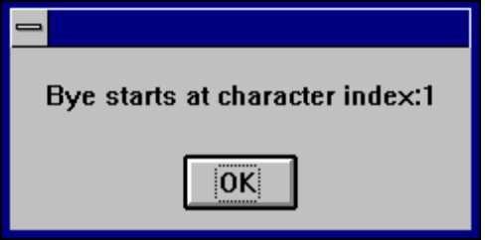

Int Function

Int(number )

Returns the integer portion of a number

Related Topics: Fix

IsDate

IsDate(variant )

Returns a value that indicates whither a variant parameter can be converted to a date.

Related Topics: IsEmpty, IsNumeric, VarType

IsEmpty

IsEmpy(variant )

Returns a value that indicates if a variant parameter has been initialized.

Related Topics: IsDate, IsNull, IsNumeric, VarType

Example:
' This sample explores the concept of an empty variant

Sub Main
Dim x ' Empty
x = 5 ' Not Empty - Long
x = Empty ' Empty
y = x ' Both Empty
MsgBox x & " IsEmpty: " & IsEmpty(x)
End Sub

IsNull

IsNull(v)

Returns a value that indicates if a variant contains the NULL value.

The parameter v can be any variant. IsNull returns a TRUE if v contains NULL. If isNull returns a FALSE the NULL the variant expression is not NULL.

The NULL value is special because it indicates the that the v parameter contains no data. This is different from a null-string, which is a zero length string and an empty string which has not yet been initialized.

Related Topics: IsDate, IsEmpty, IsNumeric, VarType

Example:

IsNumeric

IsNumeric(v)

Returns a TRUE or FALSE indicating if the v parameter can be converted to a numeric data type.

The parameter v can be any variant, numeric value, Date or string (if the string can be interpreted as a numeric).

Related topics: IsDate, IsEmpty, IsNull, VarType

Example:

Sub Form_Click ()
Dim TestVar ' Declare variable.
TestVar = InputBox("Please enter a number, letter, or symbol.")
If IsNumeric(TestVar) Then ' Evaluate variable.
MsgBox "Entered data is numeric." Message if number.
Else
MsgBox "Entered data is not numeric." ' Message if not.
End If
End Sub 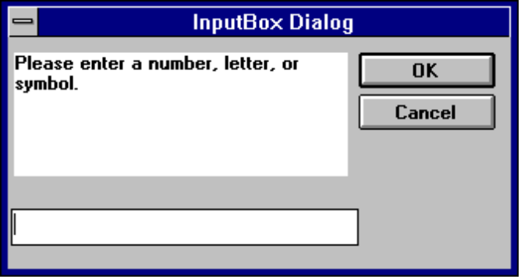

Kill Statement

Kill filename

Kill will only delete files. To remove a directory use the RmDir Statement

Related Topics: RmDir

Example:

Const NumberOfFiles = 3

Sub Main ()
Dim Msg ' Declare variable.
Call MakeFiles() ' Create data files.
Msg = "Several test files have been created on your disk. You may see "
Msg = Msg & "them by switching tasks. Choose OK to remove the test files."
MsgBox Msg
For I = 1 To NumberOfFiles
Kill "TEST" & I ' Remove data files from disk.
Next I
End Sub

Sub MakeFiles ()
Dim I, FNum, FName ' Declare variables.
For I = 1 To NumberOfFiles
FNum = FreeFile ' Determine next file number.
FName = "TEST" & I
Open FName For Output As FNum ' Open file.
Print #FNum, "This is test #" & I ' Write string to file.
Print #FNum, "Here is another "; "line"; I
Next I
Close ' Close all files.
End Sub

LBound Function

LBound(array [,dimension] )

Returns the smallest available subscript for the dimension of the indicated array.

Related Topics: UBound Function

Example:
' This example demonstrates some of the features of arrays. The lower bound
' for an array is 0 unless it is specified or option base has set it as is
' done in this example.

Option Base 1

Sub Main
Dim a(10) As Double
MsgBox "LBound: " & LBound(a) & " UBound: " & UBound(a)
Dim i As Integer
For i = 0 to 3
a(i) = 2 + i * 3.1
Next i
' Erase( a ) ' If this line is uncommented then the values will all be 0
Print a(0),a(1),a(2), a(3)
End Sub

LCase, LCase$ Function

Lcase[$](string )

Returns a string in which all letters of the string parameter have been converted to upper case.

Related Topics: Ucase Function

Example:

' This example uses the LTrim and RTrim functions to strip leading and
' trailing spaces, respectively, from a string variable. It
' uses the Trim function alone to strip both types of spaces.
' LCase and UCase are also shown in this example as well as the use
' of nested function calls

Sub Main
MyString = " <-Trim-> " ' Initialize string.
TrimString = LTrim(MyString) ' TrimString = "<-Trim-> ".
MsgBox "|" & TrimString & "|"
TrimString = LCase(RTrim(MyString)) ' TrimString = " <-trim->".
MsgBox "|" & TrimString & "|"
TrimString = LTrim(RTrim(MyString)) ' TrimString = "<-Trim->".
MsgBox "|" & TrimString & "|"
' Using the Trim function alone achieves the same result.
TrimString = UCase(Trim(MyString)) ' TrimString = "<-TRIM->".
MsgBox "|" & TrimString & "|"
End Sub

Left, Left$

Left[$](string, num)

Returns the left most num characters of a string parameter.

Left returns a Variant, Left$ returns a String

Example:

Sub Main ()
Dim LWord, Msg, RWord, SpcPos, UsrInp ' Declare variables.
Msg = "Enter two words separated by a space."
UsrInp = InputBox(Msg) ' Get user input.
print UsrInp
SpcPos = InStr(1, UsrInp, " ") ' Find space.
If SpcPos Then
LWord = Left(UsrInp, SpcPos - 1) ' Get left word.
print "LWord: "; LWord
RWord = Right(UsrInp, Len(UsrInp) - SpcPos) ' Get right word.
Msg = "The first word you entered is " & LWord
Msg = Msg & "." & " The second word is "
Msg = "The first word you entered is <" & LWord & ">"
Msg = Msg & RWord & "."
Else
Msg = "You didn't enter two words."
End If
MsgBox Msg ' Display message.
MidTest = Mid("Mid Word Test", 4, 5)
Print MidTest
End Sub

Len

Len(string)

Returns the number of characters in a string.

Related Topics: InStr

Example:

Sub Main ()
A$ = "Cypress Enable"
StrLen% = Len(A$) 'the value of StrLen is 14
MsgBox StrLen%
End Sub

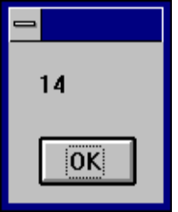

Let Statement

[Let] variablename = expression

Let assigns a value to a variable.

Let is an optional keyword that is rarely used. The Let statement is required in older versions of BASIC.

Example:

Sub Form_Click ()
Dim Msg, Pi ' Declare variables.
Let Pi = 4 * _Atn(1) ' Calculate Pi.
Msg = "Pi is equal to " & Str(Pi)
MsgBox Msg ' Display results.
End Sub

Line Input # Statement

Line Input # filenumber and name

Reads a line from a sequential file into a String or Variant variable.

The parameter filenumber is used in the open statment to open the file. The parameter name is the name of a variable used to hold the line of text from the file.

Related Topics: Open

Example:
(Not currently implemented)

Log

Log(num)

Returns the natural log of a number
The parameter num must be greater than zero and be a valid number.
Related Topics: Exp, Sin, Cos

Example:

Sub Form_Click ( )
Dim I, Msg, NL
NL = Chr(13) & Chr(10)
Msg = Exp(1) & NL
For I = 1 to 3
Msg = Msg & Log(Exp(1) ^ I ) & NL
Next I
MsgBox Msg
End Sub

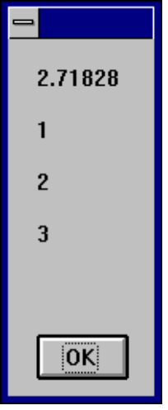

Mid Function

Mid[$](strgvar,begin,length) = string

Mid replaces part of a string with another string.

Example:

Sub Main ()
Dim LWord, Msg, RWord, SpcPos, UsrInp ' Declare variables.
Msg = "Enter two words separated by a space."
UsrInp = InputBox(Msg) ' Get user input.
print UsrInp
SpcPos = InStr(1, UsrInp, " ") ' Find space.
If SpcPos Then
LWord = Left(UsrInp, SpcPos - 1) ' Get left word.
print "LWord: "; LWord
RWord = Right(UsrInp, Len(UsrInp) - SpcPos) ' Get right word.
Msg = "The first word you entered is " & LWord
Msg = Msg & "." & " The second word is "
Msg = "The first word you entered is <" & LWord & ">"
Msg = Msg & RWord & "."
Else
Msg = "You didn't enter two words."
End If
MsgBox Msg ' Display message.
MidTest = Mid("Mid Word Test", 4, 5)
Print MidTest
End Sub

Minute Function
Minute(number)
' Format Function Example

' This example shows various uses of the Format function to format values
' using both named and user-defined formats. For the date separator (/),
' time separator (:), and AM/ PM literal, the actual formatted output
' displayed by your system depends on the locale settings on which the code
' is running. When times and dates are displayed in the development
' environment, the short time and short date formats of the code locale
' are used. When displayed by running code, the short time and short date
' formats of the system locale are used, which may differ from the code
' locale. For this example, English/United States is assumed.

' MyTime and MyDate are displayed in the development environment using
' current system short time and short date settings.

Sub Main

MyTime = "08:04:23 PM"
MyDate = "03/03/95"
MyDate = "January 27, 1993"

MsgBox Now
MsgBox MyTime

MsgBox Second( MyTime ) & " Seconds"
MsgBox Minute( MyTime ) & " Minutes"
MsgBox Hour( MyTime ) & " Hours"

MsgBox Day( MyDate ) & " Days"
MsgBox Month( MyDate ) & " Months"
MsgBox Year( MyDate ) & " Years"

' Returns current system time in the system-defined long time format.
MsgBox Format(Time, "Short Time")
MyStr = Format(Time, "Long Time")

' Returns current system date in the system-defined long date format.
MsgBox Format(Date, "Short Date")
MsgBox Format(Date, "Long Date")

' This section not yet supported
'MyStr = Format(MyTime, "h:m:s") ' Returns "17:4:23".
'MyStr = Format(MyTime, "hh:mm:ss AMPM")' Returns "05:04:23 PM".
'MyStr = Format(MyDate, "dddd, mmm d yyyy")' Returns "Wednesday, Jan 27 1993".

' If format is not supplied, a string is returned.
MsgBox Format(23) ' Returns "23".

' User-defined formats.
MsgBox Format(5459.4, "##,##0.00") ' Returns "5,459.40".
MsgBox Format(334.9, "###0.00") ' Returns "334.90".
MsgBox Format(5, "0.00%") ' Returns "500.00%".
MsgBox Format("HELLO", "<") ' Returns "hello".
MsgBox Format("This is it", ">") ' Returns "THIS IS IT".

End Sub

MkDir
MkDir path

Creates a new directory.

The parameter path is a string expression that must contain fewer than 128 characters.

Example:

Sub Main
Dim DST As String

DST = "t1"
mkdir DST
mkdir "t2"
End Sub

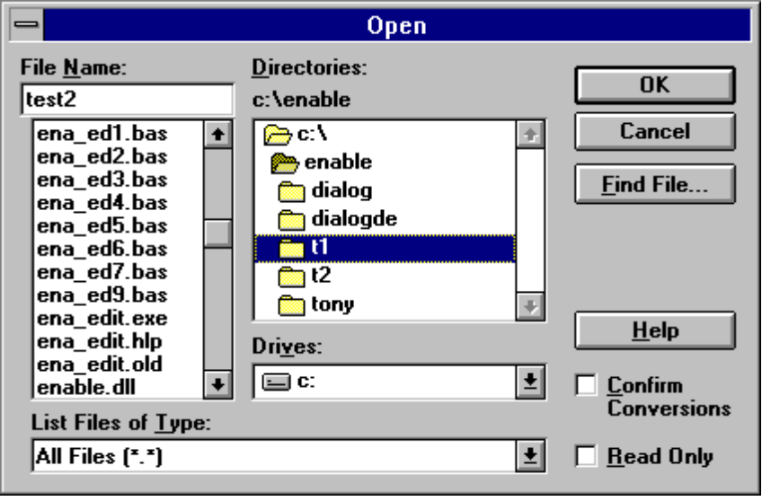

Month Function

Month(number)

Returns an integer between 1 and 12, inclusive, that represents the month of the year.

Related Topics: Day, Hour, Weekday, Year

Example:

Sub Main
Dim DST As String

DST = "t1"
mkdir DST
mkdir "t2"
End Sub

MsgBox Function MsgBox Statement

MsgBox ( msg, type, title)

Displays a message in a dialog box and waits for the user to choose a button.

The first parameter msg is the string displayed in the dialog box as the message. The second and third parameters are optional and respectively designate the type of buttons and the title displayed in the dialog box.

returns a value indicating which button the user has chosen; the MsgBox statement does not.

Symbolic constant Value Meaning
MB_OK 0 Display OK button only.
MB_OKCANCEL 1 Display OK and Cancel buttons.
MB_ABORTRETRYIGNORE 2 Display Abort, Retry, and Ignore buttons.
MB_YESNOCANCEL 3 Display Yes, No, and Cancel buttons.
MB_YESNO 4 Display Yes and No buttons.
MB_RETRYCANCEL 5 Display Retry and Cancel buttons.
MB_ICONSTOP 16
MB_ICONQUESTION 32
MB_ICONEXCLAMATION 48
MB_ICONINFORMATION 64
MB_DEFBUTTON1 0 First button is default.
MB_DEFBUTTON2 256 Second button is default.
MB_DEFBUTTON3 512 Third button is default.
MB_APPLMODAL 0 Application modal. The user must respond to the message
box before continuing work in the current application
MB_SYSTEMMODAL 4096 System modal. All applications are suspended until
the user responds to the message box.

The first group of values (1-5) describes the number and type of buttons displayed in the dialog box; the second group (16, 32, 48, 64) describes the icon style; the third group (0, 256, 512) determines which button is the default; and the fourth group (0, 4096) determines the modality of the message box. When adding numbers to create a final value for the argument type, use only one number from each group. If omitted, the default value for type is 0.

title:
String expression displayed in the title bar of the dialog box. If you omit the argument
title, MsgBox has no default default title.

The value returned by the MsgBox function indicates which button has been selected, as shown below:

Symbolic constant Value Meaning
IDOK 1 OK button selected.
IDCANCEL 2 Cancel button selected.
IDABORT 3 Abort button selected.
IDRETRY 4 Retry button selected.
IDIGNORE 5 Ignore button selected.
IDYES 6 Yes button selected.
IDNO 7 No button selected.

If the dialog box displays a Cancel button, pressing the Esc key has the same effect as choosing Cancel.

MsgBox Function, MsgBox Statement Example

The example uses MsgBox to display a close without saving message in a dialog box with a Yes button and a No button. The No button is the default response. The MsgBox function returns a value based on the button chosen by the user. The MsgBox statement uses that value to display a message that indicates which button was chosen.

Related Topics: InputBox, InputBox$ Function

Example:

Sub Main
Const MB_OK = 0
Const MB_OKCANCEL = 1 ' Define buttons.
Const MB_YESNOCANCEL = 3
Const MB_YESNO = 4
Const MB_ICONSTOP = 16
Const MB_ICONQUESTION = 32 ' Define Icons.
Const MB_ICONEXCLAMATION = 48
Const MB_ICONINFORMATION = 64
Const MB_DEFBUTTON3 =512
Const IDYES = 6
Const IDNO = 7
Const IDCANCEL = 2
Dim DgDef, Msg, Response, Title ' Declare variables.
Title = "MsgBox Sample Question"
Msg = "This is a sample of Close Without Saving?."
Msg = Msg & " Do you want to continue?"
DgDef = MB_YESNOCANCEL + MB_ICONQUESTION + MB_DEFBUTTON3 ' Describe dialog.

Response = MsgBox(Msg, DgDef, Title) ' Get user response.
If Response = IDYES Then ' Evaluate response
Msg = "You chose Yes." ' and take appropriate
ElseIf Response = IDCANCEL Then
Msg = "You chose Cancel"
Else ' action.
Msg = "You chose No or pressed Enter."
End If
MsgBox Msg ' Display action taken.
End Sub

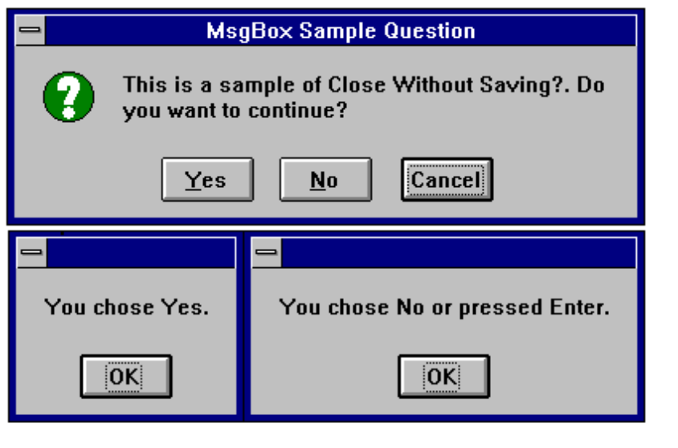

Name Statement

Name oldname As newname

Changes the name of a directory or a file.

The parameters oldname and newname are string that can optionally contain a path.

Related Topics: Kill, ChDir

Example:

Sub main ()
Dim Msg, Num ' Declare variables.
Num = InputBox("Enter a number.") ' Get user input.
Msg = Num & " decimal is &O"
Msg = Msg & Oct(Num) & " in octal notation."
MsgBox Msg ' Display results.
End Sub

Now Function

Now

Returns a date that represents the current date and time according to the seting of the computer’s system date and time

The Now returns a Variant data type containing a date and time that are stored internally as a double. The number is a date and time from January 1, 100 through December 31, 9999, where January 1, 1900 is 2. Numbers to the left of the decimal point represent the date and numbers to the right represent the time.

Related Topics:

Example:

Sub Main ()
Dim Today
Today = Now
End Sub

Oct

Oct[$](num)

Returns the octal value of the decimal parameter

Oct returns a variant and Oct$ returns a string

Related Topics: Hex, Hex$
Example:

Sub Main ()
Dim Msg, Num ' Declare variables.
Num = InputBox("Enter a number.") ' Get user input.
Msg = Num & " decimal is &O"
Msg = Msg & Oct(Num) & " in octal notation."
MsgBox Msg ' Display results.
End Sub

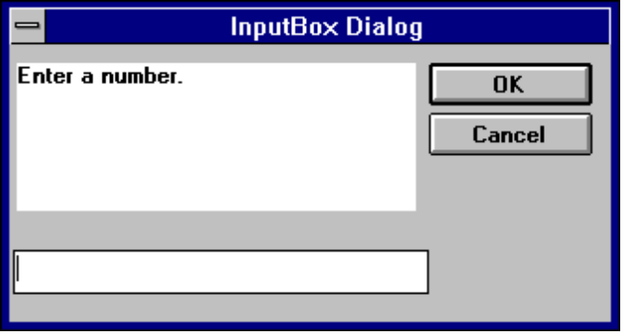

OKButton

OKBUTTON starting x position, starting y position, width, Height

For selecting options and closing dialog boxes

Sub Main ()
Begin Dialog DialogName1 60, 60, 160, 70, "ASC - Hello"
TEXT 10, 10, 28, 12, "Name:"
TEXTBOX 42, 10, 108, 12, .nameStr
TEXTBOX 42, 24, 108, 12, .descStr
CHECKBOX 42, 38, 48, 12, "&CHECKME", .checkInt
OKBUTTON 42, 54, 40, 12
End Dialog
Dim Dlg1 As DialogName1
Dialog Dlg1

MsgBox Dlg1.nameStr
MsgBox Dlg1.descStr
MsgBox Dlg1.checkInt
End Sub

On Error

On Error { GoTo line | Resume Next | GoTo 0 }

Enables error-handling routine and specifies the line label of the error-handling routine.

Related Topics: Resume

The line parameter refers to a label. That label must be present in the code or an error is generated.

Example:
(Not currently implemented)

Open Statement

Open filename$ [For mode] [Access access]c As [#]filenumber

Opens a file for input and output operations.

You must open a file before any I/O operation can be performed on it.The Open statement has these parts:

Part Description
file File name or path.
mode Reserved word that specifies the file mode: Append, Binary Input, Output
access Reserved word that specifies which operations are permitted on the open file: Read, Write.
filenumber Integer expression with a value between 1 and 255, inclusive. When an Open statement is executed, filenumber is associated with the file as long as it is open. Other I/O statements can use the number to refer to the file.

If file doesn't exist, it is created when a file is opened for Append, Binary or Output modes.

The argument mode is a reserved word that specifies one of the following file modes.

Mode Description
Input Sequential input mode.
Output Sequential output mode.

Append Sequential output mode. Append sets the file pointer to the end of the file. A Print # or Write # statement then extends (appends to) the file.

The argument access is a reserved word that specifies the operations that can be performed on the opened file. If the file is already opened by another process and the specified type of access is not allowed, the Open operation fails and a Permission denied error occurs. The Access clause works only if you are using a version of MS-DOS that supports networking (MS-DOS version 3.1 or later). You (or the network startup program) must also run the SHARE.EXE program to enable locking operations. If you use the Access clause with a version of MS-DOS that doesn't support networking, a Feature unavailable error occurs. The argument access can be one of the following reserved words.

Access type Description
Read Opens the file for reading only.
Write Opens the file for writing only.
Read Write Opens the file for both reading and riting.
This mode is valid only for Random and
Binary files and files opened for Append
mode.

The following example writes data to a test file and reads it back.

Example :

Sub Main ()
Dim FileData, Msg, NL ' Declare variables.
NL = Chr(10) ' Define newline.
Open "TESTFILE" For Output As #1 ' Open to write file.
Print #2, "This is a test of the Print # statement."
Print #2 ' Print blank line to file.
Print #2, "Zone 1", "Zone 2" ' Print in two print zones.
Print #2, "With no space between" ; "." ‘Print two strings together.
Close
Open "TESTFILE" for Input As #2 ' Open to read file.
Do While Not EOF(2)
Line Input #2, FileData ' Read a line of data.
Msg = Msg & FileData & NL ' Construct message.
MsgBox Msg
Loop
Close ' Close all open files.
MsgBox "Testing Print Statement" ' Display message.
Kill "TESTFILE" ' Remove file from disk.
End Sub

Option Base Statement

Option Base number

Declares the default lower bound for array subscripts.

The Option Base statement is never required. If used, it can appear only once in a module, can occur only in the Declarations section, and must be used before you declare the dimensions of any arrays.

The value of number must be either 0 or 1. The default base is 0.

The To clause in the Dim, Global, ReDim, and Static statements provides a more flexible way
to control the range of an array's subscripts. However, if you don't explicitly set the lower bound with a
To clause, you can use Option Base to change the default lower bound to 1.

The example uses the Option Base statement to override the default base array subscript value of 0.

Related Topics: Dim, Global and Lbound Statements

Example :

Option Base 1 ' Module level statement.
Sub Main
Dim A(), Msg, NL ' Declare variables.
NL = Chr(10) ' Define newline.
ReDim A(20) ' Create an array.
Msg = "The lower bound of the A array is " & LBound(A) & "."
Msg = Msg & NL & "The upper bound is " & UBound(A) & "."
MsgBox Msg ' Display message.
End Sub

Option Explicit Statement

Option Explicit

Forces explicit declaration of all variables.

The Option explicit statement is used outside of the script in the declarations section. This statement can be contained in a declare file or outside of any script in a file or buffer. If this statement is contained in the middle of a file the rest of the compile buffer will be affected.

Related Topics: Const and Global Statements

Example :

Option Explicit
Sub Main
Print y ‘because y is not explicitly dimmed an error will occur.

End Sub

Print # Statement

Print # filenumber, [ [{Spc(n) | Tab(n)}][ expressionlist] [{; | ,}] ]

Writes data to a sequential file.

Print statment Description:

filenumber:
Number used in an Open statement to open a sequential file. It can be any
number of an open file. Note that the
number sign (#) preceding filenumber is not optional.

Spc(n):
Name of the Basic function optionally used to insert n spaces into the printed
output. Multiple use is permitted.

Tab(n):
Name of the Basic function optionally used to tab to the nth column before printing
expressionlist. Multiple use is permitted.

expressionlist :
Numeric and/or string expressions to be written to the file.

{;|,}
Character that determines the position of the next character printed. A semicolon means the next character is printed immediately after the last character; a comma means the next character is printed at the start of the next print zone. Print zones begin every 14 columns. If neither character is specified, the next character is printed on the next line.

If you omit expressionlist, the Print # statement prints a blank line in the file, but you must include the comma. Because Print # writes an image of the data to the file, you must delimit the data so it is printed correctly. If you use commas as delimiters, Print # also writes the blanks between print fields to the
file.

The Print # statement usually writes Variant data to a file the same way it writes any other data type. However, there are some exceptions:

If the data being written is a Variant of VarType 0 (Empty), Print # writes nothing to the file for that data item.

If the data being written is a Variant of VarType 1 (Null), Print # writes the literal #NULL# to the file.

If the data being written is a Variant of VarType 7 (Date), Print # writes the date to the file using the Short Date format defined in the WIN.INI file. When either the date or the time component is missing or zero, Print # writes only the part provided to the file.

The following example writes data to a test file.

Example :

Sub Main
Dim I, FNum, FName ' Declare variables.
For I = 1 To 3
FNum = FreeFile ' Determine next file number.
FName = "TEST" & FNum
Open FName For Output As FNum ' Open file.
Print #I, "This is test #" & I ' Write string to file.
Print #I, "Here is another "; "line"; I
Next I
Close ' Close all files.
End Sub

The following example writes data to a test file and reads it back.

Sub Main ()
Dim FileData, Msg, NL ' Declare variables.
NL = Chr(10) ' Define newline.
Open "TESTFILE" For Output As #1 ' Open to write file.
Print #2, "This is a test of the Print # statement."
Print #2 ' Print blank line to file.
Print #2, "Zone 1", "Zone 2" ' Print in two print zones.
Print #2, "With no space between" ; "." ' Print two strings together.
Close
Open "TESTFILE" for Input As #2 ' Open to read file.
Do While Not EOF(2)
Line Input #2, FileData ' Read a line of data.
Msg = Msg & FileData & NL ' Construct message.
MsgBox Msg
Loop
Close ' Close all open files.
MsgBox "Testing Print Statement" ' Display message.
Kill "TESTFILE" ' Remove file from disk.
End Sub

Print Method

Print [expr, expr...] Print a string to an object.

Related Topics:

Example:

Sub PrintExample ()
Dim Msg, Pi ' Declare variables.
Let Pi = 4 * _Atn(1) ' Calculate Pi.
Msg = "Pi is equal to " & Str(Pi)
MsgBox Msg ' Display results.
Print Pi ' Prints the results on the compiler messages window
End Sub

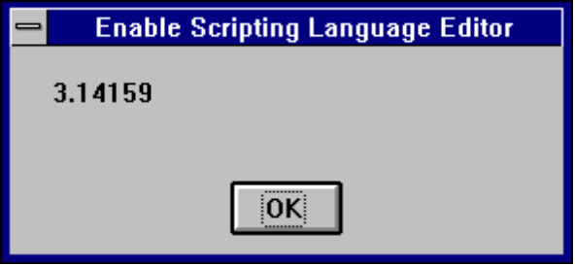

Rem Statement

Rem remark ‘remark

Used to include explanatory remarks in a program.

The parameter remark is the text of any comment you wish to include in you code.

Example:
Rem This is a remark

Sub Main()

Dim Answer, Msg ' Declare variables.
Do
Answer = InputBox("Enter a value from 1 to 3.")
Answer = 2
If Answer >= 1 And Answer <= 3 Then ' Check range.
Exit Do ' Exit Do...Loop.
Else
Beep ' Beep if not in range.
End If
Loop
MsgBox "You entered a value in the proper range."
End Sub

Right, Right$ Function

Right [$] (stringexpr, n )

Returns the right most n characters of the string parameter.

The parameter string is the string from which the rightmost characters are returned.
The parameter n is the number of characters that will be rerurned and must be a long integer.

Related Topics: Len, Left, Mid Functions.

Example:

' The example uses the Left function to return the first of two words
' input by the user.

Sub Main ()
Dim LWord, Msg, RWord, SpcPos, UsrInp ' Declare variables.
Msg = "Enter two words separated by a space."
UsrInp = InputBox(Msg) ' Get user input.
print UsrInp
SpcPos = InStr(1, UsrInp, " ") ' Find space.
If SpcPos Then
LWord = Left(UsrInp, SpcPos - 1) ' Get left word.
print "LWord: "; LWord
RWord = Right(UsrInp, Len(UsrInp) - SpcPos) ' Get right word.
Msg = "The first word you entered is " & LWord
Msg = Msg & "." & " The second word is "
Msg = "The first word you entered is <" & LWord & ">"
Msg = Msg & RWord & "."
Else
Msg = "You didn't enter two words."
End If
MsgBox Msg ' Display message.
End Sub

RmDir Statement

RmDir path

Removes an existing directory.

The parameter path is a string that is the name of the directory to be removed.

Related Topics: ChDir, CurDir

Example:
' This sample shows the functions mkdir (Make Directory)
' and rmdir (Remove Directory)

Sub Main
Dim dirName As String

dirName = "t1"
mkdir dirName
mkdir "t2"
MsgBox "Directories: t1 and t2 created. Press OK to remove them"
rmdir "t1"
rmdir "t2"
End Sub

Rnd Function

Rnd (number)

Returns a random number.

The parameter number must be a valid numeric expression.

Example:

'Rnd Function Example

'The example uses the Rnd function to simulate rolling a pair of dice by
'generating random values from 1 to 6. Each time this program is run,
'Randomize uses the Timer function to generate a new random-number sequence.

Sub Main ()
Dim Dice1, Dice2, Msg ' Declare variables.
' Randomize ' Seed random number generator.
Dice1 = CInt(6 * Rnd() + 1) ' Generate first die value.
Dice2 = CInt(6 * Rnd() + 1) ' Generate second die value.
Msg = "You rolled a " & Dice1
Msg = Msg & " and a " & Dice2
Msg = Msg & " for a total of "
Msg = Msg & Str(Dice1 + Dice2) & "."
MsgBox Msg ' Display message.
End Sub

Second Function

Second (number)

Returns an integer that is the second portion of the minute in the time parameter.

The parameter number must be a valid numeric expression.

Related Topics: Day, Hour, Minute, Now.

Example:
' Format Function Example

' This example shows various uses of the Format function to format values
' using both named and user-defined formats. For the date separator (/),
' time separator (:), and AM/ PM literal, the actual formatted output
' displayed by your system depends on the locale settings on which the code
' is running. When times and dates are displayed in the development
' environment, the short time and short date formats of the code locale
' are used. When displayed by running code, the short time and short date
' formats of the system locale are used, which may differ from the code
' locale. For this example, English/United States is assumed.

' MyTime and MyDate are displayed in the development environment using
' current system short time and short date settings.

Sub Main

MyTime = "08:04:23 PM"
MyDate = "03/03/95"
MyDate = "January 27, 1993"

MsgBox Now
MsgBox MyTime

MsgBox Second( MyTime ) & " Seconds"
MsgBox Minute( MyTime ) & " Minutes"
MsgBox Hour( MyTime ) & " Hours"

MsgBox Day( MyDate ) & " Days"
MsgBox Month( MyDate ) & " Months"
MsgBox Year( MyDate ) & " Years"

' Returns current system time in the system-defined long time format.
MsgBox Format(Time, "Short Time")
MyStr = Format(Time, "Long Time")

' Returns current system date in the system-defined long date format.
MsgBox Format(Date, "Short Date")
MsgBox Format(Date, "Long Date")

' This section not yet supported
'MyStr = Format(MyTime, "h:m:s") ' Returns "17:4:23".
'MyStr = Format(MyTime, "hh:mm:ss AMPM")' Returns "05:04:23 PM".
'MyStr = Format(MyDate, "dddd, mmm d yyyy")' Returns "Wednesday, Jan 27 1993".

' If format is not supplied, a string is returned.
MsgBox Format(23) ' Returns "23".

' User-defined formats.
MsgBox Format(5459.4, "##,##0.00") ' Returns "5,459.40".
MsgBox Format(334.9, "###0.00") ' Returns "334.90".
MsgBox Format(5, "0.00%") ' Returns "500.00%".
MsgBox Format("HELLO", "<") ' Returns "hello".
MsgBox Format("This is it", ">") ' Returns "THIS IS IT".

End Sub

Seek Function

Seek (filenumber)

The parameter filenumber is used in the open statement and must be a valid numeric expression.

Seek returns a number that represents the byte position where the next operation is to take place. The first byte in the file is at position 1.

Related Topics: Open

Example:
(Not currently implemented)

Select Case Statement

Executes one of the statement blocks in the case based on the test variable

Select Case testvar
Case var1
Statement Block
Case var2
Statement Block
Case Else
Statement Block
End Select

Related Topics: If...Then...Else

Example:
' This rather tedious test shows nested select statements and if uncommented,
' the exit for statement

Sub Test ()
For x = 1 to 5
print x
Select Case x
Case 2
Print "Outer Case Two"
Case 3
Print "Outer Case Three"
' Exit For
Select Case x
Case 2
Print "Inner Case Two"
Case 3
Print "Inner Case Three"
' Exit For
Case Else ' Must be something else.
Print "Inner Case Else:", x
End Select

Print "Done with Inner Select Case"
Case Else ' Must be something else.
Print "Outer Case Else:",x
End Select
Next x
Print "Done with For Loop"
End Sub

SendKeys Function

SendKeys (Keys, wait)

Sends one or more keystrokes to the active window as if they had been entered at the keyboard

The SendKeys statement has two parameters. The first parameter keys is a string and is sent to the active window. The second parameter wait is optional and if omitted is assumed to be false. If wait is true the keystrokes must be processed before control is returned to the calling procedure.

Example:

Sub Main ()
SendKeys “12345”
End Sub

Set Statement

Set Object = {[New] objectexpression / Nothing}

Assigns an object to an object variable.

Related Topics: Dim, Global, Static

Example:

Sub Main
Dim visio As Object
Set visio = CreateObject( "visio.application" )
Dim draw As Object
Set draw = visio.Documents
draw.Open "c:\visio\drawings\Sample1.vsd"
MsgBox "Open docs: " & draw.Count
Dim page As Object
Set page = visio.ActivePage
Dim red As Object
Set red = page.DrawRectangle (1, 9, 7.5, 4.5)
red.FillStyle = "Red fill"

Dim cyan As Object
Set cyan = page.DrawOval (2.5, 8.5, 5.75, 5.25)
cyan.FillStyle = "Cyan fill"

Dim green As Object
Set green = page.DrawOval (1.5, 6.25, 2.5, 5.25)
green.FillStyle = "Green fill"

Dim DarkBlue As Object
set DarkBlue = page.DrawOval (6, 8.75, 7, 7.75)
DarkBlue.FillStyle = "Blue dark fill"

visio.Quit
End Sub

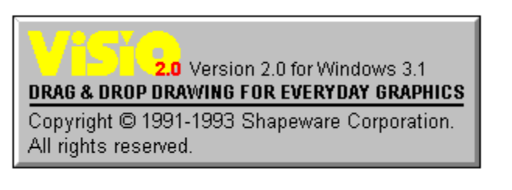

Shell Function

Shell ( app, show)

Runs an executable program.

The shell function has two parameters. The first one, app is the name of the program to be executed. The name of the program in app must include a .PIF, .COM, .BAT, or .EXE file extension or an error will occur. The second argument, show is the number corresponding to the style of the window . It is also optional and if omitted the program is opened minimized with focus.

Window styles:
Normal with focus 1,5,9
Minimized with focus (default) 2
Maximized with focus 3
normal without focus 4,8
minimized without focus 6,7

Return value: ID, the task ID of the started program.

Example:

' This example uses Shell to leave the current application and run the
' Calculator program included with Microsoft Windows; it then
' uses the SendKeys statement to send keystrokes add some numbers.

Sub Main ()
Dim I, X, Msg ' Declare variables.
X = Shell("Calc.exe", 1) ' Shell Calculator.
For I = 1 To 5 ' Set up counting loop.
SendKeys I & "{+}", True ' Send keystrokes to Calculator
Next I ' to add each value of I.

Msg = "Choose OK to close the Calculator."
MsgBox Msg ' Display OK prompt.
AppActivate "Calculator" ' Return focus to Calculator.
SendKeys "%{F4}", True ' Alt+F4 to close Calculator.
End Sub

Sin Function

Sin (rad)

Returns the sine of an angle that is expressed in radians

Example:

Sub Main ()
Calc = Shell (Calc.exe) ‘Start the Calculator
SendKeys “12345”,True ‘Send keystrokes to it
End Sub

Space Function

Space[$] (number )

Skips a specified number of spaces in a print# statement.

The parameter number can be any valid integer and determines the number of blank spaces.

Example:

' This sample shows the space function

Sub Main

MsgBox "Hello" & Space(20) & "There"

End Sub

Sqr Function

Sqr(num)

Returns the square root of a number.

The parameter num must be a valid number greater than or equal to zero.

Example:

Sub Form_Click ()
Dim Msg, Number ' Declare variables.
Msg = "Enter a non-negative number."
Number = InputBox(Msg) ' Get user input.
If Number < 0 Then
Msg = "Cannot determine the square root of a negative number."
Else
Msg = "The square root of " & Number & " is "
Msg = Msg & Sqr(Number) & "."
End If
MsgBox Msg ' Display results.

End Sub

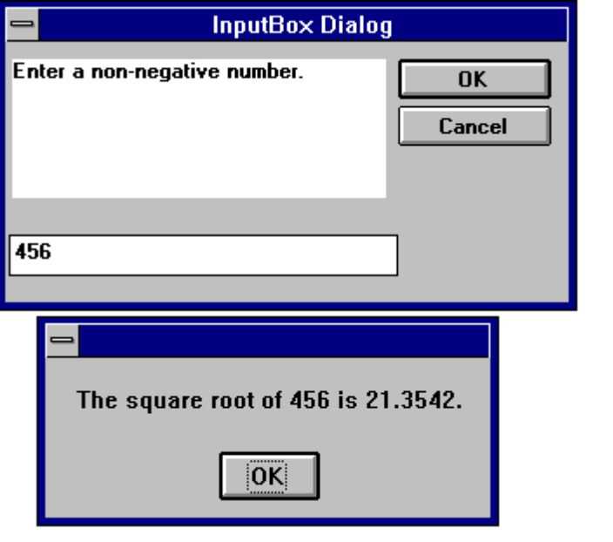

Static Statement

Static variable

Used to declare variables and allocate storage space. These variables will retain their value through the program run

Related Topics: Dim, Function, Sub

Example:

' This example shows how to use the static keyword to retain the value of
' the variable i in sub Joe. If Dim is used instead of Static then i
' is empty when printed on the second call as well as the first.

Sub Main
For i = 1 to 2
Joe 2
Next i
End Sub

Sub Joe( j as integer )
Static i
print i
i = i + 5
print i
End Sub

Stop Statement

Stop

Ends execution of the program

The Stop statement can be places anywhere in your code.

Example:

Sub main ()

Dim x,y,z

For x = 1 to 5
For y = 1 to 5
For z = 1 to 5
Print "Looping" ,z,y,x
Next z
Next y
Stop
Next x

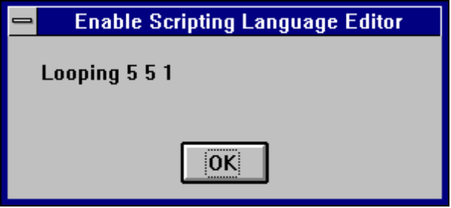

Str, Str$ Function

Str[$](numericexpr)

Returns the value of a numeric expression.

Str returns a Variant; Str$ returns a String.

Related topics: Format, Format$, Val

Example:

Sub main ()
Dim msg
a = -1
msgBox "Num = " & Str(a)
MsgBox "_Abs(Num) =" & Str(_Abs(a))

End Sub

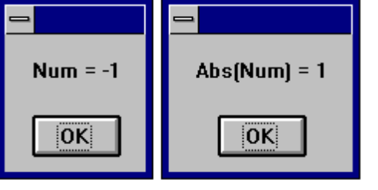

StrComp Function

StrComp( nstring1,string2, [compare] )

Returns a variant that is the result of the comparison of two strings

String, String$ Function

String[$]( numeric, charcode )
String[$]( numeric, string )

String returns a variant.
String$ returns a string.

String[$] is used to create a string that consists of one character repeated over and over.

Related topics: Space, Space Function$

Example:
(Not currently implemented)

Sub Statement

Sub SubName [(arguments)]
Dim [variable(s)]
[statementblock]
[Exit]
End Sub

Declares and defines a Sub procedures name, parameters and code.

Related Topics: Call, Dim, Function

Example:

Sub Main
Dim DST As String

DST = "t1"
mkdir DST
mkdir "t2"
End Sub

Tan Function

Tan(angle)

Returns the tangent of an angle as a double.

The parameter angle must a valid angle expressed in radians.

Related Topic: Atn, Cos, Sin

Example:
' This sample program is the example given for VB 3.0 Atn function

Sub Main ()
Dim Msg, Pi ' Declare variables.
Pi = 4 * Atn(1) ' Calculate Pi.
Msg = "Pi is equal to " & Pi
MsgBox Msg ' Display results.
x = Tan(Pi/4)
MsgBox x & " is the tangent of Pi/4"
End Sub

Text Statement

Text Starting X position, Starting Y position, Width, Height, Label

Creates a text field for titles and labels.

Example:

Sub Main ()
Begin Dialog DialogName1 60, 60, 160, 70, "ASC - Hello"
TEXT 10, 10, 28, 12, "Name:"
TEXTBOX 42, 10, 108, 12, .nameStr
TEXTBOX 42, 24, 108, 12, .descStr
CHECKBOX 42, 38, 48, 12, "&CHECKME", .checkInt
OKBUTTON 42, 54, 40, 12
End Dialog
Dim Dlg1 As DialogName1
Dialog Dlg1

MsgBox Dlg1.nameStr
MsgBox Dlg1.descStr
MsgBox Dlg1.checkInt
End Sub

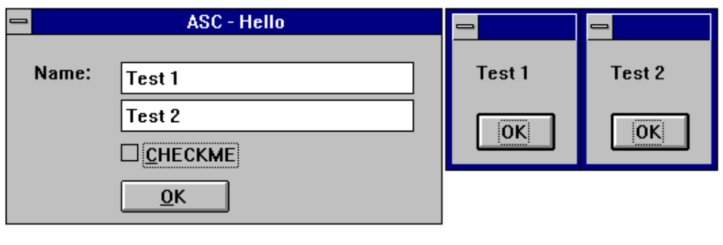

TextBox Statement

TextBox Starting X position, Starting Y position, Width, Height, Default String

Creates a Text Box for typing in numbers and text

Example:

Sub Main ()
Begin Dialog DialogName1 60, 60, 160, 70, "ASC - Hello"
TEXT 10, 10, 28, 12, "Name:"
TEXTBOX 42, 10, 108, 12, .nameStr
TEXTBOX 42, 24, 108, 12, .descStr
CHECKBOX 42, 38, 48, 12, "&CHECKME", .checkInt
OKBUTTON 42, 54, 40, 12
End Dialog
Dim Dlg1 As DialogName1
Dialog Dlg1

MsgBox Dlg1.nameStr
MsgBox Dlg1.descStr
MsgBox Dlg1.checkInt
End Sub

Time, Time$ Function

Time[$][()]

Returns the current system time.

Related topics: To set the time use the TIME$ statement.

Example:

' This example shows various uses of the Format function to format values
' using both named and user-defined formats. For the date separator (/),
' time separator (:), and AM/ PM literal, the actual formatted output
' displayed by your system depends on the locale settings on which the code
' is running. When times and dates are displayed in the development
' environment, the short time and short date formats of the code locale
' are used. When displayed by running code, the short time and short date
' formats of the system locale are used, which may differ from the code
' locale. For this example, English/United States is assumed.

' MyTime and MyDate are displayed in the development environment using
' current system short time and short date settings.

Sub Main

MyTime = "08:04:23 PM"
MyDate = "03/03/95"
MyDate = "January 27, 1993"

MsgBox Now
MsgBox MyTime

MsgBox Second( MyTime ) & " Seconds"
MsgBox Minute( MyTime ) & " Minutes"
MsgBox Hour( MyTime ) & " Hours"

MsgBox Day( MyDate ) & " Days"
MsgBox Month( MyDate ) & " Months"
MsgBox Year( MyDate ) & " Years"

' Returns current system time in the system-defined long time format.
MsgBox Format(Time, "Short Time")
MyStr = Format(Time, "Long Time")

' Returns current system date in the system-defined long date format.
MsgBox Format(Date, "Short Date")
MsgBox Format(Date, "Long Date")

' This section not yet supported
'MyStr = Format(MyTime, "h:m:s") ' Returns "17:4:23".
'MyStr = Format(MyTime, "hh:mm:ss AMPM")' Returns "05:04:23 PM".
'MyStr = Format(MyDate, "dddd, mmm d yyyy")' Returns "Wednesday, Jan 27 1993".

' If format is not supplied, a string is returned.
MsgBox Format(23) ' Returns "23".

' User-defined formats.
MsgBox Format(5459.4, "##,##0.00") ' Returns "5,459.40".
MsgBox Format(334.9, "###0.00") ' Returns "334.90".
MsgBox Format(5, "0.00%") ' Returns "500.00%".
MsgBox Format("HELLO", "<") ' Returns "hello".
MsgBox Format("This is it", ">") ' Returns "THIS IS IT".

End Sub

TimeSerial - Function

TimeSerial ( hour, minute, second )

Returns the time serial for the supplied parameters hour, minute, second.
ElapseTime = TimeSerial(“23:59:59”)

Related topics: DateSerial, DateValue, Hour Minute, Now, Second TimeValue.

Example:
(Not currently implemented)

TimeValue - Function

TimeValue ( TimeString )

Returns a double precision serial number based of the supplied string parameter.
Midnight = TimeValue(“23:59:59”)

Related topics: DateSerial, DateValue, Hour Minute, Now, Second TimeSerial.

Example:
(Not currently implemented)

Trim, Trim$,LTrim, LTrim$, RTrim, Rtrim$ Functions

[L| R] Trim[$](String )

Ltrim$, Rtrim$ and Trim$ all Return a copy of a string with leading, trailing or both leading and trailing spaces removed.

Ltrim, Rtrim and Trim all return a variant

Ltrim removes leading spaces.
Rtrim removes trailing spaces.
Trim removes leading and trailing spaces.

Example:

' This example uses the LTrim and RTrim functions to strip leading and
' trailing spaces, respectively, from a string variable. It
' uses the Trim function alone to strip both types of spaces.
' LCase and UCase are also shown in this example as well as the use
' of nested function calls

Sub Main
MyString = " <-Trim-> " ' Initialize string.
TrimString = LTrim(MyString) ' TrimString = "<-Trim-> ".
MsgBox "|" & TrimString & "|"
TrimString = LCase(RTrim(MyString)) ' TrimString = " <-trim->".
MsgBox "|" & TrimString & "|"
TrimString = LTrim(RTrim(MyString)) ' TrimString = "<-Trim->".
MsgBox "|" & TrimString & "|"
' Using the Trim function alone achieves the same result.
TrimString = UCase(Trim(MyString)) ' TrimString = "<-TRIM->".
MsgBox "|" & TrimString & "|"
End Sub

Type Statement

Type usertype elementname [(subscripts)] As typename
[ elementname [(subscripts)] As typename]
. . .
End Type

Defines a user-defined data type containing one or more elements.

The Type statement has these parts:

Part Description
Type Marks the beginning of a user-defined type.
usertype Name of a user-defined data type. It follows standard variable naming conventions.
elementname Name of an element of the user-defined data type. It follows standard variable-naming conventions.
subscripts Dimensions of an array element. You can declare multiple dimensions. The syntax of subscripts is described below.
typename One of these data types: Integer, Long, Single, Double, String (for variable-length strings), String * length (for fixed-length strings), Variant, or another user-defined type. The argument typename can't be an object type. End Type Marks the end of a user-defined type.

The argument subscripts has the following syntax:
[lower To ]upper[,[lower To] upper] . . .

The To reserved word provides a way to indicate both the lower and upper bounds of an array variable's subscripts. Array subscripts can be negative. To can be used to specify any range of subscripts between -32,768 and 32,767, inclusive. The maximum number of array dimension is 60. The Type statement can be used only in the Declarations section of a module. Once you have declared a user-defined type using the Type statement, you can declare a variable of that type anywhere in your application. Use Dim, Global, ReDim, or Static to declare a variable of a user-defined type. Line numbers and line labels aren't allowed in Type...End Type blocks.

User-defined types are often used with data records because data records frequently consist of a number of related elements of different data types. The following example shows the use of static arrays in a user-defined type:

Example:

' This sample shows some of the features of user defined types

Type type1
a As Integer
d As Double
s As String
End Type

Type type2
a As String
o As type1
End Type

Type type3
b As Integer
c As type2
End Type

Dim type2a As type2
Dim type2b As type2
Dim type1a As type1
Dim type3a as type3

Sub Form_Click ()
a = 5
type1a.a = 7472
type1a.d = 23.1415
type1a.s = "YES"
type2a.a = "43 - forty three"
type2a.o.s = "Yaba Daba Doo"
type3a.c.o.s = "COS"
type2b.a = "943 - nine hundred and forty three"
type2b.o.s = "Yogi"
MsgBox type1a.a
MsgBox type1a.d
MsgBox type1a.s
MsgBox type2a.a
MsgBox type2a.o.s
MsgBox type2b.a
MsgBox type2b.o.s
MsgBox type3a.c.o.s
MsgBox a
End Sub

UBound Function

Ubound(arrayname[,dimension%])

Returns the value of the largest usable subscript for the specified dimension of an array.

Related Topics: Dim, Global, Lbound, and Option Base

Example:

' This example demonstrates some of the features of arrays. The lower bound
' for an array is 0 unless it is specified or option base has set it as is
' done in this example.

Option Base 1

Sub Main
Dim a(10) As Double
MsgBox "LBound: " & LBound(a) & " UBound: " & UBound(a)
Dim i As Integer
For i = 0 to 3
a(i) = 2 + i * 3.1
Next i
' Erase( a ) ' If this line is uncommented then the values will all be 0
Print a(0),a(1),a(2), a(3)
End Sub

UCase, UCase$ Function

Ucase[$] (String )

Returns a copy of String is which all lowercase characters have been converted to uppercase.

Related Topics: Lcase, Lcase$ Function

Example:

' This example uses the LTrim and RTrim functions to strip leading and
' trailing spaces, respectively, from a string variable. It
' uses the Trim function alone to strip both types of spaces.
' LCase and UCase are also shown in this example as well as the use
' of nested function calls

Sub Main
MyString = " <-Trim-> " ' Initialize string.
TrimString = LTrim(MyString) ' TrimString = "<-Trim-> ".
MsgBox "|" & TrimString & "|"
TrimString = LCase(RTrim(MyString)) ' TrimString = " <-trim->".
MsgBox "|" & TrimString & "|"
TrimString = LTrim(RTrim(MyString)) ' TrimString = "<-Trim->".
MsgBox "|" & TrimString & "|"
' Using the Trim function alone achieves the same result.
TrimString = UCase(Trim(MyString)) ' TrimString = "<-TRIM->".
MsgBox "|" & TrimString & "|"
End Sub

Val

Val(string)

Returns the numeric value of a string of characters.

Example:

Sub main
Dim Msg
Dim YourVal As Double
YourVal = Val(InputBox$("Enter a number"))
Msg = "The number you enered is: " & YourVal
MsgBox Msg
End Sub

VarType

VarType(varname)

Returns a value that indicates how the parameter varname is stored internally.

The parameter varname is a variant data type.

VarType return values:
Empty 0
Null 1
Integer 2
Long 3
Single 4
Double 5
Currency 6 (not available at this time)
Date/Time 7
String 8

Related Topics: IsNull, IsNumeric

Example:

If VarType(x) = 5 Then Print "Vartype is Double" 'Display variable type

While...Wend Statement

While condition
.
.
.
[StatementBlock]
.
.
.
Wend

While begins the while...Wend flow of control structure. Condition is any numeric or expression that evaluates to tru or false. The condition is true the statments are executed. The statements can be any number of valid Enable Basic statments. Wend ends the While...Wend flow of control structure.

Related Topics: Do...Loop Statement

Example:

Sub Main
Const Max = 5
Dim Exchange, I, Msg
Static A(Max)
NL = Chr(13) & Chr(10)
A(1) = "Programmer"
A(2) = "Engineer"
A(3) = "President"
A(4) = "Tech Support"
A(5) = "Sales"
Exchange = True

While Exchange
Exchange = False
For I = 2 To Max
If A(I - 1) > A(I) Then
Exchange = True
Temp = A(I): A(I - 1): A(I - 1) = Temp
End If
Next I
Wend

Msg = Sorted order: " & NL & NL
For I = 1 To Max
Msg = Msg & A(I) & NL
MsgBox Msg

End Sub

Write # - Statement

Write #filenumber [,parameterlist ]

Writes and formats data to a sequential file that must be opened in output or append mode.

A comma delimited list of the supplied parameters is written to the indicated file. If no paramters are present, the newline character is all that will be written to the file.

Related Topics: Open and Print# Statements

Example:

Sub main
Dim name
Dim age
Open “NewFile” for Output As 1
name = “Bill Gates”
age = 37
Write #1 name, age
Close #1
MsgBox Msg
Kill “NewFile”
End Sub

Year Function

Year(serial# )

Returns an integer representing a year between 100 and 9999, inclusive. The returned integer represents the year of the serial parameter.

The parameter serial# is a number.

If serial is a Null, this function returns a Null.

The parameter serial is any number that can represent a date from January 1, 100 through December 31, 9999.

Related Topics: Date, Date$ Function/Statement, Day, Hour, Month, Minute, Now, Second and Weekday functions

Example:

ThisYear = Year(Now)

Index
A
Abs Function, 39
Accessing an object, 26
CreateObject Function, 26
GetObject Function, 26
Action, 32
Activate, 26
AppActivate Statement, 40
Application, 26
Arrays, 15
Asc Function, 40
Atn Function, 41
B
Beep Statement, 41
C
Call Statement, 42
Case, UCase$ Function, 116
CDbl Function, 43
ChDir, 35, 37, 43
ChDrive, 35
CheckBox, 44
Chr, Chr$ Function, 45
Cint Function, 46
Class, 28
Clng Function, 46
Close Statement, 46
Command, 32
Const Statement, 47
Control Structures, 5, 9
Cos, 48
CreateObject, 48
Csng Function, 50
CStr Function, 50
CurDir$ Function, 50
CVar Function, 50
Cypress Enable Scripting Language Elements, 5
D
Date Function, 51
Declare Statement, 52
Dim Statement, 54
Dir$ Function, 53, 55, 56, 57
Do...Loop Statement, 57
E
End Statement, 58
Eof, 59
Erase, 59
Exp, 35, 59, 60
F
File Input/Output, 14
File Type, 32
FileCopy, 35, 61
FileLen Function, 61
Fix Function, 61
For...Next Statement, 61
Format Statement, 62
Function Statement, 72
G
Global Statement, 73
GoSub...Return Statement, 73
GoTo Statement, 74
H
Hex, Hex$, 74
Hour Function, 75
I
Identifier, 32
If...Then...Else Statement, 10, 76
Input, Input$ Function, 77
InputBox, InputBox$, 78
Installation, 117
InStr, 78
Int Function, 79
IsDate, 79
K
Kill Statement, 81
L
LBound Function, 82
LCase, LCase$ Function, 82
Left, Left$, 83
Let Statement, 84
Line Input # Statement, 84
Log, 85
LTrim, LTrim$ Function, 113
M
Methods, 26
Mid Function, 85
Minute Funtion, 86
MkDir, 87
Month Function, 88
MsgBox, 88
N
Name Statement, 91
Now Function, 92
O
Oct, 92
OKButton, 93
OLE Automation, 25, 28, 29, 31
What is OLE Automation?, 25, 29, 31
OLE Fundamentals, 28
OLE Object, 28
On Error, 93
Open Statement, 94
Option Base Statement, 96
Other Data Types, 8
Declaration of Variables, 8
Scope of Varibles, 8
P
Print # Statement, 97
Print Method, 99
Properties, 26
R
Rem Statement, 99
Right, Right$ Function, 100
RmDir Statement, 100
Rnd, 101
S
Second Function, 101
Seek Function, 103
SendKeys, 104
Set Statement, 104
Shell, 31, 105
Sin, 106
Spc, 106
Sqr, 106
Stop, 107, 108
Str, Str$, 108
StrComp Function, 109
String, String$ Function, 109
Sub Statement, 110
Subroutines and Functions, 11
Naming conventions, 11
T
Text, 110
TextBox, 111
The Regedit program, 32
Time, Time$ Function, 112
TimeSerial - Function, 113
TimeValue - Function, 113
Trim, Trim$ Function, 113
Type Statement, 114
U
UBound Function, 116
User Defined Types, 17, 115
V
Val, 117
Variable and Constant Names, 6
Variable Types, 6
Variants and Concatenation, 6
Varialbe Types
Variant, 6
VarType, Error! Not a valid bookmark in entry on page 117
W
What is an OLE Object?, 26
While...Wend Statement, 118
Write # - Statement, 119
Y
Year, 119

