figcAuthor  Hongkai Xiao | Department | Signature (if not signed electronically) | Signature Date
Title
Instructions to setup smoke test environment

Reviewed (if not signed electronically) | Department | Signature (if not signed electronically) | Signature Date
<Full name>

Approved (if not signed electronically) | Department | Signature (if not signed electronically) | Signature Date
<Full name>

Contents
1. SUMMARY 3
2. Introduction 3
2.1. Purpose 3
2.2. Scope 3
2.3. Terminology 3
2.4. References 3
2.5. Revision History 3
3. Prerequisites 3
3.1 Test workstation machine requisites: 3
4. Install and configure FTP SERVER 3
4.1. Install and configure steps 3
5. Install and configure NFS Server 4
5.1. Install and configure steps 4
6. deploy auto SMOKE test scripts 5
6.1. Deploy auto smoke test scripts steps 5
7. install python/pytest 8
7.1. Install steps 8

SUMMARY
This document describes, step-by-step, how to put up PSS smoke test environment.

Introduction

Purpose
The purpose of this document is to be used as a step-by-step guide to put up PSS smoke test.

Scope
This setups to be used in PSS

Terminology
Term | Meaning

References
Document Id | Document Title

Revision History
Edition | Date | Author | Description

Prerequisites

3.1 Test workstation machine requisites:
- Pre-installed Windows 10
- Dual network adapters, one is connected to MOXA host, the IP address is 192.168.30.2, the other is connected to corporate Intranet, the IP address is 10.134.114.28

Install and configure FTP SERVER

Install and configure steps
- Download FTP Server software (FileZilla_Server_1.6.1_win64-setup.exe) from https://dl1.cdn.filezilla-project.org/server/FileZilla_Server_1.8.0_win64-setup.exe?h=PwT_JBKKd5weaVPmJX4idA&x=1702958569 .
- Copy “FileZilla_Server_1.8.0_win64-setup.exe” to test workstation and install it.
- Double click “Administer FileZilla Server”, then select Server->Configure…
Add “pps” user and input “Virtual path” and “Native path” as below capture.
- Press ok to save the Configure and close “Administer FileZilla Server” software.
- Double click “Start FileZilla Server” to start FTP server.

Install and configure NFS Server

Install and configure steps
- Download NFS Server software (nfs1266.zip) from https://r.hanewin.net/nfs1266.zip .
- Copy nfs1266.zip to test workstation and unzip it.
- Double click “nfssrv-64.exe”, then select Edit->References->Exports

- Click “Edit exports file” to edit exports file. Add “D:\LynxOS_VM\pps -name:PPS -range 192.168.30.2 192.168.30.11” to the last line of the file and save it.

deploy auto SMOKE test scripts

Deploy auto smoke test scripts steps
- Using svn client such as TortoiseSVN to download PPS_Controller\pysrc from http://gbcsvalm01.int.elekta.com:49158/svn/6D_PPS/PPS_Controller/trunk/pysrc.
- Copy \pysrc to test workstation D:\table
- Create a task in Windows Task Scheduler, parameters set as below
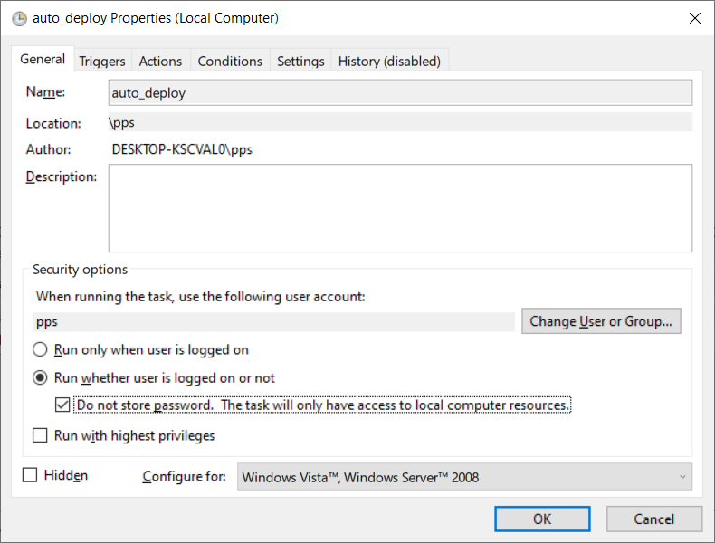

Note:
If paths of FTP server, NFS server and pysrc are different with this document, need to change the corresponding PATH in pipeline.py file.
FTP_PATH = "D:/table/tmp"
NFS_PATH = "D:/LynxOS_VM/pps"

SERVICE_UI_TEST_PATH = "D:/table/pysrc/service_ui_test"
SERVICE_IF_TEST_PATH = "D:/table/pysrc/track_test"
PIPELINE_PATH = "D:/table/pysrc/"

install python/pytest

Install steps
Refer to InstallPytestEnv.txt which is under pysrc directory.

