06. UI/UX Design
DAK (Discover Adelaide Korea) — MVP

1. Purpose
This document defines the information architecture and screen-level UI/UX design for the DAK platform. It translates the product scope defined in 02 Product Vision & Roadmap and 03 MVP Feature Specification, and the data/API structure defined in 04 Database Design and 05 API Specification, into a concrete site structure and screen designs.

2. Information Architecture (Site Map)
The site map is organised into three access levels: a Guest Area available without authentication, a Public Engagement area (community and news content, still browsable by guests), and an Authenticated Area available only after login.

2.1 Guest Area

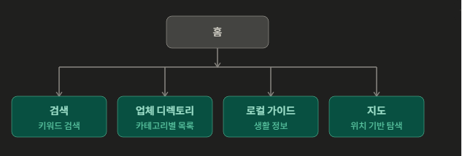

The guest area is the primary entry point for new users, aligned with the "Explore Information" step of the Primary User Journey in 02 Product Vision & Roadmap. No account is required.
- Home: Landing page and guest entry point
- Search: Keyword-based search across all content types
- Business Directory: Category-based business listings and detail pages
Local Guides is deferred to Phase 2 (see 4.5). Note: 03 MVP Feature Specification currently lists Local Guides under Local Discovery / Must Have (MVP) — this should be moved to a later phase to reconcile with this decision.
Browsable by guests, but posting and interaction require authentication.
- Community: Discussion boards and posts
- Australia Updates: News and official announcements

2.3 Authenticated Area

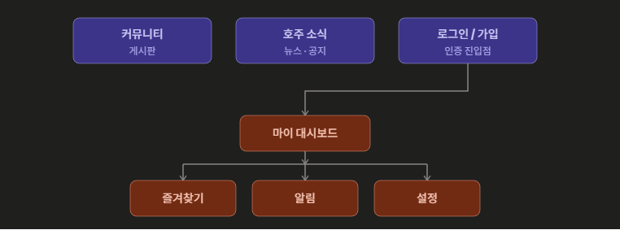
Available after Login / Sign-up. Corresponds to the "Engage" step of the Primary User Journey, covering favourite businesses, saved guides, notifications and the personal dashboard.
- Login / Sign-up: Authentication entry point
- My Dashboard: Personal home after login
  - Favourites: Saved businesses and guides
  - Notifications: Basic notification centre
  - Settings: Account and profile settings

3. Responsive Strategy
Per 01 Brand Identity, the platform is mobile-first. A single HTML/CSS (or component) codebase is used for all screen sizes; there is no separate desktop build. Layout changes are handled with CSS media queries, written mobile-first (base styles target mobile, larger breakpoints override via min-width).
- Below 768px (mobile): bottom tab bar navigation (Home, Search, Directory, AU Updates, My page), single-column content
- 768px and above (tablet / desktop): left sidebar navigation (Notion-style), multi-column card grids
Both navigation patterns exist in the same markup; CSS shows or hides the appropriate one per breakpoint. This avoids maintaining parallel desktop and mobile codebases.

4. Screen Designs

4.1 Home

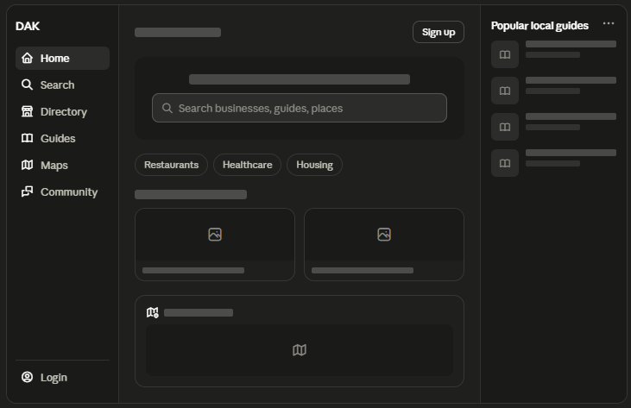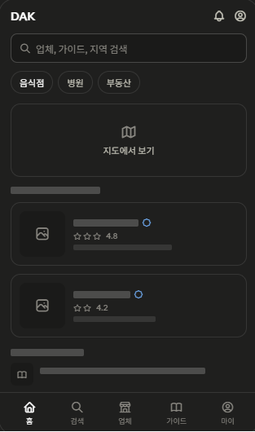

Guest entry point. Search-first layout per 01 Brand Identity.
- Top bar: logo, notifications, account entry point
- Primary search bar (businesses, guides, places)
- Category quick-filter chips (e.g. Restaurants, Healthcare, Housing)
- Business directory highlights: cards with trust badge (verified) and star rating
- Latest Australia Updates module (AI-assisted import, admin-approved before publish per 05 API Specification)
- Mobile: bottom tab bar. Desktop/tablet: left sidebar navigation

4.2 Search Results

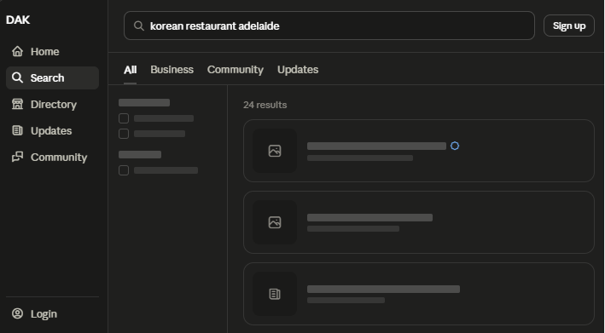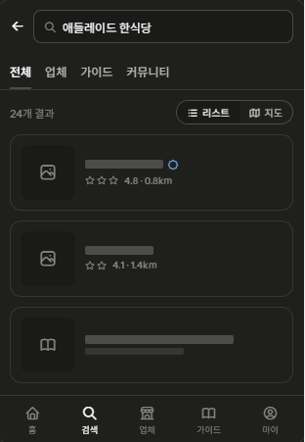
Reached from the Home search bar. High-priority screen per the Primary User Journey (Explore Information step).
- Persistent search bar retaining the query
- Result type tabs: All / Business / Community / AU Updates, aligned with 05 API Specification resource types
- Filters (category, location)
- Result cards with trust badge and distance

4.3 Directory Listing

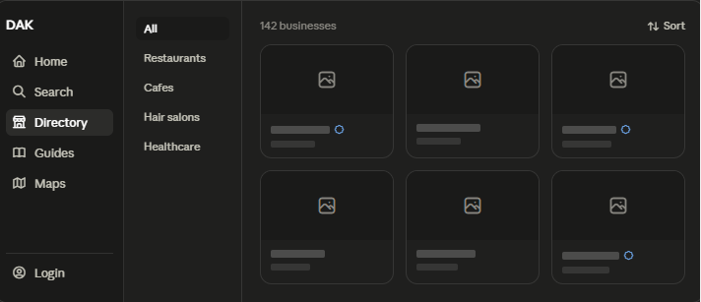

Reached by selecting Directory from navigation. Shows category browsing before the business detail.
- Category filter: horizontal scrollable chips on mobile, a category sub-list panel on desktop
- Result count and sort control
- Grid of business cards: image, name, verified badge (where applicable), category
- Card tap/click opens Business Directory Detail

4.4 Business Directory Detail

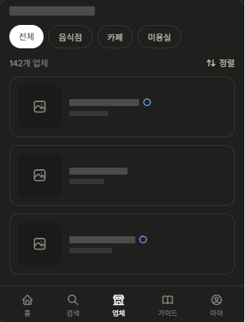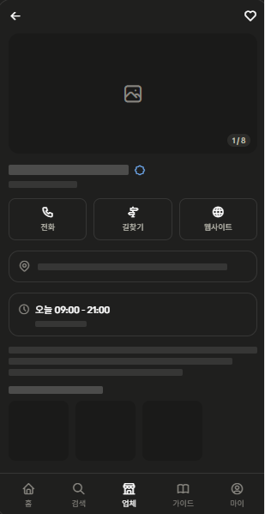
Reached from a business card in Search Results or Directory Listing. Fields map to the business entity in 04 Database Design. Star ratings/reviews are intentionally excluded here — per 03 MVP Feature Specification, business reviews and ratings are a Phase 2 feature; only the verified badge is shown in MVP.
- Photo gallery (hero image + thumbnails)
- Business name, category, verified badge
- Quick actions: call, directions, website
- Address text, with a Directions button linking out to the user's default maps app
- Opening hours, highlighting today
- Description
- Save / favourite action (requires login)

4.5 Local Guides (deferred to Phase 2)

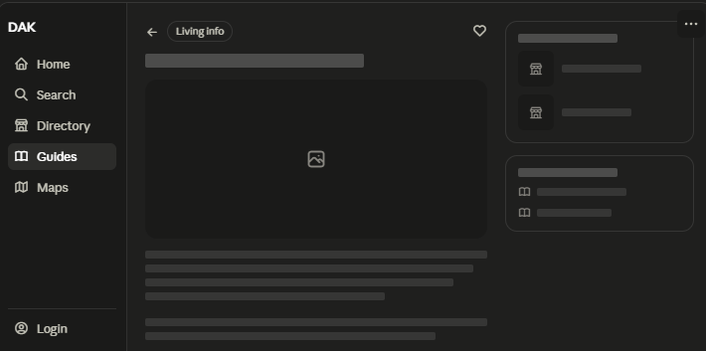
Local Guides browsing and detail screens are deferred to Phase 2. On the Home screen, the module that would have shown Popular Local Guides is replaced by Latest Australia Updates (see 4.1), since the AI-assisted import + admin-approval workflow is being built for Australia Updates first. The same workflow can be extended to Local Guides once validated. This decision narrows the "Local guides" item listed under Must Have (MVP) in 03 MVP Feature Specification — that document should be reconciled with this decision.

4.6 Maps (deferred to Phase 2)
A dedicated map-exploration screen (full-screen map, pins, search-this-area) was considered but is deferred to Phase 2. Rationale: map SDK integration cost is significant for MVP, and a curated, verified-only spatial browsing view is not essential when the core value (search and directory) does not depend on it. For MVP, location needs are covered by a Directions button on the Business Directory Detail screen (4.4), which opens the user's default maps app. Note: this narrows the "Interactive maps" item listed under Phase 1 in 02 Product Vision & Roadmap and 03 MVP Feature Specification — those documents should be reconciled with this decision.

4.7 Australia Updates List
Replaces the Local Guides module on Home. Reached from navigation or the Home Latest Australia Updates module.
Navigation label note: use "AU Updates" (not a generic "Updates") in the sidebar/tab bar/search tabs, so it's clear this is Australia-related news and official information, not generic app notifications.
- Category filter: horizontal scrollable chips on mobile, a category sub-list panel on desktop, per categories defined in 04 Database Design (12.5)
- Update cards: category tag, geographic scope tag, title, summary preview, AI summary indicator, published date
- Sort control (default: newest)
- Card tap/click opens Australia Update Detail

4.8 Australia Update Detail

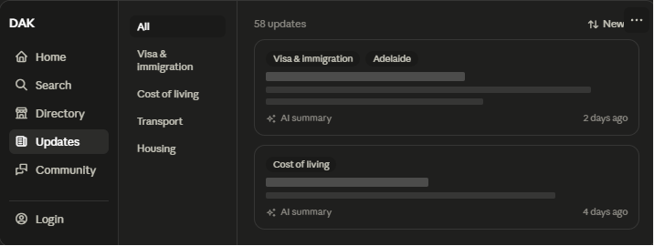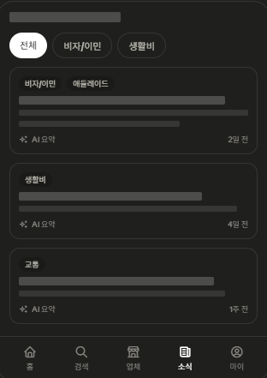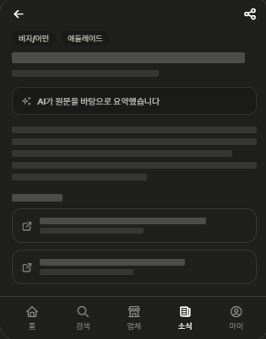

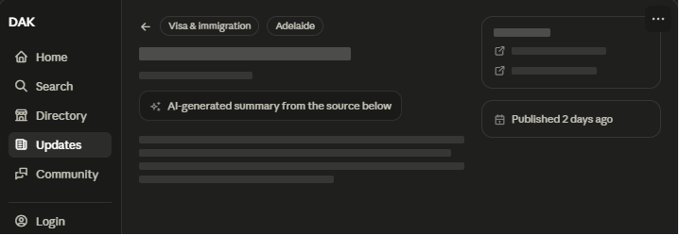

Reflects the AI-import + admin-approval workflow in 05 API Specification (10.5) and the validation rules in 04 Database Design (12.5). Source disclosure is mandatory, not optional, per those documents.
- Category and geographic scope tags, title, published date
- AI summary disclosure notice (per 03 MVP AI constraints: AI-generated content must be clearly identified)
- Korean summary body
- Source list: at least one source is required before publication; each links out to the original material
- Share action

4.9 Community List

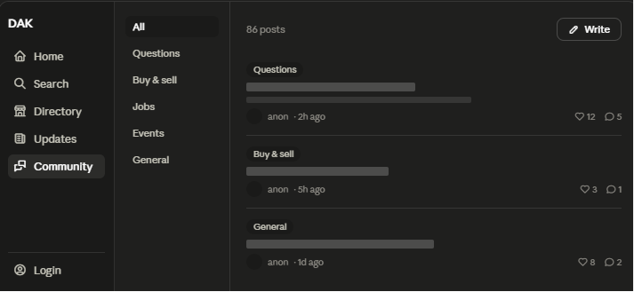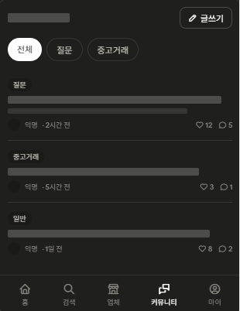
Public Engagement area. Browsable by guests; posting, commenting and reactions require login, per 05 API Specification (7. Community API).
- Category filter: horizontal scrollable chips on mobile, a category sub-list panel on desktop (same pattern as Directory Listing, 4.3)
- Write button (prompts login if not authenticated)
- Post list: category tag, title, author (may be anonymous), timestamp, like count, comment count
- Post tap/click opens Community Post Detail

4.10 Community Post Detail

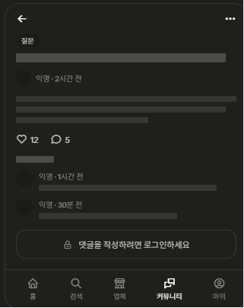
Reached from the Community List. Comments and reactions are read-only for guests.
- Category tag, title, author and timestamp
- Post body
- Like and comment count
- Comment list (author, timestamp, content)
- Comment input, replaced with a sign-in prompt for guests

4.11 Login / Sign-up

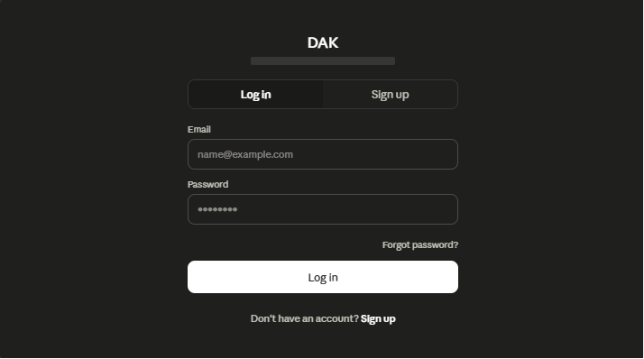

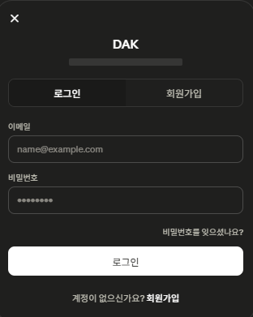
Email and password authentication only for MVP, per 03 MVP Feature Specification (social login providers are listed under Future Enhancements, not MVP).
- Tab toggle between Log in and Sign up within a single screen
- Log in: email, password, forgot-password link
- Sign up: email, password, display name
- Field-level validation errors (e.g. duplicate email, invalid credentials)

4.12 My Dashboard

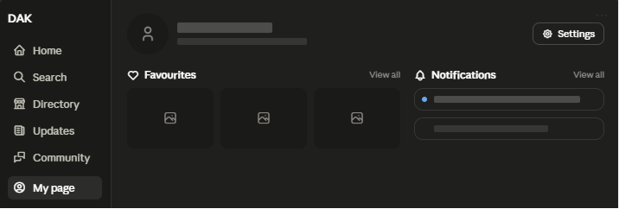

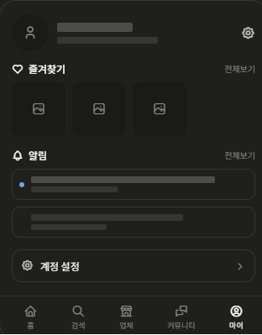
Personal home after login. Corresponds to the Engage step of the Primary User Journey.
- Profile summary (avatar, display name, email) with a settings entry point
- Favourites preview (grid on desktop, horizontal scroll on mobile) with a link to the full list
- Notifications preview (unread indicator) with a link to the full list
- Settings entry point (account and profile settings)

4.13 Favourites / Notifications / Settings

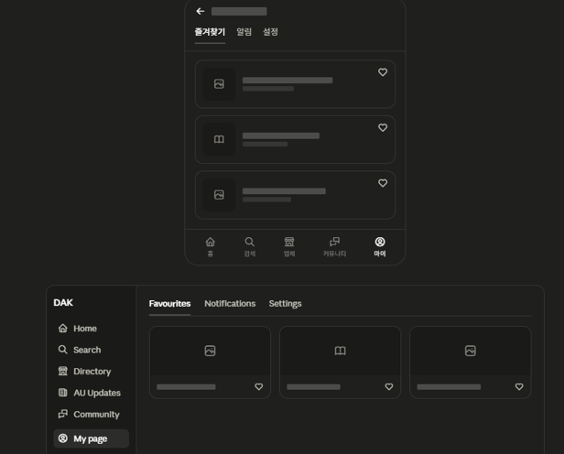
A single screen with a tab switcher (Favourites, Notifications, Settings), opened from the corresponding link on My Dashboard with the relevant tab pre-selected.
- Favourites tab: grid (desktop) or list (mobile) of saved businesses and guides, each removable
- Notifications tab: list of notifications with read/unread state
- Settings tab: account fields (display name, email, password), per 03 MVP Account Management requirements

6. Shared Component System
Reusable components extracted from the screens in section 4, aligned with 01 Brand Identity (card-based layouts, rounded corners, minimal colour). Each should be built once and reused across screens rather than redrawn per screen.

6.1 Navigation
- Left sidebar (≥768px): logo, primary nav items with icon + label, login/account entry point pinned to the bottom
- Bottom tab bar (<768px): Home, Search, Directory, AU Updates, My page — 5 items max
- Category sub-list panel: used inside Directory Listing, Community List and AU Updates List for category filtering on desktop

6.2 Cards
- Business card: image, name, verified badge (rosette icon, shown only when verified), category, optional distance. No star rating in MVP (see 4.4).
- Community post card: category tag, title, author (may be anonymous), timestamp, like count, comment count
- AU Update card: category tag, geographic scope tag, title, summary preview, AI summary indicator, published date

6.3 Badges and indicators
- Verified badge: rosette icon, accent colour — signals a business or piece of information has passed platform verification
- AI summary indicator: sparkles icon, muted colour, always paired with a short disclosure label — required wherever AI-generated content is shown, per 03 MVP AI constraints
- Unread indicator: small filled dot — used in Notifications

6.4 Buttons, chips and inputs
- Primary button: solid fill, used once per screen for the main action (e.g. Log in, Sign up)
- Secondary button: outline style, used for quick actions (Call, Directions, Website, Write)
- Category chip: pill-shaped, horizontal scroll on mobile, active state filled
- Search bar: consistent placement and style across Home, Search Results, and list screens
- Tab switcher: used for result-type tabs, Login/Sign-up toggle, and Favourites/Notifications/Settings

7. Key User Flows

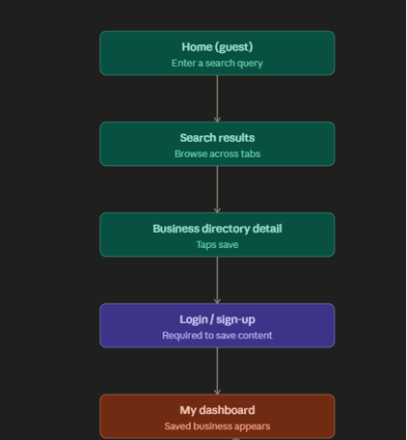

The primary conversion flow, from guest discovery to registration, following the Primary User Journey in 02 Product Vision & Roadmap.
- 1. Home (guest): user enters a search query in the primary search bar
- 2. Search Results: user browses results across Business / Community / AU Updates tabs
- 3. Business Directory Detail: user views full information and considers saving it
- 4. Save action prompts Login / Sign-up (guest cannot save without an account)
- 5. Sign-up: user registers with email, password and display name
- 6. My Dashboard: the saved business now appears under Favourites

8. Next Steps
The following sections of this document will be developed next:
- Reconcile 03 MVP Feature Specification: move Local Guides out of Must Have; promote Australia Updates AI import to Must Have
- Visual/high-fidelity design pass (colour, typography, imagery) once 01 Brand Identity visual assets are finalised
- Secondary user flows (e.g. business claim/verification request, content report, password reset)

