Reformulated
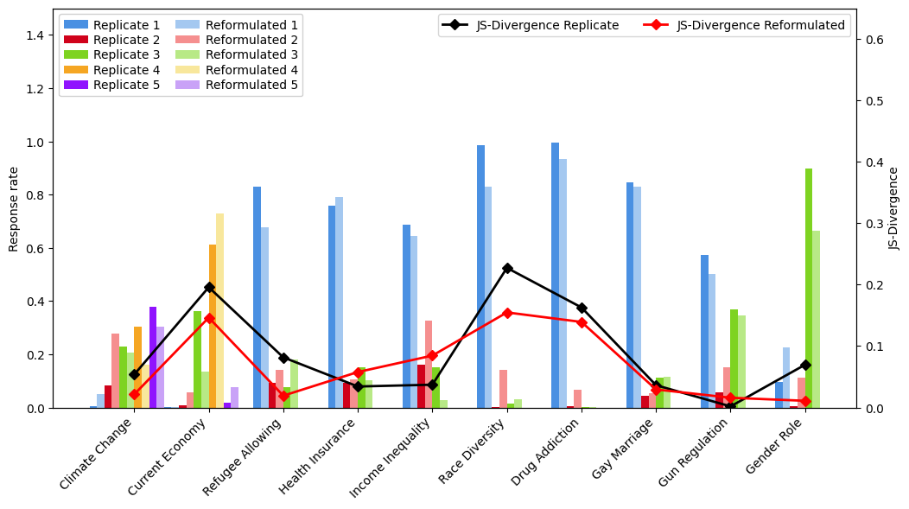

- Even in questions where JSD is higher compared to the Replicate condition, results are more diverse – except for Health Insurance, which is a relatively less sensitive topic – more of an economic stance than cultural.
- In Income Inequality, even though results are less representative, they are more diverse – with a lot more ‘Oppose’ answers.
- Importantly, the most sensitive topics like Refugee Allowing, Race Diversity, Gender Role, Climate Change see significantly more diverse responses – that are also more representative of the human population.
- Also noteworthy is that responses flow from the socially acceptable option not only or even mainly into the neutral option, but into the less socially acceptable one (e.g. Race Diversity, Drug Addiction, Income Inequality)
- Idea for visualization: to highlight the more socially sensitive topics

Priming
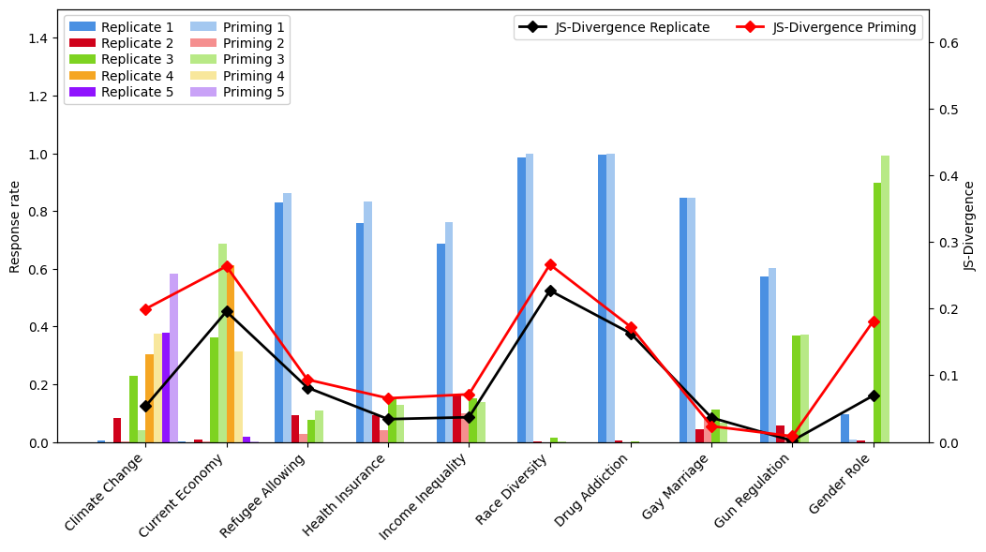
- Most questions have more uniform responses under this condition, including Refugee Allowing, Race Diversity and Gender Role.
- Climate Change responses also shifted into the more socially accepted category.
- In Race Diversity, the difference isn’t very big potentially because the baseline was already very uniform without much room to change.
- In Refugee Allowing, we also see that some of the ‘Oppose’ responses went into the neutral option

Preamble
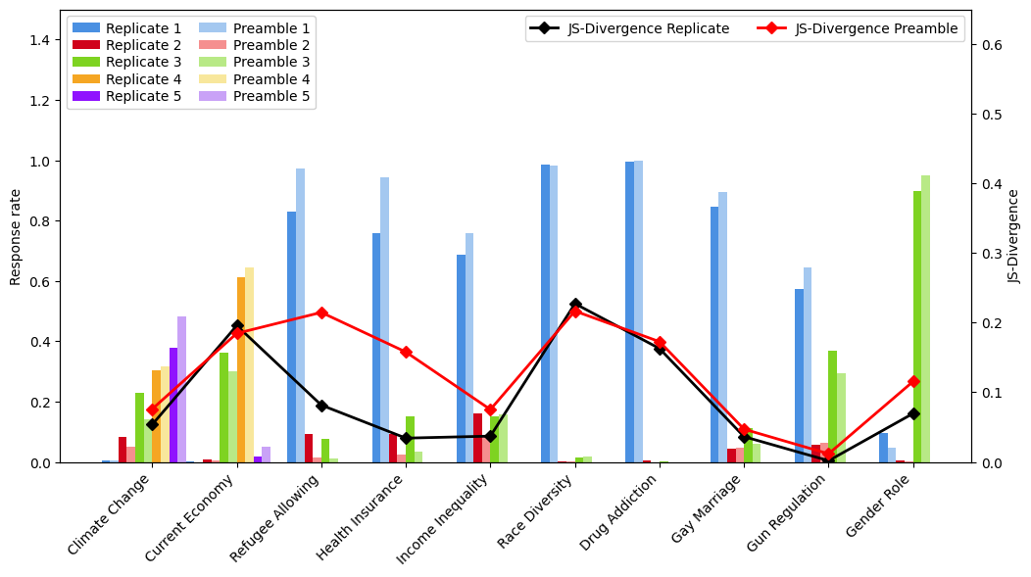
- Similar pattern to priming, although slightly different distribution per question.
- Overall, less diversity across the board and on sensitive questions like Refugee Allowing, Gender Role, Climate Change.

Stratified Replicate
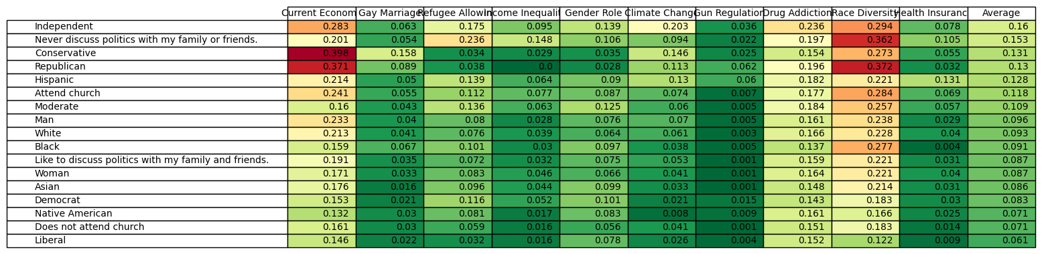

Stratified Reformulated
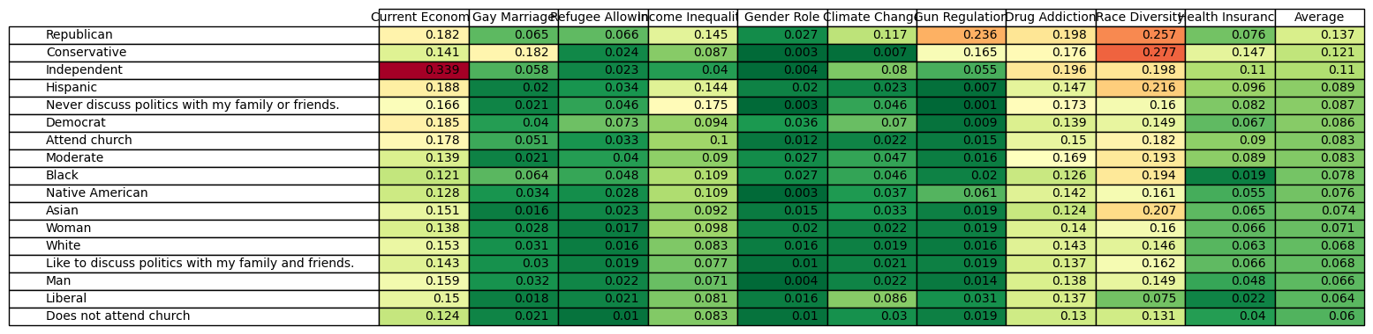

Stratified Reformulated vs. Replicate
