Simple Boiler
Version 1 / 14-01-2016

Table of Contents

Simple Boiler 1
1. Introduction 2
2. The Three Domains 3
3. Events 4
4. Factories 6
5. Delivery Domain 7
6. Regulator Domain 9
7. Parameter Visitors 10
8. Control Domain 11
9. Conclusion 12
10. Used Patterns 13

Introduction
The purpose of the boiler application is to regulate the temperature of the water in a boiler.
The boiler hardware consists of a tank with water, a temperature sensor, a heating element and a cooling element.
Of course this can be solved easily without any objects and design patterns. See the SimpleBoiler application. The problem with this solution is that if something changes, e.g. the algorithm or the hardware, we have to rewrite most of our code.
The purpose of our solution is to enable changes in algorithms, hardware (sensors and actuators) and operating system environments without major impacts in our code. To achieve this we used object oriented programming techniques and design patterns.

The Three Domains
First we divided the problem is three domains namely the Delivery, Regulator and Control domains. See Figure 1.
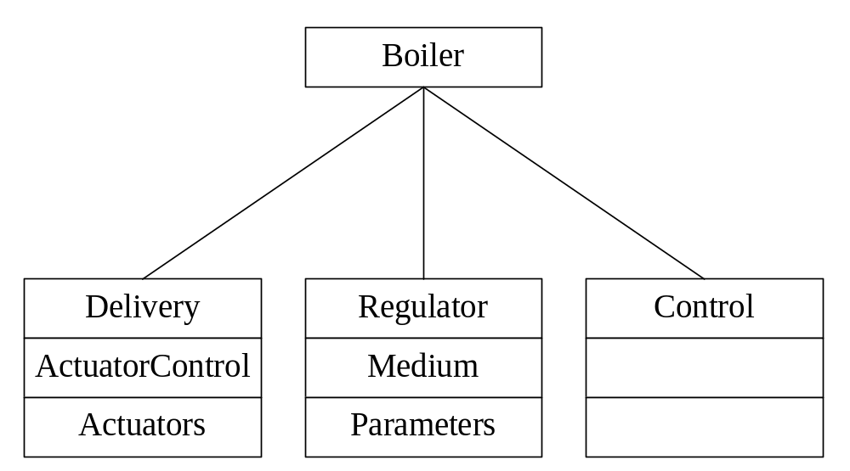
Figure 1: The Three Domains
The Delivery Domain encapsulates the resources of the system such as the actuators. The Regulator Domain encapsulates the logic of the system and the parameters to regulate. The Control Domain takes care of the interaction between the system and the user.

Figure 2 shows the three domains as a UML class diagram. The Boiler is composed of the three domains.
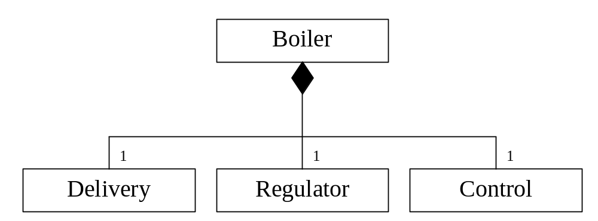
Figure 2: The Three Domains
All the domains talk to the Boiler. The Boiler thus is used as a mediator. A domain does not need to know the internal structure of the other domains. Hiding the internal structure for clients using higher abstraction objects is called the facade pattern.

Events
The three sub domains communicate with each other using events. The three sub domains only know of the Boiler object. They send their message to the Boiler object and the Boiler passes the message to the correct sub domain. This is a kind of message pattern.
Every domain has its own Event base class that is derived from the Event class (see Figure 3).
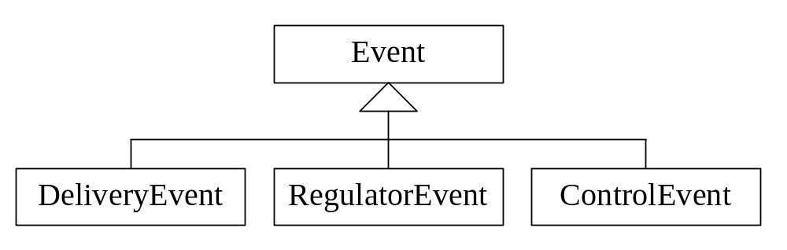
Figure 3: The Event base classes
The Delivery Domain has only one event (see Figure 4).

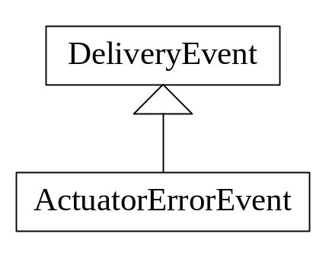
Figure 4: Delivery Events
The ActuatorErrorEvent will be sent when an actuator encounters an error. When an ActuatorErrorEvent is sent the ShowActuatorError method of the Control is called.

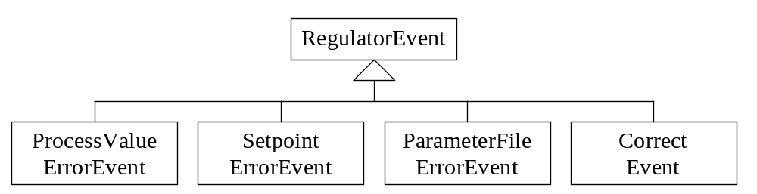
Figure 5: Regulator Events
The Regulator Domain has 4 events (see Figure 5). The ProcessValueErrorEvent will be sent when the process value of a parameter is out of bounds. The SetpointErrorEvent will be sent when the setpoint of a parameter is out of bounds. The ParameterFileErrorEvent will be sent when there was an error while reading or writing the parameter file. The CorrectEvent is send by the Algorithm to correct the output of the actuators.

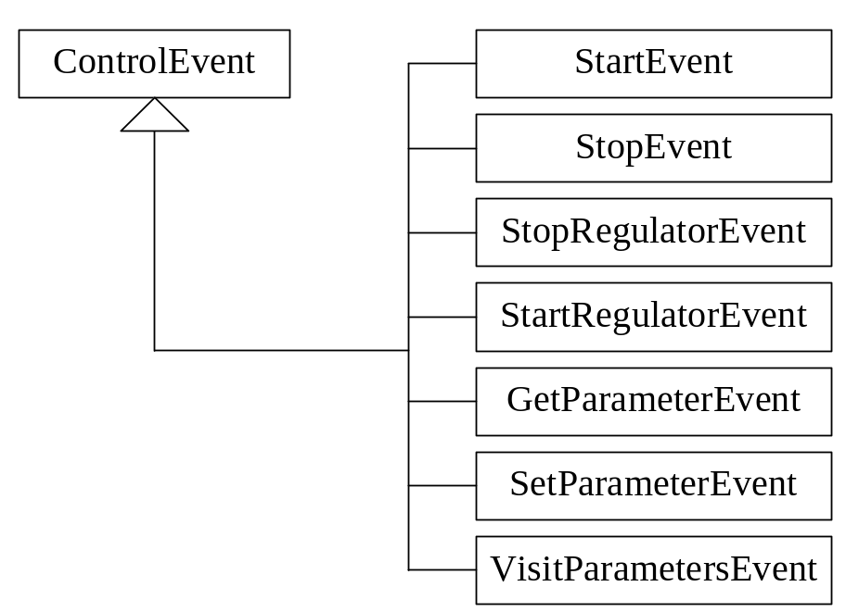
Figure 6: Control events
There are 7 events in the Control Domain (see Figure 6). The StartEvent and StopEvent are used to start and stop regulating a certain parameter. The StartRegulatorEvent and StopRegualtorEvent are used to start and stop the complete regulator. The SetParameterEvent and GetParameterEvent are used to set and get the parameter values like setpoint, process value and limits. The VisitParametersEvent is used to send all parameters to a parameter visitor. Using a parameter visitor we can in- or output all the parameter to a file or display device.

Factories
In the boiler application we used several factories (see Figure 7).
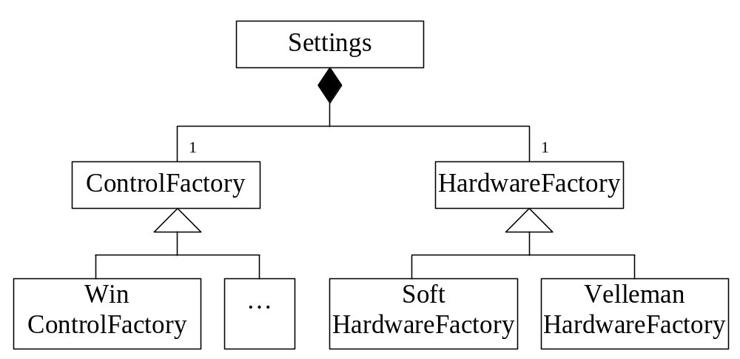Figure 7: Factories
The Settings object is a globally available class that is queried by the system for several settings such as filenames and the creation of concrete objects like data store objects, actuators and sensors. The Settings object thus is a kind of factory.
If for example, there are more actuators available then only the concrete classes have to be made for them and the appropriate settings functions has to be adapted.

The Settings class uses two factory objects to create Operating System Environment and Hardware dependent objects. The ControlFactory is used to create a platform dependent Control. For now we only have a WinControlFactory but a DOSControlFactory or UnixControlFactory is possible.
The HardwareFactory is used to create hardware objects like sensors and actuators. The SoftHardwareFactory creates hardware objects that are emulated in software. The VellemanHardwareFactory creates hardware objects that interface with the Velleman hardware.

Delivery Domain
The Delivery consists of an actuator control (see Figure 8). The ActuatorControl manages the available actuators. The ConfigurationFile is used to read the available actuators with their conversion strategies from a configuration file. The ConfigurationFile is implemented as a singleton.
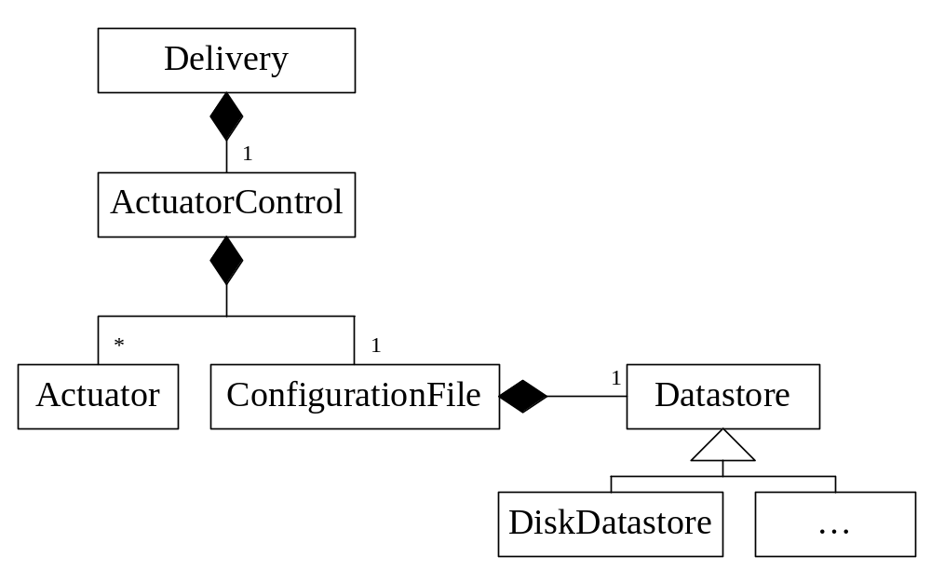
Figure 8: Delivery Domain
The ConfigurationFile uses a Datastore object that is generated by the Settings object. A concrete Datastore can for example be a disk or flash memory.
The ConfigurationFile uses the Settings class also for creating concrete actuators out of the actuator strings in the configuration file. Also the “Controller output to Actuator output” strategy is generated by the Settings object from the actuator string.
With the actuator control it is possible to have multiple actuators to regulate one parameter. Using the configuration file we can configure the available actuator and their response to the controller output at runtime.

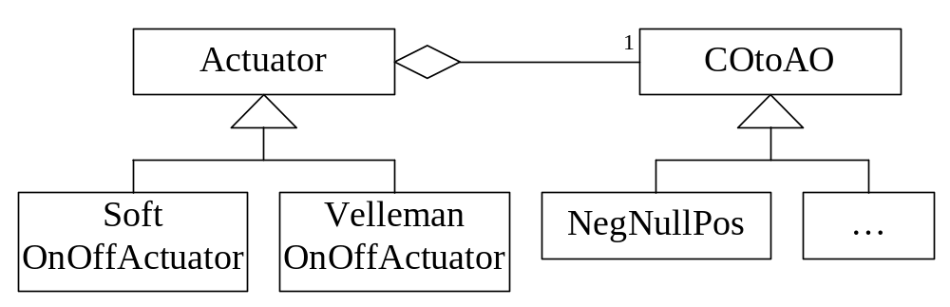
Figure 9: Actuators and ‘Controller Output to Actuator Output’ strategies
All the Actuators are derived from Actuator (see Figure 9). Currently we only have an OnOffActuator. The state of this actuator can only be on or off. Of course there are many other actuators possible for example actuators with analog outputs and actuators with error conditions.
Each actuator has a COtoAO strategy object to convert the controller output to the actuator output. Currently we only have a NegNullPos strategy. This strategy converts the controller output depending on the sign of the controller output. This strategy is used to switch the OnOffActuator on or off. Of course there are many other strategies possible.
Since the actuators and their strategies are read from a configuration file we can determine the actuators and their behavior at runtime. If for example out cooler element breaks, we can remove the cooler from the configuration file and change the strategy of the heater to respond not so strong when the temperature reached the desired value.

Regulator Domain
The Regulator Domain consists of a Medium and an Algorithm (See Figure 10). The algorithm is implemented as a strategy. The Algorithm uses a template method to calculate the next controller output. The controller output is then send to the Delivery. The Settings class creates a concrete algorithm. Currently we have a simple algorithm that calculates the difference of the setpoint value and the process values. This difference is then send out as the controller output. Of course there are other algorithms possible like PID algorithms and fuzzy logic algorithms.

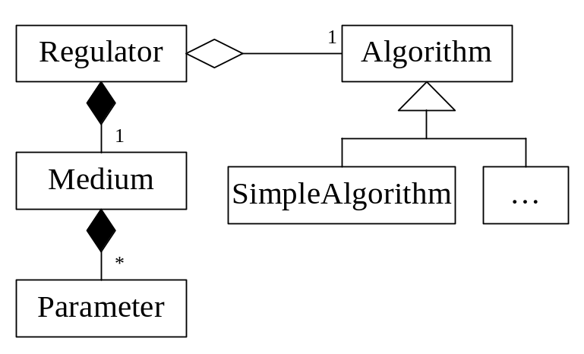
Figure 10: Regulator Domain
The Medium manages the available Parameters. The Medium provides functions to set- and get the properties of the parameter. The Settings class is used to create the available parameters so if we want extra parameters we do not have to change the Regulator or Medium. We only have to derive a new parameter class and update the Settings class.
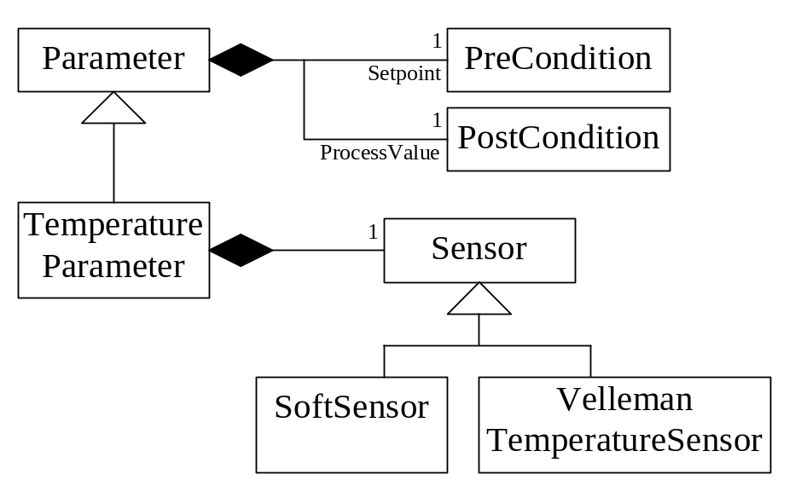
Figure 11: Parameters
Every parameter is derived from the Parameter class (See Figure 11). A parameter has a setpoint, process value, range, and a field to indicate if the parameter has to be regulated. The setpoint is a PreCondition property and the process value is a PostCondition property. For more information about the property pattern see the Property Document.
The TemperatureParameter has an associated Sensor object. The correct TemperatureSensor is created using the Settings class and the HardwareFactory object.

Parameter Visitors
A ParameterVisitor is used to in- or output the parameters from or to a device using the visitor pattern. Currently there are three concrete visitors (See Figure 12)
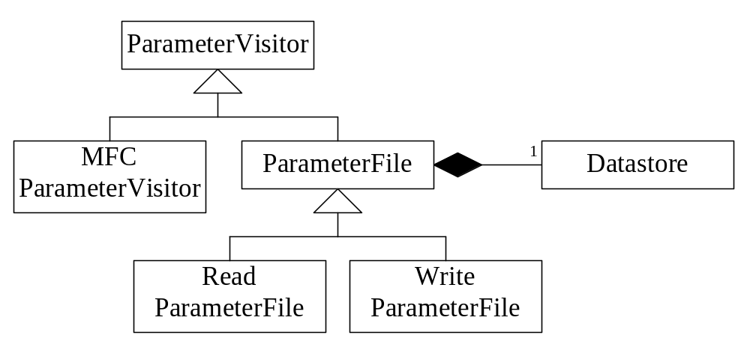
Figure 12: Parameter Visitors
The first two are the ReadParameterFile and the WriteParameterFile. These visitors are used to read and write the parameter properties (setpoint, range etc.) to a file. The actual reading and writing is done by a Datastore object thus the file storage medium can be a Disk or Flash memory etc. Whenever a parameter is updated the parameter file is written.
The Medium has a VisitParameters() method to send all parameters to a visitor. A MFCParameterVisitor is used by the WinControl to display the parameters in a list. More visitors can be created, for example to send the parameters to a log file, to send parameters to an Excel chart or to read and write parameters to the Windows registry.

Control Domain
The Control Domain consists of a concrete Control object (See Figure 13).
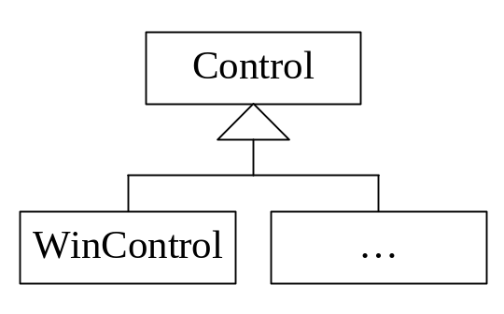
Figure 13: Control Domain
We have only made a Windows Control object that provides a user interface in Microsoft Windows. How the Windows Control is implemented is not interesting at the moment. Programming a Windows GUI is beyond the scope of this article. The interesting point is that, because a factory creates a concrete Control, we can easily provide other user interfaces without changing the rest of the program. We could for example create a DOS user interface.

Conclusion
Probably you noticed it already, except for the introduction, we rarely mention that this application is to regulate a Boiler. This means that the rest of the document is not depended on a Boiler. And this is exactly what we wanted. If we rename the Boiler class to for example GenericRegulator we have created an application frame that can be used to regulate everything, from the temperature in a boiler to the liquid level, flow, temperature and oxygen levels in a biological process. This all by only writing new specialized classes and adapting the factories.

Used Patterns

Facade pattern 3
Factory pattern 6, 11
Mediator pattern 3
Message pattern 4
Property pattern 9
Singleton pattern 7
Strategy pattern 7, 8, 9
Template Method pattern 9
Visitor pattern 5, 10

Actuators are used to enable/disable a resource such as a heater.

