均值和协方差阵的检验

Analyze-Descriptive Statistics-Explore—Plots（ Normality plots with tests）
Tests of Normality
 | Kolmogorov-Smirnovª |  |  | Shapiro-Wilk
 | Statistic | df | Sig. | Statistic | df | Sig.
净资产收益率 | .152 | 35 | .039 | .944 | 35 | .077
总资产报酬率 | .137 | 35 | .095 | .942 | 35 | .064
资产负债率 | .144 | 35 | .065 | .939 | 35 | .052
总资产周转率 | .235 | 35 | .000 | .683 | 35 | .000
流动资产周转率 | .159 | 35 | .026 | .850 | 35 | .000
已获利息倍数 | .172 | 35 | .011 | .880 | 35 | .001
销售增长率 | .116 | 35 | .200* | .982 | 35 | .836
资本积累率 | .252 | 35 | .000 | .695 | 35 | .000
a. Lilliefors Significance Correction
*. This is a lower bound of the true significance.
N>2000,选用K-S统计量；N<2000，选用S-W统计量。故一般情况下都选择S-W统计量。
假设服从正态分布，P值显著，证明拒绝原假设，认为不服从正态分布。

Analyze-General Linear Model- Multivariate
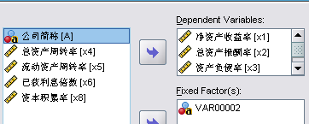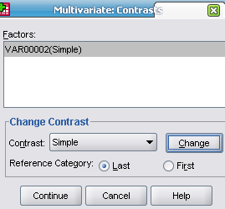

Between-Subjects Factors
 |  | N
VAR00002 | 1 | 11
VAR00002 | 2 | 15
VAR00002 | 3 | 9
行业样本计数。

Multivariate Tests^{c}
Effect |  | Value | F | Hypothesis df | Error df | Sig.
Intercept | Pillai's Trace | .947 | 130.278ª | 4.000 | 29.000 | .000
Intercept | Wilks' Lambda | .053 | 130.278ª | 4.000 | 29.000 | .000
Intercept | Hotelling's Trace | 17.969 | 130.278ª | 4.000 | 29.000 | .000
Intercept | Roy's Largest Root | 17.969 | 130.278ª | 4.000 | 29.000 | .000
VAR00002 | Pillai's Trace | .712 | 4.149 | 8.000 | 60.000 | .001
VAR00002 | Wilks' Lambda | .388 | 4.387ª | 8.000 | 58.000 | .000
VAR00002 | Hotelling's Trace | 1.317 | 4.611 | 8.000 | 56.000 | .000
VAR00002 | Roy's Largest Root | 1.077 | 8.079^{b} | 4.000 | 30.000 | .000
a. Exact statistic
b. The statistic is an upper bound on F that yields a lower bound on the significance level.
c. Design: Intercept + VAR00002
P值说明，三个行业运营能力存在显著差别。
模型Y（各指标所代表的运营能力综合水平）=b0+b1X（行业）

Tests of Between-Subjects Effects
Source | Dependent Variable | Type III Sum of Squares | df | Mean Square | F | Sig.
Corrected Model | 净资产收益率 | 458.258ª | 2 | 229.129 | 6.841 | .003
Corrected Model | 总资产报酬率 | 250.101^{b} | 2 | 125.050 | 10.034 | .000
Corrected Model | 资产负债率 | 1728.665^{c} | 2 | 864.333 | 4.515 | .019
Corrected Model | 销售增长率 | 9467.268^{d} | 2 | 4733.634 | 3.814 | .033
Intercept | 净资产收益率 | 3633.329 | 1 | 3633.329 | 108.483 | .000
Intercept | 总资产报酬率 | 1987.132 | 1 | 1987.132 | 159.453 | .000
Intercept | 资产负债率 | 71640.788 | 1 | 71640.788 | 374.189 | .000
Intercept | 销售增长率 | 15289.807 | 1 | 15289.807 | 12.321 | .001
VAR00002 | 净资产收益率 | 458.258 | 2 | 229.129 | 6.841 | .003
VAR00002 | 总资产报酬率 | 250.101 | 2 | 125.050 | 10.034 | .000
VAR00002 | 资产负债率 | 1728.665 | 2 | 864.333 | 4.515 | .019
VAR00002 | 销售增长率 | 9467.268 | 2 | 4733.634 | 3.814 | .033
Error | 净资产收益率 | 1071.745 | 32 | 33.492
Error | 总资产报酬率 | 398.790 | 32 | 12.462
Error | 资产负债率 | 6126.596 | 32 | 191.456
Error | 销售增长率 | 39711.458 | 32 | 1240.983
Total | 净资产收益率 | 4814.448 | 35
Total | 总资产报酬率 | 2483.797 | 35
Total | 资产负债率 | 85553.314 | 35
Total | 销售增长率 | 60514.046 | 35
Corrected Total | 净资产收益率 | 1530.003 | 34
Corrected Total | 总资产报酬率 | 648.891 | 34
Corrected Total | 资产负债率 | 7855.261 | 34
Corrected Total | 销售增长率 | 49178.726 | 34
a. R Squared = .300 (Adjusted R Squared = .256)
b. R Squared = .385 (Adjusted R Squared = .347)
c. R Squared = .220 (Adjusted R Squared = .171)
d. R Squared = .193 (Adjusted R Squared = .142)
三个行业在四个指标上均存在显著差别。

Contrast Results (K Matrix)行业间对比结果------多重比较
VAR00002 Simple Contrastª |  |  | Dependent Variable
 |  |  | 净资产收益率 | 总资产报酬率 | 资产负债率 | 销售增长率
Level 1 vs. Level 3 | Contrast Estimate |  | -1.070 | 1.317 | -9.215 | -27.850
Level 1 vs. Level 3 | Hypothesized Value |  | 0 | 0 | 0 | 0
Level 1 vs. Level 3 | Difference (Estimate - Hypothesized) |  | -1.070 | 1.317 | -9.215 | -27.850
Level 1 vs. Level 3 | Std. Error |  | 2.601 | 1.587 | 6.219 | 15.834
Level 1 vs. Level 3 | Sig. |  | .684 | .413 | .148 | .088
Level 1 vs. Level 3 | 95% Confidence Interval for Difference | Lower Bound | -6.368 | -1.915 | -21.883 | -60.102
Level 1 vs. Level 3 | 95% Confidence Interval for Difference | Upper Bound | 4.229 | 4.549 | 3.453 | 4.402
Level 2 vs. Level 3 | Contrast Estimate |  | -7.855 | -4.584 | 7.286 | -40.942
Level 2 vs. Level 3 | Hypothesized Value |  | 0 | 0 | 0 | 0
Level 2 vs. Level 3 | Difference (Estimate - Hypothesized) |  | -7.855 | -4.584 | 7.286 | -40.942
Level 2 vs. Level 3 | Std. Error |  | 2.440 | 1.488 | 5.834 | 14.853
Level 2 vs. Level 3 | Sig. |  | .003 | .004 | .221 | .010
Level 2 vs. Level 3 | 95% Confidence Interval for Difference | Lower Bound | -12.825 | -7.616 | -4.598 | -71.197
Level 2 vs. Level 3 | 95% Confidence Interval for Difference | Upper Bound | -2.885 | -1.552 | 19.170 | -10.686
a. Reference category = 3

1、3行业相比：
Sig. | .684 | .413 | .148 | .088

表示不能拒绝原假设，认为1、3行业在各指标间没有明显差别。
Contrast Estimate | -1.070 | 1.317 | -9.215 | -27.850
由此可以看出，1、3行业在各指标上的大小关系，进而进行分析。

Multivariate Test Results
 | Value | F | Hypothesis df | Error df | Sig.
Pillai's trace | .712 | 4.149 | 8.000 | 60.000 | .001
Wilks' lambda | .388 | 4.387ª | 8.000 | 58.000 | .000
Hotelling's trace | 1.317 | 4.611 | 8.000 | 56.000 | .000
Roy's largest root | 1.077 | 8.079^{b} | 4.000 | 30.000 | .000
a. Exact statistic
b. The statistic is an upper bound on F that yields a lower bound on the significance level.
多重比较可信度的度量，由P值可知检验是可信的。

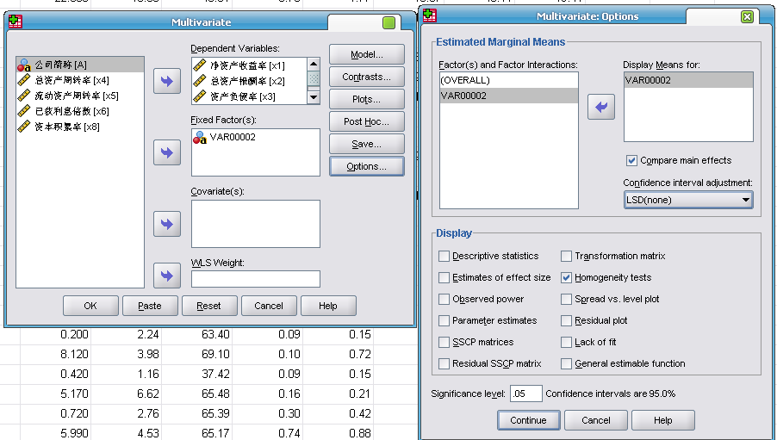

Levene's Test of Equality of Error Variancesª
 | F | df1 | df2 | Sig.
净资产收益率 | .585 | 2 | 32 | .563
总资产报酬率 | .651 | 2 | 32 | .528
资产负债率 | 3.448 | 2 | 32 | .044
销售增长率 | 3.496 | 2 | 32 | .042
Tests the null hypothesis that the error variance of the dependent variable is equal across groups.
a. Design: Intercept + VAR00002
各行业误差平方相等的检验。可以看出，净资产收益率和总资产报酬率的误差平方在行业间没有显著差别，而资产负债率和销售增长率的误差平方在行业间有显著差别，似乎说明除行业因素外，对资产负债率和销售增长率变动有显著影响的尚有其他因素。

Box's Test of Equality of Covariance Matricesª
Box's M | 35.152
F | 1.410
df1 | 20
df2 | 2585.573
Sig. | .106
Tests the null hypothesis that the observed covariance matrices of the dependent variables are equal across groups.
a. Design: Intercept + VAR00002
三个行业的协方差阵是相等的。
协方差阵相等的检验，检验统计量是Box’s M。由P值可知，{假设相等}，未拒绝原假设，认为协方差阵是相等的。

