2017年07月12日 12:08:00

阅读数：381

[Welcome to python_speech_features’s documentation!](https://python-speech-features.readthedocs.io/en/latest/)   
[Audio tools for Linux commandline geeks](http://www.talkunafraid.co.uk/2011/01/audio-tools-for-linux-commandline-geeks/)   
[Managing Linguistic Data](http://www.nltk.org/book/ch11.html)   
[Timit](http://dataju.cn/Dataju/web/datasetInstanceDetail/186)   
[快速克隆网站(Teleport Ultra)](https://jingyan.baidu.com/article/219f4bf7dce58bde442d3836.html)   
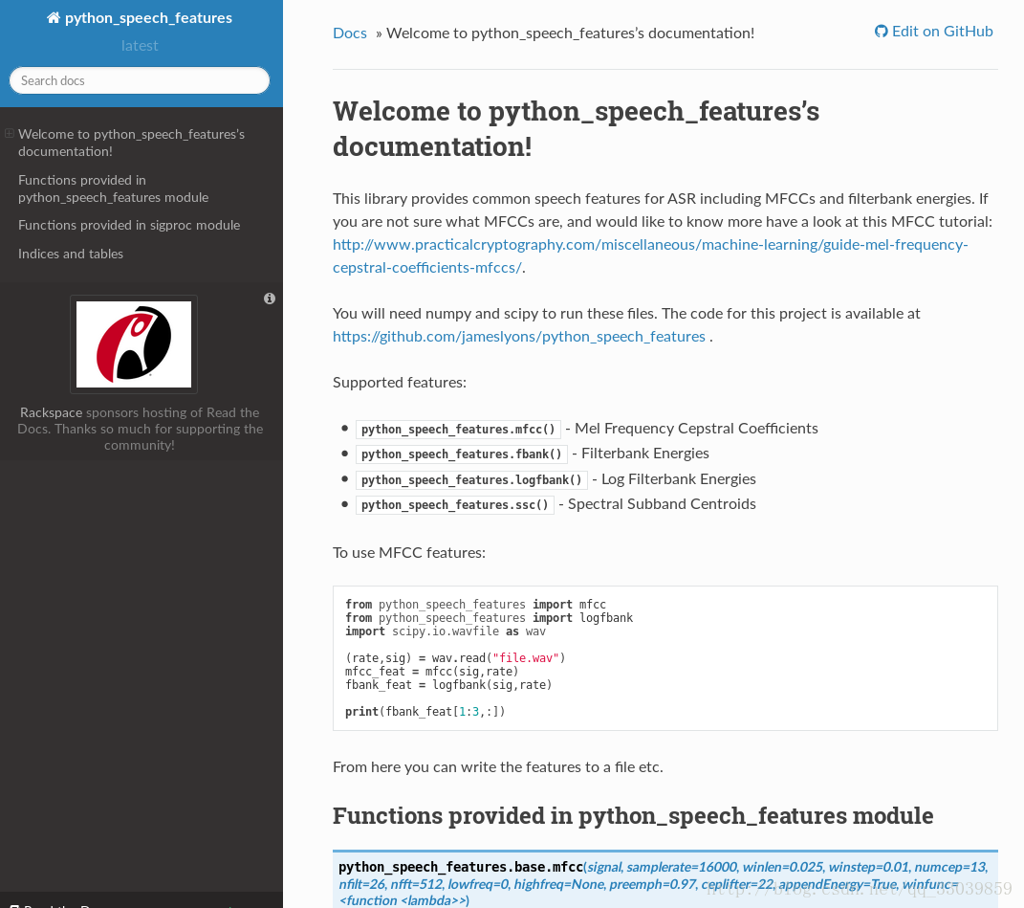

**Code:**

from python_speech_features import mfcc

from python_speech_features import logfbank

import scipy.io.wavfile as wav

(rate,sig) = wav.read("file.wav")

mfcc_feat = mfcc(sig,rate)

fbank_feat = logfbank(sig,rate)

print(fbank_feat[1:3,:])

mfcc_feat, fbank_feat are 2D matrics   
mfcc_feat: the number of row stands for the the frame number, each frame(帧) covers a sub-band of signal   
mfcc_feat: the number of columns stands for the filters numbers