dashencoder文档

软件功能：读取config文件，将文件、直播流进行编码分片，并生成mpd文件

界面：命令行

可选参数：-i inputfile

-h output help

输入可选单一文件（包含视音频或只包含视频）

还可选两个文件（一个视频文件加一个音频文件，此时会先将视音频一起打包，然后在进行编码、分片、生成mpd）

输出：mpd文件，以及组织好的文件结构，注意mpd中不要video和audio分开，否则播放器的设计会很麻烦，即在分片之前把视音频合一

用ffmpeg+MP4box分步骤进行这些操作的流程

假设现有一个视频，cuc_ieschool.mkv，需要将其变为具有两个rep的dash文件，第一个rep的vbitrate是2000k，分辨率为320x180，abitrate是48k；第二个rep的vbitrate是3000k，分辨率是480x270，abitrate是128k；dash的分片时长为4s

命令行如下

E:\postgraduate\DASH\Server\MP4Box>ffmpeg -i E:\postgraduate\DASH\Server\MP4Box\

cuc_ieschool.mkv -vcodec libx264 –s 320x180 -b:v 2000k cuc_ieschool_320.h264

E:\postgraduate\DASH\Server\MP4Box>ffmpeg -i E:\postgraduate\DASH\Server\MP4Box\

cuc_ieschool.mkv -vcodec libx264 –s 480x270 -b:v 3000k cuc_ieschool_480.h264

E:\postgraduate\DASH\Server\MP4Box>ffmpeg -i E:\postgraduate\DASH\Server\MP4Box\

cuc_ieschool.mkv -acodec libvo_aacenc -b:a 48k cuc_ieschool_48.aac

E:\postgraduate\DASH\Server\MP4Box>ffmpeg -i E:\postgraduate\DASH\Server\MP4Box\

cuc_ieschool.mkv -acodec libvo_aacenc -b:a 128k cuc_ieschool_128.aac

E:\postgraduate\DASH\Server\MP4Box>mp4box -add E:\postgraduate\DASH\Server\MP4Bo

x\cuc_ieschool_320.h264 -add E:\postgraduate\DASH\Server\MP4Box\cuc_ieschool_48.

aac cuc_ieschool_rep1.mp4

E:\postgraduate\DASH\Server\MP4Box>mp4box -add E:\postgraduate\DASH\Server\MP4Bo

x\cuc_ieschool_480.h264 -add E:\postgraduate\DASH\Server\MP4Box\cuc_ieschool_128

.aac cuc_ieschool_rep2.mp4

E:\postgraduate\DASH\Server\MP4Box>mp4box -dash 4000 -frag 4000 -rap -segment-na

me cuc_ieschool_$RepresentationID$_$Bandwidth$/cuc_iescool_seg_ -out tmp cuc_ies

chool_rep1.mp4 cuc_ieschool_rep2.mp4

最后得到的文件结构如下，mpd文件如下

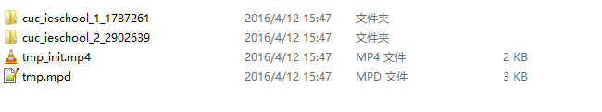

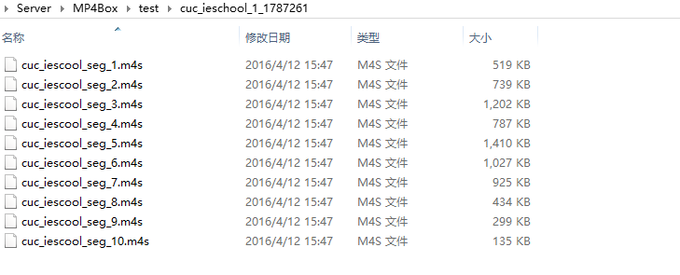

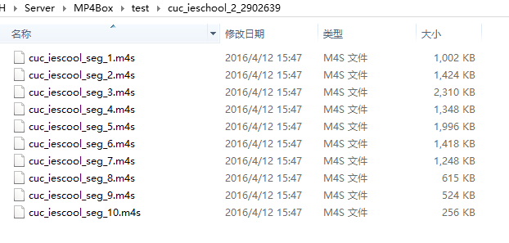

<?xml version="1.0"?>

<!-- MPD file Generated with GPAC version 0.5.2-DEV-rev1110-g9f2bf6e-master at 2016-04-12T07:47:01.770Z-->

<MPD xmlns="urn:mpeg:dash:schema:mpd:2011" minBufferTime="PT1.500S" type="static" mediaPresentationDuration="PT0H0M34.248S" maxSegmentDuration="PT0H0M4.000S" profiles="urn:mpeg:dash:profile:full:2011">

<ProgramInformation moreInformationURL="http://gpac.sourceforge.net">

<Title>tmp.mpd generated by GPAC</Title>

</ProgramInformation>

<Period duration="PT0H0M34.248S">

<AdaptationSet segmentAlignment="true" bitstreamSwitching="true" maxWidth="480" maxHeight="270" maxFrameRate="25" par="16:9" lang="und">

<AudioChannelConfiguration schemeIdUri="urn:mpeg:dash:23003:3:audio_channel_configuration:2011" value="2"/>

<ContentComponent id="1" contentType="video" />

<ContentComponent id="2" contentType="audio" />

<SegmentList>

<Initialization sourceURL="tmp_init.mp4"/>

</SegmentList>

<Representation id="1" mimeType="video/mp4" codecs="avc3.640015,mp4a.67.2" width="320" height="180" frameRate="25" sar="1:1" audioSamplingRate="44100" startWithSAP="1" bandwidth="1787261">

<SegmentList timescale="1000" duration="3493">

<SegmentURL media="cuc_ieschool_1_1787261/cuc_iescool_seg_1.m4s"/>

<SegmentURL media="cuc_ieschool_1_1787261/cuc_iescool_seg_2.m4s"/>

<SegmentURL media="cuc_ieschool_1_1787261/cuc_iescool_seg_3.m4s"/>

<SegmentURL media="cuc_ieschool_1_1787261/cuc_iescool_seg_4.m4s"/>

<SegmentURL media="cuc_ieschool_1_1787261/cuc_iescool_seg_5.m4s"/>

<SegmentURL media="cuc_ieschool_1_1787261/cuc_iescool_seg_6.m4s"/>

<SegmentURL media="cuc_ieschool_1_1787261/cuc_iescool_seg_7.m4s"/>

<SegmentURL media="cuc_ieschool_1_1787261/cuc_iescool_seg_8.m4s"/>

<SegmentURL media="cuc_ieschool_1_1787261/cuc_iescool_seg_9.m4s"/>

<SegmentURL media="cuc_ieschool_1_1787261/cuc_iescool_seg_10.m4s"/>

</SegmentList>

</Representation>

<Representation id="2" mimeType="video/mp4" codecs="avc3.64001e,mp4a.67.2" width="480" height="270" frameRate="25" sar="1:1" audioSamplingRate="44100" startWithSAP="1" bandwidth="2902639">

<SegmentList timescale="1000" duration="3493">

<SegmentURL media="cuc_ieschool_2_2902639/cuc_iescool_seg_1.m4s"/>

<SegmentURL media="cuc_ieschool_2_2902639/cuc_iescool_seg_2.m4s"/>

<SegmentURL media="cuc_ieschool_2_2902639/cuc_iescool_seg_3.m4s"/>

<SegmentURL media="cuc_ieschool_2_2902639/cuc_iescool_seg_4.m4s"/>

<SegmentURL media="cuc_ieschool_2_2902639/cuc_iescool_seg_5.m4s"/>

<SegmentURL media="cuc_ieschool_2_2902639/cuc_iescool_seg_6.m4s"/>

<SegmentURL media="cuc_ieschool_2_2902639/cuc_iescool_seg_7.m4s"/>

<SegmentURL media="cuc_ieschool_2_2902639/cuc_iescool_seg_8.m4s"/>

<SegmentURL media="cuc_ieschool_2_2902639/cuc_iescool_seg_9.m4s"/>

<SegmentURL media="cuc_ieschool_2_2902639/cuc_iescool_seg_10.m4s"/>

</SegmentList>

</Representation>

</AdaptationSet>

</Period>

</MPD>

前面多次调用ffmpeg的过程可以简化如下

E:\postgraduate\DASH\Server\MP4Box>ffmpeg -i E:\postgraduate\DASH\Server\MP4Box\

cuc_ieschool.mkv -vcodec libx264 -r 25 -s 480x270 -b:v 3000k cuc_ieschool_4800.h

264 -vcodec libx264 -r 25 -s 320x180 -b:v 2000k cuc_ieschool_3200.h264

复用类

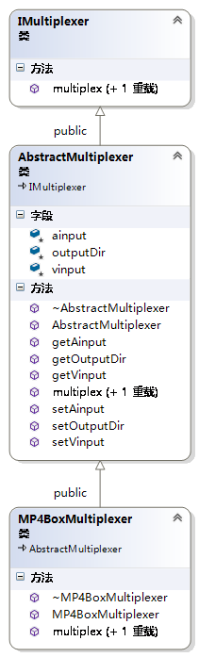

编码器类，调用ffmpeg进行编码，视频编码目前支持h264和vp8，音频编码只支持aac。视频编码可选参数有fps、gopsize、宽、高、码率；音频编码可选参数有声道数、采样率、码率。

具体到h264编码，可设置参数有编码趟数（目前只支持1趟编码），preset以及profile；aac编码没有可以再详细设置的参数，vp8编码目前不支持。

操作逻辑如下：如果是单独的输入文件，同时有视频和音频，先根据视频编码参数设置编码为多个h264文件，再根据音频编码参数设置编码为多个aac文件，相当于demux，在后面的操作中再用mp4box根据组合参数设置mux为对应的representation，此时视音频合并为mp4，再进行后面的工作。

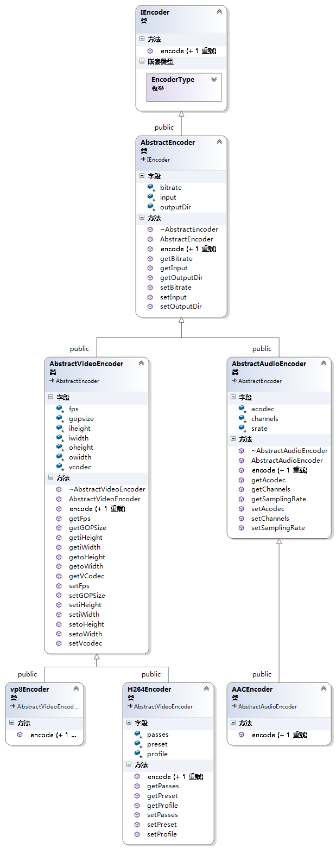

工厂模式，编码器工厂

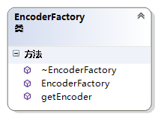

MPD生成类

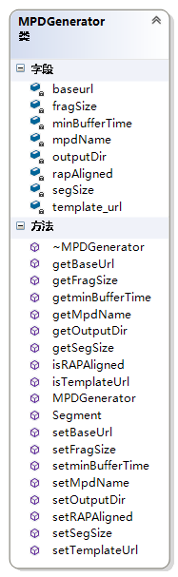

主函数

int TransAudio(AnyOption *opt, AbstractAudioEncoder* a_enc, std::map<int, std::string> &transcoded_audio_files);

int TransVideo(AnyOption *opt, AbstractVideoEncoder* v_enc, std::map<int, std::string> &transcoded_video_files);

int AVMux(AnyOption *opt, std::map<int, int> &av_mux_mapping, MP4BoxMultiplexer* muxer,

std::map<int, std::string> transcoded_video_files,

std::map<int, std::string> transcoded_audio_files,

std::vector<std::string> &muxed_files);

int MpdGen(MPDGenerator* mpdgen, std::vector<std::string> muxed_files, std::string &mpd_path);